Dr. Jordan Shurr
Central Michigan University

January 5, 2014

Dr. Lisa Pufpaff, PDERS Editor
Ball State University

Dear Dr. Pufpaff,

This manuscript, entitled “Taking the Helm: A Self-Directed Guide to Professional Development for Teachers of Students with Moderate and Severe Disabilities”, is being submitted for consideration in Physical Disabilities: Education and Related Services. This letter is to indicate that no other publisher has published this manuscript in whole or substantial part. In addition, this manuscript is not being considered concurrently in whole or substantial part by another publisher. It is the original work of the authors. Authors of this study include Jordan Shurr Ph.D., Andrea Jasper Ph.D., Meaghan McCollow Ph.D., BCBA-D, JoDell Heroux Ph.D. of Central Michigan University, and Marilyn Hirth, Ed.D. of Purdue University. Please find contact information for each author on the following page.

Thank you for taking the time to review and consider this manuscript.

Sincerely,

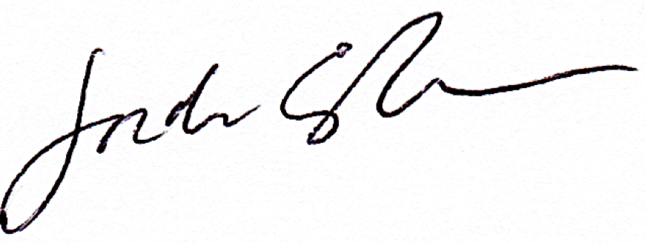

Jordan Shurr, Ph.D.

Author Contacts

Dr. Jordan Shurr  Assistant Professor | Dr. Marilyn Hirth  Associate Professor
Department of Counseling and Special Education  352 EHS  Central Michigan University  Mount Pleasant, MI 48859  Off: 989-774-7580  Fax: 989-774-2305  shurr.jordan@cmich.edu | Department of Educational Studies  BRNG 5134  Purdue University  West Lafayette, IN 47907  Off: 765-494-0319  Fax: 765-494-5832  mahirth@purdue.edu
Dr. Andrea Jasper | Dr. JoDell Heroux
361 EHS  Assistant Professor  Department of Counseling and Special Education  Central Michigan University  Mount Pleasant, MI 48859  Off: 989- 774-7206  Fax: 989-774-2305  jaspe1ad@cmich.edu | 359 EHS  Assistant Professor  Department of Counseling and Special Education  Central Michigan University  Mount Pleasant, MI 48859  Off: 989- 774-7176  Fax: 989-774-2305  herou1jr@cmich.edu
Dr. Meaghan McCollow
346 EHS
Assistant Professor
Department of Counseling and Special Education
Central Michigan University
Mount Pleasant, MI 48859
Off: 989- 774-7579
Fax: 989-774-2305
meaghan.mccollow@cmich.edu

