Journal of the Student Personnel Association
at Indiana University

2017-2018 Edition

Student Personnel Association at Indiana University Officers | ii
Editors and Advisors | iii
Letter from the Editors | iv
Contemporary Issues and Opinions  Title IX: Rebuild or Rescind? | 1
Alejandro G. Rios

Research, Assessment, and Reviews
Fulfilling the Promise through Sense of Belonging: Experiences of Norman Brown Diversity and Leadership Scholars at IUPUI | 4
Jennifer A. Azevedo, Sydney M. Howell, Luis Mora, Paige L. Thomas, & Daniel Tovar
Seeking Value Beyond Meal Points: Investigating Support for Residential Life Professionals | 19
Manjari Agrawal, Leslie W. Boey, Drew Donaldson, Monica Fung, Lindsey Snow, & Meredith D. Young
Physical Environment as an Indicator of Cultural Validation in Counseling and Psychological Services and the Center for Human Growth at Indiana University | 42
Kaamil Al-Hassan, Katherine Hornell, Alexander Moon, Markie Pasternak, Da’Shaun Scott, & Jason Simon
Bros & Booze: Assessing the Impact of Alcohol Skills Training Program on Fraternity Drinking | 68
Gino M. Andreano, Abigail Ford, Alexis L. Karwoski, & Chase K. Wilson
International Branch Campuses: Reviewing the Literature through Tierney’s Organizational Cultural Framework | 89
Jayson J. Deese, Esen Gokpinar-Shelton, & Lauren A. Wendling  Historical Studies  “Setting the Stage for Change: The Groups Scholars Program at Indiana University  Shanalee S. Gallimore | 103
“Tambien nosotros podemos aprender”: The Struggle for Latinx Student Support Services at Indiana University in the 1970s | 116
Berenice Sánchez
HESA Gift and Giving Information | 130

STUDENT PERSONNEL ASSOCIATION
AT INDIANA UNIVERSITY

Department of Higher Education and Student Affairs
School of Education
W.W. Wright Education Building, Suite 4228
Bloomington, Indiana 47405 (812) 856-8362 / 856-8364

Editors
Drew Donaldson, Rebecca Kates, and Vandana Pawa

Faculty Advisors
Dr. Lucy LePeau and Dr. Gary Pike

Review Board
Juanita Ariza, Kari Lynn Besing, Kate Chandley, Kai-Wei Cheng, Megan Covington,
Joseph Diodato, Kyle T. Fassett, Alfred Garcia, Yohana Gebremicael, Cassandra E. Govert,
Katherine Hornell, Jacqueline Mac, Kayla M. Muncie, Vanessa S. Na, Christen Priddie,
Marnie Shapiro, Samantha M. Silberstein, Paige Leigh Thomas, Elizabeth M. Wall,
Lauren A. Wendling, & Meredith D. Young

SPA at IU Officers

President Andrea Jarquin
Vice-President Ivette Olave
Treasurer Jorge Lopez
Secretary Oyindamola Bamgbola
Director of Member Relations Alejandro Rios
Directors of Outreach Kelsey Darnell, Alfred Garcia, Tyler Switsky
Directors of Programming Olivia Daley, Meagan Roberts
Webmaster Delgar Woodruff

The Journal of the Student Personnel Association at Indiana University is published annually by the Student Personnel Association at Indiana University with support from the Higher Education & Student Affairs (HESA) Program. The Journal is produced expressly to provide an opportunity for HESA master’s students to publish articles pertinent to the field of student affairs. The primary sources of funding for the Journal are alumni donations and support from the students and the HESA department. The important role that each of these contributors has played in the production of this edition is gratefully acknowledged and appreciated.

Journal Editors

1967: Ann Paloney & Michael J. Wiener
1968: Marily Liechty
1969: Dallas Bauman
1971: George C. Dehne
1972: Jane A. Lundahl
1973: Helen Mamarchev & Winnifred Weeks
1974: Elizabeth Brannon, Robert Ciesliki, Barbara Moudy, David Stacy & Dann Lobsinger
1975: Dann Lobsinger & Deborah Ann Alter
1976: Dianne Burnside & Richard Scott
1977: Susan Hopp, Frank Araiolo & Vince Carunchia
1978: Elizabeth A. Zavodny, Marc Kaplan & Jim Scroth
1979: Jim Scroth
1980: L. E. Wegryn
1981: B. J. Bischoff & Brian Pisaro
1982: Rodney P. Kirsch & Janet J. Wright
1983: Nedra Hartzell & Daniel Salter
1984: Susan Buffington & Diane Ledger
1985: Margaret O’Brien & David Stewart
1986: Lora Burnett & James Vander Putten
1987: James J. Holmen & James J. Hurley
1988: David J. Strauss & J. J. Thorp
1989: J. J. Thorp & Patricia Harned
1990: Patricia Harned & Diane Robinson
1991: Diane Robinson & Anne E. Spitler
1992: Anne Spitler & Lisa K. Mitchell
1993: Lisa K. Mitchell & Allison Block
1994: Allison Block & Melody M. Snyder
1995: Melody M. Snyder, Lisa P. Lourden, Kelli Kputska Smith & John Bean
1996: John Bean & Kelli Kaputska Smith
1997: Suzanne J. Mendoza, Jennifer Forbes & Alan Rose
1998: Jennifer Forbes & Ryan A. Forsythe
1999: Naraiah S. Broadus & Christopher R. Turner
2000: Brent Ericson & Jason Pontius
2001: Valerie A. Sarma & Kelly A. Kish
2002: Drew Griffin & Victoria S. Pasternak
2003: Victoria S. Pasternak & Tara L. Sherwin
2004: Matthew D. Nelson & Tara L. Sherwin
2005: Matthew D. Nelson & Ryan D. Padgett
2006: Laura J. Barnes & Ryan D. Padgett
2007: Laura J. Barnes & Lauren E. Morrill
2008: Eddie R. Cole & Lauren E. Morrill-Ragusea
2009: Eddie R. Cole & Autumn T. Harrell
2010: Autumn T. Harrell & Mark E. Houlemarde
2011: Mark E. Houlemarde & Tracy L. Teel
2012: Tracy L. Teel & Kelly L. Grab
2013: Kelly L. Grab & Stephanie T. X. Nguyen
2014: Stephanie T. X. Nguyen & Woody Lawson
2015: Bernard H. Lawson & Matthew D. Cramer
2016: Matthew D. Cramer & Kody K. Sexton
2017: Kody K. Sexton & Drew Donaldson
2018: Drew Donaldson, Rebecca Kates, & Vandana Pawa

Advisors

1960-1977: Elizabeth Greenleaf
1970-1971: Wanda Deutsch
1972-1976: David Decoster
1977-1982: George Kuh
1983-1987: John Schuh
1987-1988: Don Hossler
1988-1989: Frances Stage
1989-1990: Don Hossler
1990-1996: George Kuh
1996-1997: Bruce Jacobs
1997-1998: Teresa Hall
1998-2000: Ada Simmons
2000-2002: Jillian Kinzie
2002-2004: Kate Boyle
2004-2005: Lori Patton
2005-2014: Danielle DeSawal
2015: Karyn E. Rabourn
2016: Danielle M. DeSawal
2017-2018: Lucy LePeau & Gary Pike

Letter from the Editors

Drew Donaldson, Rebecca Kates, & Vandana Pawa

We are excited to present the 2017-2018 Journal of the Student Personnel Association at Indiana University (SPA at IU Journal), a publication of original scholarly works related to higher education and student affairs. The SPA at IU Journal has a long tradition of providing an opportunity for Higher Education and Student Affairs (HESA) master’s and doctoral students to submit their scholarship. First published in 1967, the Journal has featured numerous articles on a variety of topics, ranging from original research studies to literature reviews and educational policy analyses. In 2010, the Journal moved to an online format through the IUScholarWorks database, a service provided by the Indiana University Digital Libraries Program. This service has allowed us to reach a much wider audience of readers, and we are proud to make the entire digital archives, dating back to 1967, available online. We hope that you will not only enjoy but also be challenged by the scholarship in the 2017-2018 edition of the Journal and in our IUScholarWorks digital archives. This edition of the Journal marks the first inclusion of the Contemporary Issues and Opinions section, where we feature editorial style writing.
This edition features a total of eight articles on a wide array of topics, from a contemporary look at recent Title IX policy changes to Latinx student support on Indiana University’s campus. The first article in our Contemporary Issues and Opinion section, “Title IX: Rebuild or Rescind?” examines recent changes in Title IX policies and the impact they have on university campuses. The next article, “Fulfilling the Promise through Sense of Belonging,” starting off the Research, Assessment, and Reviews section, looks at student engagement in the Norman Brown Scholars Program at Indiana University-Purdue University Indianapolis. “Seeking Value Beyond Meal Points” studies the support that professional residential life staff receive from their department at Indiana University-Bloomington. Next, “Physical Environment as an Indicator of Cultural Validation” examines different offices on Indiana University’s campus that provide mental health services to students, and how different physical elements of each space can or cannot be culturally validating for minority students. The next article, “Bros & Booze: Assessing the Impact of the Alcohol Skills Training Program,” explores how alcohol education impacts fraternity members’ drinking. Our last article in this section, “International Branch Campuses,” reviews literature and studies the organizational culture of international branch campuses. Our final section, Historical Studies, starts with “Setting the Stage for Change,” which breaks down the historical context of the Groups Scholars program at Indiana University. Finally, the last article, “Latinx Student Support,” looks at the development of support systems for Latinx students on the Indiana University campus.
As the editors of this year’s SPA at IU Journal, we would like to thank the authors, the review board, the SPA webmaster, the online publishers, and our advisors, Drs. Gary R. Pike and Lucy LePeau, for their generous dedication to creating a publication that upholds HESA’s legacy of scholarship. Several months of time and effort are required from all who contribute to the Journal’s publication, and for this, we are very appreciative. The Journal would not be possible without the continued support of the Student Personnel Association at Indiana University, financial contributions from alumni, and additional resources from the HESA program. With this support, the Journal is able to provide a unique opportunity for master’s and doctoral students to experience the publication process and showcase their scholarship.
We hope you are as excited to read the scholarship presented in this year’s Journal as we are to deliver it to you. Please enjoy the 2017-2018 Journal of the Student Personnel Association at Indiana University!
Drew Donaldson is a 2018 M.S.Ed. candidate in the Indiana University Higher Education and Student Affairs program. He received his B.A. in History from the University of Chicago. At IU, he is the Graduate Supervisor for Academic Programs in Residential Programs and Services and Alumni Relations and Development Coordinator in the School of Informatics, Computing, and Engineering.

Rebecca Kates is a 2019 M.S.Ed candidate in the Indiana University Higher Education and Student Affairs program. She received her B.A. in English from the University of Maryland, College Park, along with minors in Public Leadership and Women’s Studies. At IU, she serves as a Graduate Supervisor in the Collins Living & Learning Center in Residential Programs and Services.

Vandana Pawa is a 2019 M.S.Ed. candidate in the Indiana University Higher Education and Student Affairs program. She received her B.A. in Psychology and Women’s, Gender, and Sexuality Studies from The Ohio State University. At IU, she serves as the Graduate Supervisor for Diversity Education in Residential Programs and Services

Contemporary Issues and Opinions

Title IX: Rebuild or Rescind?

Alejandro G. Rios

In light of the rescinding of two guiding pieces developed in President Obama’s era, the U.S. Department of Education’s Office of Civil Rights has begun to obscure the protocol of handling issues related to Title IX for many college and university professionals and mandated reporters of the institution (Brown, 2017). This discussion is in support of strengthening Title IX’s guiding pieces from the Obama-era. Followed by the views that support Secretary DeVos’s rescinding of these pieces and an institution’s increased flexibility to manage incidents of sexual misconduct, the author will examine how these arguments dismiss the due process for student survivors of sexual misconduct. The author will conclude with an argument that highlights why the reimplementation of President Obama’s Title IX guidelines and procedures are desirable for our students’ educational success.
The law which we refer to as Title IX directly outlines an institution’s response to sexual assault, sexual violence, and overall discrimination on the basis of sex (Title IX, Education Amendments of 1972). Effective in 1972, Title IX has evolved from prohibiting educational opportunities on the basis of sex to a law that now holds institutions responsible for preventing and handling situations of sexual misconduct to ensure a student’s success (Brodsky & Deutsch, 2015). As mentioned by Brodsky and Deutsch (2015), women came forward with multiple concerns regarding sexual harassment and sexual misconduct—this was primarily seen in the workplace. Women frequently received sexually charged attitudes, behaviors, orders, and comments in their work environments. These patterns increasingly manifested on college campuses, ultimately impeding a student’s determination and potential to pursue their education (Brodsky & Deutsch, 2015). Because institutions of higher education are committed to student learning and academic achievement, Title IX serves to reinforce this promise. With the rescinding of guidelines for Title IX, it is difficult to presume how institutions will attempt to advocate for their student survivors—the rights of both the complainants and respondents have become precarious. For clarity, student survivors are referred to as complainants, and accused students are referred to as respondents.
In 2011, the Obama administration brought clear and more informed practices to colleges and universities across the nation in response to sexual misconduct cases (Harris & Kelderman, 2017). Marked as the new era of strict enforcement, these guidelines outlined the obligation to take immediate action in the event of a reported sexual misconduct case (Department of Education, Office for Civil Rights, 2011). Consequently, those in support of strengthening Title IX argue that the rescinding of these guidelines strip survivors of their voice, favor the accused, and ultimately raise more questions than answers (Brown, 2017). Additionally, institutions are left to interpret the law and decide which standard works best for their given institution, leaving these cases open for variability. With the flexibility to handle these reports, institutions may be more likely to sweep cases under the rug, making survivors of sexual assault less comfortable reporting incidents as they arise (Brown, 2017). Brown highlights, “Nationally it will be confusing, and it will result in students’ having different protections at different schools” (Brown, 2017). Incidents involving sexual misconduct thus deserve strong, clear and efficient guidelines.
Inversely, for those in support of the rollback, having more options to conduct an investigation and various routes for resolving cases of sexual misconduct is not necessarily adverse. Administrators can shape their investigations to model the conditions and students involved in the most appropriate manner (Harris & Kelderman, 2017). Relieving staff of the pressures of time-constraint, the new interim measures state, “There is no fixed time frame under which a school must complete a Title IX investigation” (Department of Education, Office for Civil Rights, 2017). Making it a priority to advocate a fair, just, and equitable process is important for both the complainants and respondents. As mandated reporters, professionals must focus on protecting free speech to ensure that the respondent’s due process is not undermined (Harris & Kelderman, 2017). These new measures ultimately give respondents increased clarity and opportunity for their voices to be heard throughout their investigation.
While there are many avenues that institutions can implement with the new, interim measures, its ambiguity only disfavors the complainants. Furthermore, the compassion, fragility, and integrity surrounding Title IX has been disrupted. By gradually shifting the focus and protection onto the respondents, mandated reporters inherently perpetuate fear in the lives of survivors who depend on institutions to handle Title IX cases appropriately. It is important to recognize that universities have a significant role in remedying conditions that elicit sexual misconduct cases (Ellman-Golan, 2017). Therefore, professionals must continue to support student survivors and strengthen Title IX, not scale it down.

Alejandro Rios is a 2019 M.S.Ed. candidate in the Indiana University Higher Education and Student Affairs program. He received his B.A. in Sociology from Loyola University Chicago. At IU, he serves as a Graduate Supervisor in Residential Programs and Services and the Director of Member Relations in the Student Personnel Association.

References

Brodsky, A., & Deutsch, E. (2015). The Promise of Title IX. Dissent (00123846), 62(4), 135-144.
Brown, S. (2017, September 22). What does the end of Obama’s Title IX guidance mean for colleges? The Chronicle of Higher Education. Retrieved from http://www.chronicle.com/article/What-Does-the-End-of-Obama-s/241281
Ellman-Golan, E. (2017). Saving Title IX: Designing more equitable and efficient investigation procedures. Michigan Law Review, 116(1), 155-186.
Harris, A., & Kelderman, H. (2017, September 7). Citing Obama-Era failures, DeVos will replace landmark directive on sexual assault. The Chronicle of Higher Education. Retrieved from http://www.chronicle.com/article/Citing-Obama-Era-Failures/241117
Title IX, Education Amendments of 1972, 20 U.S.C. §§1681–1688.
U.S. Department of Education, Office for Civil Rights (2011 April). Dear Colleague. Retrieved from https://www2.ed.gov/about/offices/list/ocr/letters/colleague-201104.pdf
U.S. Department of Education, Office for Civil Rights (2017 September). Q&A on Campus Sexual Misconduct. Retrieved from https://www2.ed.gov/about/offices/list/ocr/docs/qa-title-ix-201709.pdf

Research, Assessment, and Reviews

Fulfilling the Promise through Sense of Belonging:
Experiences of Norman Brown Diversity and Leadership Scholars at IUPUI

Jennifer A. Azevedo, Sydney M. Howell, Luis Mora, Paige L. Thomas, & Daniel Tovar
Museus (2014) describes sense of belonging as a crucial determining factor of success for students of color. Therefore, the researchers chose to study sense of belonging within this specific population. The individual interviews reveal whether students find sense of belonging within the Norman Brown Diversity and Leadership Scholars Program (NBDLSP) or elsewhere on campus. The researchers utilize their findings to provide recommendations to the director of the NBDLSP that are centered on the experiences of the current scholars. In addition, the researchers offer implications for practice and further research for student affairs professionals involved in similar programs.

The Norman Brown Diversity and Leadership Scholars Program (NBDLSP) at Indiana University-Purdue University Indianapolis (IUPUI) is a scholarship program that aims to “recruit, retain, and prepare serious, academically gifted students who have demonstrated a commitment to social justice” (Indiana University-Purdue University Indianapolis, 2017). Originating in 1988 and named after its founder Norman Brown in 2005, the program is currently made up of 94 students (D. Tate, personal communication, September 27, 2017). Although the current online communications for the NBDLSP do not advertise the scholarship as an opportunity for students of color, Danielle Tate, program coordinator of NBDLSP, stated that the program caters to minoritized students (personal communication, September 21, 2017). Additionally, the available demographics of the NBDLSP show that the program serves mainly students of color.
Students of color persist when they feel as though they belong to a group and can identify with peers within the group (Fries-Britt, 2000; Fries-Britt, 2004; Museus, 2014). However, research shows there are far fewer students of color than White students in high-achieving programs (Fries-Britt, 2004; Grissom & Redding, 2015). The implications of the available literature have led our research team to look more closely at the NBDLSP and how participating in the NBDLSP contributes to sense of belonging. In this study, the researchers measure the extent to which the NBDLSP influences on sense of belonging, according to the Culturally Engaging Campus Environments (CECE) Model (Museus, 2014). More specifically, the purpose of this study was to collect data regarding sense of belonging of students within the NBDLSP and analyze the data based on CECE indicators.

Literature Review

Sense of Belonging
Bollen and Hoyle (1990) laid the framework for cohesion and its relation to sense of belonging by determining sense of belonging to be a part of cohesion. They also included how people feel affinity and membership to a community. Hurtado and Carter (1997) defined sense of belonging as both “cognitive and affective elements in that the individual’s cognitive evaluation of his or her role in relation to the group results in an affective response” (p. 328) and “students’ overall perception of social cohesion within the campus environment” (p. 204). These definitions attribute sense of belonging to a variety of factors.

Campus Environments
Museus (2014) outlined how seminal literature failed to include a growing number of diverse students obtaining higher education degrees. The Culturally Engaging Campus Environments (CECE) Model challenged Tinto’s Theory of Student Integration by shifting from a White washed lens to a framework that encompassed the increasingly diverse racial demographic of higher education. Museus (2014) highlighted sense of belonging and how it contributes to student success for racially-diverse students.
Museus, Yi, and Saelua (2017) studied whether or not culturally engaging campus environments have an effect on sense of belonging and found the nine CECE indicators related to sense of belonging, but it is difficult to draw definite conclusions from this one study. The authors called for more work to be done on how the intricate relationship of the indicators may positively or negatively impact sense of belonging (Museus, Yi, & Saelua, 2017). Additionally, the authors yielded results which indicated that the CECE Model makes for a sufficient conceptual framework when looking to measure sense of belonging. Further, the same study provided an explanation to varying data in terms of sense of belonging with the use of the CECE model (Museus, Yi, & Saelua, 2017).

High-Achieving Students of Color
It is important to note that there is no universally accepted definition of “students of color;” however, in the book Sociology of Education: Emerging Perspectives, students of color are defined as “persons of African American, Latino, Asian American, and Native American ancestry” (Torres & Mitchell, 1998, p. 221). A theme present in the literature (Fries-Britt, 2004; McGee & Martin, 2011) is that Black students, regardless of affiliation in an honors-like program, encountered racism and racialized experiences across academic and non-academic contexts. However, Fries-Britt (2004) asserted that Black students have a heightened and intense awareness of how their racial identities interact with their academic identities. Students either disassociated from their race and were accused of “acting White” or they participated in stereotype management, a preoccupation with proving stereotypes wrong. Similarly, Henfield, Woo, Lin & Rausch’s (2014) study of Asian American students in honors programs reported that their participants highly valued their cultural background and the importance it served in their lives. Asian American students also encountered racialized experiences because of the lack of diversity in the honors program and on campus in general. Although these two studies made claims for Black and Asian students, our study aims to extend this literature and highlight gaps in the experiences of other high-achieving students of color.

Impact of Student-Student and Student-Staff Relationships
The NBDLSP is organizationally structured in a cohort model that provides students with cohort mates, a graduate assistant, and a director. The research team found it necessary to review literature on student-student and student-staff relationships because of the students’ membership in the program and in the larger IUPUI community. Research found that race plays a role in student-student and student-staff relationships (Luedke, 2017; Strayhorn, 2008). When White staff and administrators interacted with students of color, staff focused almost solely on academic experiences while staff and administrators of color were more likely to support students holistically by validating their whole selves and valuing their backgrounds (Luedke, 2017). Consequently, staff of color were able to establish rapport and relationships with students (Luedke, 2017).
Literature also addresses interactions between Black students at predominantly White institutions and their peers (Fries-Britt, 2004; Strayhorn, 2008). Results found that Black male students’ sense of belonging at predominantly White institutions is positively related to increased interactions with peers from different racial and ethnic groups, despite some instances of concealing academic ability with fear of being accused of “acting White.” Henfield et al. (2014) discussed how the “model minority stereotype” assumes that Asian American high-achieving students are well-adjusted and pressured to meet social expectations in honors programs (p.137). The study found that because of the competitive nature of the program and the perpetuation of “model minority stereotype,” Asian Americans in the program struggled to find support among their peers of the same ethnicity (p.142). This study aims to reveal how organizational structures, like scholarship programs, may impact how high-achieving students of color experience sense of belonging, if at all.

Conceptual Framework

This study utilized two frameworks as the base of its inquiry: sense of belonging and the CECE Model of College Success Among Racially Diverse Student Populations (Museus, 2014). Research shows that sense of belonging has been proven to be a high indicator of success for students in Higher Education (Elkins, Braxton, & James, 2000; Friedlander, Reid, Shupak, & Cribbie, 2007; Naylor, 2017). Based on Hurtado and Carter’s (1997) definition of sense of belonging, the research team expected to find that the student’s perception of their place within the NBDLSP and IUPUI could result in them feeling a sense of belonging. In the CECE Framework, Museus asserted that “sense of belonging is positively associated with success among racially diverse student populations in college” and stated that the problem with many of the studies of underrepresented students in Higher Education is that they are approached from a deficit perspective (2014, p. 214). For this reason, the research team decided to include the CECE Model as a conceptual framework to inform the study.
According to Museus, not all nine indicators of the CECE Model are meant to be reached at an optimum level by a single institutional unit (personal communication, S. Museus, November 27, 2017). Rather, the indicators are meant to be examined along a spectrum. Furthermore, the CECE Model highlights the effect that the college environment has on the success of students of color. Our study takes this lens and applies it directly to the NBDLSP at IUPUI to determine its effectiveness in establishing sense of belonging among its students to create a model for other programs to follow.

Methodology

This study intended to explore the perceived experiences of students in the NBDLSP at IUPUI and determine a connection between these perceptions and the students’ sense of belonging. Therefore, the researchers adopted an interpretivist/phenomenological (Mertens, 2014) paradigm. Interpretivism is based on the concept that there are multiple realities relative to one’s individual experiences. As outsiders to the NBDLSP, our method of research was centered on acquiring relevant information from actual students based on their varied realities (Mertens, 2014).
Case study methodology, defined as “an approach to research that facilitates exploration of a phenomenon within its context using a variety of data sources” (Baxter & Jack, 2008, p. 544), provided us with the best approach to studying the behavior of students in the NBDLSP. This method was selected because the focus of the study was for participants to answer “how” and “why” questions. For example, “how are students finding a sense of belonging? And why is Norman Brown playing a role in this?” Next, the behavior of the participants could not be manipulated as it consisted of their overall experience at the university and intrinsic factors that played a role in this. Finally, while the researchers aimed to learn more about their sense of belonging, the context around the participant’s experience, especially as students of color, was necessary in order to properly answer this question (Baxter & Jack, 2008). This study was conducted as a holistic descriptive case study with embedded units. The research team followed this methodology due to the importance of considering the impact of the various campus factors that might influence participants’ sense of belonging, within and outside of the NBDLSP.

Recruitment and Participants
The researchers sought to establish a collaborative relationship with stakeholders of the NBDLSP in order to recruit students to participate in the study. Eligible participants included any current Norman Brown scholar. The NBDLSP accepts “academically gifted students” from historically underrepresented populations (Indiana University-Purdue University Indianapolis, 2017). As of the 2017-2018 academic year, 94 students are enrolled in the program. Of the 94, 42 students identify as Black, 17 as Asian, 16 identify as Hispanic/Latino, 7 as White, 2 as American Indian/Alaska Native, and 10 unknown (D. Tate, personal communication, September 27, 2017; see Appendix A). Researchers used a homogenous sampling strategy to explore the variety of the experiences students with similar circumstances might have (Patton, 2005).
Upon receiving Institutional Review Board approval, the researchers were added to an online communication platform with all members of the program. Using this platform for communication, an announcement was sent to every student explaining the purpose of the study and asking those interested to participate. Students were offered an incentive to participate in the form of a program credit. Students were able to count participation in the research interview as one of the cultural events that they are required to attend throughout the semester. The research sample consisted of 10 total Norman Brown scholars. Of the 10, six were first-year students and four were second-year students. Seven students identified as female and three as male. There were seven participants who self-identified as Black, two as Hispanic, and one as Asian-American/Pacific Islander. The average GPA of participants was 3.58 on a 4.0 scale.

Data Collection
In this study, the researchers interviewed students in the Norman Brown Scholarship program to answer the following research questions:
- Where, if at all, do Norman Brown Scholars at IUPUI find sense of belonging?
- How does the Norman Brown Diversity and Leadership Scholars Program contribute to sense of belonging for its scholars?
The researchers then drew conclusions and implications for practice to offer to stakeholders within the NBDLSP based on participants’ answers to a set of pre-established questions (Appendix C). The interview questions were formed based on indicators presented in the CECE Model (Museus, 2014). Data for this study was collected through a series of either one-on-one or two-on-one interviews. Each interview was audio recorded. This method was chosen because it establishes an environment that allows participants to share their perceptions, thoughts, and feelings about a particular topic (Krueger & Casey, 2014).
The following demographic information was collected from each participant upon completing the interview: race, class standing, GPA, and gender. As discussed in the literature review, there is a direct correlation between these factors and sense of belonging. Anonymity was preserved when presenting data and findings to stakeholders. This demographic information was collected in order to help ensure that there was parallelism between the participant demographic that the study was intended for and how the participants self-identified. In the year 2015, the NBDLSP switched to a cohort model, meaning that students in the program with different class standing could have potentially different experiences from one another, which made class standing an important feature when determining sense of belonging.
In order to ensure goodness, trustworthiness, and rigor, which are necessary when conducting qualitative inquiry (Cooper & Shelley, 2009), the research team conducted each participant interview in pairs with the exception of two interviews. Two interviewers were used to avoid bias and maximize the dynamics of the people in the room. By doing this, multiple perspectives were considered. Furthermore, the research team coded participant responses collectively, which helped to remove interviewer subjectivity and enhance the findings.

Data Analysis

Once all individual interviews were complete, the research team transcribed the audio recordings. Each researcher reviewed all transcriptions and convened to identify themes to determine whether the ideas discussed were shared by the majority or whether they are singularly held (Schuh, Biddix, Dean, & Kinzie, 2016). Using strategies from Qualitative Research: A Guide to Design and Implementation, the research team conducted a cross-case analysis in which they grouped interview responses together and focused on the varying perspectives presented on the issue (Patton, 1990). The team then connected the results to identify if participants find a sense of belonging in the NBDLSP or if that sense of belonging is found elsewhere. The research team connected their findings to theory to highlight ways in which the NBDLSP or other on campus programs impact students’ sense of belonging.

Results: Connection to Conceptual Framework

The results from the study are consistent with previous research. The themes identified reinforce Museus’ (2014) CECE indicators of a culturally engaging campus environment. Participant responses were consistent with seven out of nine of the indicators, thus further supporting that “undergraduates who encounter more culturally engaging campus environments are more likely to have a greater sense of belonging” (Museus, 2014, p. 210). The following CECE indicators were present in participant responses:
- Indicator #1: Cultural familiarity. Participants shared how their relationship with the program director as well as opportunities to connect at monthly meetings with scholars who look like them and have shared experiences positively impacted them. One participant shared that they “got to meet people that look like me and have same struggles and difficulties that I’m going through which is really helpful because you think you’re the only one alone going through all this stuff.”
- Indicator #2: Cultural Relevant Knowledge. Participants shared that attending cultural heritage month events and their involvement with cultural identity-based organizations like the African Student Association, Latino Student Association, and the Diversity Enrichment and Achievement Program (DEAP) allowed them opportunities to sustain and increase knowledge of their culture and other cultures. Participants shared “It just feels really invigorating to be surrounded by other minorities” and “For me it’s fun since I’m Mexican/Mexican-American. It’s fun for me to learn a little bit more about what really is being Mexican.”
- Indicator #5: Collectivist Cultural Orientations. Participants discussed how aspects of NBDLSP such as having the same t-shirts, being grouped by major, and having the opportunity to share their backgrounds and experiences with each other, contributes to a collectivist culture that helps them feel sense of belonging to the program. One participant shared “I see people wearing the t-shirts… I’m a part of something bigger…Even if I don’t know the person but I know they’re in Norman Brown, I’ll say ‘hey can I sit with you at lunch?’ so I feel more welcome and know I have someone to talk to.”
- Indicator #6: Culturally Validating Environments. Participants shared that the required cultural events that they attend with the NBDLSP reaffirms their cultural identities. The Multicultural Center was also shared as a space that students feel a sense of belonging. One participant also spoke about campus overall saying, “It’s a very mixed campus like racially, religion-wise, there’s a lot of diversity and I like that.” Another stated that their major was not culturally validating, “I was like the only Black person in my class…[it] was hard because I’m not with my friends and people who look like me or understand me.”
- Indicator #7: Humanized Educational Environments. Participants identified the NBDLSP staff as individuals who contribute to students’ sense of belonging to the program through their commitment to the students and the relationships that they have formed. Academic programs and student organizations are campus environments that students identified developing meaningful relationships with. One participant reflected on this perceived support during their campus tour saying, “I felt like that really sold [IUPUI] for me, knowing I was going to have people who cared about me.”
- Indicator #8: Proactive philosophies. The NBDLSP director was explicitly named by participants as an individual who advocates on their behalf, is available to help them when needed, and provides them with relevant resources. One participant reflected, “She makes me feel really good about myself and as well as that I belong to campus and to Norman Brown, so it’s a great scholar program.”
- Indicator #9: Availability of Holistic Support. Participants shared having close proximity to the NBDLSP staff who connects them to information, academic support, and cultural events on campus. Participants shared that the NBDLSP provided them ample support and also connected them with academic advisors, the Multicultural Center, DEAP, and identity-based organizations, like the African Student Association.

Findings
Below are the results gathered from the interviews with Norman Brown scholars about their experiences at IUPUI, including experiences in the NBDLSP, in order to explore sense of belonging. The list of questions can be found in Appendix C. It is important to note that the depth of participant responses varied. Many participants went into great detail, while others simply stated their answer.
When asked why they decided to apply to IUPUI, nine out of ten participants responded that IUPUI was not their top choice, but because of financial reasons they decided to apply to IUPUI. The one other individual responded to the same question, stating that diversity was the main reason they decided to apply to IUPUI. As for why students decided to attend the school, the responses were somewhat more varied. Three participants mentioned financial compensation as their main reason. Three stated that the inclusivity and diversity of the campus drew them to IUPUI. Another three participants mentioned that academic opportunities and their major being offered made them attend IUPUI. Finally, one person mentioned the closeness to home as the main factor for attending IUPUI.
When asked why participants have decided to stay at IUPUI, three of the participants mentioned the community around them, one mentioned closeness to home, one perseverance, one money, one faculty and staff, and three mentioned a good fit with their major and academic support. The fourth question asked individuals if they felt like they belonged on campus; seven people said yes while three had mixed feelings about it. When asked about how participants engaged in the community, three participants answered through student organizations, three participants mentioned events around campus and Indianapolis, three participants mentioned the NBDLSP, and one participant mentioned volunteer opportunities. Moreover, participants pointed out that they found out about the NBDLSP through family (three participants), friends (two participants), a high school mentor (two participants), by themselves (two participants), and from the financial office (One participant). Eight participants stated feeling a positive sense of belonging to the NBDLSP, one said that they did not, and one said maybe. Finally, when asked if there had been a time when they had not felt a sense of belonging on campus, four participants mentioned feeling like that when they first arrived on campus, one because of a difficult course during their first semester, one participant mentioned feeling like they do not belong in any environment where there is not much diversity, and the last four mentioned never feeling like they did not belong.

Themes
Connectedness to major. Participants were asked why they decided to apply to and ultimately attend IUPUI. While their responses varied based on their own diverse individual experiences, there were many common themes that related to the participants’ academics. The NBDLSP intentionally clusters students by major in order to help them build relationships with one another. As mentioned by one participant, these groups also serve as an opportunity for upperclassmen students to mentor underclassmen. This informal mentorship helps students ask their more experienced peers regarding their classes, professors, career opportunities, student organizations, etc. Furthermore, these groups were mentioned several times during interviews when participants were asked if they felt a sense of belonging to the Norman Brown program.
A vast majority of participants expressed clear academic goals coming into college. Participants’ majors were a common theme when they answered questions about belonging to the IUPUI community. One participant directly stated that the biggest factor in their decision to stay at IUPUI was “because the school is satisfying all my needs in terms of the academics” Another participant stated that the most important question to ask when considering satisfaction was “Is the college giving me a worthwhile education?” Professors were also mentioned across many interviews. Two participants stated liking their professors, and therefore feeling like they had no reason to leave IUPUI. Finally, four participants mentioned that one of the main reasons for their decision to attend IUPUI was because of the vast array of opportunities that the school, and the city could offer them related to their long-term career interests.
Program structure. The following sub-themes related to the NBDLSP program structure were revealed in participant responses that positively contributed to their sense of belonging: support from the program director, monthly meetings, and cultural event requirements. Six out of ten participants specifically named the program director as a contributing factor to their sense of belonging. Some reflections on the program director’s role include being “cool,” “trying her best,” “there to help,” and “makes me feel good about myself.” The NBDLSP required events are perceived positively based on the interviews. Participants stated understanding the value of these events as it helped them explore new cultures and gain skills necessary for their college success. Nine out of ten participants referred to their attendance at required cultural events as an opportunity for engagement with and sense of belonging to NBDLSP and the IUPUI community. One participant reflected that “going to that [monthly cultural events] and learning about different cultures and lifestyles and point of views and everything that has helped me in a way.” Three participants specifically mentioned participation on NBDLSP’s Regatta team as a positive experience. One participant stated, “I got to meet people through being on the Regatta team ‘cause no one knew how to use a paddle, and so that was a really good bonding experience.” Another present subtheme within the program structure is the monthly meeting. Three participants mentioned the monthly meeting, with one sharing that when attending the monthly meetings, knowing other scholars there helps to find sense of belonging. One participant shared that, “it just feels really invigorating to be surrounded by other minorities.”
Student organizations. A common trend throughout the interview responses was the impact various student organizations have made in shaping the college experiences of participants. Identity based organizations were common spaces in which students reported feeling sense of belonging. Organizations such as the African Student Association (ASA), the Latino Student Union, and the Diversity Enrichment and Achievement Program (DEAP) were mentioned. Answers to the questions, “How do you engage with the campus community?” and “Where in the campus community do you feel you belong to most?” illuminated these themes. One participant stated, “I got to meet people that look like me and have the same struggles and difficulties that I’m going through which is really helpful because you think you’re the only one alone going through all this stuff and DEAP really helped with that.” Not only did participants connect engagement with student organizations, but they also attributed their involvement to sense of belonging.
Storytelling. Three participants mentioned learning personal stories in relation to experiences and cultures of other scholars helped create connections and find sense of belonging within NBDLSP. When asked “Do you feel you belong to the Norman Brown Program?,” one participant shared, “once I started hearing people’s background stories I’m like – Ok, maybe I do belong in Norman Brown.” In general, participants mentioned that knowing and hearing that other scholars have similar backgrounds and similar struggles made them feel sense of belonging to the program and feel affinity to other scholars.
Physical environments. When asked where in the campus community participants feel they belong to most, four out of ten participants identified physical environments. One participant reported feeling that they belonged most at the Informatics & Communications Technology Complex (ICTC) on campus because they spend the most time there for classes and projects. Another participant shared that they feel the most sense of belonging when they are at the Multicultural Center. The IUPUI Campus Center was also identified as a physical environment that a participant felt sense of belonging to. Finally, one participant shared that the soccer field is where they felt the most sense of belonging.

Discussion

Based on the interviews, the research team was able to answer both research questions. It was determined that sharing stories with other students that hold similar identities, connectedness to major, student organizations, and physical environments all influenced sense of belonging of participants. Participants reported feeling a sense of belonging both to the NBDLSP and to IUPUI. Throughout the ten interviews, it became clear that participants have an overwhelmingly positive disposition towards NBDLSP. As previously stated, seven of the ten participants claimed to feel a strong sense of belonging to IUPUI. Similarly, eight stated feeling a sense of belonging to the NBDLSP. These findings are particularly interesting because they illuminate a possible correlation between the two. They suggest that the NBDLSP has done a good job at addressing the racial and academic needs of the participants, which in turn has led them to find their niche within the greater IUPUI campus community and therefore feel a sense of belonging to IUPUI. There were very few participants who shared negative experiences. Some negative remarks included the inefficiency of the peer mentor groups and the lack of non-STEM tutoring initiatives and support. Other negative experiences that participants shared that are unrelated to the program but impact their sense of belonging include the lack of representation of people of color in academic Bridge experiences and in non-identity based student organizations.
The results from this study are consistent with previous research. Specifically, the results reinforce Museus’ (2014) CECE Model indicators’ correlation between sense of belonging and student success. This is supported by the fact that all participants stated not feeling the need to transfer from IUPUI because, as the research team concluded, they found sense of belonging on campus in some form. Participant responses were consistent with seven out of nine of the model’s indicators. Not only was the research team able to identify how IUPUI and the NBDLSP contribute to sense of belonging for participants, but also how they are doing so through these indicators. The CECE indicators can be used to address the need for students to feel supported in both their academic and racial identities as both intersect in the NBDLSP. According to Museus, the degree to which people integrate the indicators into their practice will vary (S. Museus, personal communication, November 27, 2017). When practitioners are able to focus their efforts on the indicators that most align with the mission of their program, they can then connect students to other programs on campus that may fulfill the other indicators for the students. The research team identified the most salient indicators using the participants’ frequency and depth of responses. The three indicators that appeared to be the most salient throughout the results of this study were: Culturally Relevant Knowledge, Culturally Validating Environments, and Availability of Holistic Support.

Implications and Conclusion

In order to gain a broader perspective of the experiences of this particular population and those similar, the researchers recommend that future studies aim to have a larger sample size than the one obtained in this study. Future research should aim to look at an entire program’s participants to get a better understanding of the holistic support provided by an environment such as the NBDLSP.
The research encompassed the experiences and narratives of first and second year students, which could prompt researchers to look at how a program similar to Norman Brown supports students who have been at their respective university for longer than two years. This work could also lead to discovering how the role of a program like the one researched may change or develop for a student as they get closer to obtaining their degree. A closer look at the Norman Brown program can shed light on how the cohort model may or may not be fulfilling program outcomes and/or the CECE indicators, and if this new framework also has an effect on sense of belonging.
Participant responses touched upon seven of the nine CECE indicators. The two indicators not evident in the study are: Meaningful Cross-Cultural Engagement and Cultural Community Service. Participants did not mention experiences related to these two indicators. The NBDLSP might consider these as areas of improvement for the program. The NBDLSP staff should also explore whether there are opportunities elsewhere on campus for these indicators to be met for their scholars. Practitioners who are looking to cultivate sense of belonging for students of color should be mindful of how their program’s structure facilitates or discourages sense of belonging for its students. Practitioners can utilize components of the NBDLSP’s structure, like the monthly meetings or cultural event requirements, and adapt them in ways that align with their program’s mission while being careful to not adopt “one size fits all” approach. Practitioners must also realize the difficulty that comes with trying to have one program encompass all nine CECE indicators. By taking student-centered initiatives and analyzing which indicators are being met, student affairs professionals can optimize the indicators they demonstrate well.
This research shows the importance of cross-campus collaboration to ensure many CECE indicators are being implemented at an institution. By strengthening partnerships, practitioners at an institution can depend on other offices and programs to fortify the student experience through all nine CECE indicators. Research is needed to identify how other institutions are creating environments that support all nine indicators in the CECE model throughout their entire campus, not just in one program or department. This research can help to reiterate the importance of an institution’s initiative to improve their holistic support services and cultivate sense of belonging among students, especially students of color.
This study illuminates the importance of meaningful relationship building in a program that produces sense of belonging for its students. Participants spoke about staff openness to conversations which impacted student affinity toward the Norman Brown program. Participants also discussed how previous opportunities to build relationships among their peers positively impacted their experiences in the program. Institutions should take a look at how staff and student relationships impact the support their programs provide to students.
Taking into consideration the populations that have been historically excluded from higher education, the researchers hope that this research serves as a call to action for colleges and universities to extend current efforts and adapt strategies to meet the needs of high-achieving students of color.

Jennifer Azevedo completed her undergraduate studies at the University of Delaware in her hometown of Newark, Delaware and her graduate studies in Higher Education and Student Affairs at Indiana University. Azevedo held an assistantship at Marian University in Housing and Residence Life during her time in the IU HESA program.

Sydney M. Howell is a native of Columbus, Ohio. She received her Bachelor’s degree in Human Development and Family Studies from Bowling Green State University in 2016. During her time in the IU HESA program, Sydney worked at the IU School of Medicine as their first Wellness and Family Programming Graduate Assistant.

Luis Mora is originally from San Jose, Costa Rica and graduated from Indiana University Bloomington in 2016 with a Bachelor's in Business: Marketing. He also went on to complete his Master's degree in Higher Education and Student Affairs at IU where he held an assistantship as a Graduate Hall Director in Residence Life at IUPUI.

Paige L. Thomas is a native of Indianapolis, Indiana. ​While in the IU HESA Program, Paige served in the Diversity Enrichment and Achievement Program at IUPUI as their first Diversity and Residence Life Graduate Assistant. She also held practicums at the IU School of Medicine and Ivy Tech Community College. ​She is excited and thankful for the opportunity to share this work with the readers.

Daniel Tovar was born and raised in Orlando, FL. He completed his undergraduate work at Florida International University and will graduate from Indiana University's Higher Education and Student Affairs master's program in May 2018. When not studying, Daniel enjoys reading poetry, playing with dogs, and eating popcorn.

References

Baxter, P., & Jack, S. (2008). Qualitative case study methodology: Study design and implementation for novice researchers. The Qualitative Report, 13(4), 544-559.
Bollen, K. A., & Hoyle, R. H. (1990). Perceived cohesion: A conceptual and empirical examination. Social Forces, 69(2), 479-504.
Brimeyer, T. M., Schueths, A. M., & Smith, W. L. (2014). Who benefits from honors: An empirical analysis of honors and non-honors students’ background, academic attitudes, and behaviors. Journal of the National Collegiate Honors Council, 15(1), 69-84.
Cooper, R. M., & Shelley, M. C. (2009). Data analysis. In J.H. Schuh and Associates (Eds.), Assessment methods for student affairs (pp. 141-170). San Francisco: Jossey-Bass.
Elkins, S. A., Braxton, J. M., and James, G. W. (2000) Tinto’s separation stage and its influence on first-semester college student persistence. Research in Higher Education, 41(2), 251-268.
Friedlander, L. J., Reid, G. J., Shupak, N., & Cribbie, R. (2007). Social support, self-esteem, and stress as predictors of adjustment to university among first-year undergraduates. Journal of College Student Development, 48, 259–274.
Fries-Britt, S. (2000). Identity development of high-ability black collegians. New Directions for Teaching and Learning, 2000(82), 55-65.
Fries-Britt, S. (2004). The challenges and needs of high-achieving black college students. In M. C. Brown II and K. Freeman (Eds.), Black colleges: New Perspectives on Policy and Practice, (p. 161-175). Westport, CT: Praeger.
Grissom, J. A., & Redding, C. (2015). Discretion and disproportionality: Explaining the underrepresentation of high-achieving students of color in gifted programs. AERA Open, 2(1), 1–25.
Harper S. R. (2009). Niggers no more: A critical race counter narrative on Black male student achievement at predominantly White colleges and universities. International Journal of Qualitative Studies in Education, 22, 697-712.
Henfield, M., Woo, H., Lin, Y., & Rausch, M. (2014). Too smart to fail: perceptions of Asian American students’ experiences in a collegiate honors program. Gifted Child Quarterly. 58(2), 137-148.
Hurtado, S., & Carter, D. F. (1997). Effects of college transition and perceptions of the campus racial climate on Latino college students' sense of belonging. Sociology of Education, 324-345.
Indiana University-Purdue University Indianapolis. (2017). Norman Brown diversity & leadership scholars program. Retrieved from: https://diversity.iupui.edu/norman_brown/index.html
Krueger, R. A., & Casey, M. A. (2014). Focus groups: A practical guide for applied research. Sage publications.
Luedke, C. L. (2017). Person First, Student Second: Staff and Administrators of Color Supporting Students of Color Authentically in Higher Education. Journal of College Student Development, 58(1), 37-52.
McGee, E. O., & Martin, D. B. (2011). “You would not believe what I have to go through to prove my intellectual value!” Stereotype management among academically successful black mathematics and engineering students. American Educational Research Journal, 48(6), 1347-1389.
Meeuwisse, M., Severiens, S. E., & Born, M. P. (2010). Learning environment, interaction, sense of belonging and study success in ethnically diverse student groups. Research in Higher Education, 51(6), 528–545.
Mertens, D. (2014). Research and evaluation in education and psychology: Integrating diversity with quantitative, qualitative, and mixed methods. Thousand Oaks, CA: Sage.
Milner IV, H. R. (2007). Race, culture, and researcher positionality: Working through dangers seen, unseen, and unforeseen. Educational Researcher, 36(7), 388-400.
Museus, S.D. (2014). The culturally engaging campus environments (CECE) model: A new theory of success among racially diverse college student populations. In M.B. Palmer (Ed). Higher education handbook of theory and research (pp. 189-227). New York City, NY: Springer.
Museus, S. D., & Neville, K. M. (2012). Delineating the ways that key institutional agents provide racial minority students with access to social capital in college. Journal of College Student Development, 53(3), 436-452.
Museus, S. D., Yi, V., & Saelua, N. (2017). The impact of culturally engaging campus environments on sense of belonging. The Review of Higher Education, 40(2), 187-215.
Naylor, R. (2017). First year student conceptions of success: What really matters? Student Success, 8(2), 9-19.
Patton, M. Q. (1990). Qualitative research: A guide to design and implementation. In Schuh, J. H., Biddix, J. P., Dean, L. A., & Kinzie, J. (2016). Assessment in student affairs (pp. 163). John Wiley & Sons.
Patton, M. Q. (2005). Qualitative research. John Wiley & Sons, Ltd.
Scager, K., Akkerman, S. F., Keesen, F., Tim Mainhard, M., Pilot, A., & Wubbels, T. (2012). Do honors students have more potential for excellence in their professional lives? Higher Education, 64(1), 19–39.
Schuh, J. H., Biddix, J. P., Dean, L. A., & Kinzie, J. (2016). Assessment in student affairs. John Wiley & Sons.
Strayhorn, T.L. (2008). Fittin' in: Do diverse interactions with peers affect sense of belonging for Black men at predominantly white institutions? NASPA Journal, 45(4): 501–527.
Torres, C. A., & Mitchell, T. R. (Eds.). (1998). Sociology of education: Emerging perspectives. SUNY Press.

Appendix A

RACE/ETHNICITY OF NBDLSP STUDENTS AND PARTICIPANTS
Reported Race/Ethnicity | Population (n=94) | Sample (n=10)
American Indian/Alaskan Native | 2 | 0
Asian/Pacific Islander | 17 | 1
Black | 42 | 7
Hispanic/Latino | 16 | 2
White | 7 | 0
Unknown | 10 | 0
(D. Tate, personal communication, September 27, 2017)

Appendix B

COMMUNICATION WITH PARTICIPANTS

Initial Contact

Hello!

We are students in the Higher Education and Student Affairs Master’s program here at IUPUI. As a part of our program, we study how undergraduate students interact with campus environments. We would like to take a closer look at sense of belonging for students in the Norman Brown Diversity and Leadership Scholars Program at IUPUI, and we are inviting you to be a part of our research.

If you are interested in participating in this study, please sign up for an interview slot here. Interviews will take place during the week of October 30th-November 5th. If the hyperlink does not work, please copy and paste this link into your browser: https://doodle.com/poll/yansn7wgm5nsikak

Your interview will be kept confidential, and will not be associated with your name or any other identifying information. However, we will give you the option to submit your name as a part of a list of all students who completed this study to be submitted to Danielle Tate for credit toward one of your monthly cultural/service program requirements.

Please see the attached non-disclosure agreement for more information about the nature and purpose of this study. If you have any questions, please feel free to respond to this message.

We hope that you partake in this study!
Jennifer, Sydney, Luis, Paige, & Daniel

Reminder Message

Hello [NAME],

This message serves as a reminder that you have signed up for an individual interview slot at [TIME] on [DATE]. The interview will take place in the [LOCATION]. You will be interviewing with two of the researchers. If you can no longer attend your interview slot, please respond to this message.

Best,
Jennifer, Sydney, Luis, Paige, & Daniel

Appendix C

Interview Questions
- Why did you choose to apply to IUPUI?
- Why did you choose to attend IUPUI?
- Why have you chosen to stay at IUPUI?
- Do you feel like you belong on campus? Tell us more about why or why not.
- How do you engage with the campus community?
- How did you find out about the Norman Brown program?
- Do you feel you belong to the Norman Brown program? Tell us more about why or why not.
- Tell us more about your experience in the NBDLSP.
- Has Norman Brown helped you feel a sense of belonging to IUPUI? Tell us why or why not.
- Where in the campus community do you feel you belong to most?
- Can you recall a time when you felt you did not belong at IUPUI?

Seeking Value Beyond Meal Points:
Investigating Support for Residential Life Professionals

Manjari Agrawal, Leslie W. Boey, Drew Donaldson,
Monica Fung, Lindsey Snow, & Meredith D. Young

This assessment of Residential Life at Indiana University-Bloomington (IUB) investigates the support that residential life professionals feel from their department. Framing the study with the Culturally Engaging Campus Environments (CECE) model’s definition of holistic support (Museus, 2014), the research team asked (1) what constitutes support for professionals in Residential Life at IUB? and (2) do residence life professionals feel supported? As results were analyzed from an 82-item questionnaire, the team found that feelings of support depended largely on position in the department and that support connected to feeling valued. The findings provided further support for Museus’s definition and can provide insights for other institutions in evaluating their support for employees.

Effective support of students requires effective support for the staff who work with them, such as residential life staff. These staff are both significant touchpoints for students and likely to experience turnover and burnout (ACUHO-I, 2008). Like many housing and residence life departments, the Division of Residential Programs and Services (RPS) at Indiana University–Bloomington (IUB) operates an on-campus living experience that encompasses communal residential living in residence centers and other on-campus services, such as dining. Nearly all undergraduate students are required to participate in this residential experience due to IUB’s one-year live-on requirement (Trustees of Indiana University, 2017a). Within this system, the Department of Residential Life has a prominent role in educating and developing students through out-of-classroom experiences (Trustees of Indiana University, 2017b), which makes the work of staff in this department integral to student life.
Residential Life at IUB attempts to have a diverse professional staff to meet student needs and has worked to establish a sense of support among staff (J. Ailes, personal communication, September 11, 2017), a critical component to retaining housing and residence life professionals (ACUHO-I, 2008; Blimling, 2015). Blimling (2015) also suggested that the college student population is diversifying with increasing numbers of students who are underrepresented in higher education. Within the Culturally Engaging Campus Environments (CECE) model, Museus (2014) argued that increased opportunities for students to interact with staff with whom they share common backgrounds is associated with increased success in college. This suggests that staff overall are essential to ensuring student success, and consequently, supporting staff is essential to student success. However, there has not been an assessment of the sense of support among IUB’s Residential Life staff in memory (M. Gowin, personal communication, September 11, 2017). For this reason, this study assesses the degree to which IUB Residential Life professional staff feel supported in their department. In addition to enhancing our knowledge of this specific department, this study provides insight into issues faced by similar departments and a roadmap for completing similar assessments. The study aims to define factors that contribute to feelings of support at all position levels within the department and provide recommendations to create a more supportive environment for staff within this functional area. This assessment is guided by two research questions. First, what constitutes support for professionals in Residential Life at IUB? Second, do Residential Life professionals at IUB feel supported in their department?
Within the CECE model, Museus (2014) characterized holistic support for students as institutions providing access to one or more faculty or staff members who students feel will connect them to information, help, and will support their needs. This concept of holistic support relates to students, but can be understood and adapted for staff (S. Museus, personal communication, September 29, 2017). The research team used this definition as a starting place and investigated what Residential Life staff believe support is and whether they believe they receive it. Since entry-level and senior staff often have mismatched understandings of support and associated elements (ACUHO-I, 2008), this investigative aspect of this assessment is important.
Though this assessment was initially created with internal stakeholders in mind, it can provide insight for professionals both inside and outside Residential Life at IUB. Internal stakeholders can use this assessment for inclusive and data-informed decision-making for their department. Individuals outside Residential Life at IUB, especially those in large departments with many entry-level staff, may find that the assessment provides a starting place to evaluate their own departments and guide questions for practice.

Literature Review

Literature relevant to this study shows that residential life professionals have important influence on students. Past research has also explored what elements are important for supporting these professionals in their roles on campus. First, literature on job satisfaction frames factors and challenges of supporting student affairs professionals. Second, literature on the role of residence life professionals at colleges and universities reveals the significance and influence that these professionals have on student success and learning. Finally, writing on the context of IUB and residence life professionals’ experiences focuses the literature on this study’s specific environment. Together, these areas of research show the connection between residential life professionals’ work, job satisfaction, and influence on student experiences.

Job Satisfaction in Student Affairs
Within student affairs, many studies have been conducted regarding job satisfaction and these elements may relate to perceived support within the work environment. Specifically, support resides in these factors relating to job satisfaction, commitment, and professional development. Boehman (2007) found that "a supportive work environment leads to affective attachment among student affairs professionals" (p. 318). Furthermore, commitment to one’s role is based on perceived level of support (Boehman, 2007). By more deeply understanding the way the staff perceive support, a supervisor can help to create a supportive environment (Boehman, 2007). In Renn and Hodges’s (2007) study, receiving adequate support was one of the “six professional development needs ranked highest by respondents” (p. 369). Support from the department and a perception of being valued by the organization increases commitment to one’s role (Boehman, 2007). Hirt (2006) noted that student affairs administrators rank intrinsic rewards more highly than extrinsic benefits from work, and that both kinds of elements contribute to feelings of value and performing meaningful work. However, being valued is often overlooked when investigating what a supportive environment looks like for student affairs professionals (Boehman, 2007). Notably, this literature addresses types of support needed for professionals in residence life, but not what constitutes this support or who should be providing it.

Importance of Residential Life Professionals
While there are a wide variety of other student affairs positions imperative to the overall success of college students, residential life professionals play a key role in this success. This is especially the case at IUB, where nearly all first-year students live in residence halls (Trustees of Indiana University, 2017a). In the current organizational structure within Residential Life at IUB, there are three primary position levels: entry-level professionals (Assistant Residence Manager, Residence Life Coordinator) who primarily live in the halls they work in, mid-level professionals (Residence Manager) who work in specific halls but do not live in them, and upper-level professionals (Assistant Director, Associate Director) who work in central administration, not with an individual hall, and compose the Residential Life Leadership Team (RLLT; Indiana University Department of Residential Life, 2017). Both live-in and live-out residential life professionals work closely with students and provide a number of resources (Akens & Novak, 2011). Akens and Novak (2011) wrote that one primary job responsibility of residential life professionals is to provide an atmosphere focused on student learning and development, both inside and outside of the classroom. Professionals in this functional area are important contributors to student success and demonstrate a need for supportive work environments. Furthermore, residential life professionals have large impacts on the ways that education, leadership, and management are achieved in residence halls (St. Onge, Ellett & Nestor, 2008). These professionals have the responsibility of developing cohesive, integrated, and effective living environments most adequate for community building among students (Akens & Novak, 2011). Specifically, welcoming, diverse environments that allow for exploration of differences are important for students to thrive in a university setting (Akens & Novak, 2011). These goals and responsibilities are also confirmed by the functional-area specific competencies outlined by Cawthon, Schreiber, and associates for the Association of College and University Housing Officers–International (2012).
Moreover, residential life professionals are responsible for upholding and supporting the institution’s academic goals and mission through the services and programs these professionals provide (Akens & Novak, 2011). It is important for these professionals to understand how to promote the institution’s academic goals and mission while being mindful of student needs and expectations. According to Wawrzynski and Jessup-Anger (2010), residential life professionals have a duty to learn students' expectations of their environment to better interpret and analyze behavior and satisfaction within the environment. In order for residential life professionals to learn these expectations, they need to have direct contact with residents as well as supervise the paraprofessionals that work closely with the residents (St. Onge et al., 2008). As such, there are many instances where these professionals take on roles of educators, counselors, programmers, and managers to meet the diverse needs of the students they work with (Akens & Novak, 2011). As campus housing is an expected component of the American college educational experience (Sheffield, 2016), it is vital that the residential experiences of students are constantly being assessed and improved by residential life professionals. Residential life professionals, then, are critical to the overall success of residential life and housing departments because of the key role they play in enhancing the resident experience. Their importance to the quality of student experiences makes their support and success crucial to enabling student success.

Theoretical Framework

Student engagement as it relates to student success is widely studied within the field of higher education. Student engagement is at the intersection of student behaviors and institutional conditions (Kuh et al., 2006). Student affairs professionals have more control over these conditions, which can result in higher student satisfaction and persistence (Kuh et al., 2006). In turn, these factors can translate into student success. While Tinto’s (1993) interactionalist theory of college student success was widespread and conceptualized notions about engagement (Kuh et al., 2006), Museus (2014) criticized this perspective as negligent of how cultural factors may play a role in the environment for success. In response, Museus (2014) proposed the Culturally Engaging Campus Environments (CECE) model, which argues that inclusive undergraduate environments aid in student success. Upon further discussion with Museus, he explained his future plans to adapt parts of the CECE model for professional staff members (personal communication, September 29, 2017) and thus, the research team adapted this model to examine how factors of the Residential Life environment shape the department’s professional staff members’ sense of support.
The CECE model uses nine indicators of culturally engaging environments that impact the success of diverse students on college campuses (Museus, 2014). To narrow the focus of this study, the research team utilized one indicator, the availability of holistic support, as a guide and used Museus’s definition of support to shape the survey instrument. The research team conferred with Museus in building their instrument (personal communication, September 29, 2017). The CECE model suggests that the availability of holistic support is positively correlated with the level of student success (Museus, 2014). As previously noted, Museus (2014) defined the availability of holistic support for students as having “access to one or more faculty or staff members [... who] will provide them with the information they seek, offer the help that they require, or connect them with the information or support that they need” (p. 213-214). Although the core meaning of the term “holistic support” remains the same for all individuals, there is a difference in how that support is provided and experienced (S. Museus, personal communication, September 29, 2017). Students may rely on one faculty or staff member for holistic support, but faculty and staff members may need to rely on an entire network for support that consists of their supervisors, colleagues, and [other] support staff (S. Museus, personal communication, September 29, 2017). If there is a lack of support for professional staff members within Residential Life, this could hinder their ability to provide support for students.

Methods

This assessment is guided by two research questions. First, what constitutes support for professionals in Residential Life at IUB? Second, do Residential Life professionals at IUB feel supported in their department? The CECE model definition of holistic support was adapted for professional staff and used as a framework for the study (Museus, 2014). The project studied a socially constructed environment in order to understand how staff are experiencing their environment, as the focus was individuals’ subjective perceptions of their surroundings (Strange & Banning, 2015). This model of environment allowed for examination of the ways even similar members of the population may perceive Residential Life differently (Strange & Banning, 2015).

Population
The population for this study was student affairs professional staff members working within the Department of Residential Life at IUB, not including staff of the larger Division of Residential Programs and Services, office support staff, part-time undergraduate and graduate student employees, or the Director of Residential Life. The Director was excluded from this population as she was the principal contact and her staff was the focus of the study. Thirty-six employees fit the criteria of this study (Indiana University Department of Residential Life, 2017). The study focused on depth rather than breadth, considering the smaller sample size, which allowed the research team to examine more experiences from this population (Schuh et al., 2016).

Survey Design
The survey instrument was an 82-item questionnaire designed to explore a variety of areas related to the work environment and employee satisfaction. The survey was designed to mitigate framing bias in participants’ responses. Both closed- and open-ended questions were used to collect data. The closed-ended questions with preset responses provided descriptive data and included Likert scales, multiple choice, multiple response questions, and demographic questions. The open-ended questions allowed participants to elaborate, which enabled the research team to more deeply understand participants’ experiences. All responses were self-reported and optional. Additionally, the Director provided feedback on the survey instrument to ensure that the questions were read as intended and were appropriate for the population, which added to the validity of the study (Fowler, 1995).
The survey was divided into five sections. The first section asked questions to help understand participants’ definitions of support and to what extent their experiences within Residential Life aligned with literature regarding factors of support in a higher education context. The second section asked questions to show from whom participants received support, informed by the importance the CECE model places on relationships for support (Museus, 2014). The third section asked questions to determine the degree to which participants’ lived experiences reflected the division’s Statement on Diversity, since this can have an impact on sense of support (Museus, 2014). The fourth section asked participants to provide any information that had not yet provided and wished to provide, which bolsters results and analysis (Walvoord, 2004). The fifth section asked demographic information related to both social identities and position in the department and university.
The survey was distributed individually to the population through an anonymous link via the email address of the Director. Protecting participants’ confidentiality was important in this study because the survey asked participants to comment on their work environment for a report that would be shared with the director of their department. The survey did not collect participants’ names, contact information, or ID numbers; therefore, the research team was not able to match responses to specific participants. Providing demographic data was optional, and all efforts were taken to ensure that this information was not used or reported in a way that identified participants. Additionally, the report given to the Director excluded any identifying demographic information.
It is important to note the research team’s position in relation to the population. The team consisted of six Higher Education and Student Affairs master’s students at IUB. Three worked in Residential Life and each of those three’s supervisors were eligible to participate in the study. This insider status was helpful in gaining access to participants, departmental information, and an understanding of some current issues facing the department.

Data Analysis

The data gained through this survey is both quantitative and qualitative. For quantitative data, the research team compiled descriptive data to characterize and understand the constructed environment and basic demographics of the respondents. For responses like the first section’s on prevalence and quality of factors of support, data was compared across topic areas to determine trends. This information was also analyzed by respondent, noting how qualitative responses elaborated on a respondent’s perception of support. Quantitative responses were examined further by different levels of employment. Analysis of this data helped the research team identify underlying organizational and cultural dynamics within the environment. This demographic was also one of the only indicators usable for publishing results of this study, as many other demographic categories had very few respondents (such as race, gender, and religious beliefs) which posed a risk of identifying respondents if disclosed. The findings do not indicate causality and are limited to correlation between variables. Quantitative responses should be primarily considered for the descriptive information they provide about the participant’s sentiments.
Qualitative data was collected from the free-response questions in the survey. For this data, the research team used general qualitative data coding as described by Schuh, Biddix, Dean, and Kinzie (2016). Responses for each question were reviewed by three team members who generated codes based on the responses. A team member then compared the codes generated and created consensus codes for each response. The team reviewed the data generated from qualitative questions and consensus codes and generated overall codes for “similarities, differences, or other interesting concepts that seem[ed] to come up repeatedly” (Schuh et al, 2016, p. 159). Finally, the themes were discussed in terms of the research questions to ensure that the purpose of the study was addressed (Schuh et al, 2016).
Additionally, to further assess the trustworthiness of the study, the research team compared themes from respondents’ definition of support against the three factors of support from Museus’s (2014) definition. In this way, a deeper understanding of how perceived support (from respondent definitions) differs from supportive environments (as defined by the CECE model) was presented as a finding. Determining whether Museus’s (2014) definition of support resonates with Residential Life staff also helps to invite additional dialogue surrounding the CECE model and whether it can be applied to residential life employees.

Findings

Demographics
There are currently 36 full-time student affairs professional staff members who work in Residential Life at IUB. Twenty-nine members of this population responded to the survey, some of whom did not disclose demographic information. When asked about their level of position within Residential Life, 28% identified as entry-level (Assistant Residence Manager or Residence Life Coordinator), 28% were mid-level (Residence Manager), 24% were upper-level (Assistant Director or Associate Director), and 21% did not respond. Participants were also asked questions regarding other demographic information, including social identities, time at IUB, etc. The research team did not identify trends between other demographic data and raw data, therefore, they did not include those percentages in this report.

What Constitutes Support?
Feeling valued as a staff member emerged as an overarching theme when considering the second research question, “What constitutes support for professionals in Residential Life at IUB?” Based on qualitative responses, the research team found three factors that contributed to feeling valued as a staff member: feeling heard, the presence of care for one’s well-being, and trust. For example, one respondent felt that support is being “listened to, [having] voices heard.” Care for one’s well-being can be related to one respondent’s feeling of support in that “support can stem from individuals who care about my well-being and take actions to help me maintain my well-being.” Lastly, respondents repeatedly referred to the importance of trust. The research team identified the following three sub-themes to the overall theme of value, all derived from the respondents’ understandings of support: the importance of relationships, transparent communication, and alignment with the RPS Statement on Diversity.
Importance of Relationships. The first sub-theme found within the overarching theme of feeling valued was the importance of relationships. Seven respondents answered that they felt relationships played an important role in feelings of support within Residential Life at IUB. Overall, responses highlighted that relationships significantly contribute to how people feel supported within the department. Seven respondents explicitly mentioned relationships, with responses like, “I feel the relationships I have built within this department have directly assisted me in my own professional development and have always felt supported.” The data demonstrated the importance of individual relationships, whether it was between other professional staff members or supervisors, and the importance of trust leading into relationships.
In regards to individual relationships, 73% of respondents felt supported by their supervisor and 65% of respondents felt supported by another professional staff member within Residential Life at IUB. Fourteen percent of respondents strongly did not feel supported by their supervisor. Feelings of support from supervisors did not vary considerably by position level. When asked to elaborate on relationships within their roles, one respondent answered, “[s]upport from colleagues is nice, [but] support from supervisors is essential.” Another answered with “[i]n general, I feel that I have been able to develop positive relationships with colleagues at and above my power level in the department.” Nearly all respondents were either neutral or positive when asked if they felt supported by someone other than a supervisor. However, this number varied greatly by position level. Compared to 100% of upper-level respondents who felt supported, only 63% of mid-level and 50% of entry-level respondents felt supported.
Some respondents felt that their interactions with certain individuals affected their overall experience within the department. One respondent stated, “the relationship I have with my supervisor is terrible. Since day one that I worked here, this person has not trusted me to do my job […] On the other hand, I have a great relationship with those that I supervise.” Between 13% and 24% of respondents at both the entry- and upper-level indicated that someone has hindered them in some way, largely in connecting them with the information they need. Some respondents provided statements like “[s]ometimes, folks sabotage each other.”
In general, respondents felt a lack of trust in relationships between colleagues or supervisors and felt that this affected their overall feelings of support. Some respondents made statements such as “this person has not trusted me to do my job,” “the feeling of support overall from the department is severely impacted by a lack of mutual trust,” and “there's a lot of broken trust across the whole department.” This lack of trust was also noted as a distinction between personal relationships and those with what was considered “the department,” or those upper-level professional staff members on the Residential Life Leadership Team (RLLT). Respondents felt this lack of trust in their lack of participation in departmental decision-making and “information hoarding” by the department.
Transparent Communication. The second sub-theme, transparent communication, further echoes the notion of trust found within relationships. Respondents had a clear desire to be included in decision-making, and for those decisions to be clearly communicated well when they were determined. Transparent communication appeared within many aspects of the survey results, but most often when respondents were defining relationships and suggesting improvements. One respondent included “openness to dialogue and ability and willingness to engage” in their definition of support, and one suggestion for improvement was “two-way communication and a willingness to move forward.” From both a quantitative and qualitative perspective, transparent communication consisted of involvement in decision-making as well as information sharing, clear job expectations, and an overall disconnect between the RLLT and in-center staff members.
Some staff felt they were not included in decision-making. When asked about the prevalence of involvement in decision-making processes, 48% of respondents said that this is “not at all prevalent” or “rarely prevalent,” and no respondents said that this involvement was “always prevalent.” This lack of prevalence was reflected in the qualitative data as well, with one respondent stating that “transparency in decision making would be helpful” when suggesting improvements. Furthermore, another respondent thought support looked like “processing decisions with my supervisor and hav[ing] them backed-up when needed.” Overall, fewer respondents felt that they had a say in the decisions being made by the department as a whole, which often led to perceptions of not feeling heard or valued.
In addition to decision-making, information sharing appeared as a concern. Of the components of Museus’s (2014) adapted definition of support, “In general, when I seek information, it is easy to find” scored the lowest on a five-point Likert scale, where 52% of respondents chose either “strongly disagree,” “disagree,” or “neither agree nor disagree” for this statement. Respondents reported more agreement with the statement of “In general, when I need support, someone connects me to it,” with 69% responding with “agree.” Some respondents elaborated on a need for more information within their qualitative responses. One respondent disagreed that information is readily shared, and recalled a time when “[q]uestions asked were also put aside to be answered later and were always answered last minute [...and i]nformation was VERY hard to get” (emphasis in original). Another respondent shared that they are “in a leadership role within the department [...which] allows me to get the information I need easily.”
Additionally, a general feeling of disconnect between the RLLT and in-center staff members emerged in responses. Those in both types of roles expressed confusion on how to support those at different levels, partially due to lack of understanding regarding unfamiliar roles. Some of the responses from RLLT staff members that reflect this are “I don't think my colleagues know exactly what I do” or “I don't think I know many in center professional staff well to know how I can be supportive of their work.” More of this disconnect was expressed through responses from in-center staff members, who highlighted feelings such as “it seems like RLLT is consolidating their decision-making into just their group, not involving those who are most directly impacted.” This area emerged entirely from qualitative data, but was a consistent topic brought up by respondents. Those who responded in line with this frustration sometimes incorporated reactions to diversity initiatives in the same response, which is addressed below.
Alignment with the RPS Statement on Diversity. The third sub-theme found within the overall need for value for professional roles in Residential Life regards the alignment with the RPS Statement on Diversity. The sub-theme had two components: accountability from the larger Department of Residential Life and individual staff members’ commitment to the diversity statement. In addition to these components, overall, respondents felt a lack of representation for their identities. Only about 45% of respondents chose either “often prevalent” or “always prevalent” when asked about the prevalence of “colleagues with whom you share salient identities.” This response reflected what was found for the accountability component.
Qualitatively, 44% of respondents said that “[d]epartmental diversity and inclusion initiatives, including caucus groups,” were either “often prevalent” or “always prevalent.” Respondents had a similar, but slightly less positive response for the quality of these initiatives, with 44% of respondents describing these initiatives as “good or “very good.” In questions about the department’s alignment to the Statement on Diversity, no respondents selected “strongly agree” for all provided portions of the statement. Responses for “strongly agree” were relatively low within all statements, the highest being 14%. Notable trends include respondents selecting “agree” or “strongly agree” for the following items: 66% for diversity taking on many forms within the Department of Residential Life, 13% for the environment fostering “freedom of thought and opinion in the spirit of mutual respect,” and 58% for the Department of Residential Life not tolerating as well as responding to inappropriate behavior. The majority of respondents felt positively about the accountability and larger department response when necessary, but there were also respondents who did not agree. Some experienced specific instances that were not handled well, responding in ways such as “there have been many anti-semitic incidents in the res halls while I have worked here and nothing has been done about it.” One respondent stated that they “believe there is a lot of smoke and mirrors for the diversity statement but there isn't any true follow through.” This commitment, or lack of commitment to the statement was not only felt to be reflected by the department, but by individuals as well. This was reflected through qualitative responses such as “there seems to be distance and/or dissonance between the goals of diverse environments and the realities of the same environments in residential life” and from respondents who work with colleagues who had “widely exhibited sexist, racist, and incredibly ableist behavior.”
Diversity initiatives were also a common topic within suggestions for improvement Residential Life. While some respondents see that the department’s “professional staff is much more diverse this year compared to the past,” another stated that “bringing more diverse people onto a staff team makes it appear diverse” but questioned how well diverse perspectives were considered in team function.

Prevalence of Support
Roughly half of the respondents felt they were supported in their role within Residential Life at IUB. Specifically based on their own definition of support, 48% agreed or strongly agreed that they felt supported. Similarly, based on Museus’s (2014) definition of support, 55% of respondents felt supported in the context of their overall work environment. However, only one self-identified entry-level respondent indicated that they felt supported in the department by their definition, in contrast to 63% of mid-level and 71% of upper-level respondents. Similarly, of respondents who have worked for Residential Life for less than three years, 33% felt supported by their own definition and 42% felt supported by Museus’s definition. While many respondents reported feeling supported within their roles, roughly half of the department did not respond affirmatively that they felt supported. Seventy-five percent of respondents felt that Museus’s definition was congruent with their own.

Discussion

One of the most pronounced findings is that while feelings of support across the department are roughly equal between positive and neutral-to-negative feelings, staff in entry-level positions report feeling supported in dramatically lower numbers. Only one respondent at this level said that they felt supported, by their own understanding of support, while only two felt supported by Museus’s (2014) definition. Further, entry-level staff are more likely to feel as though they have been hindered by another staff member. These findings are consistent with research on how entry-level professionals are less likely than senior administrators to feel satisfied in the workplace due to a lesser understanding of organizational culture and shorter duration to form work relationships (Renn & Hodges, 2007; Volkwein & Zhao, 2003). As literature suggests, support for entry-level professionals is important, and seems to be an area in which IUB is particularly lacking. These findings may be concerning for Residential Life, as the department transitions towards a staffing model which relies heavily on in-center, entry-level professionals such as those who overwhelmingly said they did not feel supported by the department. A critic of these staff members’ lack of sense of support may suggest that they do not have a realistic understanding of what support in the workplace should look like. However, the findings show that the majority of participants agreed that Museus’s (2014) definition of support aligned with their own, which suggests congruence about what support is. Further, the data did not show a significant difference between entry- and mid- or upper-level staff in how they define support. It is possible that application of support definitions must look different for live-in staff, such as for entry-level professionals, and mid- and upper-level professionals. Volkwein and Zhao (2003) and Cook (2006) both point to some of these differences in experiences and the higher rates of job satisfaction in more senior roles.
The answer to the second research question, what constitutes support for staff, is by necessity expansive and multifaceted. As noted above, feeling valued was the common denominator in understanding what feeling supported meant. Based on responses, the research team determined that feeling valued consisted of feeling heard, presence of care for one’s well-being, and trust. While these definitions are not in direct alignment with Museus’s (2014) definition, which emphasized relationships and connecting to resources and information, there are elements which confirm Museus’s definition. As Museus describes support being mediated, the ideas that make up value for these professionals are played out in the relationships that they have in the department. Further, quantitative data and portions of qualitative responses confirm Museus’s definition. When asked directly if Museus’s definition of support aligned with their own definition, 76% said that it did, and confirmed this through qualitative responses which emphasized sharing information and the significance of relationships.
The difference between entry-level and other staff has implications for how readers understand the themes the research team uncovered. As noted in the first theme, importance of relationships, quality of relationships with supervisors did not vary significantly amongst staff level. It is possible that while these relationships are generally of good quality, they may not be functioning in all the ways Museus’s definition would wish for, namely, providing key information (Museus, 2014). This breakdown points to the second theme, transparent communication. These staff may be further from feeling as though they are making decisions which are impactful and meaningful. These factors may lead to a feeling of distance between the entry-level staff and the upper-level staff—and thus decision-making—which is not felt by mid-level staff, who are supervised by upper-level staff, and upper-level staff, who may represent the departmental decision-making apparatus. Literature did not explicitly address differences in decision-making based on position level, though as mentioned, different position levels have different experiences (Cook, 2006). The third theme, alignment with the RPS Statement on Diversity, did not impact entry-level professionals disproportionately, but comments and quantitative responses highlighted an overall sense of lack of dedication to “walking the walk” of the statement.
The findings are particularly of note considering that Residential Life is in a period of change, with a relatively new director and a shift towards relying more on entry-level professionals. It is worth noting however, that without prompting, several respondents commented that they are optimistic about the change and perspectives brought by the newly-appointed director.

Recommendations

Provided with this information, the research team has several recommendations for Residential Life to continue to build on successes in supporting employees, and to ensure that a greater proportion of employees feel supported over time. However, given the specificity of this study, these recommendations are limited in their applicability to other campuses. Broadly, the findings echoed prior research on entry-level staff feelings of support and job satisfaction (Cook, 2006; Volkwein & Zhao, 2003), and reaffirmed Museus’s (2014) definition of holistic support. Additionally, the research team found consistencies on the IUB campus with Boehman’s (2007) work on the importance and often-overlooked component of feeling valued in the workplace. This is an area that calls for further research to determine broadly applicable methods for improving this feeling of value for all employees, but especially those at the entry-level.
Although feelings of support were not alarmingly negative in this study, there are clearly a significant portion of employees who could feel more support in their roles. Additionally, Residential Life at IUB is moving towards a model where a greater portion of staff will be considered entry-level. Though this study and prior research has indicated greater satisfaction with relationships and support for those at higher administrative levels or greater tenure (Volkwein & Zhou, 2003), the expanding share of entry-level staff will need special attention to ensure a positive sense of support. Due to the low reporting of support among those professionals who identified as entry-level, the research team encourages increased focus on ensuring entry-level employees are still feeling valued, both at IUB and in future studies. Positive relationships among colleagues were found to be beneficial in leveraging support and adding feelings of value, and this can be created between colleagues who choose each other as their own support network. However, over-reliance on this method of creating support organically should not be utilized as the only mode of creating support for employees.
With regard to diversity statements, the research team recommends reflection on how such statements serve as more than just lip service or an empty promise to promote diversity without guidelines for follow through (Ahmed, 2012). In this instance, active validation of diverse perspectives, of both identity and position level, will help to enact the espoused values of the Statement on Diversity. Future research should be conducted in a way where demographic information can be utilized in data analysis, to better understand the level to which residential life departments are both inclusive and consistent, minimizing breakdowns in communications between levels or specific supervisors to their direct reports.

Limitations

Though this study provided rich data, there are limitations that should be noted. Many respondents opted not to include demographic information, as all response fields were optional. Thus, the research team was unable to make conclusions using descriptive data based on demographics without the risk of potentially identifying individuals in this study. Along with this lack of identifying information, the population was also informed that the Director of Residential Life at IUB would receive a report with their feedback and that the data collected would be presented in a public forum, which may have impacted willingness to respond to the survey or to respond fully. For those who did respond to the study, some responses may have been influenced by emotions reflective of a moment in time. The survey was initially sent immediately following an all-staff meeting, which may have influenced how some respondents felt when filling out the survey. Finally, this survey was only open for just over a week, and given the tight turnaround time for the research team to draw conclusions, researchers were not able to send consensus themes back to participants for additional validation of coding.

Conclusion

This assessment determined that feelings of support in Residential Life at IUB were varied, and while fairly high for mid- and upper-level staff, were low amongst entry-level staff. Staff consider feeling valued to be the cornerstone of support in the department. Additionally, staff identify value as encompassing the importance of relationships, transparent communication, and alignment with the RPS statement on diversity. The presence of these three sub-themes in the work environment is imperative for staff to feel supported. More importantly, as the proportion of entry-level positions continues to expand, it is crucial for the department to consider how to best support staff at this level. Thus, there is a need for continued assessment to occur to understand and enhance the means necessary to create a more supportive environment.

Manjari Agrawal graduated from the University of California, San Diego in 2014 with a B.S. in Management Science. At Indiana University, she held an assistantship at the Career Development Center and a practicum with the Student Advocates Office. She completed her M.S. Ed. at IU in Higher Education and Student Affairs in 2018.

Leslie Boey is a native of the Milwaukee suburbs and earned her degree from the University of Wisconsin-Madison in Communication Arts and a certificate in Integrated Liberal Studies. Leslie completed her masters at Indiana University Bloomington in Higher Education & Student Affairs and worked in student learning, equity, and curriculum development.

Drew Donaldson hails from Louisville, Kentucky, and came to IU by way of the University of Chicago. Drew came to IU to complete his Master’s in Higher Education and Student Affairs, and at IU, he has worked in Residential Life, Development at the School of Informatics, Computing, and Engineering, and the Office of the Bicentennial.

Monica Fung is a 2018 M.S.Ed candidate in the Indiana University Higher Education and Student Affairs program. She received her B.S. in Public Health from Rutgers University. She currently serves as a Graduate Supervisor in Residential Programs and Services at IU and has completed a practicum with the Kelley School of Business and a NODA internship with Florida International University.

Lindsey Snow is completing her M.S.Ed. in Higher Education and Student Affairs at Indiana University. She is originally from Ponte Vedra Beach, FL and received her bachelor’s degree in marketing from The University of Florida. At IU, Lindsey serves as a Graduate Assistant for the Career Development Center.

Meredith Young is a 2018 M.S.Ed. candidate in the IU Higher Education and Student Affairs program. She received her B.A. in Sociology and Urban Studies from Northwestern University. At IU, she is a Graduate Advisor to the Indiana Memorial Union Board and a Graduate Intern for ACUI’s conference management team.

References
Association of College & University Housing Officers – International (ACUHO-I). (2008). Recruitment and retention of entry-level staff in housing and residence life. Columbus, Ohio.
Ahmed, S. (2012). On being included: Racism and diversity in institutional life. Durham, NC: Duke University Press.
Akens, C. & Novak, J. (2011). Residence halls. In N. Zhang (Ed.) Rentz’s Student Affairs Practice in Higher Education (4th ed.), pp. 315-358. Springfield, Illinois Charles C Thomas Publisher, Ltd.
Blimling, G. S. (2015). Student learning in college residence halls: What works, what doesn’t, and why. San Francisco: Jossey-Bass.
Boehman, J. (2007). Affective commitment among student affairs professionals. NASPA Journal, 44(2), 307-326.
Cawthon, T. W., Schreiber, P. J., & Associates. (Eds.) (2012). ACUHO-I core competencies: The body of knowledge for campus housing professionals. Columbus, Ohio: Association of College and University Housing Officers.
“CECE Surveys at a Glance: A New Generation of Diversity Surveys.” (2017). National Institute for Transformation & Equity. Retrieved from https://www.indiana.edu/~cece/wordpress/surveys-at-a-glance/
Cook, J. L. (2006). The interrelationship among job satisfaction/dissatisfaction of student affairs professionals and selected demographic variables (Doctoral dissertation, Washington State University).
Fowler, F. J., Jr. (1995). Improving survey questions: Design and evaluation. Thousand Oaks, CA: Sage Publications.
Indiana University Department of Residential Life. (2017). Res Life Org Chart 8.7.2017 [PDF file].
Hirt, J. B. (2006). Where you work matters: Student affairs administration at different types of institutions. Washington, DC: American College Personnel Association.
Kuh, G. D., Kinzie, J. L., Buckley, J. A., Bridges, B. K., & Hayek, J. C. (2006). What matters tostudent success: A review of the literature (Vol. 8). Washington, DC: National Postsecondary Education Cooperative.
Museus, S.D. (2014). The culturally engaging campus environments (CECE) model: A new theory of success among racially diverse college student populations. In M.B. Palmer (Ed). Higher education handbook of theory and research (pp. 189-227). New York City: Springer.
Renn, K. A., & Hodges, J. (2007). The first year on the job: Experiences of new professionals in student affairs. NASPA Journal, 44(2), 367-391.
St. Onge, S., Ellett, T., & Nestor, E. M. (2008). Factors affecting recruitment and retention of entry-level housing and residential life staff: Perceptions of chief housing officers. Journal of College & University Student Housing, 35(2).
Schuh, J. H., Biddix, J. P., Dean, L. A., & Kinzie, J. (2016). Assessment in student affairs. San Francisco: Jossey-Bass.
Sheffield, J. (2016). Historical highlights of higher education housing and residential communities. Allied Academics International Conference. Academy of Educational Leadership Proceedings, 21(1) 35-40.
Strange, C.C. & Banning, J.H. (2015). Designing for learning: Creating campus environments for student success. (2nd ed.). San Francisco: Jossey-Bass.
Tinto, V. (1993). Leaving college: Rethinking the causes and cures of student attrition (2nd ed.). Chicago: University of Chicago Press.
Trustees of Indiana University (2017a). Residency policy. Retrieved from: http://www.rps.indiana.edu/resrequire.cfml
Trustees of Indiana University (2017b). About us. Retrieved from: http://www.rps.indiana.edu/aboutrps.cfml#missionstatement
Walvoord B. E. (2004). Assessment Clear and Simple. San Francisco: Jossey-Bass.
Volkwein, J. F., & Zhou, Y. (2003). Testing a model of administrative job satisfaction. Research in Higher Education, 44(2), 149-171.
Wawrzynski, M. R. & Jessup-Anger, J. E. (2010). From expectations to experiences: Using a structural typology to understand first-year student outcomes in academically based living-learning communities. Journal of College Student Development, 51(2), 201-217.

Appendix A

This report contains the responses from a survey conducted in October 2017. For quantitative questions, responses are presented for all respondents and by position level in the department. This demographic item proved to be one of the most widely answered and yielded some interesting perspectives on data.

Section 1

1.1 Please rate the prevalence of the following elements in your experience in Residential Life at IUB.

1.1.1 Departmental diversity and inclusion initiatives, including caucus groups

 | All Staff |  | Upper-level |  | Mid-level |  | Entry-level
Not at All Prevalent | 0 | 0% | 0 | 0% | 0 | 0% | 0 | 0%
Rarely Prevalent | 3 | 10% | 0 | 0% | 0 | 0% | 2 | 25%
Somewhat Prevalent | 11 | 38% | 4 | 57% | 3 | 38% | 3 | 38%
Often Prevalent | 10 | 34% | 2 | 29% | 2 | 25% | 3 | 38%
Always Prevalent | 3 | 10% | 0 | 0% | 2 | 25% | 0 | 0%
Blanks | 2 | 7% | 1 | 14% | 1 | 13% | 0 | 0%
Total | 29 | 100% | 7 | 100% | 8 | 100% | 8 | 100%

1.1.2 Involvement in decision-making process

 | All Staff |  | Upper-level |  | Mid-level |  | Entry-level
Not at All Prevalent | 5 | 17% | 1 | 14% | 2 | 25% | 2 | 25%
Rarely Prevalent | 9 | 31% | 1 | 14% | 3 | 38% | 3 | 38%
Somewhat Prevalent | 5 | 17% | 1 | 14% | 1 | 13% | 2 | 25%
Often Prevalent | 10 | 34% | 4 | 57% | 2 | 25% | 1 | 13%
Always Prevalent | 0 | 0% | 0 | 0% | 0 | 0% | 0 | 0%
Blanks | 0 | 0% | 0 | 0% | 0 | 0% | 0 | 0%
Total | 29 | 100% | 7 | 100% | 8 | 100% | 8 | 100%

1.2 Please rate the quality of the following elements in your experience in Residential Life at IUB.

1.2.1 Departmental diversity and inclusion initiatives, including caucus groups

 | All Staff |  | Upper-level |  | Mid-level |  | Entry-level
Very Poor | 1 | 3% | 0 | 0% | 0 | 0% | 1 | 13%
Poor | 5 | 17% | 1 | 14% | 1 | 13% | 2 | 25%
Fair | 10 | 34% | 3 | 43% | 1 | 13% | 3 | 38%
Good | 10 | 34% | 2 | 29% | 5 | 63% | 2 | 25%
Very Good | 3 | 10% | 1 | 14% | 1 | 13% | 0 | 0%
Blanks | 0 | 0% | 0 | 0% | 0 | 0% | 0 | 0%
Total | 29 | 100% | 7 | 100% | 8 | 100% | 8 | 100%

1.3 Based on my definition of support, I feel supported in my role in Residential Life at IUB.

 | All Staff |  | Upper-level |  | Mid-level |  | Entry-level
Strongly Disagree | 2 | 7% | 1 | 14% | 0 | 0% | 1 | 13%
Disagree | 6 | 21% | 0 | 0% | 1 | 13% | 3 | 38%
Neither Agree Nor Disagree | 7 | 24% | 1 | 14% | 2 | 25% | 3 | 38%
Agree | 13 | 45% | 5 | 71% | 4 | 50% | 1 | 13%
Strongly Agree | 1 | 3% | 0 | 0% | 1 | 13% | 0 | 0%
Blanks | 0 | 0% | 0 | 0% | 0 | 0% | 0 | 0%
Total | 29 | 100% | 7 | 100% | 8 | 100% | 8 | 100%

1.4 Please respond to the following statements in the context of your work overall in Residential Life at IUB.

1.4.1 (formerly 1.6) In general, when I seek information, it is easy to find.

 | All Staff |  | Upper-level |  | Mid-level |  | Entry-level
Strongly Disagree | 3 | 10% | 0 | 0% | 0 | 0% | 2 | 25%
Disagree | 6 | 21% | 2 | 29% | 2 | 25% | 1 | 13%
Neither Agree Nor Disagree | 6 | 21% | 1 | 14% | 1 | 13% | 3 | 38%
Agree | 13 | 45% | 4 | 57% | 4 | 50% | 2 | 25%
Strongly Agree | 1 | 3% | 0 | 0% | 1 | 13% | 0 | 0%
Blanks | 0 | 0% | 0 | 0% | 0 | 0% | 0 | 0%
Total | 29 | 100% | 7 | 100% | 8 | 100% | 8 | 100%

1.4.2 In general, when I need support, someone connects me to it.

 | All Staff |  | Upper-level |  | Mid-level |  | Entry-level
Strongly Disagree | 2 | 7% | 0 | 0% | 0 | 0% | 1 | 13%
Disagree | 5 | 17% | 1 | 14% | 1 | 13% | 1 | 13%
Neither Agree Nor Disagree | 7 | 24% | 1 | 14% | 3 | 38% | 3 | 38%
Agree | 15 | 52% | 5 | 71% | 4 | 50% | 3 | 38%
Strongly Agree | 0 | 0% | 0 | 0% | 0 | 0% | 0 | 0%
Blanks | 0 | 0% | 0 | 0% | 0 | 0% | 0 | 0%
Total | 29 | 100% | 7 | 100% | 8 | 100% | 8 | 100%

1.4.3 In general, I feel supported.

 | All Staff |  | Upper-level |  | Mid-level |  | Entry-level
Strongly Disagree | 3 | 10% | 0 | 0% | 0 | 0% | 1 | 13%
Disagree | 4 | 14% | 1 | 14% | 1 | 13% | 2 | 25%
Neither Agree Nor Disagree | 6 | 21% | 1 | 14% | 2 | 25% | 3 | 38%
Agree | 15 | 52% | 5 | 71% | 4 | 50% | 2 | 25%
Strongly Agree | 1 | 3% | 0 | 0% | 1 | 13% | 0 | 0%
Blanks | 0 | 0% | 0 | 0% | 0 | 0% | 0 | 0%
Total | 29 | 100% | 7 | 100% | 8 | 100% | 8 | 100%

Section 2

Relationships play a factor in Museus’s (2014) definition of holistic support.

Please respond to the statements below in relation to your supervisor.

2.1 Per my own definition of support, I generally feel supported by my supervisor.

 | All Staff |  | Upper-level |  | Mid-level |  | Entry-level
Strongly Disagree | 4 | 14% | 1 | 14% | 1 | 13% | 1 | 13%
Disagree | 0 | 0% | 0 | 0% | 0 | 0% | 0 | 0%
Neither Agree Nor Disagree | 4 | 14% | 1 | 14% | 1 | 13% | 1 | 13%
Agree | 15 | 52% | 3 | 43% | 4 | 50% | 4 | 50%
Strongly Agree | 6 | 21% | 2 | 29% | 2 | 25% | 2 | 25%
Blanks | 0 | 0% | 0 | 0% | 0 | 0% | 0 | 0%
Total | 29 | 100% | 7 | 100% | 8 | 100% | 8 | 100%

Please respond to the statements below in relation to those other than your supervisor.

2.2 Per my own definition of support, I generally feel supported by another professional staff member within Residential Life at IUB.

 | All Staff |  | Upper-level |  | Mid-level |  | Entry-level
Strongly Disagree | 0 | 0% | 0 | 0% | 0 | 0% | 0 | 0%
Disagree | 1 | 3% | 0 | 0% | 0 | 0% | 1 | 13%
Neither Agree Nor Disagree | 9 | 31% | 0 | 0% | 3 | 38% | 3 | 38%
Agree | 18 | 62% | 7 | 100% | 4 | 50% | 4 | 50%
Strongly Agree | 1 | 3% | 0 | 0% | 1 | 13% | 0 | 0%
Blanks | 0 | 0% | 0 | 0% | 0 | 0% | 0 | 0%
Total | 29 | 100% | 7 | 100% | 8 | 100% | 8 | 100%

Appendix B

This is the text of the survey distributed to participants.

(Survey information sheet & welcome & thank you for participation)

SECTION 1
- Please rate the prevalence of the following elements in your experience in Residential Life at IUB. (Not at all prevalent, Rarely prevalent, Somewhat prevalent, Often prevalent, Always prevalent, N/A)
  - Professional development opportunities
  - Opportunities for advancement in the department
  - Colleagues with whom you share salient identities
  - Departmental diversity and inclusion initiatives, including caucus groups
  - Relationship(s) with supervisor(s)
  - Relationship(s) with colleagues
  - Relationships(s) with supervisees
  - Involvement in decision-making processes
  - Availability of mentors to you
- Please rate the quality of the following elements in your experience in Residential Life at IUB. (Very Poor, Poor, Fair, Good, Very Good, N/A)
  - Living conditions
  - Professional development opportunities
  - Opportunities for advancement in the department
  - Colleagues with whom you share salient identities
  - Departmental diversity and inclusion initiatives, including caucus groups
  - Salary
  - Benefits (health insurance, retirement plan, paid time off)
  - Other compensation (meal plan, tuition remission)
  - Relationship(s) with supervisor(s)
  - Relationship(s) with colleagues
  - Relationships(s) with supervisees
  - Involvement in decision-making processes
  - Clarity of job expectations
  - Availability of mentors to you
- We recognize that people define support in many different ways. How do you define “support” specifically in your role in Residential Life at IUB? (Free Response)
- Based on my definition of support, I feel supported in my role in Residential Life at IUB. (Strongly Disagree - Strongly Agree; 5-point Likert Scale)
TEXT: Drawing from Museus’s (2014) work on culturally engaging campus environments, we define support for professional staff members as having access to one or more colleagues who “will provide them with the information they seek, offer the help that they require, or connect them with the information or support that they need” (p. 213-214).
- I feel that this definition aligns with my definition of support. (Strongly Disagree - Strongly Agree; 5-point Likert Scale)
- Please respond to the following statements in the context of your work overall in Residential Life at IUB. (Strongly Disagree - Strongly Agree; 5-point Likert Scale)
  - In general, when I seek information, it is easy to find.
  - In general, when I require help, people offer it to me.
  - In general, when I need information, someone connects me to it.
  - In general, when I need support, someone connects me to it.
  - In general, I feel supported.
- What portion of the professional staff members in the Department of Residence Life do you think feel supported by colleagues? (None - Some - Half - Most - All; 5-point Likert Scale)
- What portion of the professional staff members in the Department of Residence Life do you think feel supported by the department? (None - Some - Half - Most - All; 5-point Likert Scale)

SECTION 2
TEXT: Relationships play a factor in Museus’s (2014) definition of holistic support.
- Please respond to the statements below in relation to your supervisor. My supervisor... (Strongly Disagree - Strongly Agree; 5-point Likert Scale)
  - … generally has provided me with information I seek.
  - ... generally has offered the help that I require.
  - ... generally has connected me with the information I need.
  - ... generally has connected me with the support that I need.
  - Per my own definition of support, I generally feel supported by my supervisor.
- Please respond to the statements below in relation to those other than your supervisor. A professional staff member within Residential Life at IUB, other than my supervisor... (Strongly Disagree - Strongly Agree; 5-point Likert Scale)
  - … generally has provided me with information I seek.
  - ... generally has offered the help that I require.
  - ... generally has connected me with the information I need.
  - ... generally has connected me with the support that I need.
  - Per my own definition of support, I generally feel supported by another professional staff member within Residential Life at IUB.
- Please respond to the statements below in relation to your supervisor and/or those other than your supervisor. A professional staff member within Residential Life at IUB...” (Strongly Disagree - Strongly Agree 5-point Likert Scale)
  - … has hindered me from getting information I seek.
  - ... has hindered me from getting the help that I require.
  - ... has hindered me from connecting with the information I need.
  - ... has hindered me from connecting with the support that I need.
  - LOGIC: If participant responds “Agree” or “Strongly Agree” to any of the above questions, then:
    - If desired, please elaborate on the experience(s) in which someone hindered you. (Free Response)
- Please elaborate on your relationships overall within your role and how those relationships affect your feelings of support. (Free Response)

SECTION 3
TEXT: Drawing from Museus’s (2014) work on Culturally Engaging Campus Environments, environments play a role in holistic support. The statements below are pulled from the RPS Statement on Diversity.
- Please respond to the statements as you see reflected in your work environment. (Strongly Disagree - Strongly Agree; 5-point Likert Scale)
  - I feel that Residential Life “communities are rich, alive, dynamic, and inclusive environments”
  - I feel that Residential Life “communities [...] enable all individuals to stretch and grow to their full potential”
  - I feel that “the diversity of [the Department of Residential Life] takes many forms [including] differences related to race, culture, geography, ethnicity, national origin, gender, gender identity and expression, genetic information, sexual orientation, religion, age, ability, socio-economic background, education, job role and function, and veteran and military status.”
  - I feel that “all of [the Department of Residential Life] programs, activities, and interactions are enriched by accepting each other as we are and by celebrating our uniqueness, as well as our commonality.”
  - Within the Department of Residential Life, I feel that the “living environment fosters freedom of thought and opinion in the spirit of mutual respect”
  - I feel that “the department is ‘committed to celebrating the rich diversity of people who [...] work in […] our residence halls and apartment communities”
  - I feel that the “[Department of Residential Life] will not tolerate any form of bigotry, harassment, intimidation, threat, or abuse, whether verbal or written, physical or psychological, direct or implied.”
  - I feel that “[The Department of Residential Life] will respond to such behavior” listed in the statement above “in an appropriate manner, recognizing that education is our most powerful tool.”
- If desired, please elaborate on any of the above responses, referring to specific portions of the statement when appropriate. (Free Response)

SECTION 4
- Please include any additional comments you would like to provide regarding feelings of support within your role in Residential Life at IUB? (Free Response)
- Please provide any thoughts on how support for professional staff in Residential Life at IUB may be improved. (Free Response)

SECTION 5
- How many years have you worked as a full-time professional within the field of Higher Education and/or Student Affairs? (Rounding to the nearest year.) (Free Response)
- How many years have you worked as a full-time professional at IUB? (Rounding to the nearest year.) (Free Response)
- How many years have you worked as a full-time professional for Residential Life at IUB? (Rounding to the nearest year.) (Free Response)
- At what level is your position within RPS? (Multiple Choice)
  - Entry level (ARM, RLC)
  - Mid-level (RM)
  - Upper-level (Assistant Director, Associate Director, Director)
  - Prefer not to answer
- Do you have a post-secondary degree in Higher Education, Student Affairs, or a closely related field? (Select all that apply.) (Multiple Choice)
  - I have a Master’s degree (M.A, M.S., M.Ed., M.S.Ed.) in this field.
  - I have a Doctoral degree (Ph.D., Ed.D.) in this field.
  - I do not have a post-secondary degree in this field.
- How do you identify regarding the following. (Please leave blank if you prefer not to answer.) (Free Response)
  - Race/ethnicity
  - Sexual orientation
  - Gender
  - Religious identification
  - Ability
  - National origin
- Are there any other identities that are important to you that you wish to disclose? (Free Response)

Thank you for taking our survey.

Physical Environment as an Indicator of Cultural Validation in Counseling and Psychological Services and the Center for Human Growth at Indiana University

Kaamil Al-Hassan, Katherine Hornell, Alexander Moon,
Markie Pasternak, Da’Shaun Scott, & Jason Simon

With minority groups constituting roughly forty percent of the United States population (Miller & Garren, 2017), there is a growing number of students on college campuses with non-majority identities. Psychological well-being is a critical component of overall college student success, and individuals of underrepresented identities still experience perceptions of marginalization and isolation that accompany barriers to receiving psychological support (Ahmed et al., 2011). This study uses the Culturally Engaging Campus Environments (CECE) Model to examine cultural validation through the physical space of two offices that provide mental health services for students on the Indiana University Bloomington campus. The study names elements of each physical space that validate minority identities within the counseling space. Additionally, the study outlines areas of improvement for both services to offer to represent or support specific non-majority identities.

With minority groups constituting roughly forty percent of the United States population (Miller & Garren, 2017), counseling centers at institutions of higher education should represent non-majority identities within their environments through their staff, communication, waiting rooms, and amenities. Because psychological well-being is a critical component of overall student success, the disparity between students of majority identities and students of underrepresented backgrounds further exaggerates social inequities (Williams, 2014). Despite the growing plurality on campuses, however, individuals of underrepresented identities still experience perceptions of marginalization and isolation that accompany barriers to receiving psychological support (Ahmed et al., 2011). Counseling centers should seek to create environments that make all students feel comfortable using their services (Anthony & Watkins, 2007). Assessment of culturally engaging spaces is one of the most powerful ways that psychological support services can engage students who otherwise may not benefit from resources which were originally constructed for a primarily majority clientele.
This paper will examine the Center for Human Growth (CHG) and Counseling and Psychological Services (CAPS) as the focus environments for the assessment. Both the CHG and CAPS are located at Indiana University Bloomington (IUB) in Bloomington, Indiana. Indiana University Bloomington is a public research university with an enrollment currently over 48,000 (Class Profiles, 2017). The CHG was established in 1970 and is staffed by graduate students enrolled in the Department of Counseling and Educational Psychology at IUB (The Center for Human Growth, 2017). CAPS is staffed by certified and trained mental health professionals (CAPS Counseling and Psychological Services, 2017). The clientele at the CHG and CAPS consists of IUB students, staff, and faculty.
The Culturally Engaging Campus Environments (CECE) framework can be used to analyze spaces on their campuses using nine indicators contained within the model (Museus, 2014). The Cultural Validation indicator “postulates that culturally validating environments are positively related to success in college” and will be used as the basis for this study (Museus, 2014, p. 212). According to the CECE framework, cultural validation can be described as the acknowledgment and appreciation of diverse backgrounds and cultural identities; educators in the environment are responsible for valuing the perspectives of their diverse student population through their actions and the physical spaces they construct (Museus, 2014). Counselors must continue their pursuit of competency in multicultural issues and the beliefs of diverse clients in order to foster equity in the academy. An often-overlooked component of cultural validation lies in the physical space in which psychological services are rendered; physical indicators within counseling environments have the power to validate students of socially marginalized identities.
This project will assess both the environments of CAPS and the CHG to examine what components of the respective physical environments validate students’ cultural identities and values according to the current body of research available, thereby compiling insight into factors that affect students’ ability to succeed at IUB as noted within the CECE model (Museus, 2014). According to Strange and Banning (2015), the physical environment of a college campus provides initial impressions to students. The impact of multiple dimensions of the physical environment may be different for various student populations. Different artifacts, symbols, and objects in a physical environment send nonverbal messages to students and visitors which can influence their feelings of safety and inclusion. Because national trends demonstrate that underrepresented groups are less likely to seek mental health services, our assessment team aims to help dissect how the physical environments for psychological support specifically on the IUB campus may affect students’ desire to use mental health resources (Kearney et al., 2005; Masuda et al., 2009). The question we are looking to address is how the physical environments of Counseling and Psychological Services and the Center for Human Growth contribute to the validation of the values and experiences of diverse student groups on campus.

Literature Review

Theoretical Framework
Cultural validation is an indicator of Culturally Engaging Campus Environments that can guide the development an inclusive atmosphere for marginalized students and improve those students’ prospects of learning, satisfaction with their experiences, and persistence to graduation (Museus, 2014). Many students of underrepresented identities are less likely to seek out mental health resources due in part to cultural mistrust of resources established without plural identities in mind (Townes et al., 2009). Mental health spaces were originally tailored to the white, heterosexual, cisgender, able-bodied individuals who historically comprised the majority of student bodies in American higher education institutions; for the purposes of this paper, identities outside those listed here will be included in our definition of “minority individuals” or “underrepresented groups”. With campuses growing more diverse, the providers of these resources must reexamine how to use their spaces to validate students of different backgrounds as it should be their priority to provide a space where all students feel comfortable seeking the services they need.
Cultural validation can take on a myriad of forms, which is why professionals must be both discerning and open-minded with regard to the needs of all of their clients. For example, seeing LGBTQ+ representation and perceiving inclusivity in a community can positively impact a student’s comfort with their own identity (Gomillion & Giuliano, 2011). Having space for larger bodied people and those with accessibility needs removes barriers to using a service (Connell et. al., 1997). By using this framework to study the physical space of mental health centers one can “diagnose it from an equity and inclusion perspective” and begin to uncover ways in which the environment can improve (Museus, 2014).
In examining the literature, it was important to recognize how counseling spaces contribute to student success. Mental health conditions such as depression, anxiety, or eating disorders can have negative effects on academic performance, and students who live with mental health challenges are less likely to persist to graduation (Eisenberg et. al, 2009). One of the main reasons this assessment focuses on mental health centers is that these resources have historically been designed for clients of majority identities, which can cause students of marginalized backgrounds to avoid their services (Townes et. al., 2009). This in turn can deprive these students of mental health resources they might need to succeed in college. By looking at the physical space in conjunction with the CECE model, one can see indicators that may contribute to making these students feel culturally validated and thereby affect their engagement or desire to use this service. Because of this, the literature review is framed to examine mood and client comfort, as well as direct affirmations of particular identities.

Mood and Comfort
Client comfort within a counseling center can partially be attributed to the mood set by the space they are entering. Two of the most salient aspects of mood within a physical space are color and lighting. Yildirim et. al (2011) studies the effects of interior color and how it can influence mood. Warmer colors incite more arousal, while cooler shades garner feelings of restfulness. According to Miwa and Hanyu (2006), the brightness of lights and colors follows a similar trend to that of interior design color. Soft light, in both intensity and color, can create a greater sense of trust and ease in the space (Miwa & Hanyu, 2006; Chaiken, Derlega, & Miller 1976). Creating a welcoming and restful mood within a counseling space is particularly important for students who may otherwise feel on edge by seeking psychological support services. Developing a counseling space with colors that evoke high stimuli or lighting that creates glaring tone can exacerbate this preexisting feeling of anxiety rather than mitigate it.
Mood also proves to be a factor which shapes how willing students may be to self-disclose to a counselor or mental health professional, along with the client/counselor dynamic and other factors within the atmosphere of the counseling space. An early study on this phenomenon (Chaikin et al., 1976) revealed that the warmer the atmosphere of the counseling space, the more likely clients are to self-disclose. A colder, more clinical space, however does not lend itself to client comfortability for the majority or underrepresented groups. Especially for hyper-visibly marginalized students (students of color, students who wear religious garments, students with disabilities, etc.), a cold or bright space may reinforce fears of being observed or scrutinized. Since there are many patterns of marginalized students being “othered” in the normal discourse of daily activity by majority groups (Inckle, 2015; Gailey, 2012; Stanciu & Christensen, 2014), it is crucial that the counseling space is welcoming to students of marginalized identities.
Comfort is an important factor to examine if we hope to provide supportive psychological support resources to all students on campus. Assessment supports the phenomenon that comfortability of the counseling room correlates to perceptions of the quality of the therapy itself (Devlin et al., 2013). There is also a direct correlation between client comfort and persistence of pursuing treatment (Backhaus, 2008). When it comes to the physical space of the counseling room, there are several factors based in the research that we will examine that are tied to client comfortability in the therapy setting. Devlin, Nasar, and Cubukcu identify softness, personalization, and order as the three most salient factors of a comfortable therapy room across multiple cultures (2013). Seating style and arrangement in the session room proves to have significant impact on client experience. One study posits that similarities between the chairs of the client and the therapist improve client perceptions of comfortability; providing the client with multiple seating options within the room is preferred (Karakuçuk, 2010). Most sources confirm that the overall softness of the room (whether achieved by personalization, furnishings, lighting, or temperature) is one of the most important factors in client retention, self-disclosure, and perceptions of care (Chaikin et al., 1976).

Student Identities on College Campuses
Beyond understanding the effects of mood on cultural validation within a counseling environment, it is imperative to delve into the specifics of how identity informs cultural validation. Students with identities outside the dominant culture must have an assurance that they are welcome in certain spaces in order to experience belonging; a component of facilitating this lies in constructing an environment in which these students can fit as comfortably as students of majority identities. Blume (2016) emphasizes important pieces in creating inclusivity for multicultural students—particularly cross-racial interaction and co-curricular diversity activities. While this study was tailored toward more treatment intervention services for diverse student populations it nevertheless remains important for mental health resources. Since counseling centers have historically been occupied by white individuals, there could be hesitation about entering the space because as Blume (2016) mentions, negative cross-racial interactions have been shown to significantly impact the experiences of students of color. Co-curricular diversity activities (also referred to as multicultural experiences) improve perceptions of welcome and belonging on a college campus. Some efforts put forward by counseling and mental health centers to enhance the multicultural experience are hiring a more diverse staff and partnering with diversity and equity offices.
The power dynamic between client and staff persists in the physical environment for many clients across different cultures (Miller, 2017). According to Miller (2017), the placement of the reception desk can communicate how clients may be respected or valued in the environment. Dijkstra (2006) found that environmental factors which validate marginalized identities heavily influence clients’ well-being and response to services; cultural inclusivity encourages retention of clients. Waiting rooms in healthcare facilities reflect cultural assumptions, representation, and biases (Miller, 2017). Small elements in the waiting room environment can communicate which specific identities the facility primarily serves.
The way in which a physical environment intersects with identities becomes more complex when thinking about people who historically have been considered invisible within society. Students in the LGBTQ+ community have experienced active invalidation by those who reject non-heteronormative sexual identity or expression. Within the framework of counseling centers, historical context often stirs fear with LGBTQ+ individuals that counselors will attempt to “cure” them of their identities. Because of this context, visual representation and affirmation in a counseling environment is key for a population on the margins. Written affirmation of LGBTQ+ identities is crucial for resource center communication according to McKinley et al. (2010).
With an increasing number of transgender, gender nonconforming, and/or non-binary students visible on college campuses, institutions must consider being inclusive of these students and their specific needs (Dirks, 2016). Surveys of transgender students indicate that they experience many challenges in campus communities (Dirks, 2016). One big challenge these students face is the lack of gender-neutral restrooms available for them to use on campus (Beemyn, 2005). The decision-making process of choosing a bathroom that may not fit with their gender identity is shown to create added stress to the individual (Herman, 2013). According to a study by the Williams Institute, 70 percent of transgender students have reported experiencing negative reactions when using the restroom and nine percent have reported being physically assaulted in a restroom (Herman, 2013). Experiencing physical and verbal assaults has caused transgender and non-binary students to seek mental health services on campus. When students seek mental health services, they might query bathroom options available in the counseling center and if they notice an absence of gender-neutral restrooms, it leads to them feeling that the center is non-affirming of their identities (Kirk et al., 2008). Counseling centers can create single stall gender-neutral restrooms to ensure the safety of their clients (Beemyn et al., 2005). Another proposed solution is to develop “‘trans-affirmative language’” on signs, doors, etc. (Herman, 2013). This solution directs students to restrooms where they feel comfortable, but it also demonstrates an attempt from the counseling center that all gender identities are important and that efforts are being made to create an inclusive environment.
Two identities that specifically experience disregard in the context of the physical space are students who struggle to move through tight spaces due to disability or body size (Burgstahler, 2009). For these clients, tight spaces in counseling rooms or clinical spaces may reinforce the notion that they were not considered in the planning stages of the counseling space (Burgstahler, 2009). The 2010 ADA standards for accessible design is a guiding document for understanding the design requirements for both the environments considered in our study. Accessible design allows individuals with physical disabilities to use facilities freely, and it prevents the ostracism of those who have difficulty navigating spaces (Kitchin, 1998). Especially if clients require assistance to navigate the space due to constricted areas for movement, their experience of getting to the counseling room may itself be marginalizing. As Rimmer and Rowland suggest, “enabling the environment and empowering the person” leads to healthier lives and greater student success for those with physical disabilities (2008, p. 416).

Methods

To collect data, our research team chose to look at various physical aspects of the CHG and CAPS based on literature that highlighted the importance of mood and comfort within counseling centers combined with the CECE indicator which emphasized creating culturally validating environments for students of diverse backgrounds and identities.
Instrument
To collect and record data acquired from our observations of the CHG and CAPS, we utilized a constructed rubric (Appendix A). This observation rubric lists themes from the literature regarding physical spaces to assess for the CECE indicator of creating culturally validating environments e.g. the significance of colors of furniture or lighting on mood. Based on our research, creating comfortable and inviting environments for diverse populations in a counseling center involves several factors e.g. what posters are displayed on the walls, color scheme, furniture options, etc. The observation rubric lists what to observe, details of the observation, and client identities we should consider as we were observing. In addition to capturing individual notes on the observation rubric, we took photos of the CHG and CAPS which serves as a secondary source of observational data (Appendix C). We used the literature assessment rubric (Appendix B) to seamlessly connect our observations with themes in the literature. Both instruments—the observation rubric and the literature rubric—served as tools to record our individual observations, thoughts, and relevant literature to compare it to the specific facets of the physical spaces that we observed. Collecting data on both of instruments allows for structured group reflection regarding how the physical spaces of the CHG and CAPS reflect how the CECE indicator focusing on culturally validating spaces is exemplified within the centers.

Procedure
Our team contacted the directors of the CHG and CAPS via email to discuss the purpose of our research project, our desire to look at how the environment of the centers are culturally validating for diverse students and request their approval for us to observe after hours and without clients present. During a subsequent in-person meeting, they both agreed to allow us access to observe their spaces and move forward with our research. Considering our positionalities and possible prior services received by the CHG or CAPS, which could contribute to biases, our team split into two groups of three to observe each counseling center. The three team members who observed CAPS had not used their services before, and in the CHG team, one person had briefly used their services but had also used CAPS. We structured our teams this way to lessen bias that could be held from previous experiences in these spaces. The time frame to observe each space was two times for 1 hour and 15 minutes per visit. One group solely observed CAPS and the other group observed the CHG. Each group independently conducted observations during each visit. All six of our team members had their own individual observation rubric to record observations.

Findings and Results

Counseling and Psychological Services
Entrances and exits. There is an elevator to get up to the 4th floor the building where CAPS is located, and a set of double doors to enter the waiting room.
Waiting rooms. There are two separate waiting room areas. One waiting room has dimmer lighting, furniture with more cushions and books to read about the LGBTQ+ community and self-help. The space has four couches, five chairs and complimentary tea available for clients. The second waiting room is smaller and has more fluorescent lighting, magazines, and standard chairs that are a bright green color. This waiting room also houses the front desk where clients check in to their appointments. There are a variety of magazines for clients to read. The furniture is arranged in a square shape in both waiting room, where clients face each other. Lastly, there were pamphlets made available in this space on a variety of wellness topics and support groups.
Intake room. Next to the waiting room, there is a room specifically designed for students to fill out intake forms before each appointment on private computers.
Hallways. The hallways have white walls, are brightly lit, and are wide enough to accommodate wheelchairs and people with different body sizes. Name plaques are placed next to doors in the hallways that state the professional’s degree, some with decorated with affirming language such as “Safe Space Zone” and “Black Lives Matter” and “Positive Space.”
Bathrooms. There are restrooms that are labeled “men”, “women”, and “restroom” on the 4th floor. The 3rd floor only has restrooms labeled “men” and “women”. The restrooms are equipped with bars near the toilets to assist with accessibility.
Individual session rooms. These rooms are designed to conduct therapy with only one or two clients, and different rooms for this purpose vary in the amount of space that they have. Most of the time, these rooms belong to individual counselors and function as their private office, therefore, they are able to decorate these rooms however they would like. Many counselors choose to decorate their office with pictures of their families and artifacts that represent their hobbies and their personal beliefs such as sports or Greek affiliations. (Some of the rooms featured rainbow pins recognizing LGBTQ+ students, human rights campaign stickers, and “Safe Space” posters on the wall. These rooms are lit with dim white lights and some lamps and windows.
Group session room. These rooms are made for sessions that contain more than one client with an average of 10-12 chairs arranged in a circle.. These rooms were also equipped with technology including: projection screens, laptops, speakers, TVs and cameras.

Center for Human Growth
Entrances and exits. The CHG is located on the bottom floor of the School of Education, with an automatic door entry. The welcome sign at the entrance is in both English and American Braille. In addition, there are signs in Spanish with the hours of operation. There is a sign that reminds counselors to use the back entrance rather than the front where clients enter.
Waiting rooms. The only waiting room in the CHG is located right in the middle of the entrance of the office. There is a banner that advertises counseling services in multiple languages, and some of the reading materials were in the other languages that the center caters to in their counseling sessions. There is a table that contains small slips of paper with quotes and sayings on each slip that are affirming to the LGBTQ+ community. Towards the back of the waiting room, there is a board with the biographies of the counselors on the wall that include a headshot and personal information.
Hallways. The hallways are wide enough to accommodate wheelchairs and people with different body sizes. In the far hallway, the entire wall is lined with research posters done by graduate students who work in the CHG.
Intake rooms. The intake room is a space where clients complete their first appointment in which the mental health professional asks questions. There are cameras in this room that are round and on two of the four walls to record sessions for educational use. Under the table located at the back of the room, there is a laundry basket full of children’s toys.
Individual session rooms. In the CHG, counselors do not have one assigned room, but rather use whichever space is available when they have a client. Every session room has two chairs, a small table that contains a clock, box of tissues, lamp, and a bottle of lavender-vanilla air freshener. There are two-way mirrors in each of the session rooms that are covered up by a patterned curtain. Additionally, there are small and round cameras in these rooms to record sessions for educational purposes.
Group session rooms. The group rooms have couches and multiple chairs, some gathered around a table. There is an overhead fluorescent lighting and technology such as computers and speakers available.
Bathrooms. There are gendered bathrooms on the same floor as the CHG, located in the hallway outside of the CHG. There is a sign in the middle of the restrooms saying that there is a gender-neutral bathroom located on the second floor. There are handicapped accessible doors to enter the hallway where the bathroom is located (i.e. have an automatic open button) and handicapped accessible stalls.

Discussion

Limitations
Since we chose to observe confidential spaces for our project, it limited the hours that we were able to observe and the manner in which we observed. The sub-group that visited the CHG had more freedom in their exploration of the space because the staff allowed them to wander freely and at their own pace. The doors throughout the space were unlocked since the CHG conducts their individual appointments in standardized session rooms. The subgroup that went to CAPS was guided through the space by the director, who unlocked counselor’s private office doors where individual therapy sessions take place. During the first observation, the director of CAPS provided commentary and feedback while she guided them through the space which potentially caused some bias. During the following observation at CAPS, the director did not provide additional commentary or feedback.
Counseling and Psychological Services. Recognizing that counseling centers and psychological services are historically utilized by majority populations, namely racial majorities, we entered our project centering students with marginalized identities and how culturally validating these spaces are. During our observations at CAPS, we noted that the lighting in both waiting rooms were mainly fluorescent which research indicates is cold and not as comforting for clients from marginalized racial and ethnic identities (Prueter & Mezzano, 1973). Softer lighting was utilized by some of the counselors in their individual offices which evokes more pleasant, warmer, and relaxed feelings (Chaikin et al., 1976). Color is another important factor to consider when thinking about feelings of comfortability and ease for clients. Cool colors are perceived as more inviting and can limit levels of anxiety and increase positive moods while in a counseling space, especially for students of color (Yildirim, 2011). It is also important to have adequate representation in the physical spaces (Miller, 2017). Through the essence of counseling, there is already a power dynamic relayed between the client and the mental health professional, but this power dynamic can mean different things to clients from different cultures. The CAPS staff picture in the hallway has little representation of minorities, specifically racial minorities, which may decrease retention of students from these populations (Dijkstra, 2006). The walls at CAPS in their waiting rooms and offices had affirming language on posters such as “Black Lives Matter”. Counseling centers have greater percentages of retention of clients when they see people identities can be seen throughout the waiting rooms (Dijkstra, 2006).
The powered entrance doors at CAPS are the first denotations that the inclusion of people with various physical disabilities were considered in the design of the building; as Burgstahler identifies, these signals are important to validate the inclusion of those with physical impairments (2009). In the waiting rooms, there is a variety of seating that can meet the needs of multiple body types, including single chairs or wider couches. The session rooms have single seats with rigid, wood armrests which may not allow those with large body types to be seated comfortably within the rooms. Accessibility and comfort in a space can make the students feel at ease instead of further highlighting a marginalized identity (Kitchen, 1998).
On the 4th floor of the Health Center where most of the CAPS services reside, there are three bathrooms. Two are representative of the gender binary labeled as men and women and one bathroom is labeled simply as “Restroom”. While the presence of a gender-neutral restroom helps alleviate the pressure of choosing a bathroom, it is not located near the waiting rooms and there was no signage directing students to it. Having to ask if a gender-neutral restroom exists and where it is located may cause anxiety and add stress to the student’s experience at CAPS because they may feel that they have to expose and explain a personal part of their identity (Kirk et al., 2008).
The Center for Human Growth. The CHG atmosphere mood is neutral; work has certainly been done to create a sense of comfort (lighting, furniture, etc.). Because softer colors within a counseling space have been shown to create a greater atmosphere of comfort—especially for students of marginalized racial identities—it was important to observe colors that might mitigate the anxiety they might experience entering that space (Yildirim et. al, 2011; Miwa et al., 2006). All session rooms have blue chairs and cream-colored walls. These softer colors can create a calmer atmosphere for students of color who are entering and interacting with the space. Lighting can have a similar effect to color on a student with a racially marginalized identities experience depending on the intensity and color of the light (Miwa et al., 2006). The CHG has an overall system of fluorescent lights throughout the space, but there are two lamps in each individual session room and three in the intake room all of which provide soft white light. This creates a calmer atmosphere and can lead to greater self-disclosure in counseling sessions (Chaikin et al., 1976). Along the back wall of the CHG is a long series of research posters compiled by the CHG staff. The subjects of the posters primarily cover topics pertaining to underrepresented groups such as Asian Americans, Latino college students, African American men, multicultural issues, and queer people of color. In the pictures of the counselors that staff the CHG, there is more than one underrepresented race represented on staff. Racial, ethnic, and national representation within an environment can validate the identities of students who share those underrepresented identities (Dijkstra, 2006). Inclusion of different ethnicities is further communicated through the advertisements offering of counseling services in multiple languages such as Spanish and Mandarin and reading materials in both of these languages.
Overall the CHG is accommodating to people with an array of disabilities and body sizes. The only areas within the CHG which are more physically constrictive are some of the smaller individual session rooms that are irregularly shaped due to the way that the hallway bisects the floorplan of the rooms. The bathrooms have automatic doors and a have one handicapped accessible stall per bathroom which creates a private space for people living with a physical disability and communicates to them that they are welcome in this space (Burgstahler, 2009).
Outside of the gendered bathrooms, there is a sign communicating that there is a gender-neutral bathroom located on the second floor. This tells students who do not identify with the gender binary that there is an inclusive and comfortable space for them to use the bathroom, therefore reducing anxiety about using counseling services (Kirk et al., 2008). There are also multiple signs supporting LGBTQ+ individuals throughout the entire center, along with affirming materials in the waiting room. Representation of support for LGBTQ+ communities and individuals are shown to have a positive impact on the success of students who hold a marginalized sexual identity or gender expression (McKinley et. al., 2010).

Recommendations and Implications

Counseling and Psychological Services
Our group suggests that CAPS incorporate softer lighting in all of the individual and group sessions rooms to reduce potential anxiety for students (Yildirim et. al, 2011). Additionally, CAPS should consider how to improve the accessibility of some of the smaller rooms located on the third floor to reduce feelings of exclusion in design when students with large body sizes and disabilities try to navigate cramped environments (Kitchen, 1998). The small rooms on the third floor allow limited room for students to enter and sit comfortably without drawing attention to the potential mobility issues large-bodied individuals or students with disabilities face (Kitchen, 1998). Chairs without rigid armrests may also help students of varying body sizes and ability levels sit comfortably and feel they are being welcomed into the space (Kitchen,1998). In one study, clients rated furniture as even more important than lighting and accessories on their overall comfort within a space (Backhaus, 2008). Increased visual affirmation of underrepresented groups through artwork, magazines, and pamphlets in various languages will help diverse student groups feel included within the counseling environment. As noted above, increased representation can lead to better outcomes through receptivity and repeated use of services (Dijkstra, 2006). Finally, creating signage that directs students to the gender-neutral bathroom can reduce anxiety in transgender or non-binary students that wish to use the restroom but fear discrimination (Herman, 2013).

Center for Human Growth
We recommend that the CHG incorporate cool colors into the rooms to produce a calmer atmosphere and encourage client self-disclosure (Yildirim et. al, 2011). We suggest utilizing softer lighting in the waiting room, as used in the session rooms, to increase feelings of calm. Additionally, we recommend that the dome cameras be made less prominent to reduce potentially heightened anxiety in marginalized students who may feel as if they are on display in the counseling space (Yildirim et. al, 2011). We would like to see the CHG make the counseling rooms look more personal to allow for students to have concrete indicators for what to expect of their experience (i.e. what their counselor values and prioritizes). The research suggests that personalization contributes to perceptions of comfortability (Devlin et al., 2013) and perceptions of room softness (Chaikin et al., 1976) which improve client retention and self-disclosure. Additionally, we suggest removing unused shelves or artwork from the counseling rooms to improve organization in the environment as per the research of Devlin, et. al. who identify organization as one of the three most significant cross-cultural components of a comfortable therapy room (2013). Maximizing the area of the rooms would further increase perceptions of order and would offer more room for students with mobility concerns to move. Finally, expanding representation to include other marginalized groups such as Muslim students, African-American students, and Southeast Asian students is recommended as this influences reception and continued use of services (Dijkstra, 2006).

Conclusion and Call to Action

We would like to recognize the benefit that two psychological support centers can offer to a campus create physical environments that can make clients feel culturally validated. We hope the centers familiarize themselves with each other’s services in order to analyze the populations which are represented and validated by the offices collectively. We ask that the centers use this familiarity to evaluate how to add or improve support for groups who remain underrepresented on the Indiana University Bloomington campus. In addition, we hope both centers will take into consideration the research done and think critically about the different elements of their physical space and add more elements to communicate that their services are inclusive to students of various identities and backgrounds. We believe this intentionality could increase the number of students who feel comfortable seeking mental health services.

Kaamil Al-Hassan is a proud native and product of Oakland, CA. Kaamil earned her B.A degree in Sociology from CSU Sacramento. Following her undergraduate education, which included extensive leadership involvement, she worked in the VPSA office, the Registrar's office, and two years in the Office of Admissions as an Admissions and Outreach Counselor. She is passionate about social justice advocacy, retention for underrepresented students, identity development, and supporting students' holistic wellness and development as they navigate higher education. Following graduation, Kaamil is excited to return to a large urban city environment and empower students from marginalized backgrounds.

Katherine Hornell has served the Indiana University Bloomington campus though two graduate assistantships in fulfillment of her M.S.Ed. in Higher Education and Student Affairs: one as a Hearing Officer in the Office of Student Conduct, and another as a Confidential Victim Advocate coordinating legal and institutional support for students who have suffered interpersonal violence. ​

Alex Moon is a second year Masters student from Trenton, Georgia. At IU, Alex held an assistantship with the Office of Student Conduct as a hearing officer. In addition to that he held a practicum in Disability Services for Students and two internships. One was in Residential Programs and Services Marketing working with residence life tours and another in the Scholarly Communications Department of the Library working with metrics and open scholarship.

Markie Pasternak is a current second-year Master’s student in the Higher Education and Student Affairs program at Indiana University Student. She received her undergraduate degree in psychology from Marquette University. While a Master’s student she held an assistantship with the Office of Student Life and Learning as the Graduate Assistant for Community Engagement and a practicum with the Office of First Year Experience Programs as an Intern for New Student Orientation.

Da’Shaun Scott ​is a second-year student in the Higher Education and Student Affairs program at Indiana University Bloomington. He is also receiving a graduate certificate in Education Law. His assistantship is in Residential Programs and Services as a Graduate Supervisor. He recently served as the Presidential Intern for American College Personnel Association (ACPA) President, Ms. Donna Lee. After graduation, Da’Shaun hopes to continue to make a positive and influential difference in the lives of future students.

Jason Simon is a 2018 graduate of Indiana University’s Higher Education and Student Affairs Master’s program. In addition to the degree, Jason obtained a graduate certificate in institutional research during his time at IU. As a Graduate Supervisor for Residential Programs and Services, Jason oversaw Ashton Residence Center for two years. Jason also completed a practicum experience as research assistant for the Confidential Victim Advocates.

References

ADA standards for accessible design. (2010). Washington, D.C.: Dept. of Justice. Retrieved from https://www.ada.gov/regs2010/2010ADAStandards/2010ADAstandards.htm
Ahmed, S., Wilson, K. B., Henriksen, R., & Jones, J. (2011). What does it mean to be a culturally-competent counselor? Journal for Social Action in Counseling and Psychology, 3(1), 17-28.
Anthony, K. H., & Watkins, N. J. (2007). The design of psychologists' offices: A qualitative evaluation of environment-function fit. American Institute of Architects (AIA) Academy Journal. Retrieved from: https://www.ideals.illinois.edu/bitstream/handle/2142/25508/ The%20Design%20of%20Psychologists%27%20Offices%3a%20A%20Qualitative%20Evaluation%20of%20Environment-Function%20Fit.pdf?sequence=3&isAllowed=y
Backhaus, K. L. (2008). Client and therapist perspectives on the importance of the physical environment of the therapy room: A mixed methods study (Doctoral dissertation). Retrieved from ProQuest Dissertations and Theses database. (UMI Microform 3347055)
Beemyn, B. G. (2005). Making campuses more inclusive of transgender students. Journal of gay & lesbian issues in education, 3(1), 77-87.
Blume, A. W. (2016). Advances in substance abuse prevention and treatment interventions among racial, ethnic, and sexual minority populations. Alcohol Research: Current Reviews, 38(1), 47.
Burgstahler, S. (2009). Universal Design of Instruction (UDI): Definition, Principles, Guidelines, and Examples. DO-IT. Retrieved from: https://eric.ed.gov/?id=ED506547
Chaikin, A. L., Derlega, V. J., & Miller, S. J. (1976). Effects of room environment on self-disclosure in a counseling analogue. Journal of Counseling Psychology, 23(5), 479-481.
Connell, B., Jones, M., Mace, R., Mueller, J., Mullick, A., & Ostroff, E., Sanfrod, J., Steinfeld, E., Story, M., & Vanderheiden, G. (1997). The principles of universal design. North Carolina State University, The Center for Universal Design. Retrieved from https://projects.ncsu.edu/ncsu/design/cud/about_ud/udprinciples text.htm
Counseling and Psychological Services (2017). Counseling. Retrieved from: http://healthcenter.indiana.edu/counseling/
Devlin, A. S., Donovan, S., Nicolov, A., Nold, O., Packard, A., & Zandan, G. (2009). “Impressive?” Credentials, family photographs, and the perception of therapist qualities. Journal of Environmental Psychology, 29(4), 503-512.
Devlin, A. S., & Nasar, J. L. (2012). Impressions of psychotherapists' offices: Do therapists and clients agree?. Professional Psychology: Research and Practice, 43(2), 118.
Dijkstra, K., Pieterse, M., & Pruyn, A. (2006). Physical environmental stimuli that turn healthcare facilities into healing environments through psychologically mediated effects: systematic review. Journal of Advanced Nursing, 56(2), 166-181.
Dirks, D. A. D. (2016). Transgender people at four Big Ten campuses: A policy discourse analysis. The Review of Higher Education, 39(3), 371-393.
Gailey, J. A. (2012). Fat shame to fat pride: Fat women's sexual and dating experiences. Fat Studies, 1(1), 114-127.
Gass, C. S. (1984). Therapeutic influence as a function of therapist attire and the seating arrangement in an initial interview. Journal of Clinical Psychology, 40(1), 52-57.
Gomillion, S. C., & Giuliano, T. A. (2011). The influence of media role models on gay, lesbian, and bisexual identity. Journal of Homosexuality, 58(3), 330-354.
Herman, J. L. (2013). Gendered restrooms and minority stress: The public regulation of gender and its impact on transgender people's lives. Journal of Public Management & Social Policy, 19(1), 65.
Inckle, K. (2015). Debilitating times: compulsory ablebodiedness and white privilege in theory and practice. Feminist Review, 111(1), 42-58.
Indiana University Office of Admissions (2017). Class Profile. Retrieved from: https://admissions.indiana.edu/education/class-profile.html
Karakuçuk, S. (2010). A study of physical/spatial conditions of the school guidance services (In context of guidance teachers’ spatial perceptions). The Journal of Enstitute of Social Sciences of Erciyes University, 28(1), 421-440.
Kearney, L. K., Draper, M., & Barón, A. (2005). Counseling utilization by ethnic minority college students. Cultural Diversity and Ethnic Minority Psychology, 11(3), 272.
Kirk, J., & Belovics, R. (2008). Understanding and counseling transgender clients. Journal of Employment Counseling, 45(1), 29-43.
Kitchin, R. (1998). 'Out of Place',' Knowing One's Place': Space, power and the exclusion of disabled people. Disability & Society, 13(3), 343-356.
Eisenberg, D., Golberstein, E., & Hunt, J. B. (2009). Mental health and academic success in college. The BE Journal of Economic Analysis & Policy, 9(1).
Masuda, A., Anderson, P. L., Twohig, M. P., Feinstein, A. B., Chou, Y. Y., Wendell, J. W., & Stormo, A. R. (2009). Help-seeking experiences and attitudes among African American, Asian American, and European American college students. International Journal for the Advancement of Counseling, 31(3), 168-180.
McKinley, C. J., Luo, Y., Wright, P. J., & Kraus, A. (2015). Reexamining LGBT resources on college counseling center websites: An over-time and cross-country analysis. Journal of Applied Communication Research, 43(1), 112-129.
Miller, J., & Garran, A. M. (2017). Racism in the United States: Implications for the helping professions. New York: Springer Publishing Company.
Miwa, Y. & Hanyu, K. (2006). The effects of interior design on communication and impressions of a counselor in a counseling room. Environment and Behavior. 38(4). 484-502.
Museus S. D. (2014) The Culturally Engaging Campus Environments (CECE) Model: A New Theory of Success Among Racially Diverse College Student Populations. In M. Paulsen (Ed.), Higher Education: Handbook of Theory and Research, vol. 29. (pp. 189-227). Dordrecht: Springer.
Prueter, B. A., & Mezzano, J. (1973). Effects of Background Music upon Initial Counseling Interaction. Journal of Music Therapy, 10(4), 205-212.
Rimmer, J. H., & Rowland, J. L. (2008). Health promotion for people with disabilities: Implications for empowering the person and promoting disability-friendly environments. American Journal of Lifestyle Medicine, 2(5), 409-420.
Stanciu, E. L., & Christensen, B. (2014). Controlling women’s bodies: The black and veiled female body in western visual culture. Analize: Journal of Gender and Feminist Studies. 2 (16), 8-36.
Strange, C. C., & Banning, J. H. (2015). Designing for learning: Creating campus environments for student success. (2nd ed.). San Francisco: Jossey-Bass.
The Center for Human Growth (2017). About Us. Retrieved from http://education.indiana.edu/chg/
Townes, D. L., Chavez-Korell, S., & Cunningham, N. J. (2009). Re-examining the relationships between racial identity, cultural mistrust, help-seeking attitudes, and preference for a Black counselor. Journal of Counseling Psychology, 56(2), 330-336
Williams, J. P. (2014). College of tomorrow: The changing demographics of the student body. US News & World Report.
Yildirim, K., Hidayetoglu, M. L., & Capanoglu, A. (2011). Effects of interior colors on mood and preference: comparisons of two living rooms. Perceptual and Motor Skills, 112(2), 509-524.
Zane, N., & Ku, H. (2014). Effects of ethnic match, gender match, acculturation, cultural identity, and face concern on self-disclosure in counseling for Asian Americans. Asian American Journal of Psychology. 5(1), 66-74.

Appendix A

What is being observed? | Details of observation | What population does this relate to?
Walls—posters, pictures, artwork, language, etc. |  | racial, ethnic, national, sexual, gender, and religious identities
Colors—walls, furniture, session room
Furniture—amount, placement, sizes, etc. |  | body size, ability
Lighting |  | gender, ethnicity, race
Amenities—reading materials, waiting room supplies, technology, etc. |  | racial, ethnic, national, sexual, gender, and religious identities;  socioeconomic status
Bathrooms |  | gender, ability
Entrances, exits, transitions (hallways & check-in/out) |  | ability, body size, socioeconomic status
Degree display/accolades |  | socioeconomic status;  first-generation students;  racial, ethnic, national identities
Accessibility |  | ability, body size
Waiting room—front desk, layout, size/space |  | ability, body size, socioeconomic status
Decorations—holidays, décor, etc. |  | religion, national origin, race, ethnicity
Other Comments:

Appendix B

What is being observed? | What population does this relate to? | What literature does this draw from? | To what extent does the space reflect what is said in the literature?
Walls—Posters, pictures, artwork, language, etc. | racial, ethnic, national, sexual, gender, and religious identities
Colors—Walls, furniture, session room
Furniture—Amount, placement, sizes, etc. | body size, ability
Lighting | gender, ethnicity, race
Amenities—reading materials, waiting room supplies, technology, etc. | racial, ethnic, national, sexual, gender, and religious identities;  socioeconomic status
Bathrooms | gender, ability
Entrances, exits, transitions (hallways & check-in/out) | ability, body size, socioeconomic status
Degree display/accolades | socioeconomic status;  first-generation students;  racial, ethnic, national identities
Accessibility | ability, body size
Waiting room—Front desk, layout, size/space | ability, body size, socioeconomic status
Decorations—holidays, décor, etc. | religion, national origin, race, ethnicity

Appendix C

Figure 1 | Figure 2
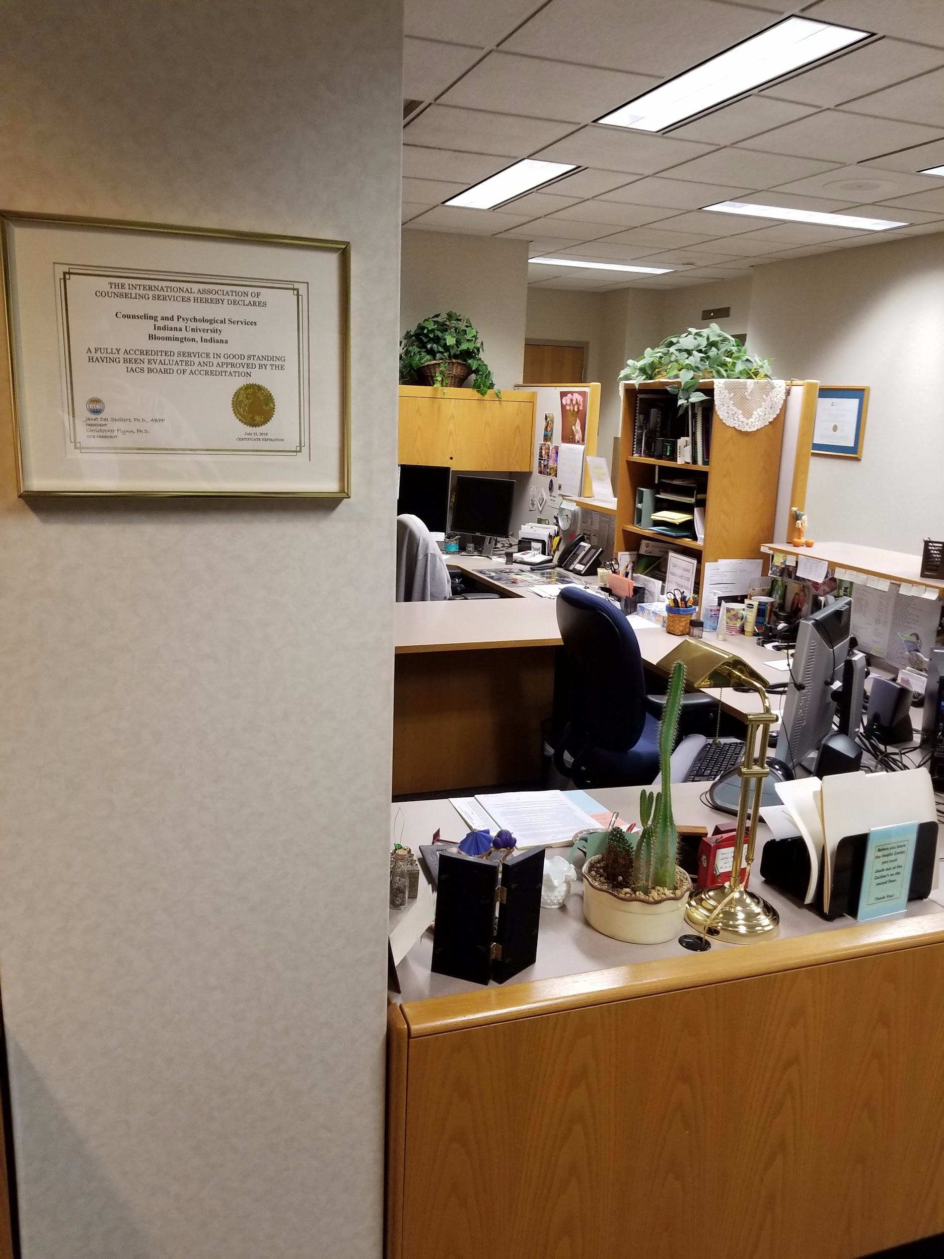 | 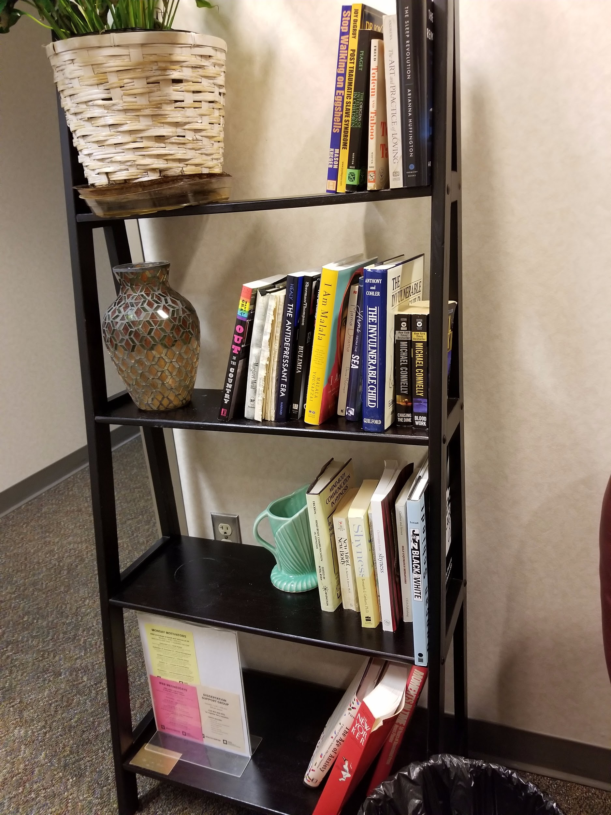
Figure 3 | Figure 4
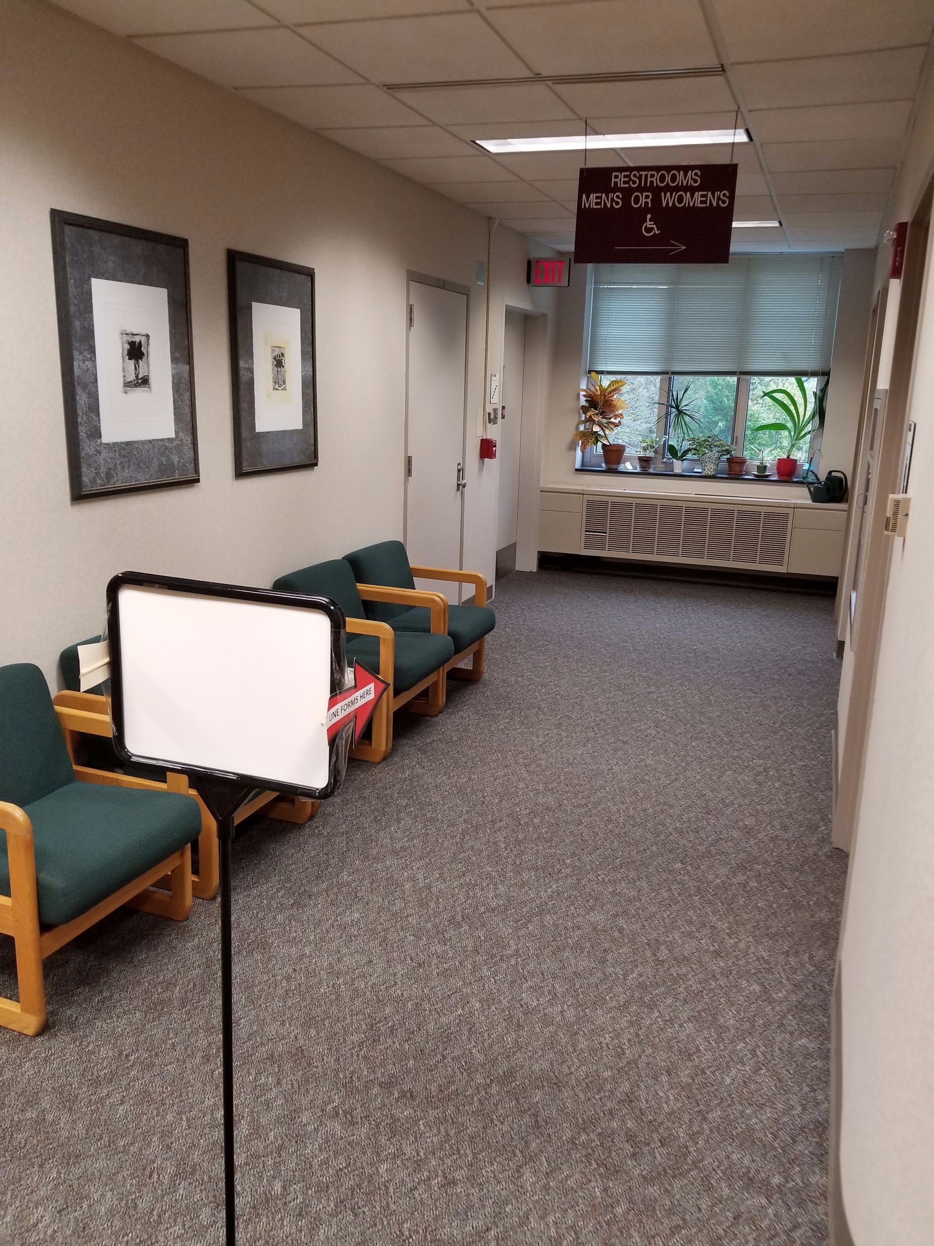
Figure 5 | Figure 6
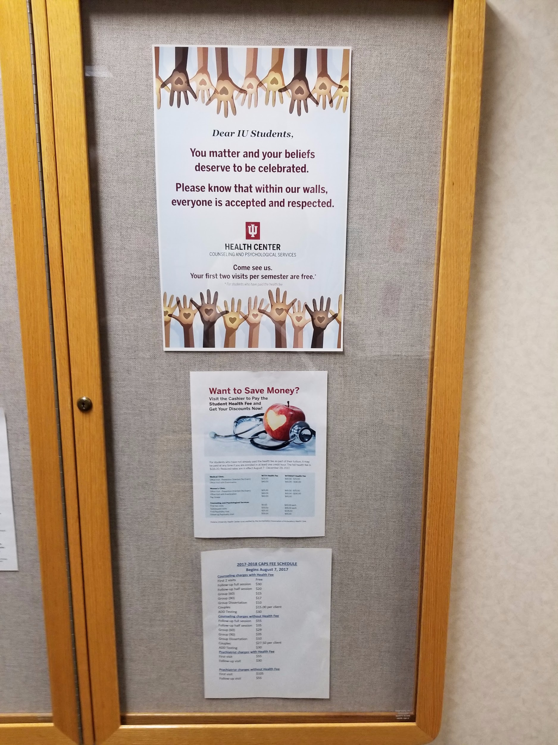 | 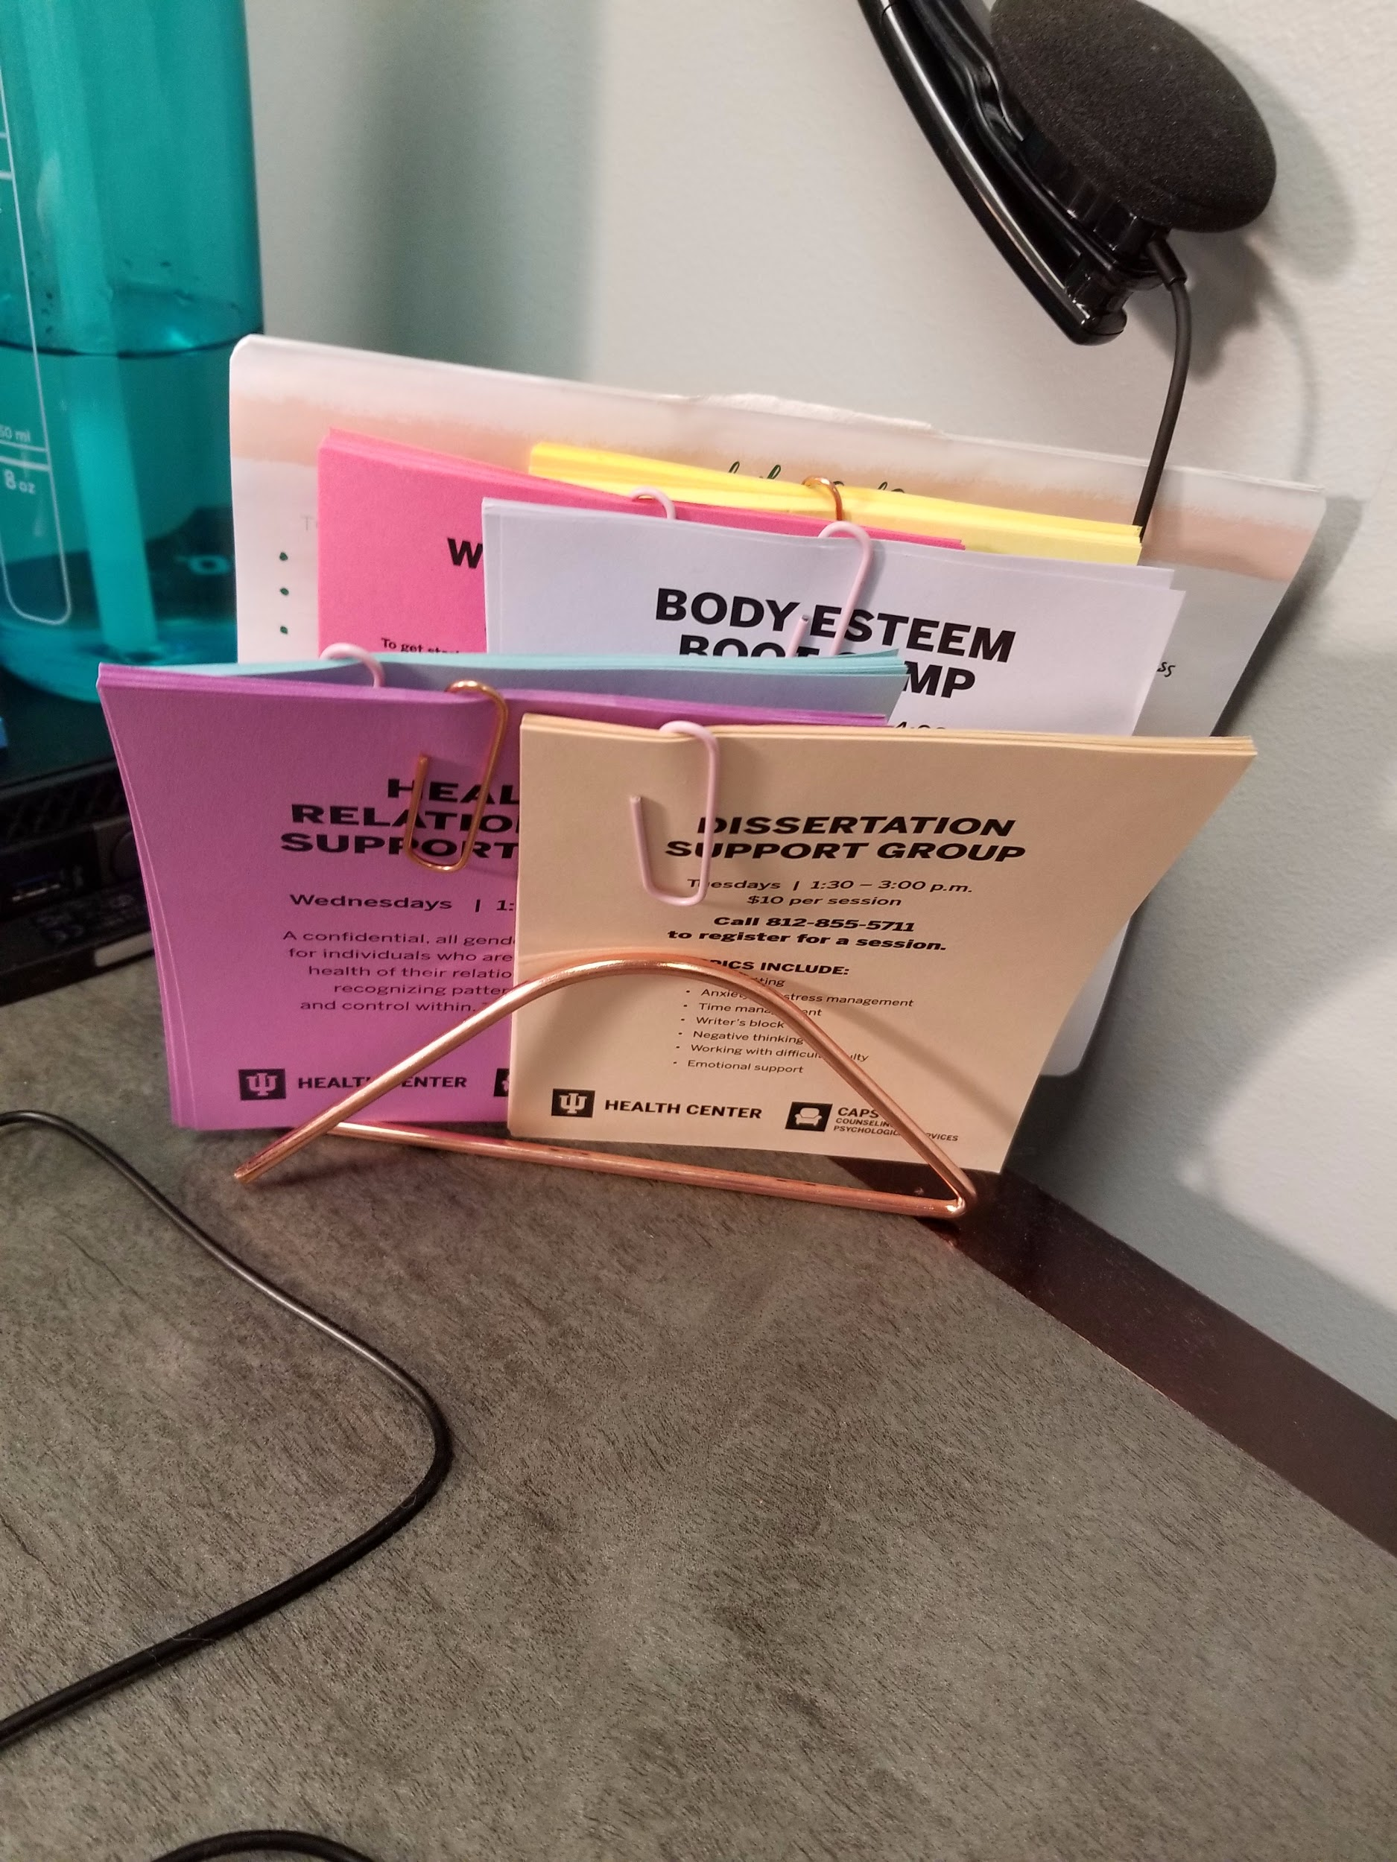
Figure 7 | Figure 8
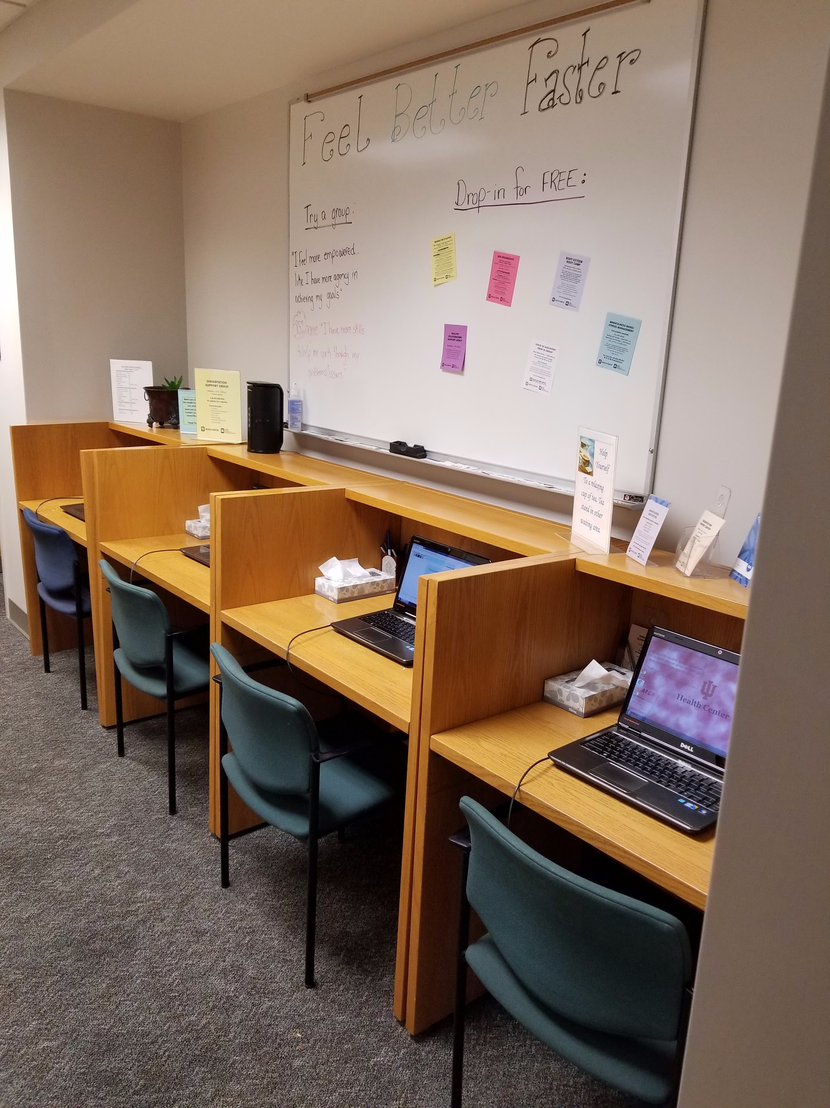 | 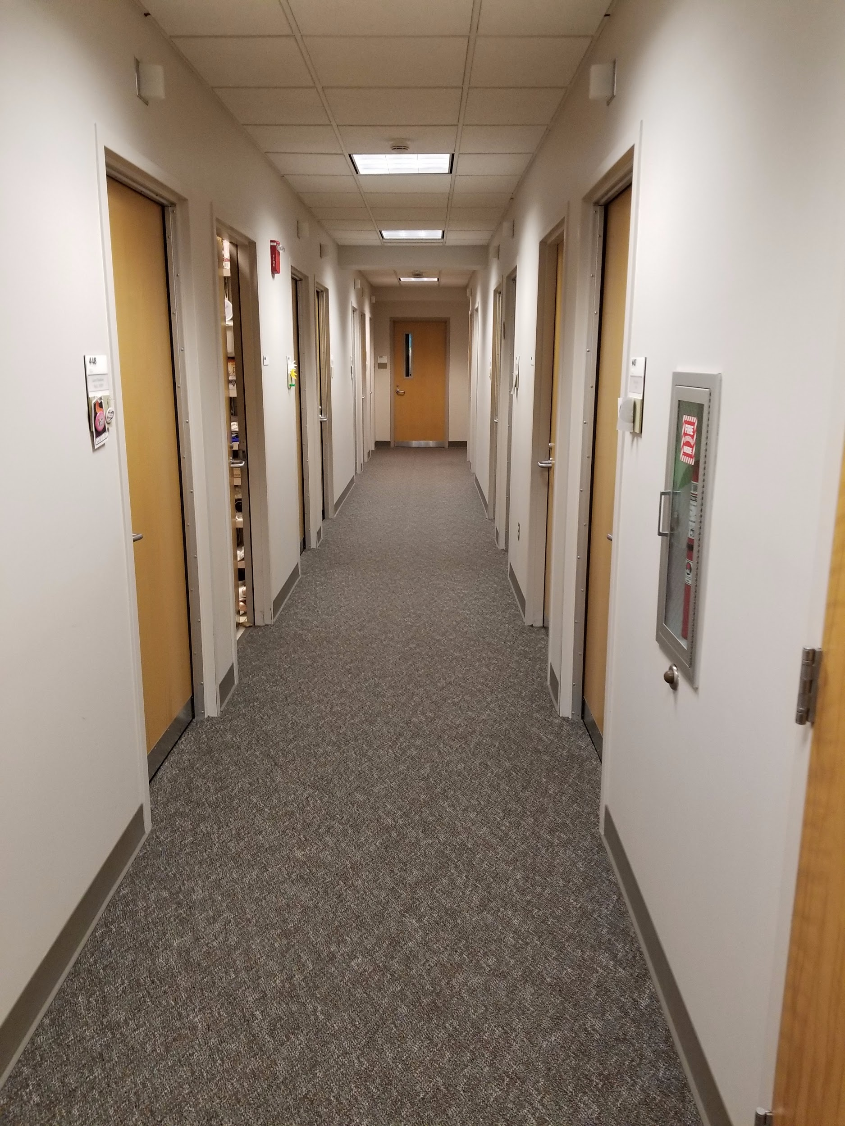

Figure 9 | Figure 10
Figure 11 | Figure 12

Figure 13 | Figure 14
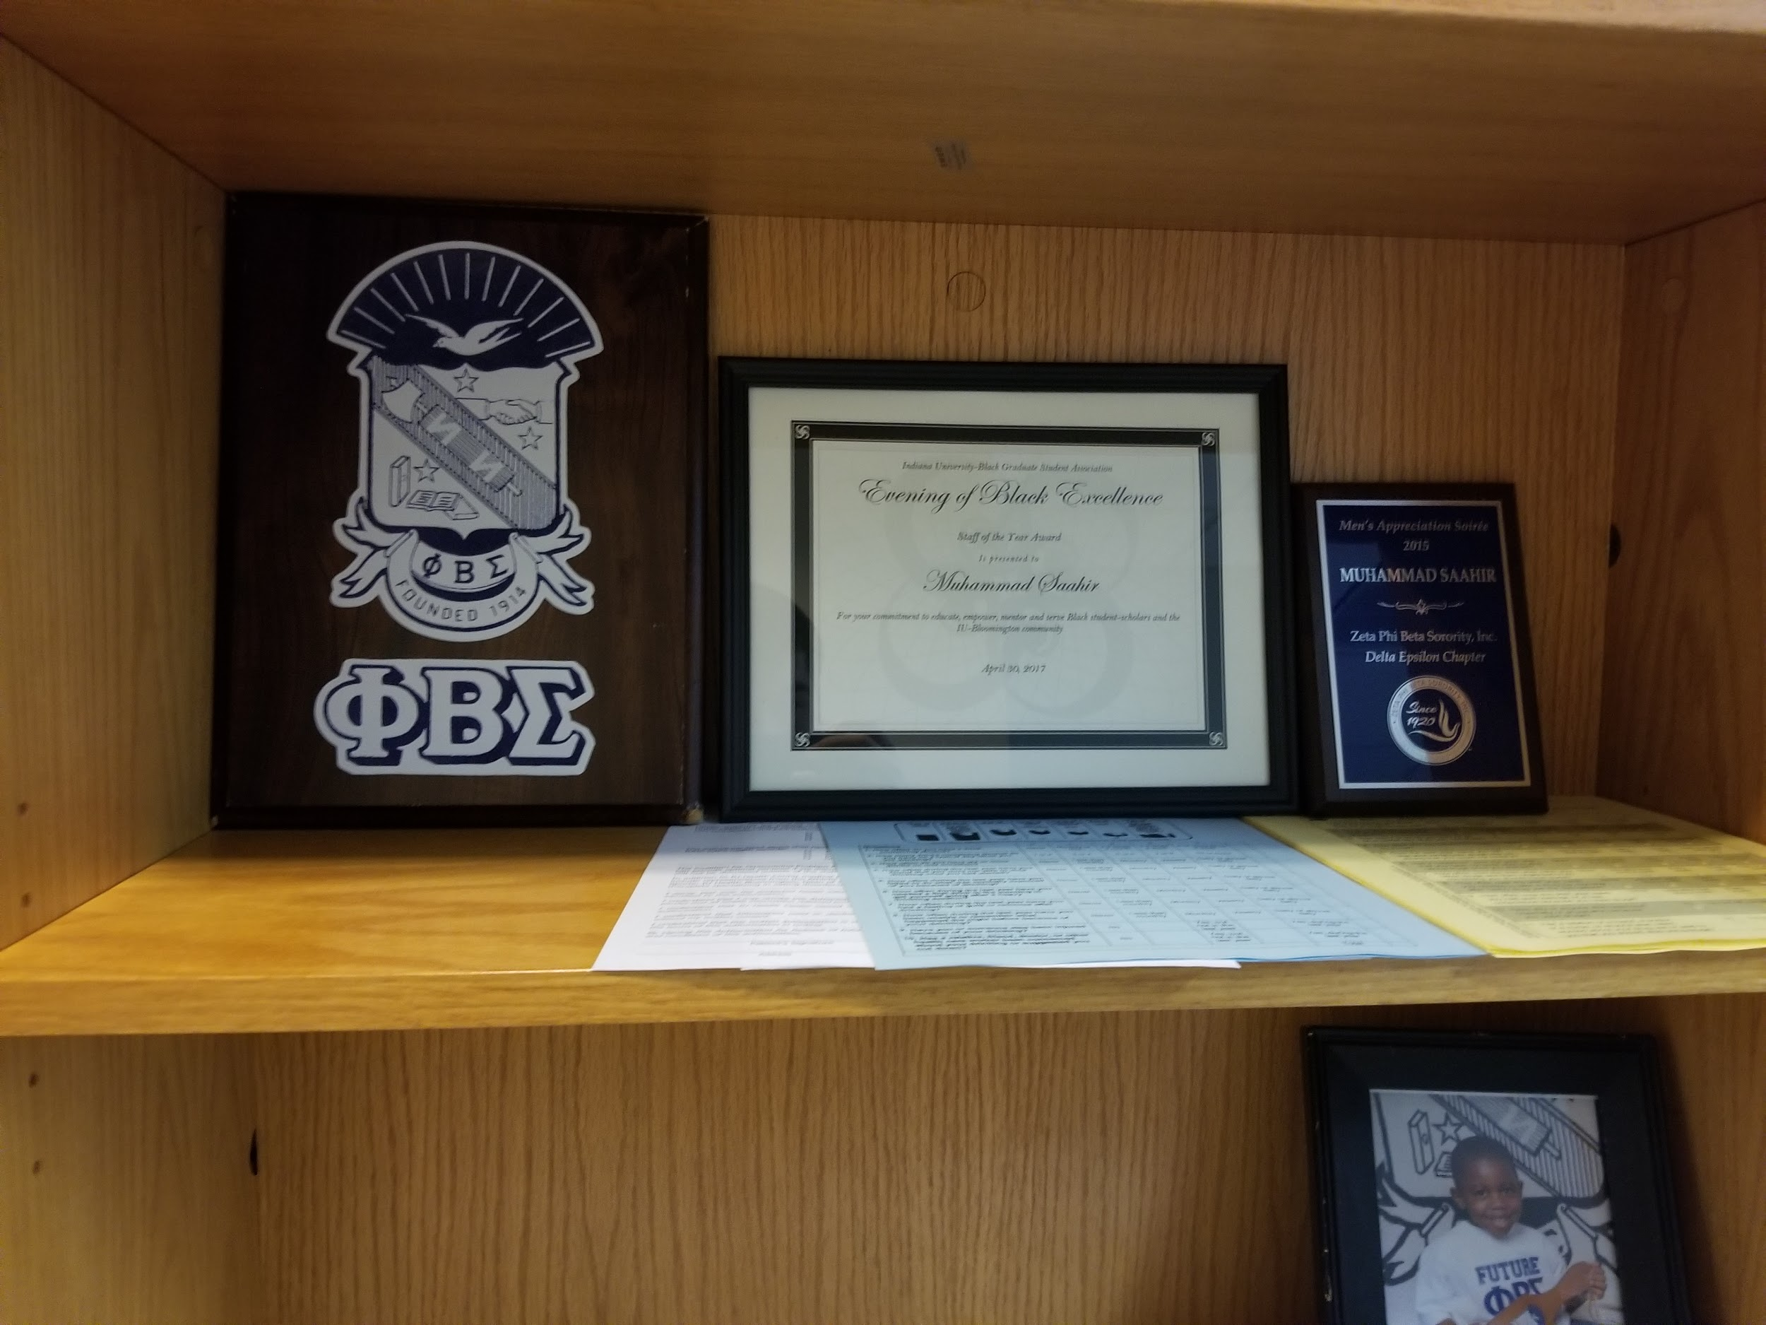 | 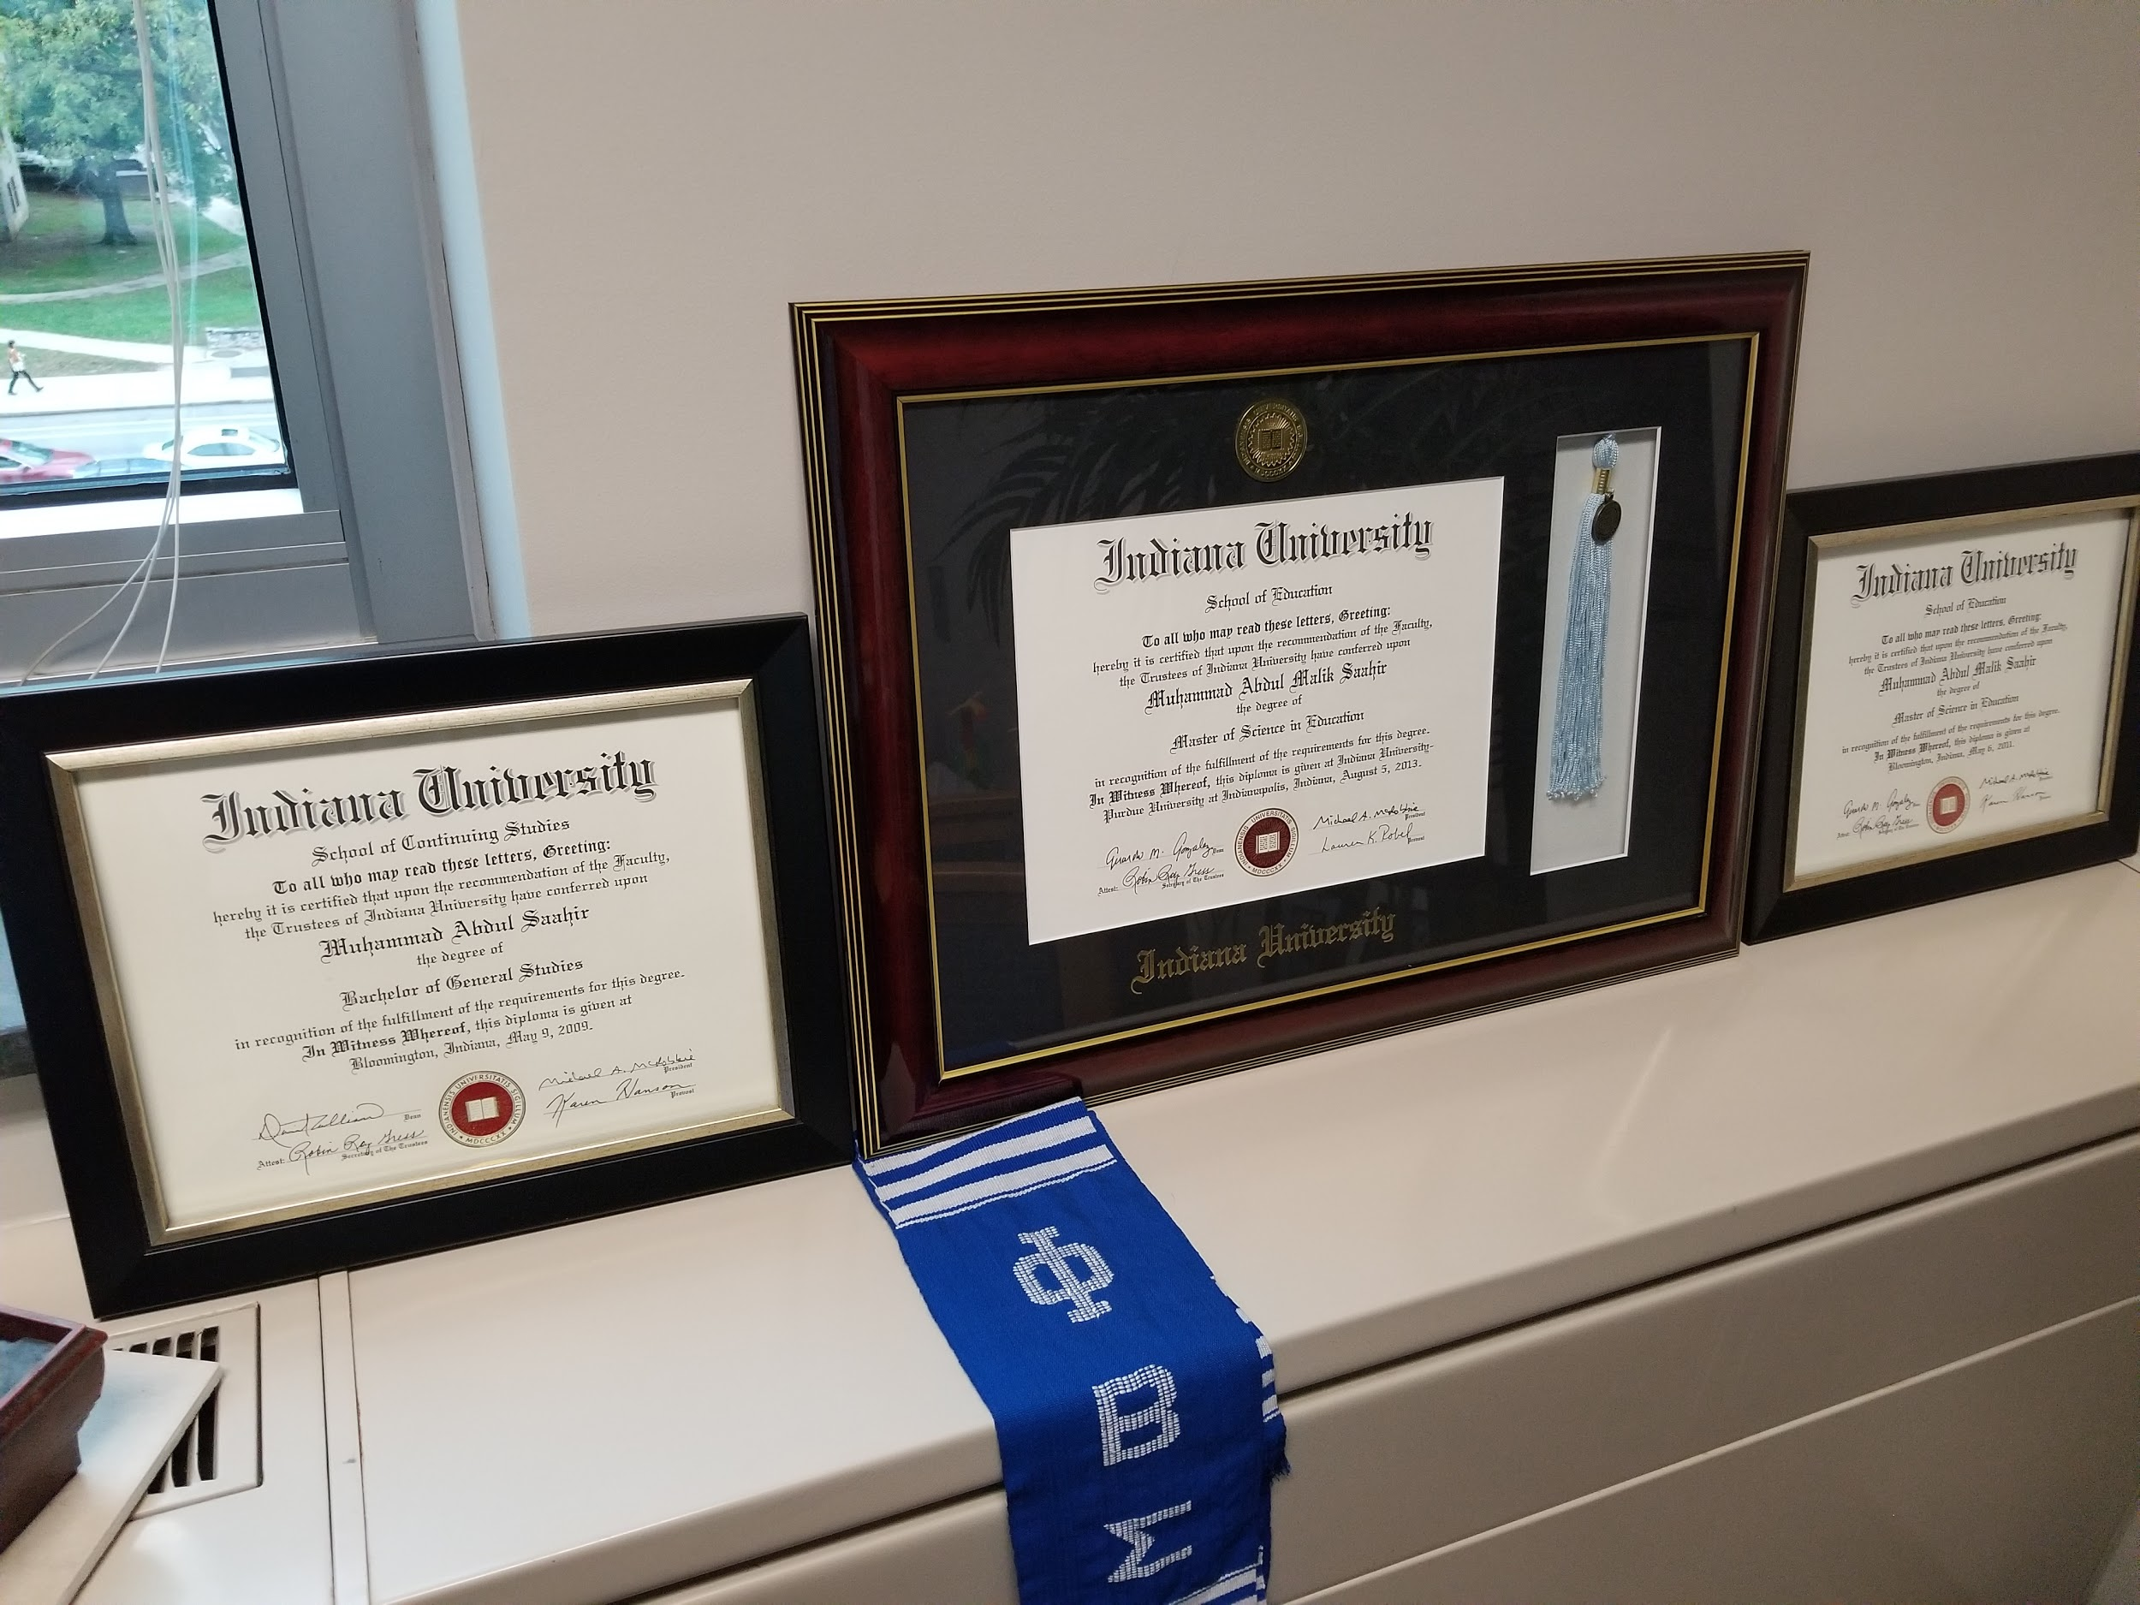
Figure 15 | Figure 16
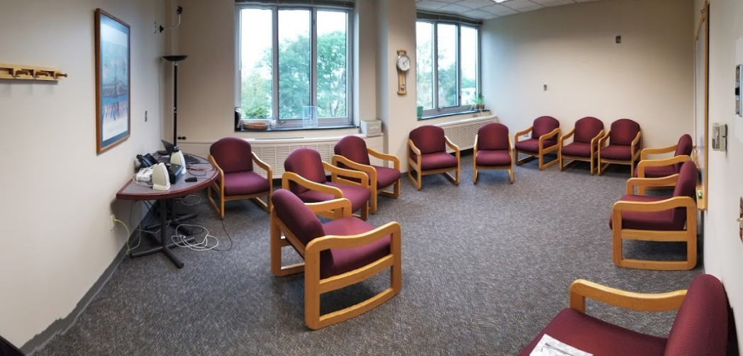 | 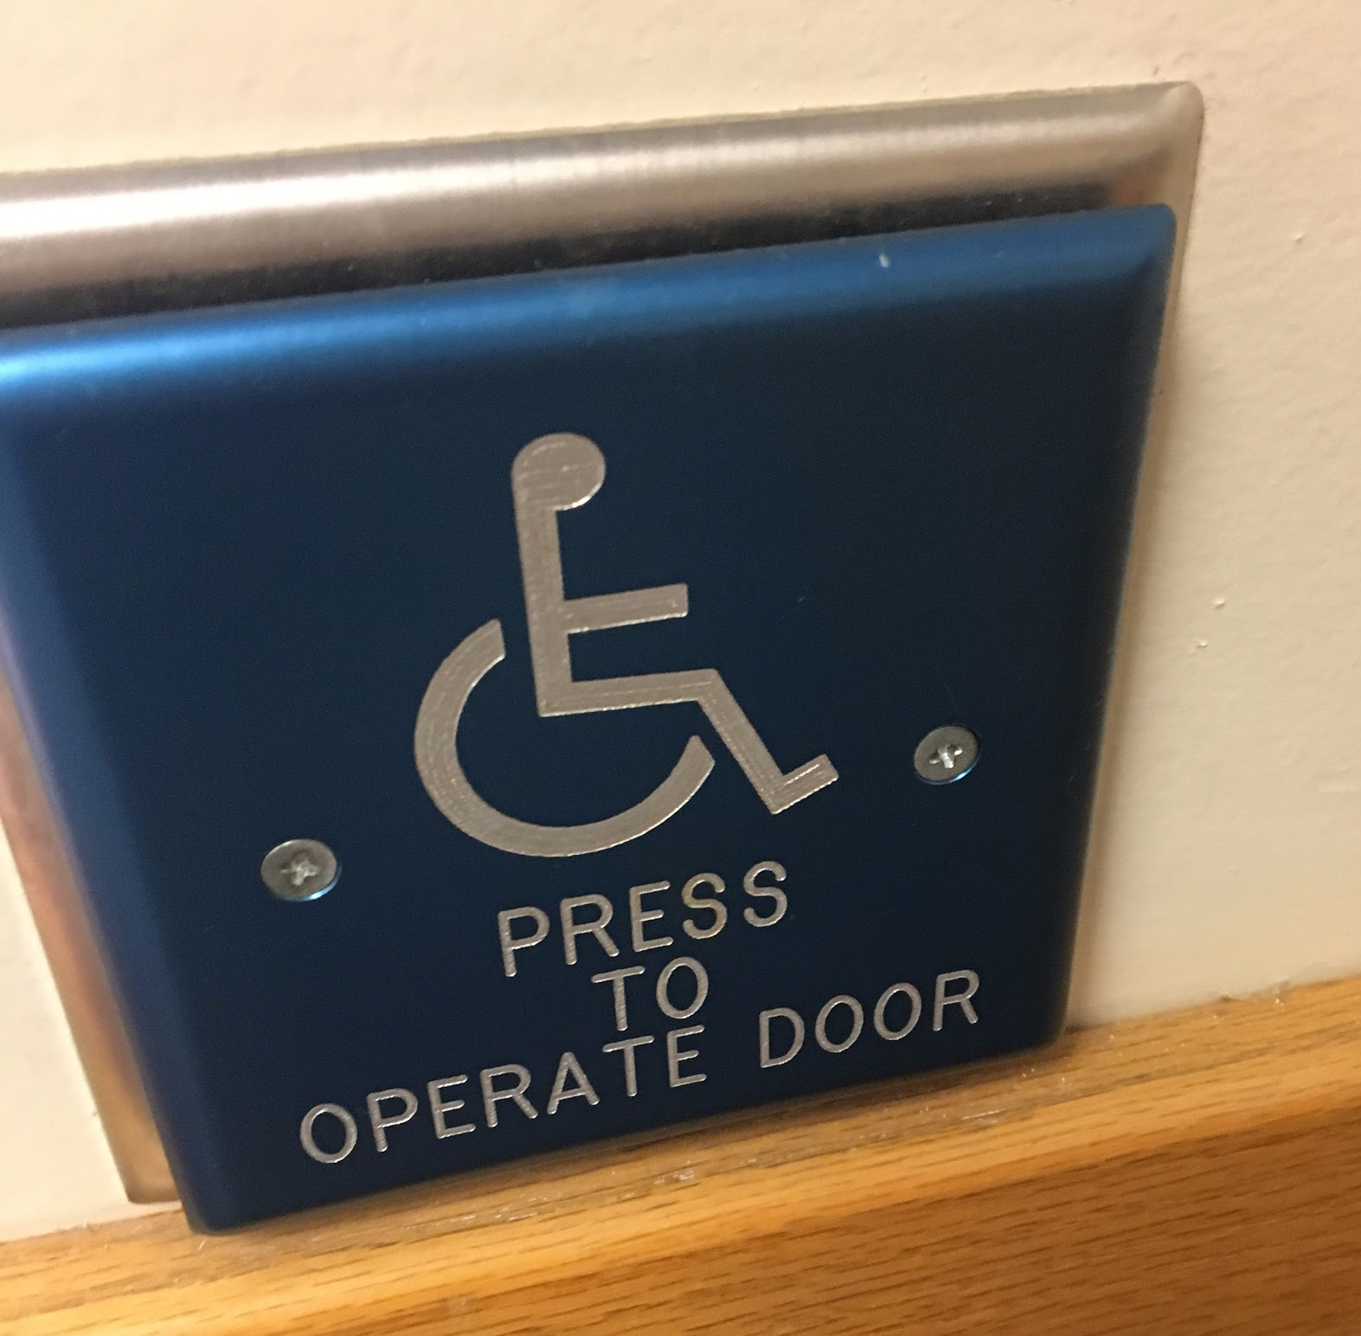

Figure 17 | Figure 18
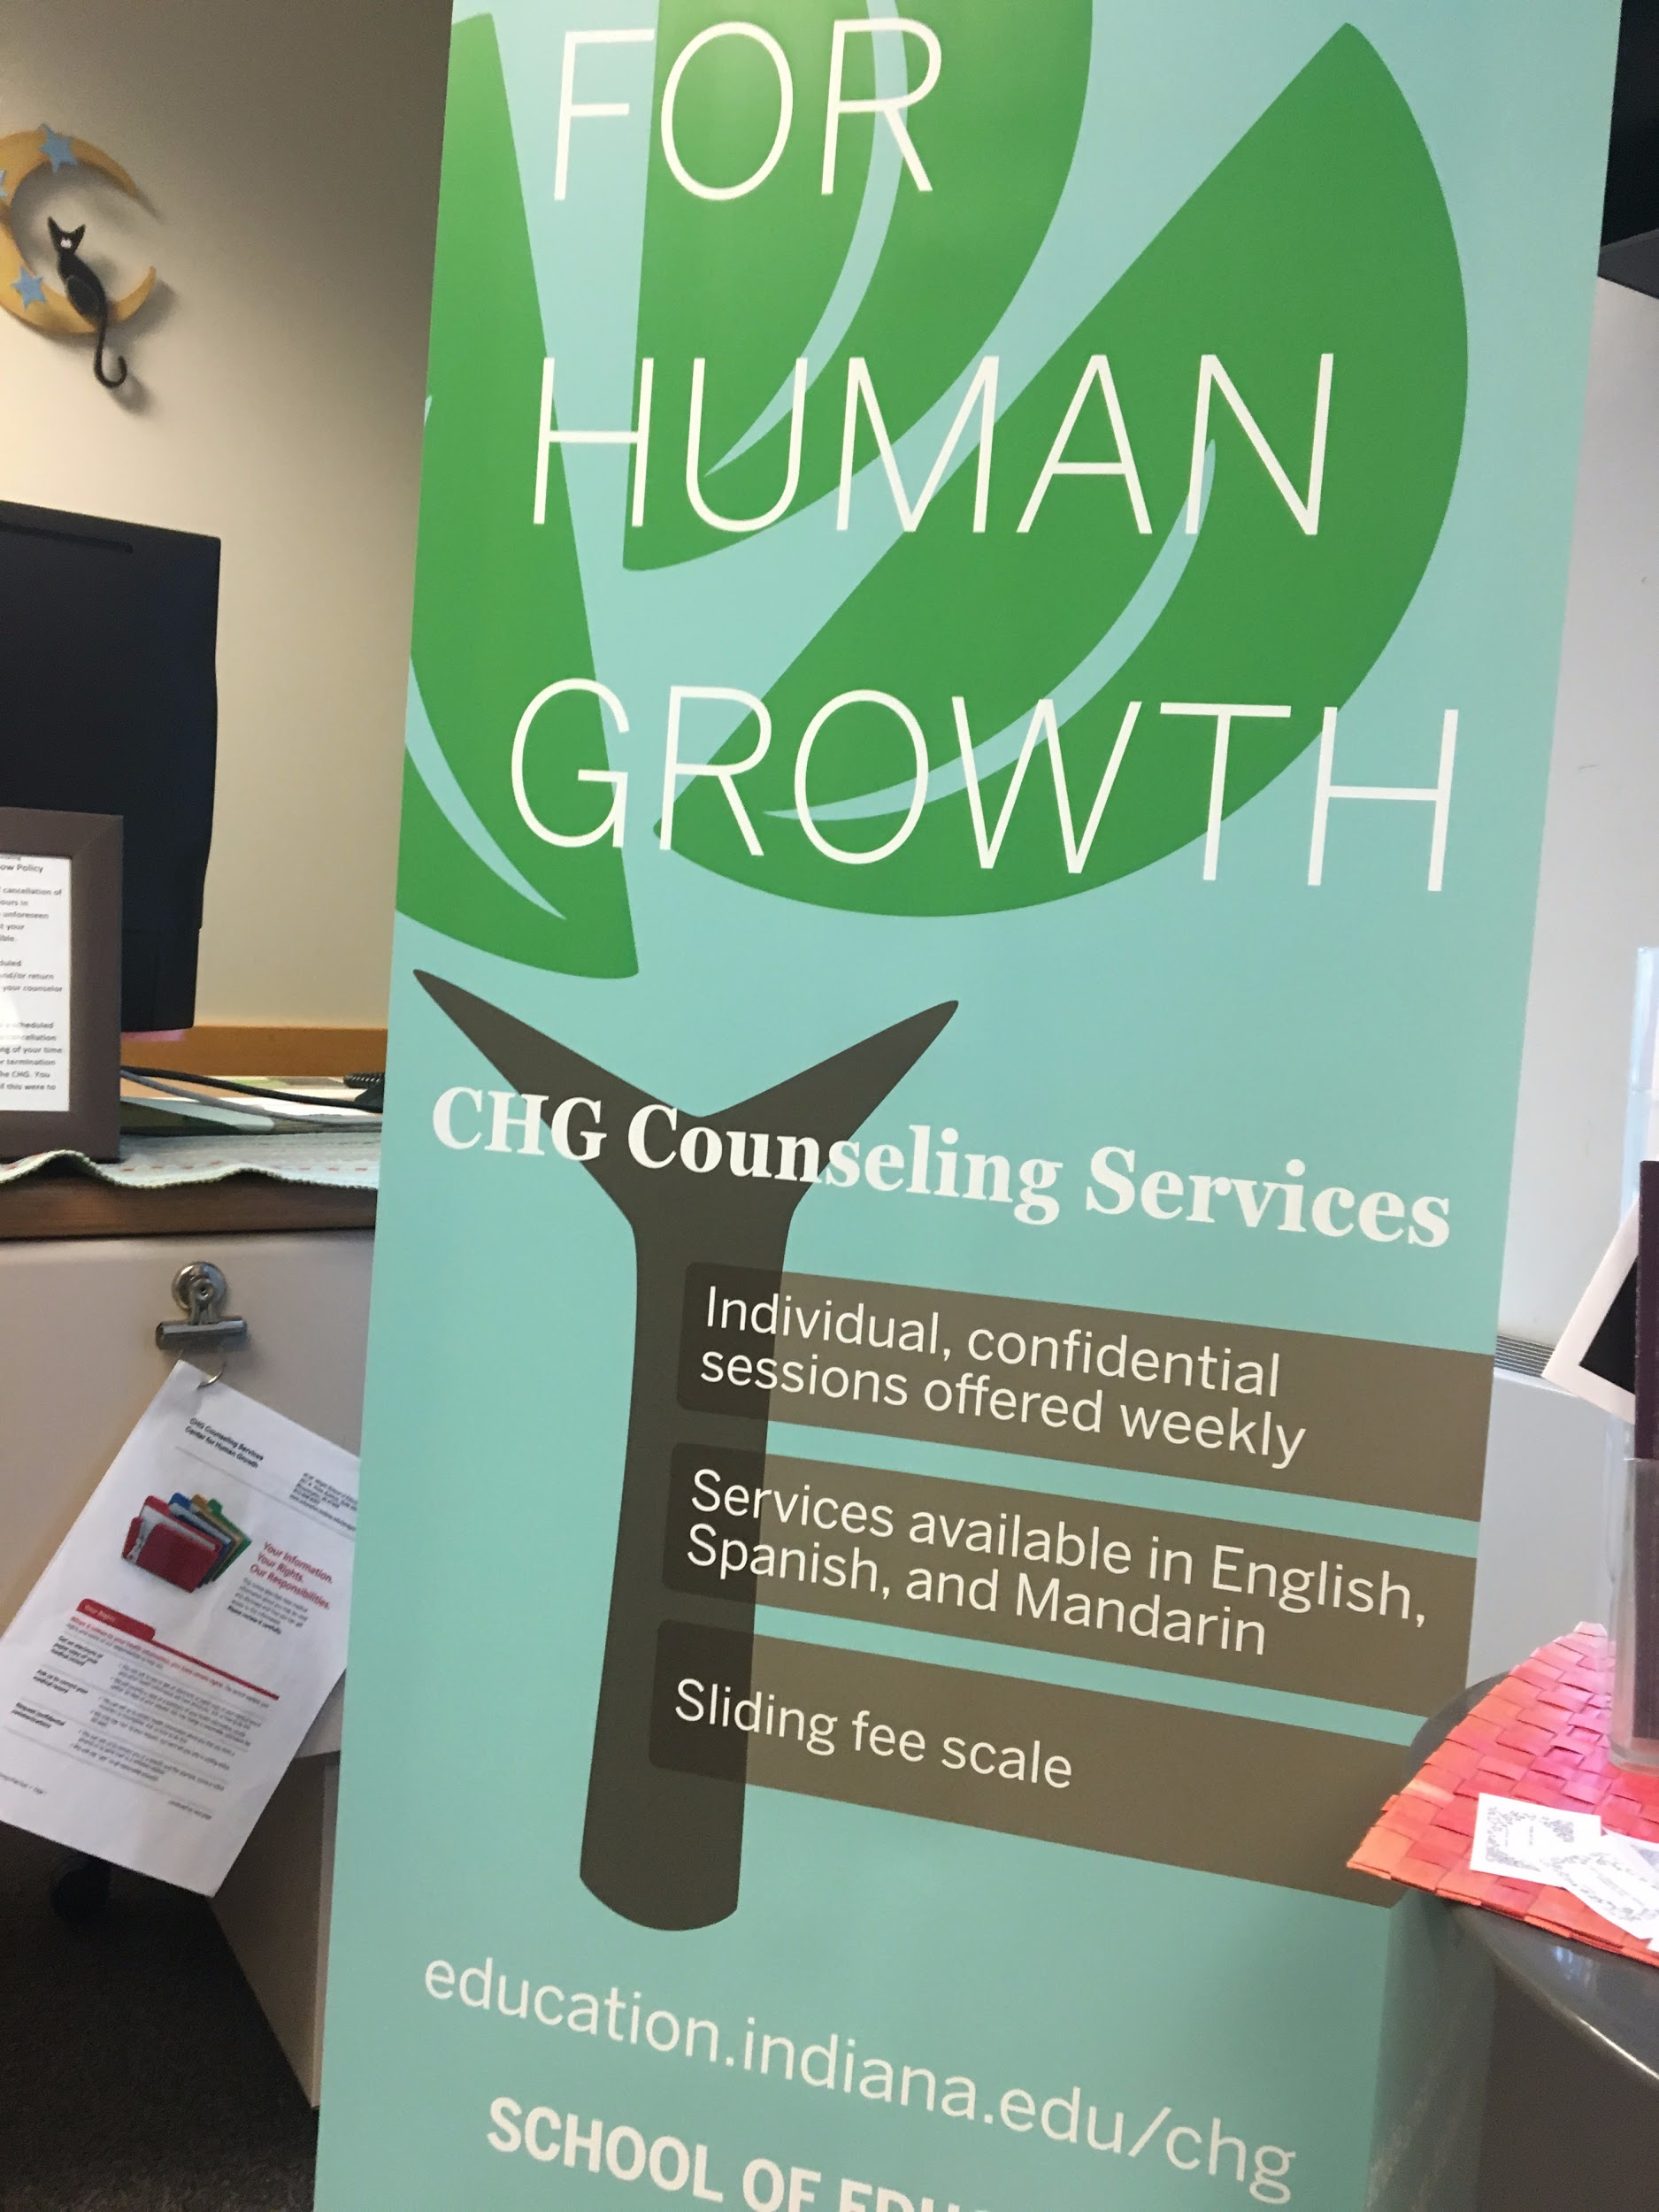
Figure 19 | Figure 20
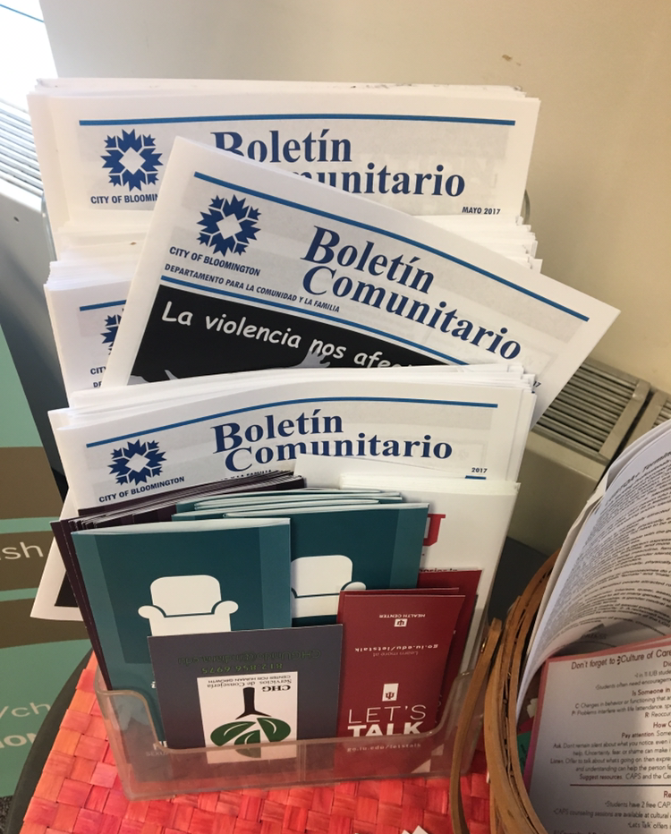 | 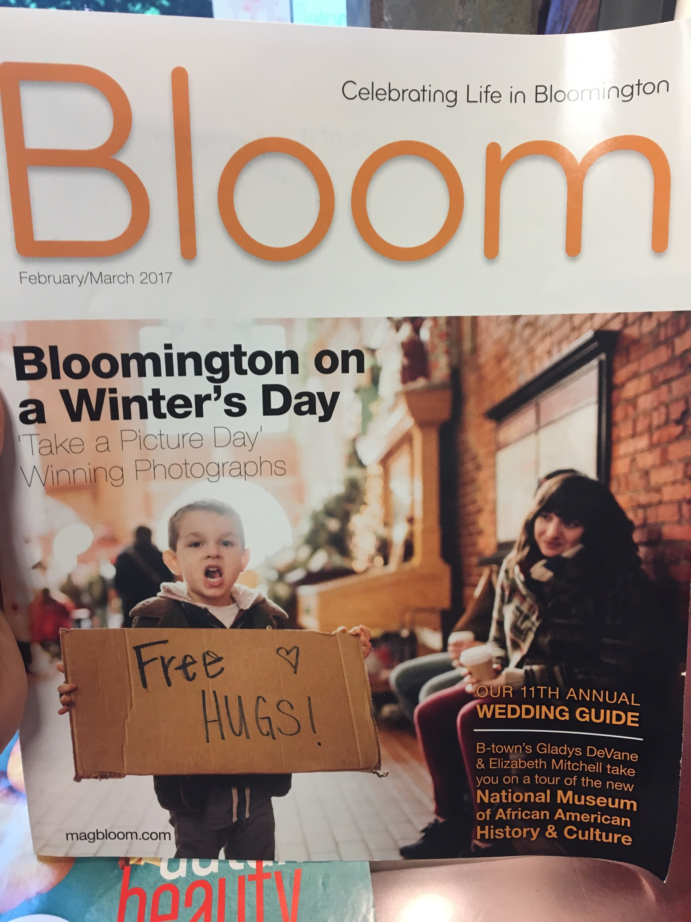

Figure 21 | Figure 22
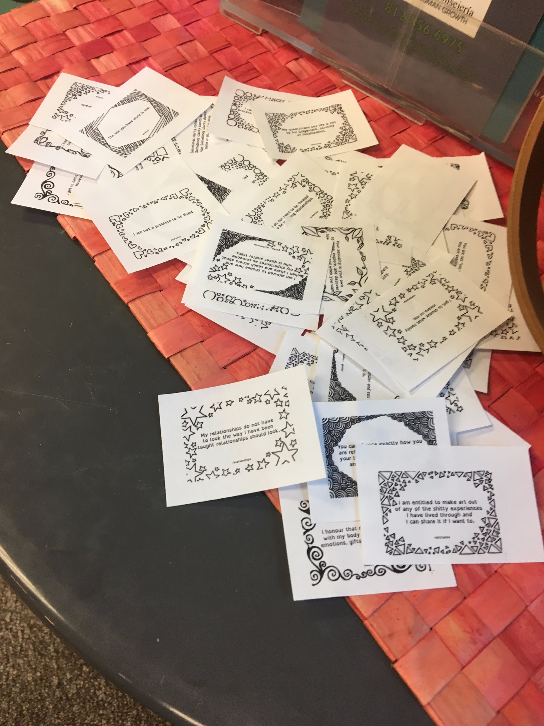 | 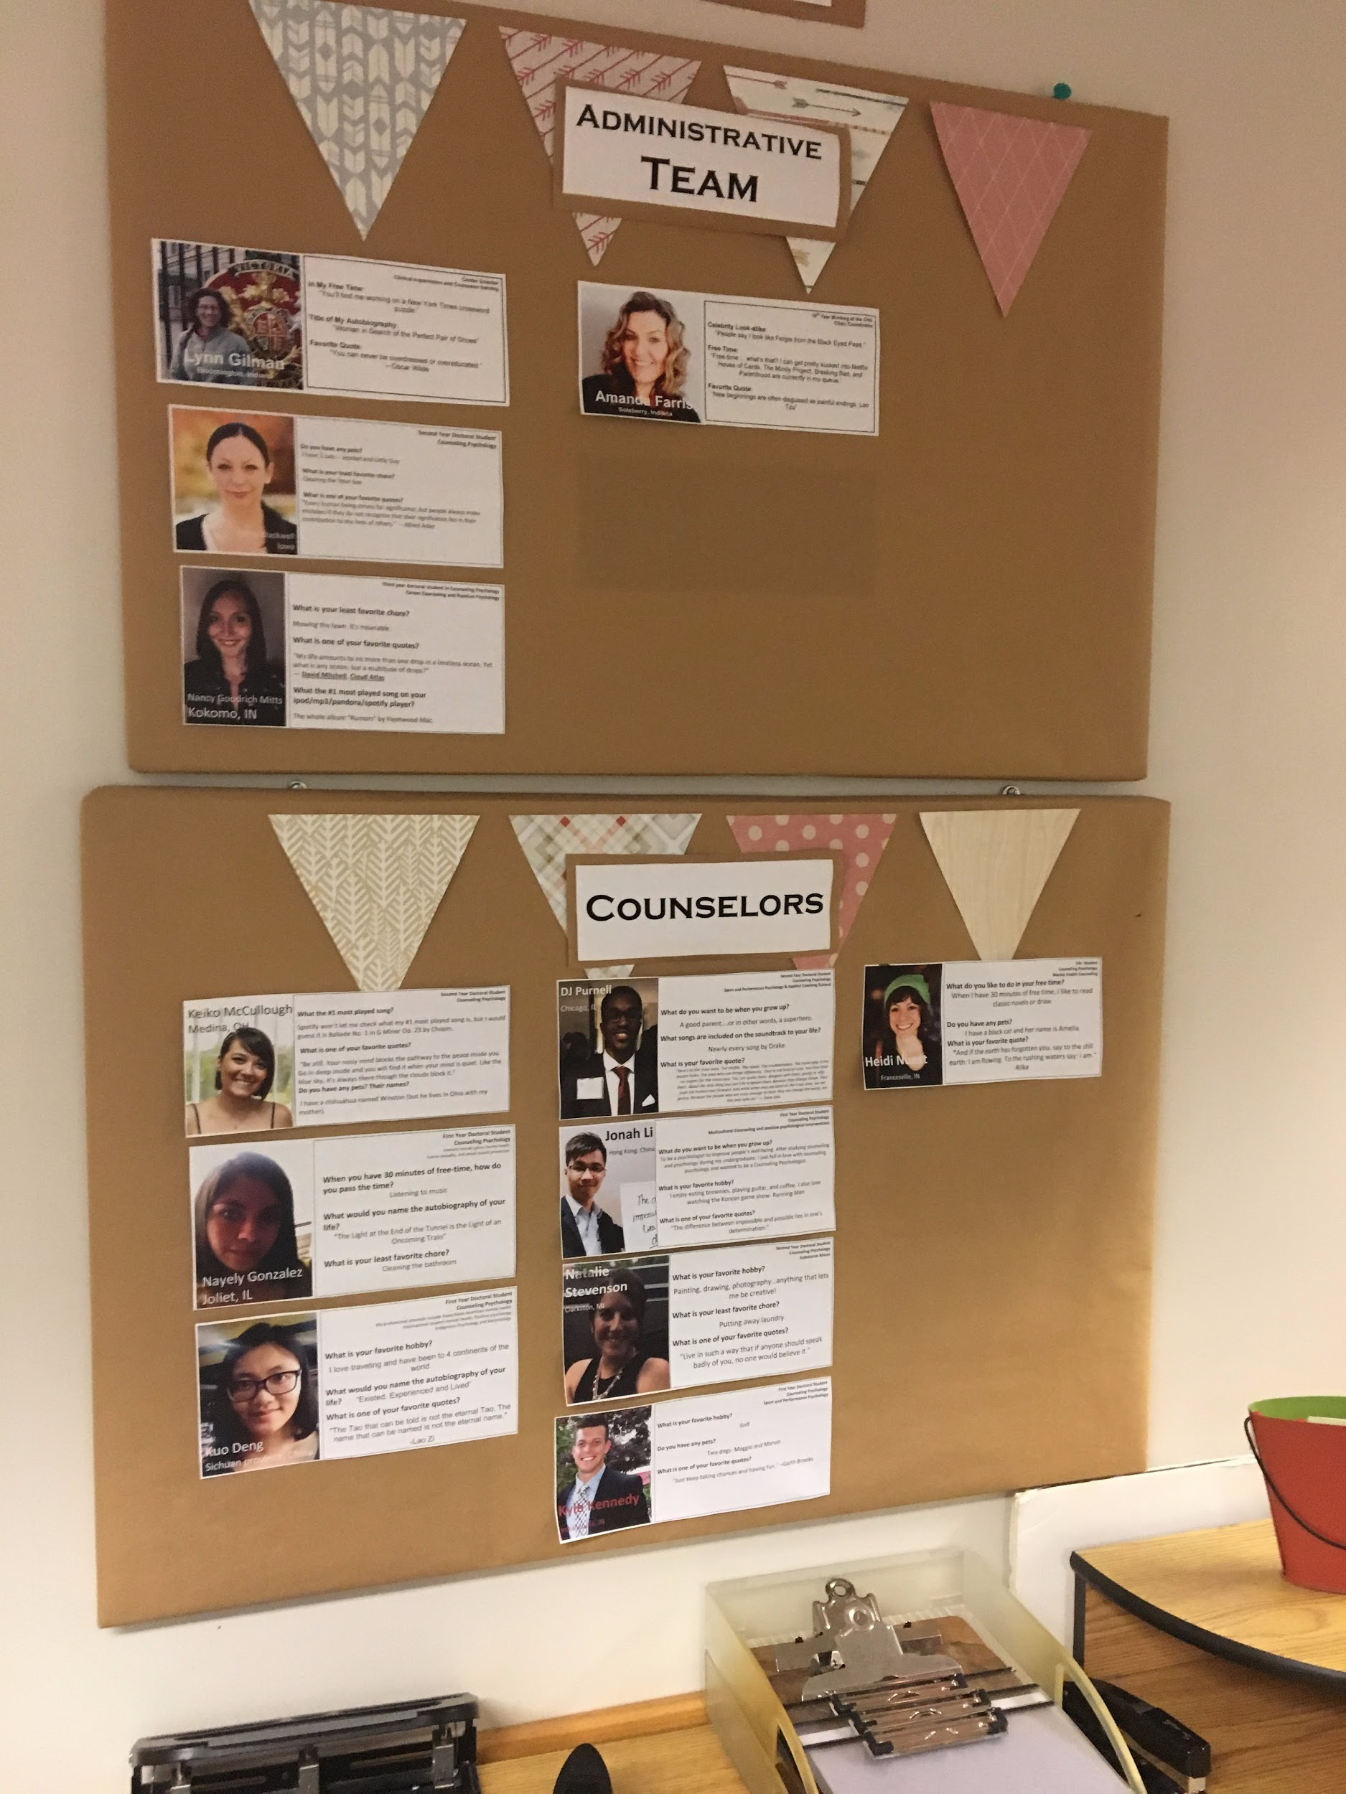
Figure 23 | Figure 24
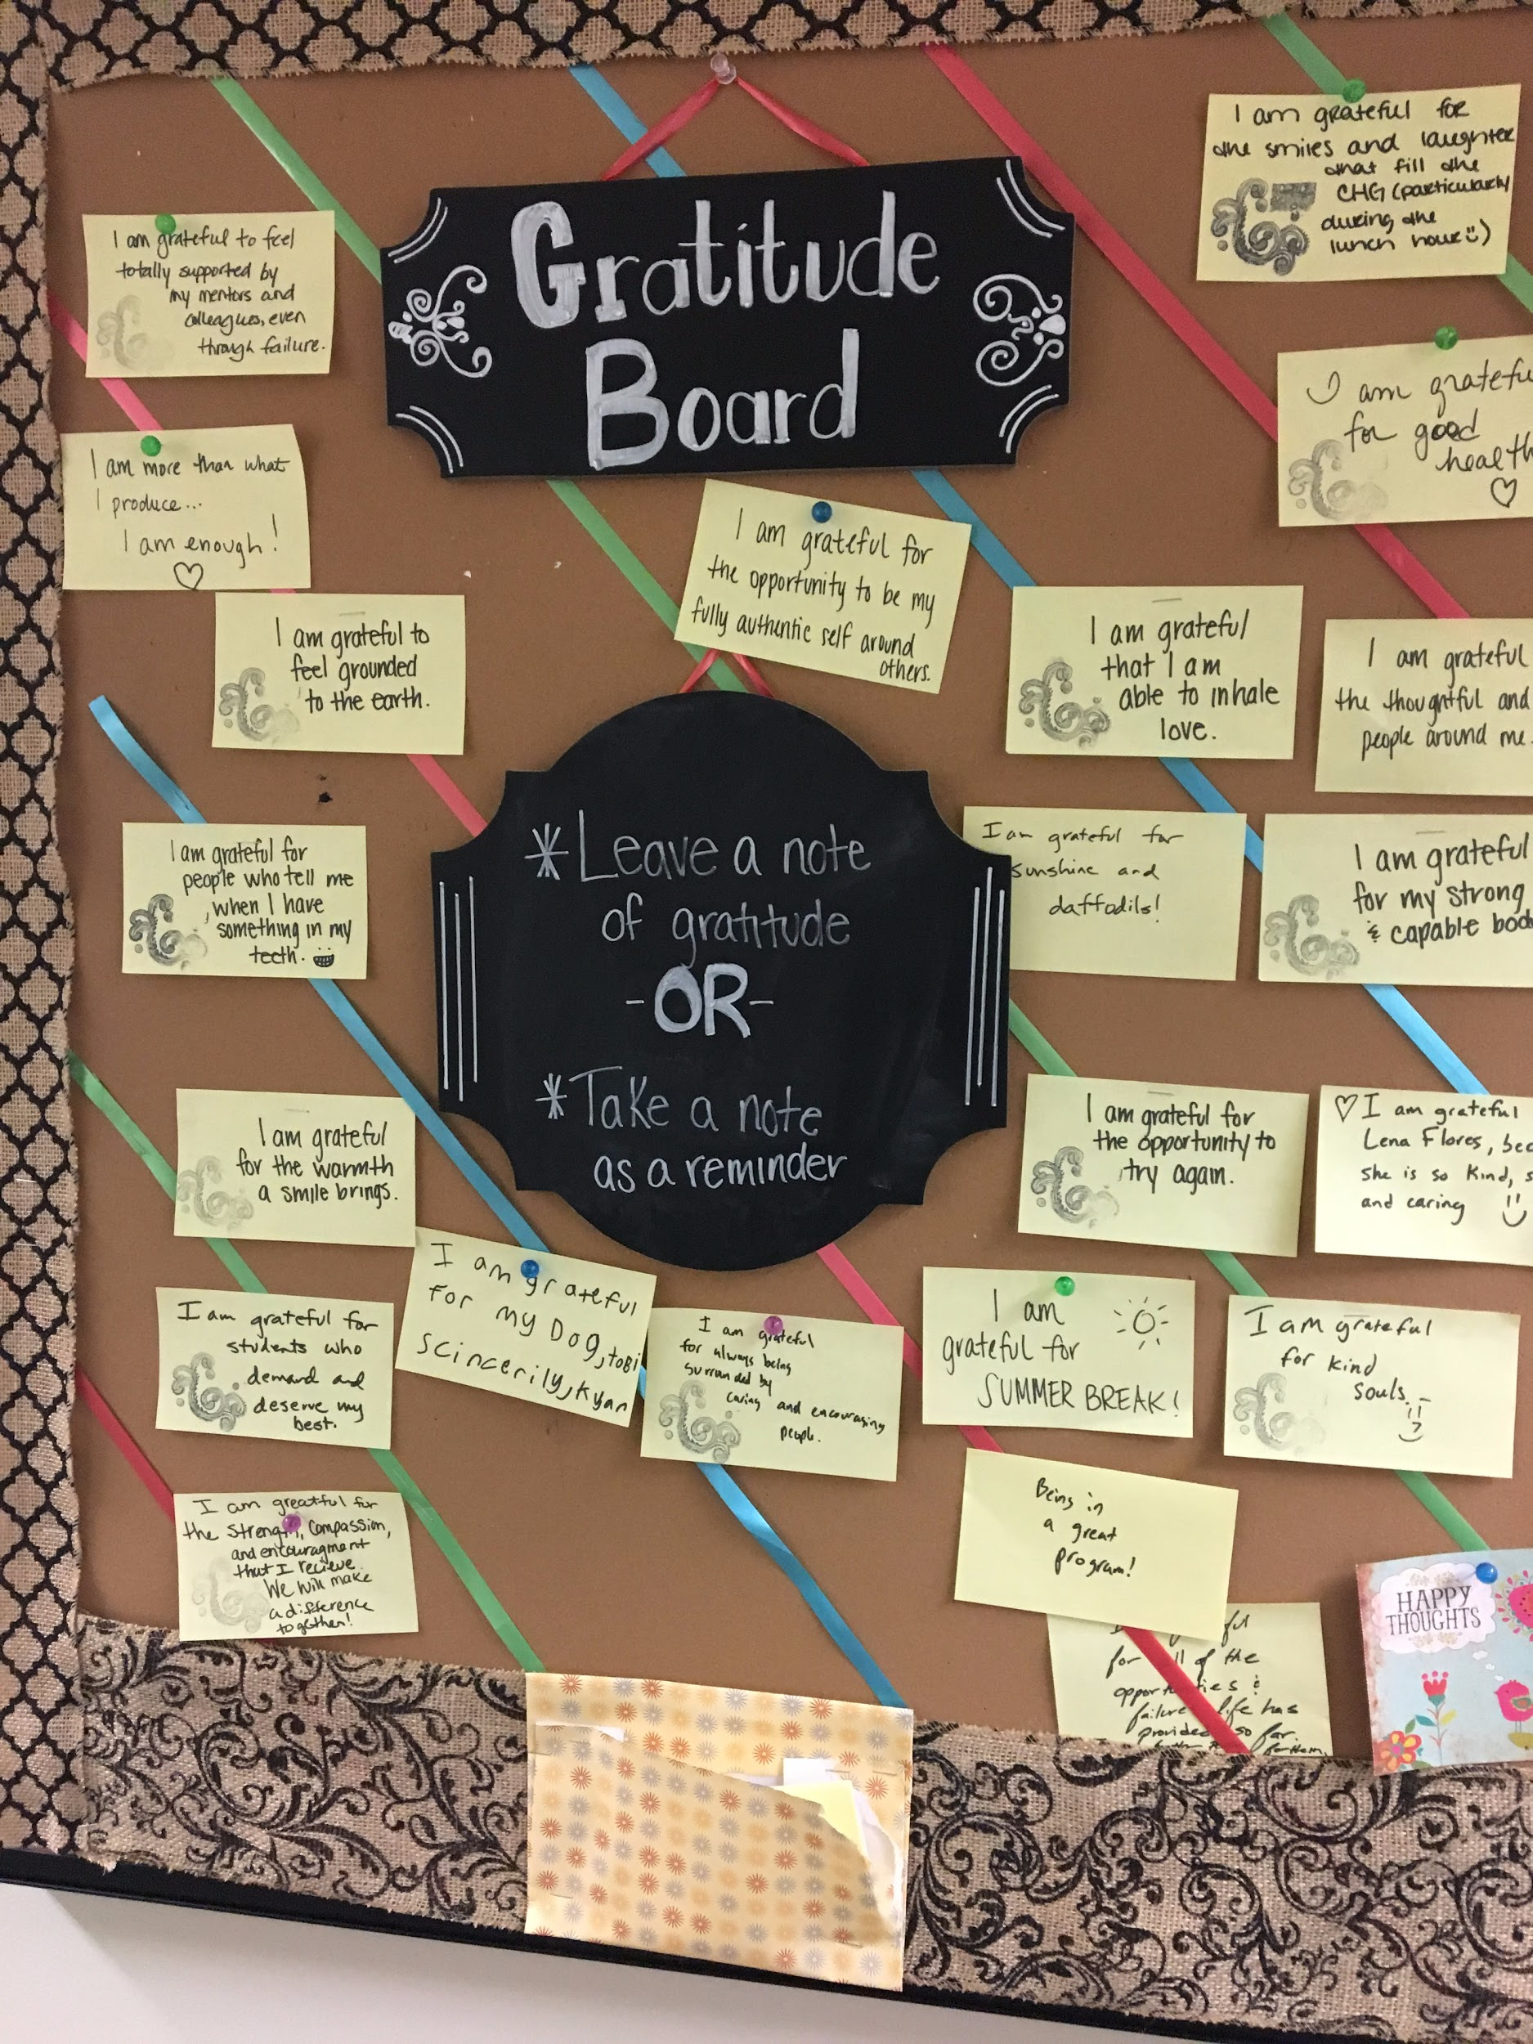 | 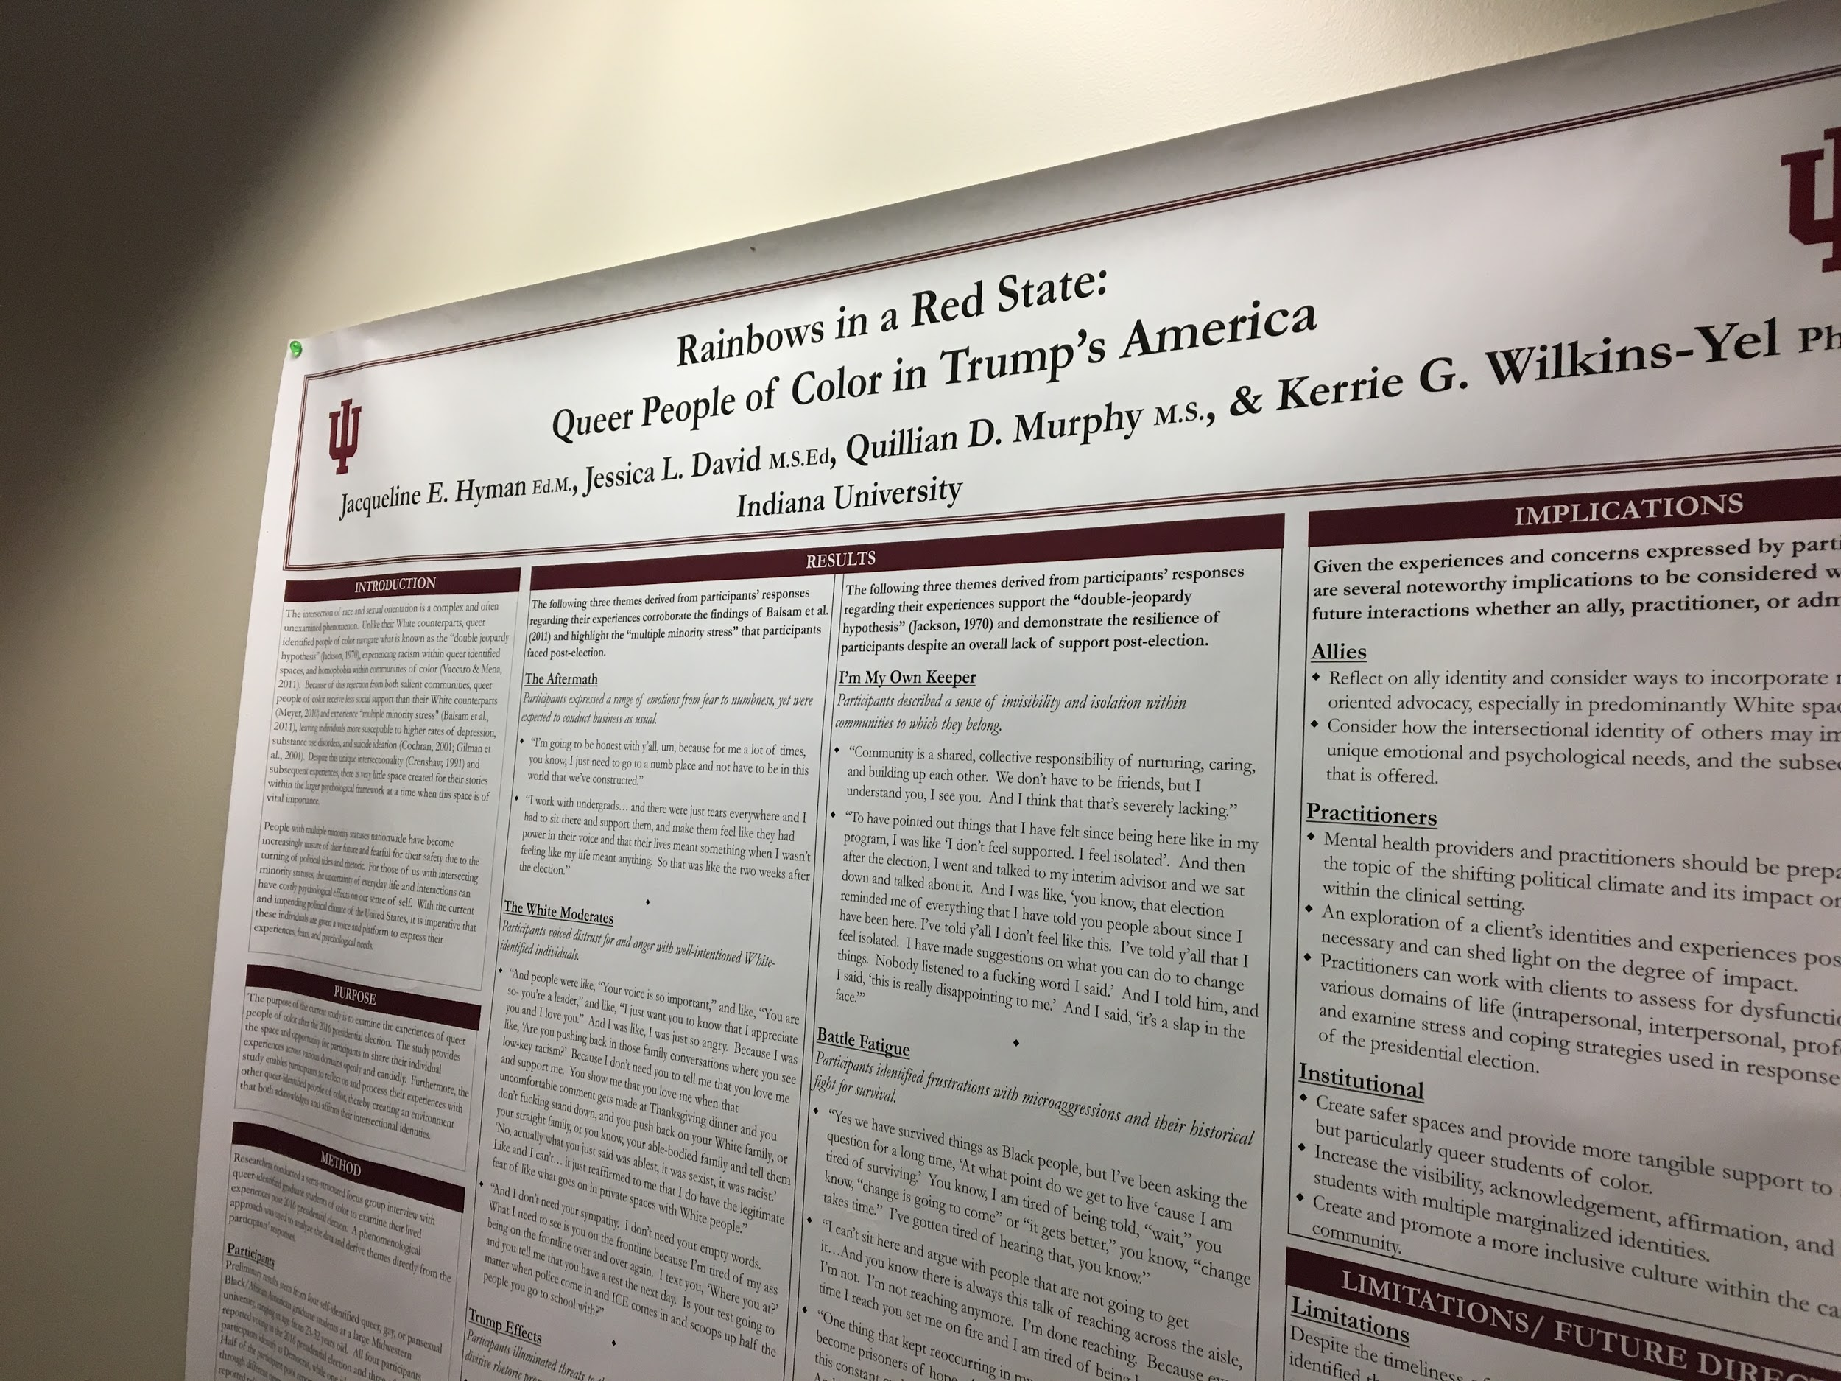

Figure 25 | Figure 26
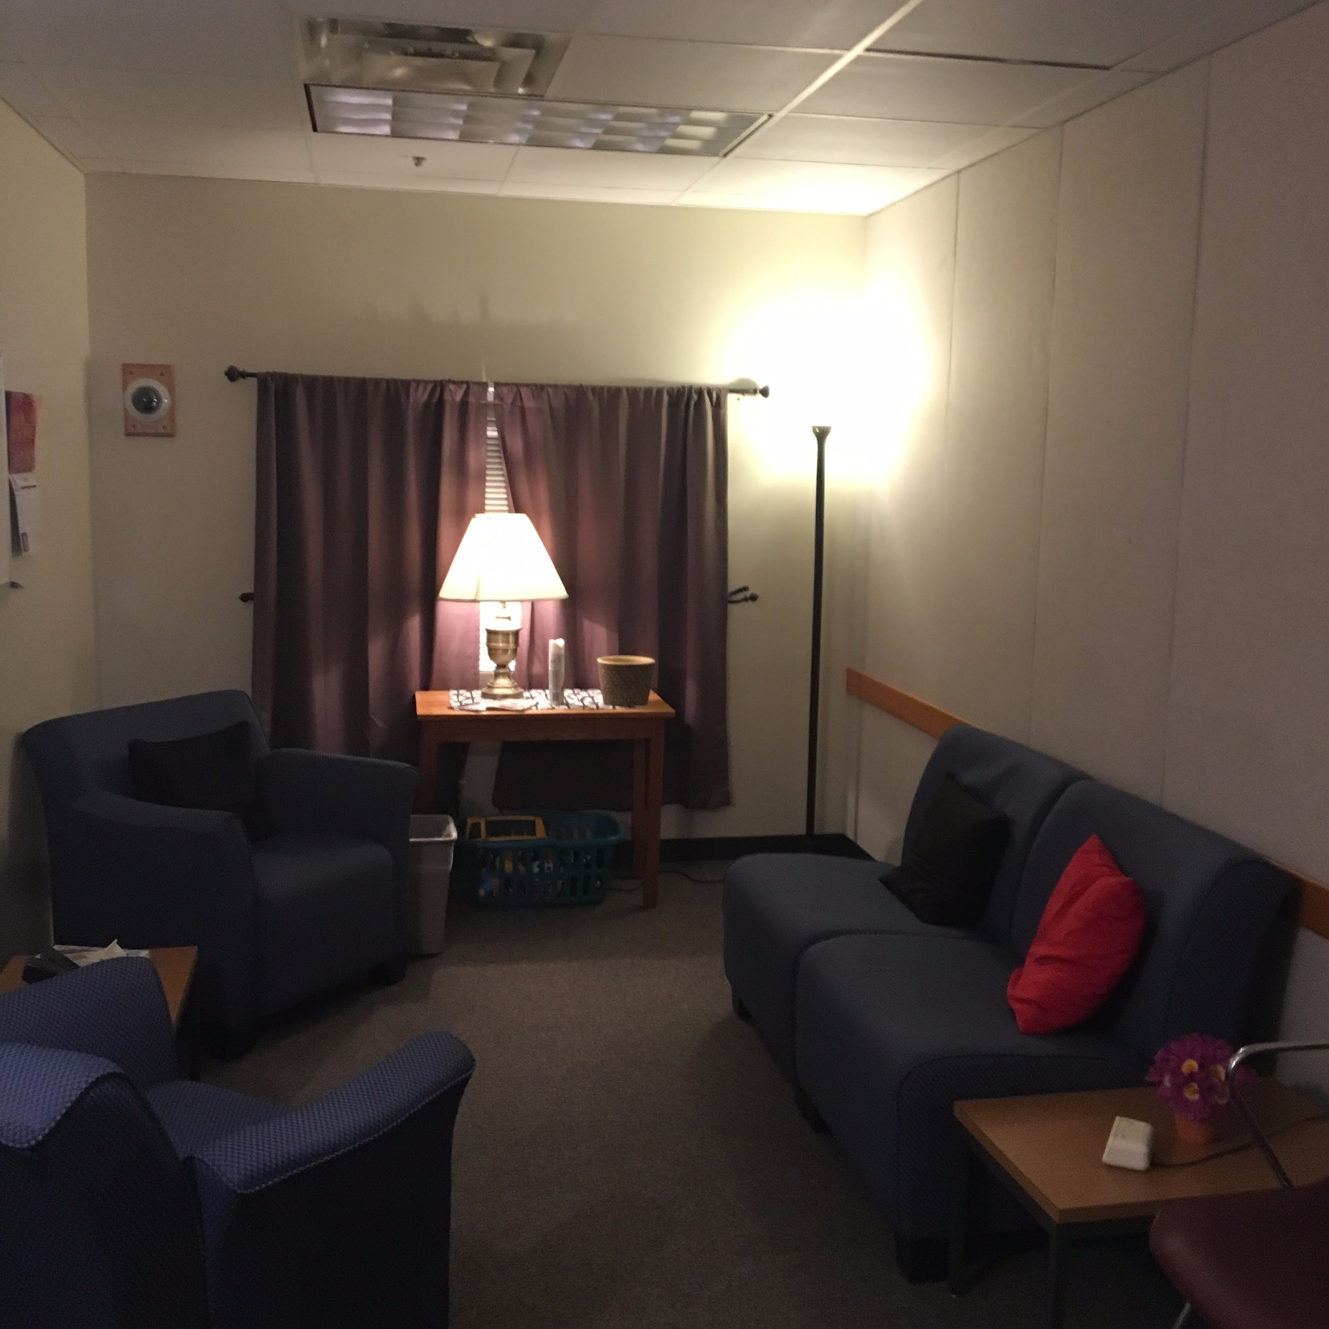 | 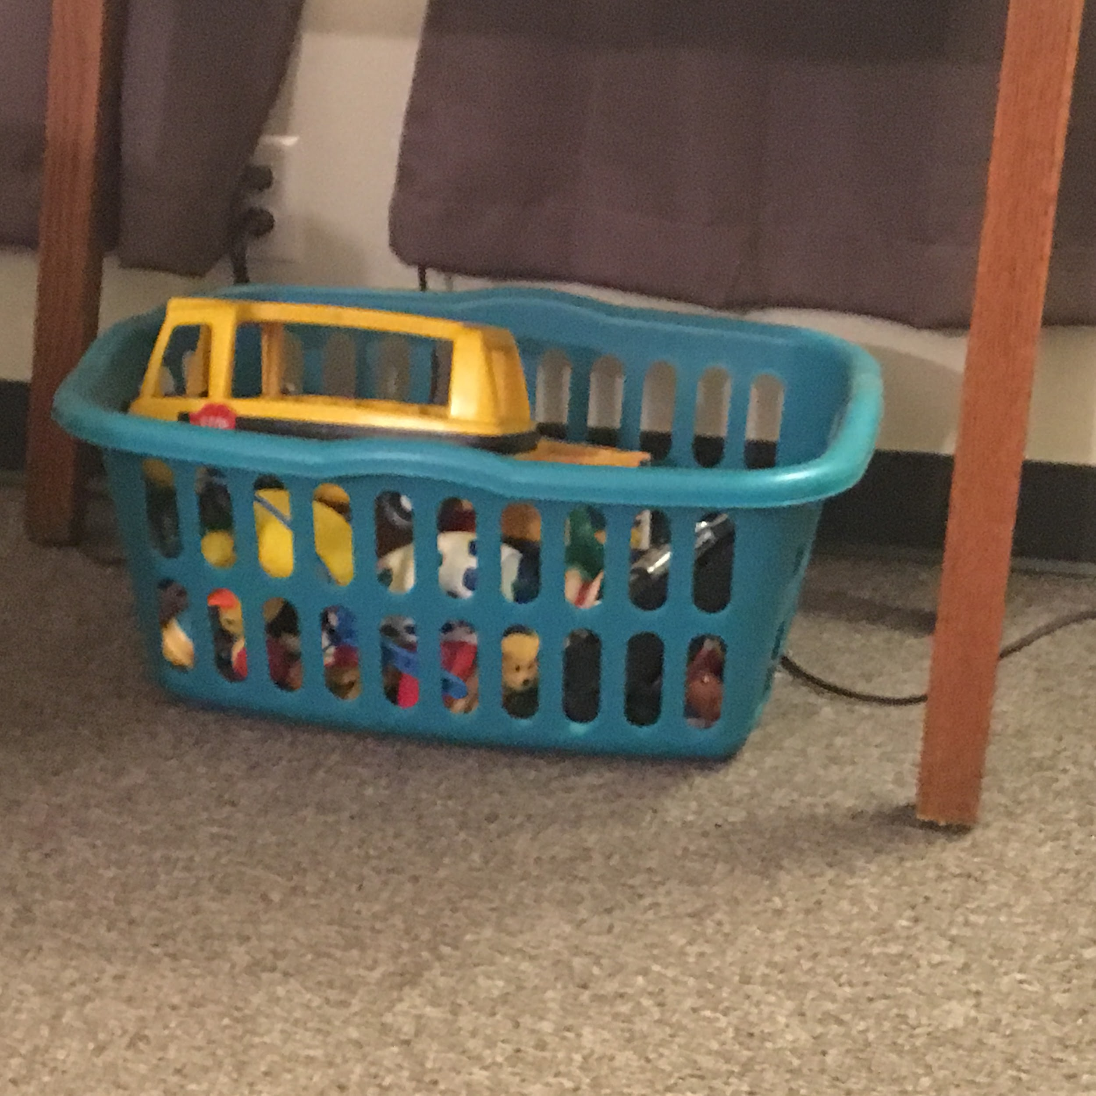
Figure 27 | Figure 28
 | 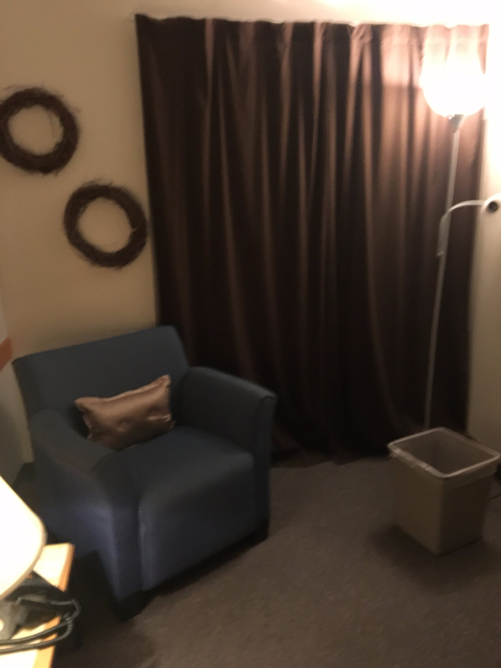

Figure 29 | Figure 30
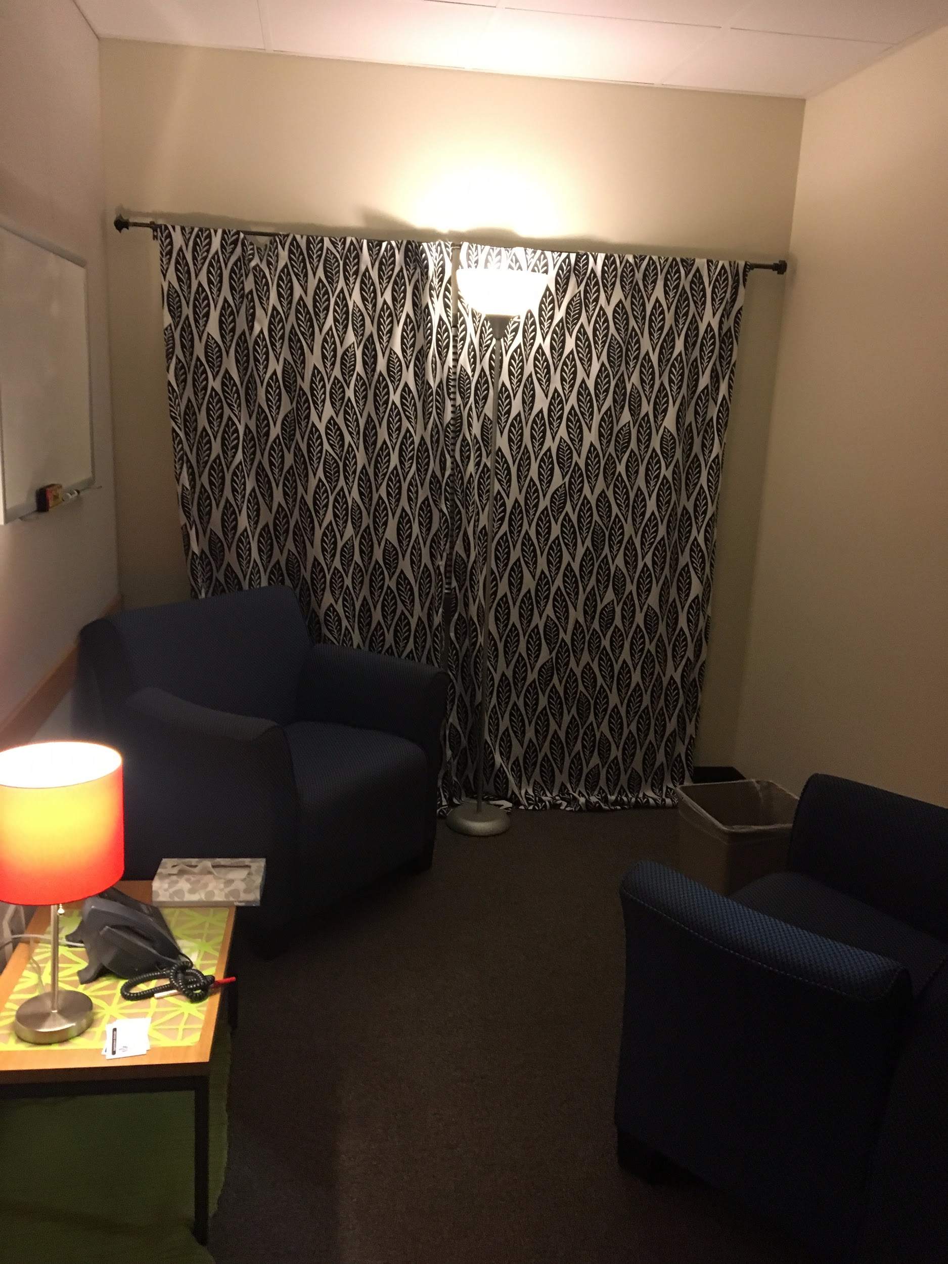 | 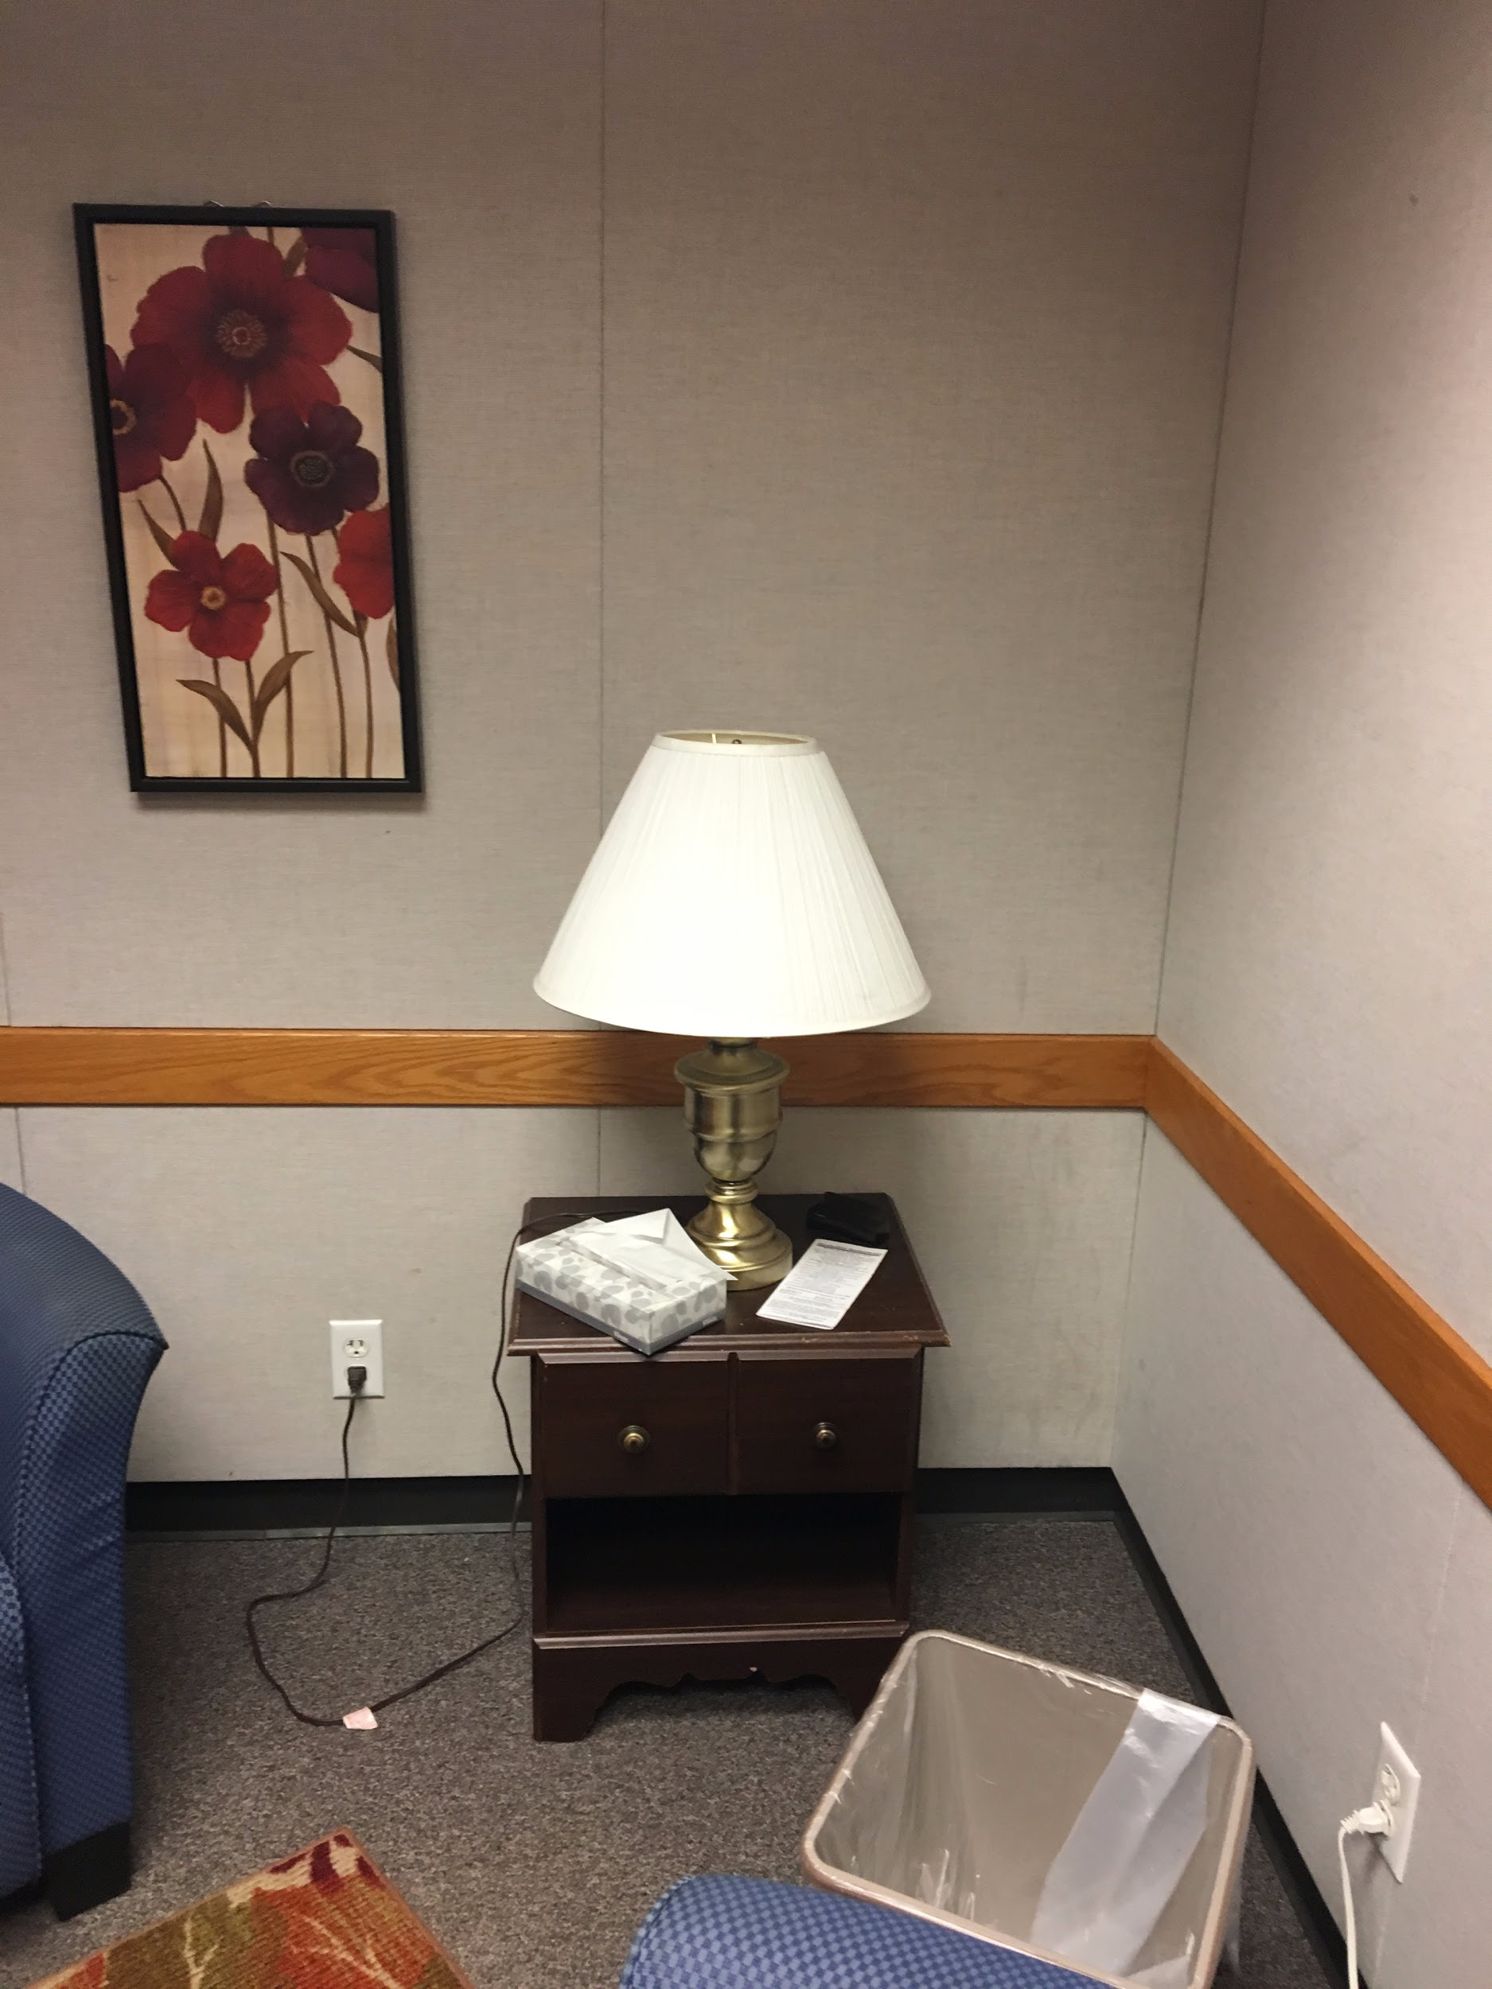
Figure 31 | Figure 32
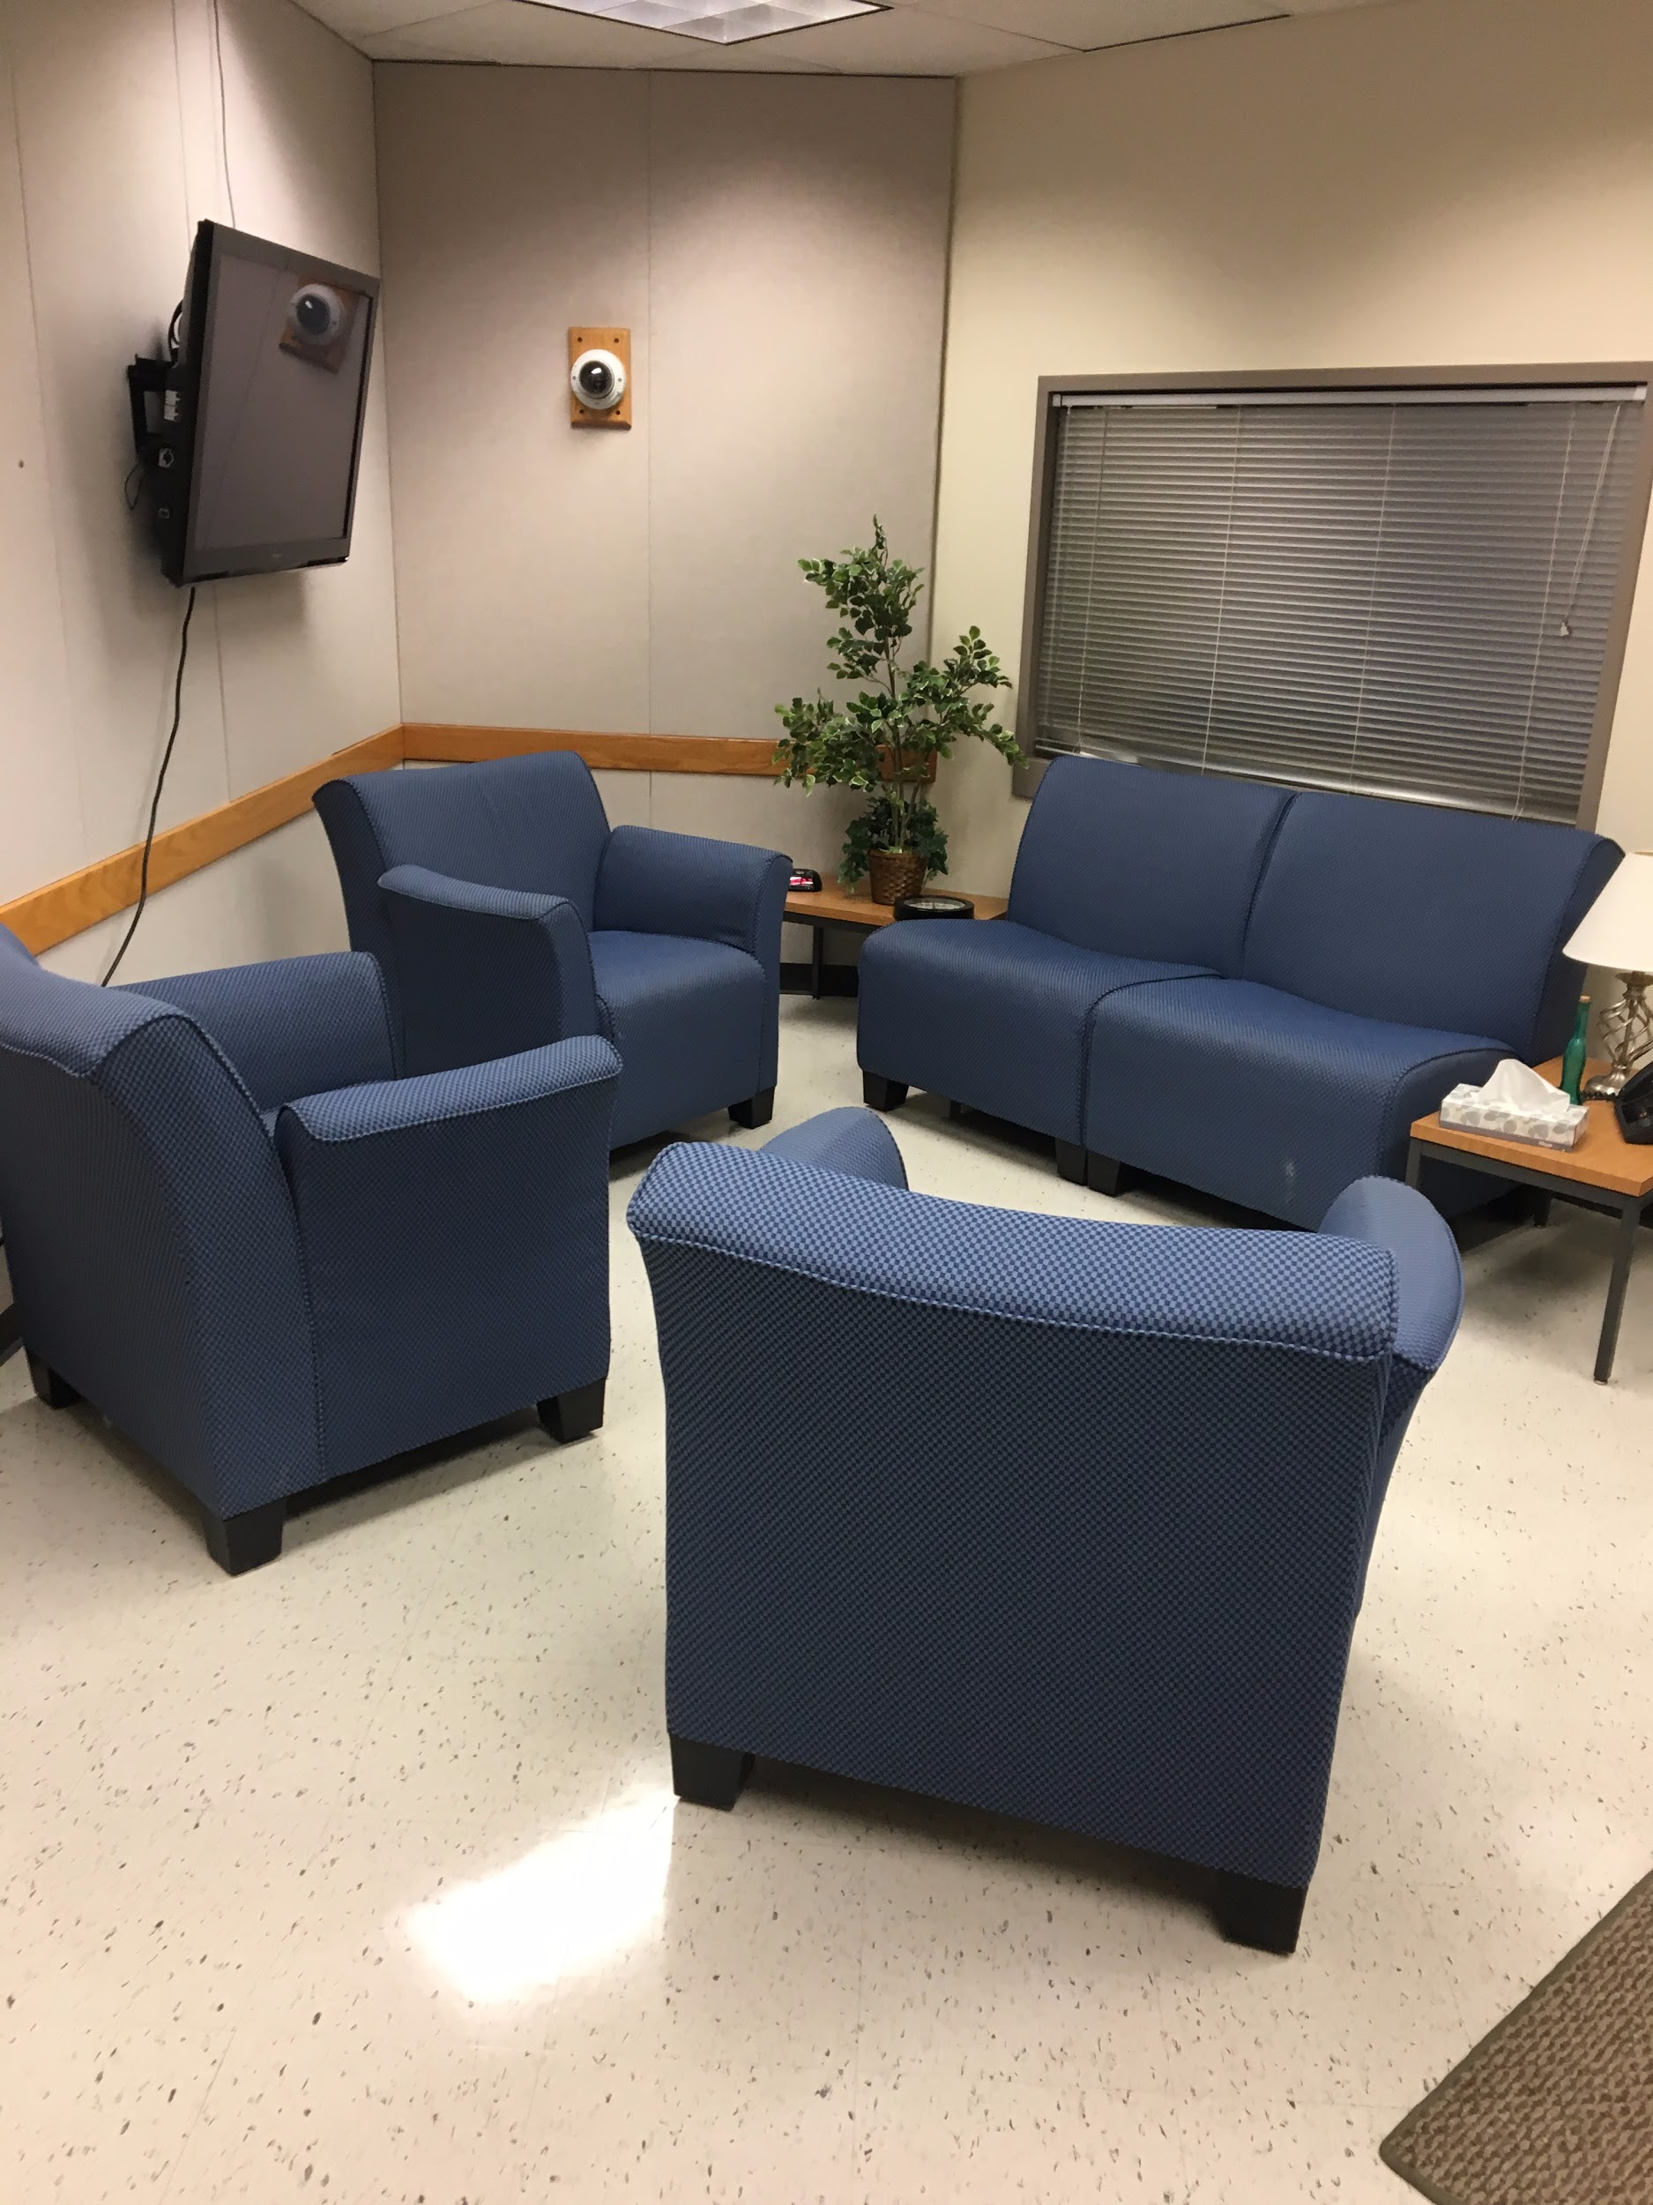 | 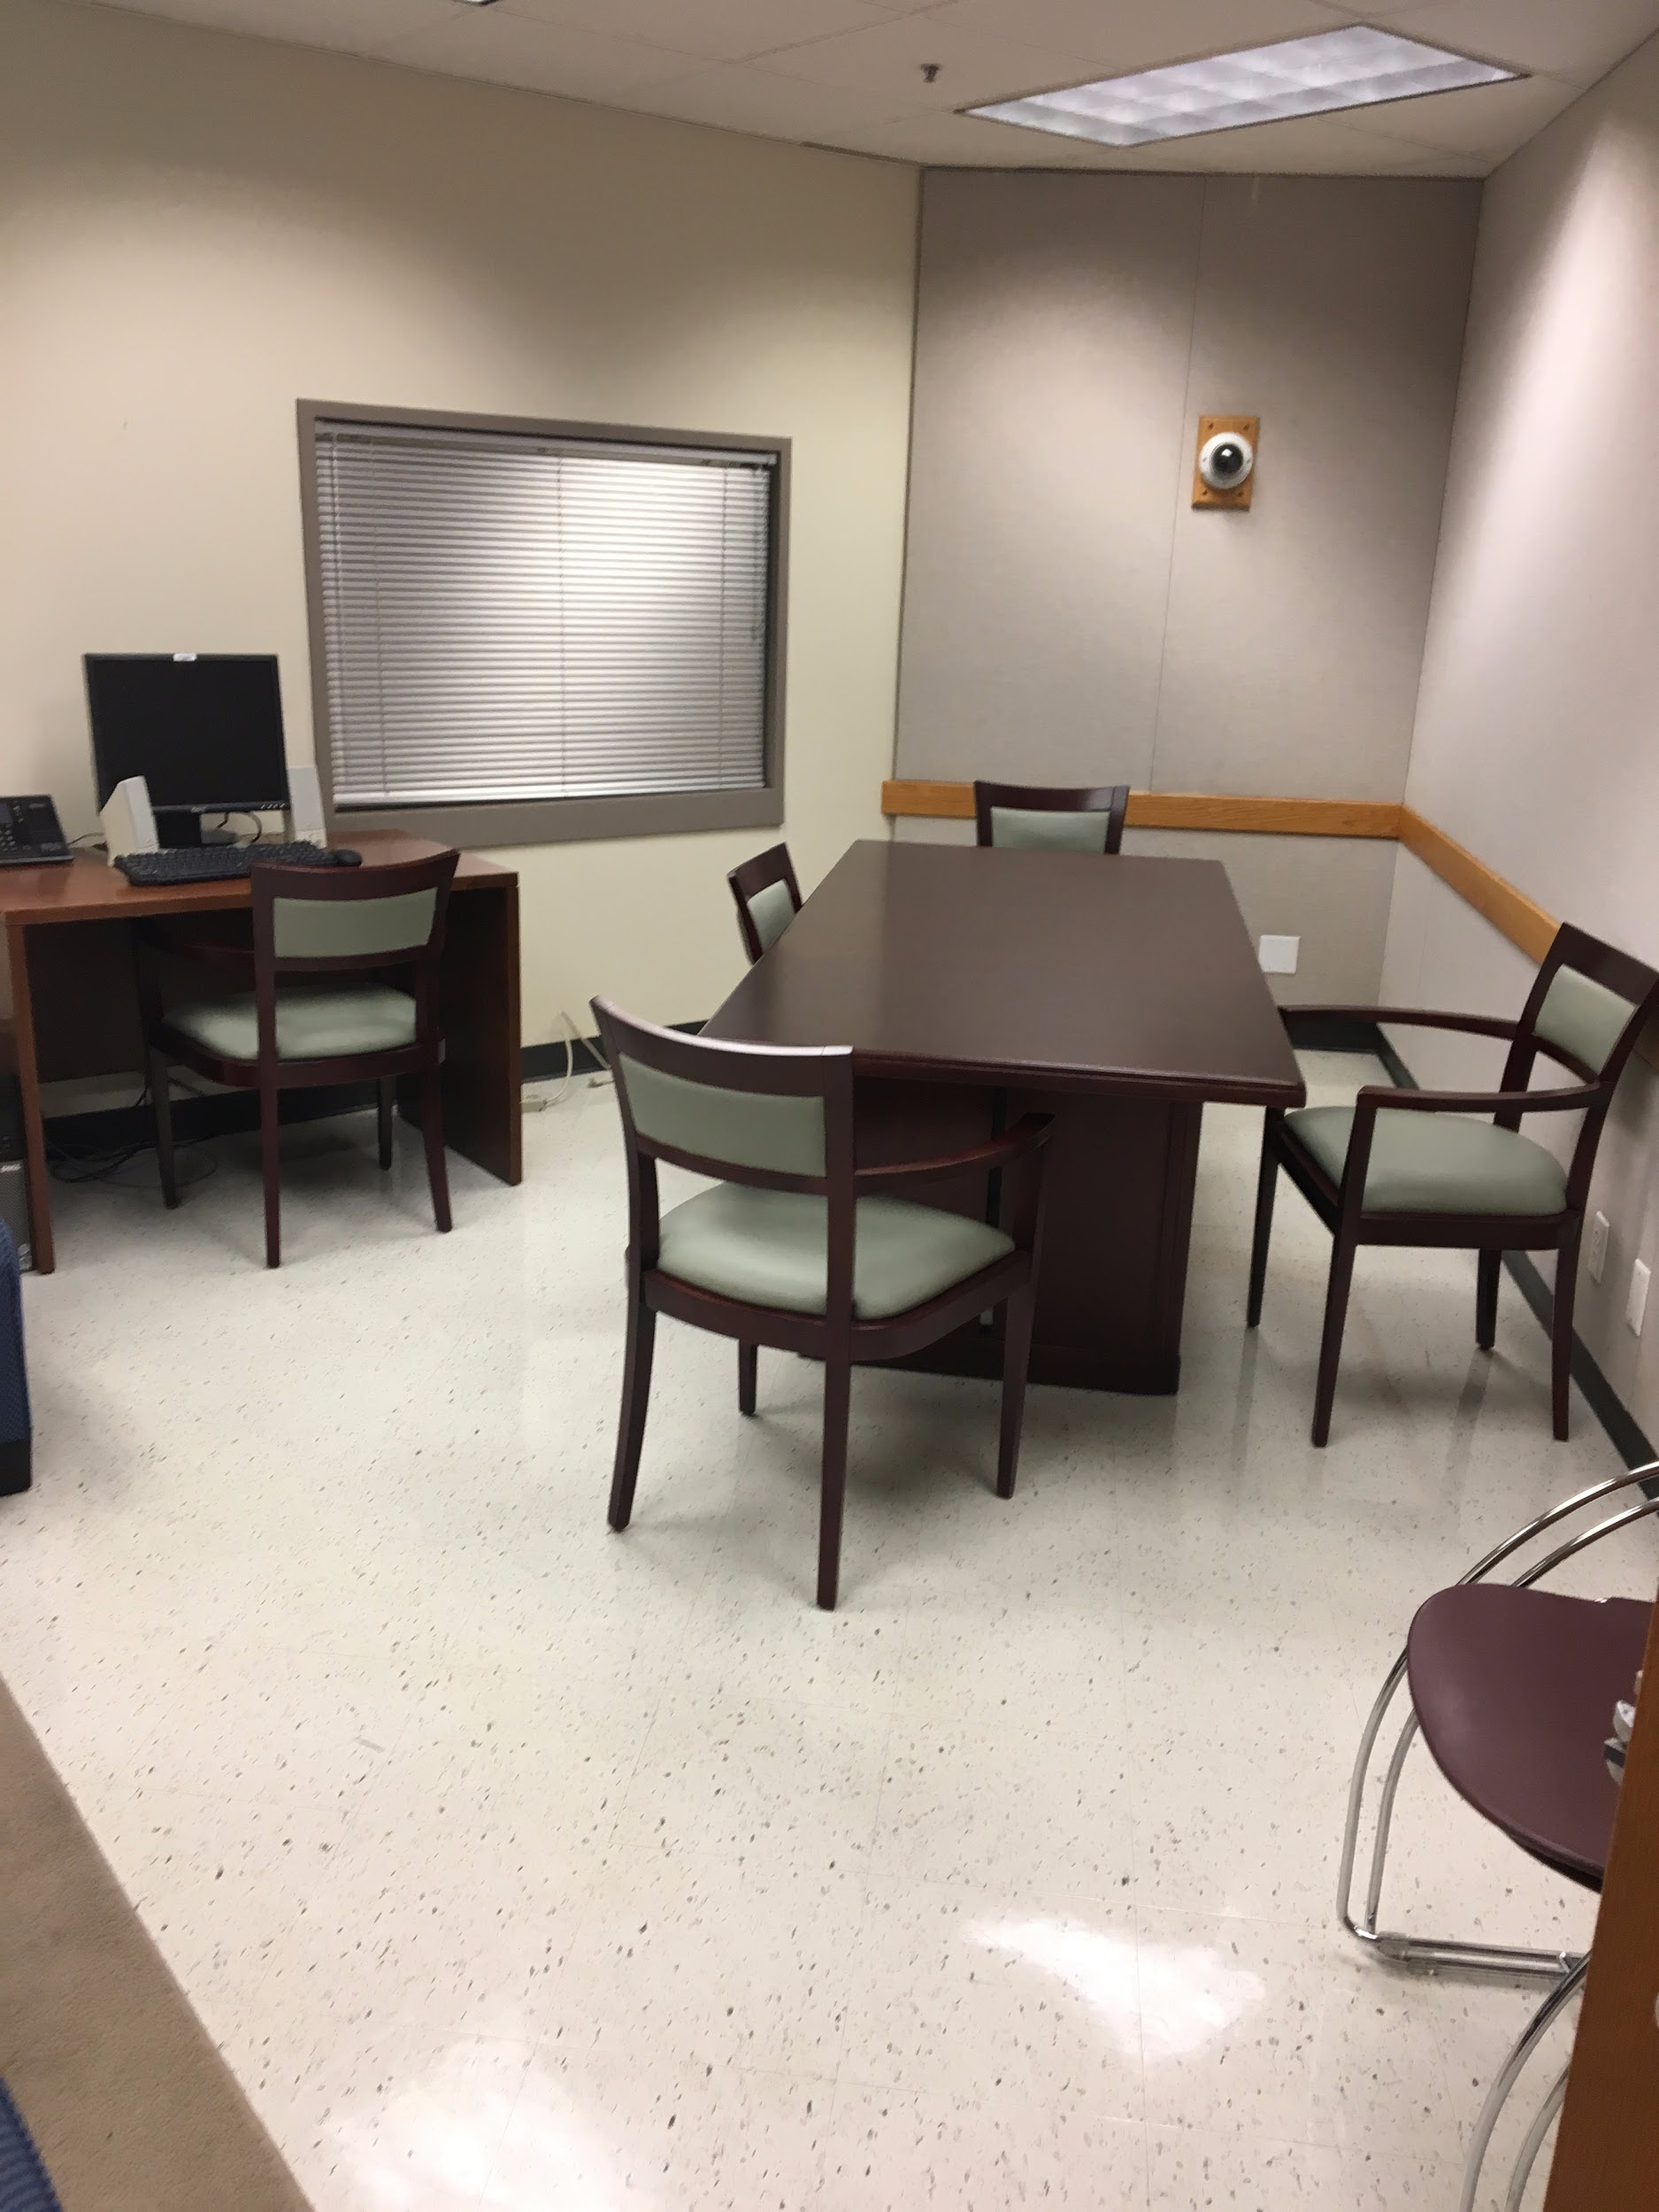

Figure 33 | Figure 34
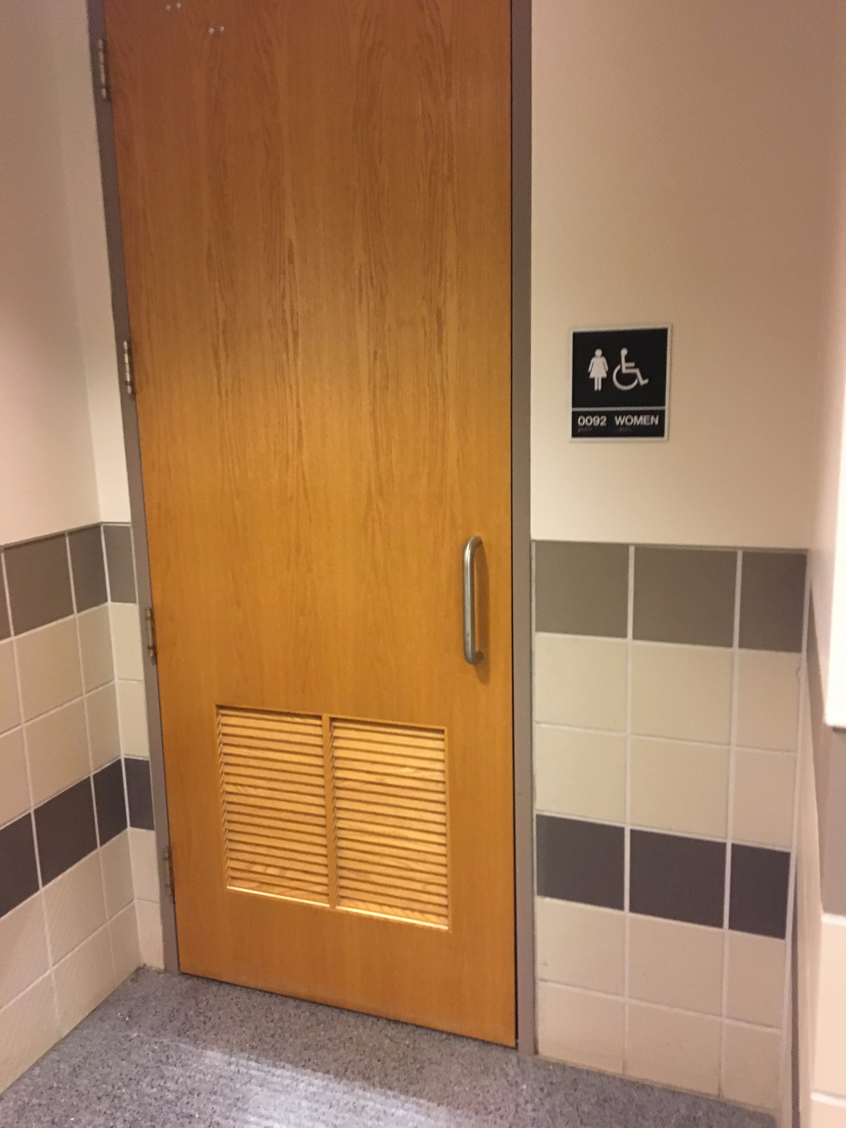 | 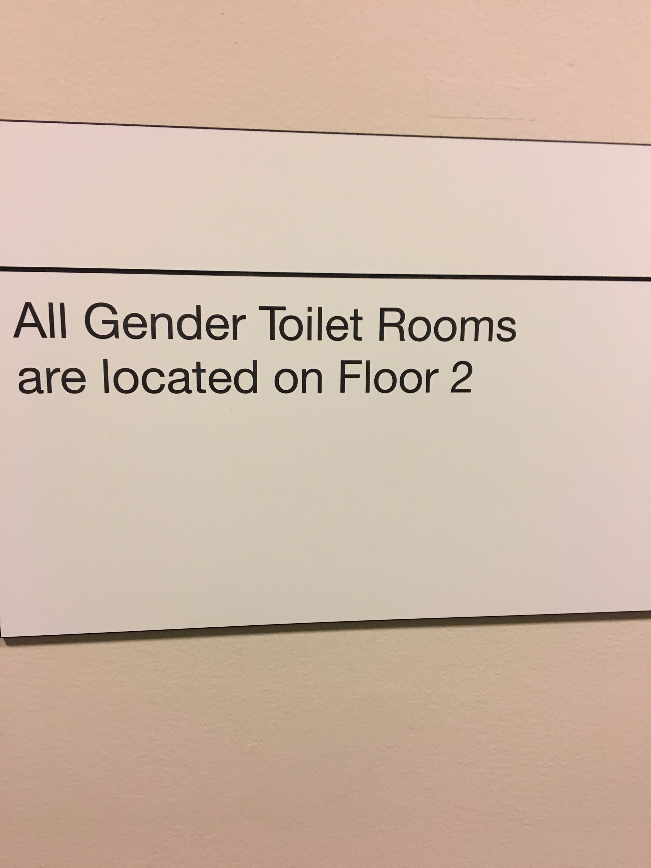

Bros & Booze: Assessing the Impact of Alcohol Skills Training Program on Fraternity Drinking
Gino M. Andreano, Abigail Ford, Alexis L. Karwoski, & Chase K. Wilson
The Alcohol Skills Training Program (ASTP) is designed with the goal of providing students a better understanding of how alcohol affects the body and focuses on how to engage in drinking behaviors in a less risky manner. No research has been conducted at IUB since Student Life and Learning adopted the program for the Fraternity and Sorority Life community in 2014; however, findings from this research study provide insight to IUB professionals for future practice.
Keywords: alcohol, ASTP, drinking, fraternity, harm reduction, risk

Research indicates fraternity members drink more heavily and frequently than their non-affiliated peers on average, often engaging in binge drinking tendencies (Wechsler, Kuh, & Davenport, 1996). Binge drinking is a pattern of drinking that rapidly raises an individual’s blood alcohol concentration to 0.08 percent or higher; for men, this typically occurs when five or more drinks are consumed in a period of two hours (Centers for Disease Control, 2018). Binge drinking is twice as prevalent among men, and is more likely to occur among fraternity men who live in fraternity housing (Centers for Disease Control, 2018; Larimer, Irvine, Kilmer, & Marlatt, 1997). Fraternities and sororities are prevalent on many college campuses, including Indiana University Bloomington (IUB). According to the Integrated Postsecondary Education Data System (2016), IUB has an approximate total undergraduate enrollment of 39,184 undergraduate students, with 19,200 of those students identifying as male. Of those male undergraduate students, an estimated 3,950 are members of a fraternity (Student Life and Learning, 2018).
In recognizing this national trend, the office of Student Life and Learning at IUB began facilitating the Alcohol Skills Training Program (ASTP) for members of fraternity and sorority life at IUB. ASTP is designed to provide students a better understanding of the effects of alcohol on the body and focuses on adapting less risky drinking behaviors (Kilmer et al., 2012). According to the previous Associate Director of Student Life and Learning, there has been no formal assessment made to determine the impact of the program upon the fraternity and sorority community (M. Kish, personal communication, August 25, 2017). The majority of chapters are a part of the Interfraternity Council (IFC) at IUB; membership within IFC is comprised of strictly male students (Student Life and Learning, 2018). By assessing ASTP, the effectiveness of the program may be determined in regards to its goal of risk reduction related to alcohol consumption. Specifically, we seek to learn if IFC members at IUB are altering their drinking behaviors to be less risky or harmful as a result of ASTP.
This assessment is essential due to the current climate within fraternity and sorority life across the nation, as well as the number of student deaths involving alcohol and hazing in fraternities this past year (U.S.A. Today, 2017). Throughout this manuscript, a deeper dive into ASTP and the significance of related education is further explored. This particular assessment provides recommendations for improvements at IUB, but is also applicable to similar campuses that utilize and/or are looking to utilize ASTP as a means of transparent and open-minded alcohol education.

Literature Review

Fraternity and sorority members drink more heavily and frequently than their non-Greek peers (Alva, 1998; Cashin, Presley, & Meilman, 1998; Hamm, 2012; Sher, Bartholow, & Nanda, 2001; Wechsler, Kuh, & Davenport, 1996). Research also shows that men tend to drink, on average, more often and in higher quantities than women, and problem drinking in the Greek system most often occurs at fraternity functions (Borsari & Carey, 1999; Kapner, 2003). DeSimone (2009) discusses how fraternity membership plays a role in the intensity, frequency, and recency of drinking behaviors. Adverse consequences of alcohol consumption may include health problems, judicial problems, and poor decision making, whereas positive alcohol expectancies correlate alcohol use with fostering relationships, maintaining a group identity, and being more relaxed and sociable (Borsari & Carey, 1999; DeSimone, 2009; Evans & Dunn, 1995; Hasking & Oei, 2002; Park, 2004). Because collegiate fraternity men drink almost twice as much as their non-affiliated peers (Bartholow, Sher, & Krull, 2003), it is important to consider all of the risk factors and consequences involved with heavy drinking and the fraternity experience.
Many students who engage with drinking behaviors during their adolescence or adult life form expectations around how they think alcohol is affecting them (Borsari & Carey, 1999; Park, 2004). In turn, these alcohol and tolerance expectancies play a significant role in the maintenance of drinking and potentially alcohol-abusing behaviors. Additional studies provide evidence that “greater alcohol expectancies of social facilitation held by adolescents even before they began drinking predicted increases in drinking over time” (Borsari & Carey, 1999, p. 31). Because many students hold preconceived notions regarding alcohol expectancies throughout their college tenure, many intervention and prevention efforts work to eliminate and provide perspective surrounding the effects of alcohol.
Intervention and Prevention Efforts
There is ample research that provides evidence suggesting that intervention and prevention efforts are effective when considering alcohol use and abuse behaviors. Alcohol-prevention efforts have been prevalent on college campuses since the 1990s, many of which specifically target fraternity and sorority organizations (e.g. Caudill et al., 2007; Far & Miller, 2003; Larimer et al., 2001). Over the years, many colleges and universities implemented different programs and adapted promising practices from colleges and universities that currently lead the way in alcohol education research. An analysis of alcohol prevention efforts by Hunnicutt, Davis, and Fletcher (1991) indicates:

Traditional education and prevention efforts, which have focused primarily on behavioral mandates and educational campaigns, have proven to be ineffective at changing the drinking behaviors of Greek members, and confronting current drinking rates can be seen as a personal attack on the organization (as cited in Hamm, 2012, p. 13).

Group-based skills and intervention training programs have greater success. Caudill et al. (2007) found that months after such programs were introduced to individual chapters within a national fraternity, general risky drinking behavior and the total number of drinks consumed among the riskiest of members were successfully reduced. In addition to group-based administered programs, there is also strong empirical evidence supporting brief motivational interview (BMI) interventions (Cronce & Larimer, 2011). BMI interventions, which focus on enhancing an individual’s motivation and commitment to change problematic behaviors through an empathetic facilitation style, are more likely to reduce individual alcohol consumption and high-risk drinking behaviors (Borsari, Murphy, & Barnett, 2007; Cronce & Larimer, 2011; Hamm, 2012). Specifically related to influencing drinking among fraternity and sorority members, Larimer et al. (2001) suggest effective interventions focus on increasing peer accountability and awareness of accurate drinking norms and perceptions. Additionally, effective interventions focus on decreasing perceptions of alcohol’s socialization value and peer influence to drink heavily (Larimer et al., 2001). Therefore, research suggests the use of group-administered, fact providing, motivational interview techniques will be most effective at changing fraternity and sorority drinking behaviors and cultural norms.

Alcohol Skills Training Program
One program that incorporates motivational interviewing techniques in a group-administered format is the Alcohol Skills Training Program (ASTP). ASTP is widely used on a national level in risk reduction efforts; at press, we were aware of 12 national fraternity and sorority organizations that have adopted ASTP as an educational tool. ASTP utilizes a harm-reduction approach aimed at teaching students the basic principles of moderate drinking, determining strategies for reducing high-risk drinking behaviors, and acknowledging that any steps toward minimizing risk and moderating drinking are beneficial (Hamm, 2012; Kilmer et al., 2012; Kivlahan, Coppel, et al., 1990; Task Force, 2002). Students who make the choice to drink learn skills and strategies to moderate their drinking and minimize harm, including abstinence as one such strategy (Kilmer et al., 2012).
The Alcohol Skills Training Program consists of 10 components, which can be observed in Appendix A. Together, these components work to educate and increase students’ interest in examining their drinking patterns, as well as positively impact their motivation to implement the skills they have learned through the program (Miller, Kilmer, Kim, Weingardt, & Marlatt, 2001). The program takes approximately 2 hours to facilitate. A report produced by The Task Force of the National Advisory Council on Alcohol Abuse and Alcoholism (NIAAA) in 2002 indicates that ASTP “significantly reduce [sic] drinking rates and associated problems at the one-year and two-year follow up periods” (p. 17), thereby making it one of the most effective tools to challenging alcohol and perceptions and ultimately reducing fraternity and sorority members’ high-risk drinking.
It’s important to note that ASTP seeks to reduce harm, not necessarily drinking behaviors themselves (J. Kilmer, personal communication, September 28, 2017). As a result, the program looks at changes in overall drinking behaviors. If a student drinks ten alcoholic beverages before and after attending ASTP, but chooses to alternate drinks with water and always use a designated driver as a result of the program, then harm reduction has occurred (J. Kilmer, personal communication, September 28, 2017). In this example, ASTP is effective in reducing risky drinking behaviors, even if consumption itself does not change.
While national data supports the use and effectiveness of ASTP within fraternity and sorority life, there have not been specific assessments completed regarding the effectiveness of ASTP within the IUB fraternity and sorority life community. Similarly, most efforts to evaluate ASTP have examined the facilitators and their manner of delivering the content, as opposed to the students receiving the information (J. Kilmer, personal communication, September 28, 2017). As student affairs professionals at IUB, we sought to better understand the current alcohol culture in IFC chapters and the impact of ASTP in this community.

Methods

For this study, we utilized a survey methods approach, employing both quantitative and qualitative components, to assess the impact of ASTP among IFC members at Indiana University Bloomington. Students completed a standardized questionnaire (Schuh et al., 2016) that combined four existing surveys: The Rutgers Alcohol Problem Index (RAPI), the Protective Behavioral Strategies Survey (PBSS), the Daily Drinking Questionnaire (DDQ), and the Satisfaction Survey. The first survey, the RAPI, assesses how often students experience negative consequences as a result of their drinking, while the second survey, the PBSS, predominantly measures the frequency of participant’s utilization of harm-reduction behaviors during their alcohol consumption. Both the RAPI and PBSS have strong internal consistency and construct validity (Martens et al., 2005; White & Labouvie, 1989). The internal consistencies of the RAPI and PBSS are .83 and .81, respectively (Arterberry, Smith, Martens, Cadigan, & Murphy, 2014). The third survey, DDQ, is used in ASTP studies to validate behavioral changes and examine college student drinking behaviors (Baer et al., 2001; Kivlahan, Marlatt, Coppel, & Williams, 1990; Larimer et al., 2001). The DDQ asks for students to indicate the typical number of drinks they consume, as well as the typical number of hours spent drinking on each day of the week. Finally, the fourth survey, Satisfaction Survey, is currently utilized at the University of Washington to specifically gauge the desired outcomes of ASTP, as well as provide feedback on the program facilitator (J. Kilmer, personal communication, September 28, 2017).
Independently, these surveys address components of fraternity drinking behaviors and ASTP learning outcomes. By utilizing the existing surveys, we were able to construct a valid and reliable survey aimed at understanding student’s drinking behaviors and perceptions within the IUB fraternity and sorority community. The comprehensive questionnaire incorporates pre-coded and open-ended responses, as well as space at the end of the survey for students to share additional comments regarding the program. When combining the four surveys into one questionnaire, we modified each survey’s instructions to include specific reference to Indiana University’s fraternity and sorority community. We directly replicated the survey questions for the DDQ, the PBSS, and the Satisfaction survey in our questionnaire, but made modifications to the RAPI. Specifically, we selectively utilized ten of the original RAPI’s twenty-three questions and modified the wording to be consistent with language used within the IUB fraternity and sorority community. This survey tailoring was an intentional effort to keep the survey response time short in order to encourage a higher response rate, while also intentionally highlighting behaviors that are perceived as prevalent in IUB’s IFC community. Additionally, we expanded the original survey’s scale from “more than five times” up to “more than 20 times” in order to get an accurate scope of behaviors within the IUB fraternity and sorority community.
In recognizing that the program’s goal of risk reduction manifests differently for each individual participant (Merriam, 1988), open-ended questions were included in the comprehensive questionnaire for students to qualitatively share additional comments pertaining to the program and describe their change in drinking behaviors, if and when applicable. The collective use of qualitative and quantitative data ultimately allowed for a balanced assessment of the program’s effectiveness, a larger scope of participant feedback, and an inclusion of participant’s individualized experiences.

Survey Distribution
In order to gain access to students, we attended an IFC President’s Council meeting and shared the purpose of our study with all IFC presidents. We reiterated that survey answers could not be linked back to them personally or to their chapter, and asked that IFC presidents encourage their members to be as honest as possible in their survey responses. We asked each IFC president to review the survey and disperse the link to qualifying chapter members, who attended an ASTP session as a new member between August 2016 and May 2017. It was estimated that approximately 1200 new IFC members participated in ASTP during that time frame. The survey was accessible on any device with internet access from October 17, 2017 to November 17, 2017 and took approximately ten minutes to complete.

Community Culture Considerations
Given the size and stature of the IFC community, there were several sensitive issues that we anticipated, but did not directly observe during the course of our study. Many IFC organizations engage in social functions numerous times a week through paired social events with Panhellenic sororities. McCreary and Schutts (2015) posit organizations “who measure high in shared social experiences would be more likely to make decisions as a group based on conventional moral schema, particularly those centered around maintaining norms in order to achieve social status on campus” (p. 46). As a result of regular social functions, students may perceive heavy drinking behaviors as normalized community behavior. Additionally, brotherhood is at the core of the fraternity experience, which includes lifelong commitment and the care and concern that each member ideally has for one another. A chapter’s brotherhood may be reinforced partly through bonding over their shared use of alcohol and drugs. Over time, this can continue to manifest within the chapter culture, creating a brotherhood that encourages risk-taking behaviors while potentially undermining genuine care for one another.

Methodological Limitations
Several limitations exist within our methods. For one, there may have been scattered recollection of ASTP for many students which could have affected our results. Since some students participated in ASTP in August 2016, recollection of the program content may not have been as clear as it was for a student who participant a month prior to taking the survey. Relatedly, there may have been confounding factors, outside of the scope of ASTP, that influenced students to change their drinking behaviors (e.g. legal or personal circumstances).
A second limitation relates to the concept of social desirability. Fowler (1995) found that student “respondents tend to underreport socially undesirable behavior and over-report socially desirable behavior. They distort their answers towards the social norm in order to maintain a socially favorable self-presentation” (p. 29). Knowing this, students may have responded to our survey questions with social desirability in mind. That is to say, students may have under- or over-estimated the true prevalence and frequency of their alcohol perceptions and behaviors depending upon what they perceive as normative in the IUB IFC community as a means to fit in (Krumpal, 2013). The surveys that we utilized for our study did not specifically set out to address social desirability. Thus, the influence of social desirability potentially impacted the effectiveness of our survey in a way that we could not measure.
Lastly, because survey responses were completely anonymous, we were not able to analyze responses by demographics beyond being a member of the IFC community. We also could not ask follow-up questions to allow students to expand upon their open-ended response answers. Also, since we did not have access to participant contact information, we could not send reminder emails and instead relied on Chapter Presidents to encourage their members to complete the survey. We believe this limitation had a significant effect on our response rate, as only thirty-two students out of a possible 1,200 students who completed ASTP in the 2016-2017 academic year completed the survey.

Data Analysis
Survey results were collected via Qualtrics and compared to ASTP’s learning outcomes, particularly related to students’ reduction of harmful among drinking behaviors and increased understanding of the effects of alcohol on the body. Responses in which students indicated risk mitigating behaviors and retention of knowledge indicated successful implementation of the ASTP’s learning outcomes. Responses that noted no change or risk seeking behaviors regarding alcohol consumption indicated that the learning outcomes were not achieved. It is important to note that perceptions of “safer” or less risky drinking behaviors can vary person to person. One student may feel that restricting themselves to six 12-ounce cans of beer after previously consuming eight 12-ounce cans of beer may constitute as safe, whereas another may continue to affirm that choosing not to drink is the safest choice. Due to the broad definition of effectiveness adopted to evaluate the program, this analysis blended both qualitative and quantitative components. Standardized responses were calculated to determine the frequency of students’ answers, while the open-ended response portion at the end of the survey gathered qualitative data from students regarding their perceptions of the most effective and least effective portions of the program. We separately coded themes for open-ended response answers, thus maintaining validity and reliability of the data. During this phase of the coding, themes were adjusted to assure consistency in phrasing. We evaluated responses for completeness, congruence, relevance, and uniqueness as defined by Schuh, Biddix, Dean, and Kinzie (2016).

Results

Of the possible 1,200 students who participated in ASTP, thirty-two students responded to the survey. Thirty-one agreed to complete the survey, while one student did not. This represented a 2.58% response rate. While the student response rate is not statistically significant, the results of this study still provide important insights into the drinking behaviors and perceptions of IUB
IFC members.

Overview of Typical Drinking Patterns
The majority of students (93.55%) stated they drank alcohol prior to joining their fraternity. The same percentage of students (93.55%) stated they currently drink alcohol. When asked about a typical week of drinking within the Fraternity and Sorority community at Indiana University, students indicated they consumed the most amount of drinks on Saturday, Friday, and Thursday, respectively. For all three days, the majority of students indicated they consume 3-8 drinks. Students were also asked to think about how many hours they typically consume the previously identified number of drinks.
Table 1
Students’ Reported Number of Drinks Consumed During a Typical Week at IUB
Day of the Week | 0-2 Drinks | 3-8 Drinks | 9+ Drinks
Saturday | 11.11% | 62.96% | 25.93%
Friday | 11.11% | 66.67% | 22.22%
Thursday | 44.45% | 51.85% | 3.70%
Note. Students were first asked to indicate the number of standard drinks they consumed on each week day. Then, they were asked to indicate the typical number of hours spent drinking on those same days. The percentages indicate the percentage of student responses according to the specified drink range.
ª Students’ 9+ standard drink consumption noticeably increases between Thursday and Friday/Saturday. Students are consuming most of these drinks at a faster pace than 1 standard drink per hour, as indicated in Table 3.

Table one indicates the percentage of students corresponding to the number of drinks consumed drinking on those three days of the week, while table two indicates the percentage of students reporting the number of hours spent drinking on those same three days of the week.

Risky Drinking Behaviors and Outcomes
Table 2
Students’ Reported Number of Hours Spent Drinking During a Typical Week at IUB
Day of the Week | 0-2 Hours | 3-8 Hours | 9+ Hours
Saturday | 7.41% | 85.18% | 3.70%
Friday | 11.11% | 85.18% | 3.70%
Thursday | 51.85% | 44.44% | 7.41%
Note. Students were first asked to indicate the number of standard drinks they consumed on each week day. Then, they were asked to indicate the typical number of hours spent drinking on those same days. The percentages indicate the percentage of student responses according to the specified drink range.
Students were asked to indicate how often they experience certain behaviors, thoughts, or feelings when using alcohol or “partying.” The three most common experiences included drinking to the point of “blacking out” (55.56%), getting into a verbal argument with another individual (51.85%), and doing something they regretted (48.15%). The students indicated that the aforementioned outcomes have occurred between one to seven times. It is important to note that 3.7% of students indicated that they have drank to the point of “blacking out” more than 20 times. Additionally, 14.81% of students have done something that they refretted 8-15 times. Finally, the majority of students (74.07%) stated that they drink shots of liquor, with 59.26% indicated they do so sometimes, usually, or always.

Harm-Reducation Drinking Behaviors
In addition to identifying outcomes of their alcohol-use, students were also asked the degree to which they engage in harm-reduction behaviors when using alcohol or “partying.” Of the 15 behaviors listed, the majority of students indicated usually or always engaging in the following harm-reduction behaviors: using a designated driver (96.3%) and knowing where their drink has been at all times (85.18%). Students also indicated that they sometimes or usually alternate alcoholic and non-alcoholic drinks (66.67%), drink water while drinking alcohol (59.26%), drink slowly rather than gulping or chugging (59.26%), and avoid trying to “keep up” or “out-drink” others (51.85%). Harm-reduction behaviors that students never or rarely engage in include: avoiding drinking games (59.26%), having a friend let them know when they have had enough to drink (33.33%), and putting extra ice in their drink (33.33%). Overall, more students indicated engaging in harm-reduction behaviors sometimes, usually, or always compared to students who indicated occasionally, rarely, or never, with the exception of “avoiding drinking games.”

Tangible Outcomes of ASTP
Because ASTP seeks to provide skills and strategies for students to moderate their drinking and minimize harmful behavior, students were asked about how they changed their thinking and behaviors around alcohol-use, if at all. In response to the question, “The information I received in this program caused me to change my pattern of alcohol use,” 23.8% of students agreed, 23.8% of students were undecided, and 52.38% of students disagreed. When asked to elaborate on how they changed their pattern of alcohol use, the prominent themes of open-ended response answers included: no change in behavior (46.15%), less overall drinking (11.54%), more mindfulness when drinking (30.77%), or drinking water while consuming alcohol (11.54%).
In response to the statement “The information I received caused me to think differently about my pattern of alcohol use,” 30.43% of students agreed, 30.43% of students were undecided, and 39.13% of students disagreed. In elaborating on how they changed their thinking regarding their pattern of alcohol use, students stated: “I drink too much and need to drink less” (26.92%), “Drinking more water is important” (7.69%), and “I give more thought to the effects of alcohol” (19.23%). Of the remaining students, 3.85% of students stated they changed their thinking around alcohol use, but did not elaborate; 42.31% of students did not change their thinking about their alcohol-use as a result of ASTP.
Finally, when prompted with “I left the presentation with a specific goal in mind about changing my alcohol use,” 18.18% of students agreed, 27.27% of students were undecided, and 54.54% of students disagreed. The prominent goals that students set for themselves included: drinking less (26.92%), not drinking until other obligations are done (3.85%), and having a more conservative mindset while drinking (3.85%). The majority of students did not set a goal (57.69%), while 7.69% of students set a goal, but did not elaborate on what it was.
Overall, the majority of students (54.17%) stated they would recommend ASTP to a friend, while 29.17% were undecided. Students indicated several themes regarding what they found to be most useful from ASTP, including: education surrounding standard size drinks, education regarding alcohol’s interaction with the body, knowledge regarding how to handle difficult or tough situations, and individual strategies and habits pertaining to alcohol-use. While most students were unsure or did not indicate any criticism to “What did you find least useful in regards to ASTP?,” the two primary response themes included the program’s “time commitment” and “length,” as well as its assumed intent of “trying to change students.”
Finally, when asked to share additional comments regarding IUB’S ASTP and how it impacted their perceptions of alcohol use and/or current drinking behaviors, two students responded. One student recognized ASTP could have a positive impact on students, but did not feel personally moved by the program. This idea was indicated in their statement, “It probably helped others more than it helped me.” Another student believed behavioral mandates are ineffective, but it is still important to provide students with tools for success, should they personally choose to use them. This concept was highlighted in the student’s statement, “I don't think telling people to drink less will make them do it. They'll do what they want to. Education is all you can give.”

Discussion

On the surface, the array of themes from this study appear to lead to antithetical findings. Many students indicated specific harm-reduction behaviors that they employ during alcohol consumption as a result of ASTP. Approximately half of the students indicated that they did not change their drinking behaviors as a result of ASTP. This idea, compounded with the knowledge that students indicated that they currently engage in binge drinking even after taking ASTP, poses questions surrounding the effectiveness of the program. In order to analyze the results, it is imperative that the meaning of “effectiveness” is operationalized.
The goal of ASTP is to reduce risk and not necessarily drinking behaviors themselves; therefore, there are several considerations to be made. First, while our survey response rate was limited by our survey distribution methods, the survey sample size of students does not necessarily equate to the interpretation of ASTP’s effectiveness in the IUB IFC community. The thirty-two student responses may indicate that these thirty-two IFC members were more engaged in the program than other members. These individuals who responded may naturally be more attentive by nature and were able to give more context into IUB’s ASTP effectiveness. Additionally, the completion of our survey by thirty-two students may also signal an overall lack of reception to ASTP due to the recent addition of the program. Because ASTP has not been established at IUB for very long, it may be perceived by students as a passing administrative requirement. As the program matures on campus, it may gain additional validity from the students. In turn, positive student buy-in to ASTP would help future studies attain greater participant levels and increased feedback.
It is also essential to note that each student has their own respective view of how they define “reducing harmful drinking behaviors.” For instance, one individual may feel that reducing their alcohol consumption from six beers to two beers a day constitutes “reducing harmful drinking behaviors,” while another individual may define “reducing harmful drinking behaviors” as alternating alcoholic beverages with water. Both individuals in this example are correct in their views of decreasing these risky drinking behaviors. To try and give a standard of reducing harmful drinking behaviors would then discredit the efforts that one has made to decrease such behaviors.

Implications for Practice
To begin understanding the constructed environments within fraternity life, it is important to recognize the typical rate at which students are consuming alcohol. When comparing the number of consumed drinks to the number of hours spent drinking, the data indicates that the majority of students are drinking more than one standard drink per hour. While research has shown more generally that fraternity members tend to drink more heavily and frequently than their non-affiliated peers (Wechsler, Kuh, & Davenport, 1996), the current data suggests that binge drinking is prevalent within the IFC community at IUB.
The data illustrates that while many fraternity members are binge drinking, they are also engaging in harm-reduction behaviors. The most commonly indicated strategies that current IFC members utilize to reduce harm include: using a designated driver, knowing where their drink has been at all times, alternating alcoholic and non-alcoholic drinks, drinking water while consuming alcohol, drinking slowly rather than gulping or chugging, and avoiding trying to “keep up” or “out-drink” others. While a large percentage of students indicated they regularly engage in harm-reduction behaviors, the current utilization of harm-reduction strategies does not offset the impact and prevalence of binge drinking within the IFC community. As a result, we suggest that the IUB ASTP facilitators spend more time conversing about risk reduction strategies. Inserting more risk reduction conversations at various points within the presentation could also be beneficial in the continual assessment of what is or is not resonating with students. In recognizing that ASTP has a different impact on each individual, the continued facilitation of ASTP at IUB is essential for the future education of IFC members, encouragement of risk reduction, and the creation of positive social environments that include safer alcohol-use norms in the fraternity community.
Finally, the importance of incorporating motivational interviewing techniques into the delivery of ASTP is reinforced by one student’s comment: “I don't think telling people to drink less will make them do it. They'll do what they want to. Education is all you can give.” If facilitators solely present information, it may increase knowledge, but may not impact behavior or motivation for change (J. Kilmer, personal communication, September 28, 2017). In this regard, ASTP can only do so much to positively influence individuals to reduce their risky drinking behaviors; at the end of the day, IFC members will do whatever they decide to do. Facilitators of ASTP can provide information pertaining to the risks of drinking alcohol and offer tips to limit harmful behavior. However, the integration of motivational interviewing into the program significantly increases the likelihood that students will be inspired and committed to changing their alcohol consumption and risky drinking behaviors (Borsari, Murphy, & Barnett, 2007; Cronce & Larimer, 2011; J. Kilmer, personal communication, September 28, 2017). To ensure that ASTP facilitators always utilize motivational interviewing in their delivery method, IUB should provide ongoing training and feedback for ASTP facilitators through staff observations and participant evaluations.
In motivational approaches like ASTP, it is important to recognize that sleeper effects may occur (J. Kilmer, personal communication, September 28, 2017). A student can dislike the message, program, or facilitator in the moment, but they can still agree that the message is true. If a facilitator explains to a student the rate at which alcohol processes in the body, they can still provide useful information to the student, regardless if the student liked what they are hearing. In this regard, students may retain ASTP’s information and/or find it useful in a future situation, even if not in the present moment. Ongoing assessment of ASTP within the IUB IFC community at various intervals after the facilitation of the program ultimately provides insight into students’ immediate and prolonged drinking behavioral changes. This feedback offers clearer insight into ASTP’s influence on reducing drinking rates at one- and two-year follow up periods at IUB, allowing administrators to determine if the impact of ASTP at IUB is consistent with the NIAAA Task Force’s (2002) overall findings of ASTP. Continued assessment also results in meaningful feedback for improving facilitation of the program, while also leading towards increased sample and participant sizes.

Conclusion

It is important for Indiana University Bloomington to continue facilitating ASTP within the IFC community. Larger research shows that a single session of ASTP is more impactful than an ongoing abstinence-only program (Logan & Marlatt, 2010). That being said, a mix of prevention, policy, intervention, and environmental strategies is most effective in addressing and changing fraternity drinking behaviors (J. Kilmer, personal communication, September 28, 2017). As such, IUB should continue to provide a variety of complementary programming opportunities for students, specifically IFC chapter members. In addition to the facilitating of ASTP and other alcohol-related educational programming, it is also essential that IUB continues to assess the impact of ASTP in the IFC community. This ongoing assessment will allow for administrators to gain larger sample sizes, obtain feedback at different intervals following ASTP, and to track larger trends as it relates to alcohol expectations and behaviors.
While this research impacts IUB, it also informs universities who administer ASTP of potential areas of improvement—specifically, the extensive program length and the notion that ASTP is trying to change students. By utilizing effective facilitation methods and clarifying ASTP’s goals, students engaging in ASTP across the nation will more likely be motivated to learn. Especially during the current fraternity and sorority climate, this study emphasizes the continued facilitation of ASTP, as the program positively contributes to challenging alcohol perceptions and decreasing fraternity and sorority members’ high-risk drinking.

Gino Andreano’s path into higher education began when he realized the strong fulfillment he received from helping coach people toward their goals. After nearly three years removed from his job as a work-study student at The Ohio State University, he noticed how much he missed being in an environment of learning. From there he decided to return to school and pursue his Master’s in Higher Education and Student Affairs at Indiana University-Bloomington. He hopes to continue growing as an educator at his next place of work and serve students in a Career or Academic Advisory Role.

Chase Wilson is a 2018 M.S.Ed. candidate in the Indiana University Higher Education and Student Affairs program. He received his B.A. in Public Affairs from The Ohio State University. At IU, he supervises Resident Assistants at Wright Quad in Residential Programs and Services.​

Alexis Karwoski is a 2018 M.S.Ed. candidate in the Indiana University Higher Education and Student Affairs program. She received her B.S. in Psychology and B.A. in Law & Society from Purdue University and previously worked for Pi Beta Phi Fraternity for Women. At IU, she coordinates leadership programming and advises fraternity and sorority chapters.

Abby Ford is a 2018 M.S.Ed. candidate in the Indiana University Higher Education and Student Affairs program. She graduated in 2016 from Florida State University with a Bachelor’s in Elementary Education and a certificate in Leadership Studies. She currently serves as a Fraternity and Sorority advisor in the Student Life and Learning Office at IU Bloomington.

References
Alva, S. A. (1998). Self-reported alcohol use of college fraternity and sorority members. Journal of College Student Development, 39, 3-10.
Arterberry, B. J., Smith, A. E., Martens, M. P., Cadigan, J. M., & Murphy, J. G. (2014). Protective behavioral strategies, social norms, and alcohol-related outcomes. Addiction Research & Theory, 22(4), 279-285.
Baer, J. S., Kivlahan, D. R., Blume, A. W., McKnight, P., & Marlatt, G. A. (2001). Brief intervention for heavy-drinking college students: 4-year follow-up and natural history. American Journal of Public Health, 91, 1310-1316.
Bartholow, B. D., Sher, K. J., & Krull, J. L. (2003). Changes in heavy drinking over the third decade of life as a function of collegiate fraternity and sorority involvement: A prospective, multilevel analysis. Health Psychology, 22(6), 616-626.
Borsari, B. E., & Carey, K. B. (1999). Understanding fraternity drinking: Five recurring themes in the literature, 1980–1998. Journal of American College Health, 48(1), 30-37.
Borsari, B. E., Murphy, J. G., & Barnett, N. P. (2007). Predictors of alcohol use during the first year of college: Implications for prevention. Addictive Behavior, 32(10), 2062-2086.
Cashin, J. R., Presley, C. A., & Meilman, P. W. (1998). Alcohol use in the greek system: Follow the leader. Journal of Studies on Alcohol, 59, 63-70.
Caudill, B. D., Luckey, B., Crosse, S. B., Blane, H. T., Ginexi, E. M., & Campbell, B. (2007). Alcohol risk-reduction skills training in a national fraternity: A randomized intervention trial with longitudinal intent-to-treat analysis. Journal of Studies on Alcohol and Drugs, 68(3), 399-409.
Centers for Disease Control. (2018, March 27). Alcohol and public health. Retrieved from https://www.cdc.gov/alcohol/fact-sheets/binge-drinking.htm
Cronce, J. M., & Larimer, M. E. (2011). Individual-focused approaches to the prevention of college student drinking. Alcohol Research & Health, 34(2), 210-221.
DeSimone, J. (2009). Fraternity membership and drinking behavior. Economic Inquiry, 47(2), 337-350.
Evans, D. M., & Dunn, N. J. (1995). Alcohol expectancies, coping resources, and self-efficacy judgments: A replications and extension of Cooper et al.’s 1988 study in a college sample. Journal of Studies on Alcohol, 56, 186-193.
Far, J. M., & Miller, J. A. (2003). The small groups norms-challenging model: Social norms interventions with targeted high-risk groups. In H.W. Perkins (Ed.), The Social Norms Approach to Preventing School and College Age Substance Abuse: A Handbook for Educators, Counselors, and Clinicians (pp. 111-132). San Francisco, CA: Jossey-Bass.
Fowler, F. J. (1995). Improving survey questions: Design and evaluation (Vol. 38). Thousand Oaks, CA: Sage Publications.
Hamm, K. J. (2012). Impact of alcohol skills training program on college fraternity members' drinking behaviors (Doctoral dissertation, Georgian Southern University). Retrieved from https://digitalcommons.georgiasouthern.edu/cgi/viewcontent.cgi?referer=https:// scholar.google.com/&httpsredir=1&article=1397&context=etd
Hasking, P. A., & Oei, T. P. S. (2002). The differential role of alcohol expectancies, drinking refusal self-efficacy and coping resources in predicting alcohol consumption in community and clinical samples. Addiction Research & Theory, 10, 465-494.
Hunnicutt, D. M., Davis, J. L., & Fletcher, J. (1991). Preventing alcohol abuse in the greek system on a commuter campus: Prevention contracts. NASPA Journal, 28(2), 179-184.
Integrated Postsecondary Education Data System. (2016). Indiana University-Bloomington. National Center for Education Statistics. Retrieved from https://nces.ed.gov/ collegenavigator/?s=IN&zc=47405&zd=0&of=3&id=151351#general
Kapner, D. A. (2003). Alcohol and other drugs on campus: The scope of the problem. Higher Education Center for Alcohol and Other Drug Abuse and Violence Prevention. Newton, MA: Education Development Center.
Kilmer, J. R., Palmer, R. S., Cronce, J. M., & Logan, D. E. (2012). Reducing the harms of college student drinking: How Alan Marlatt changed approaches, outcomes, and the field. Addiction Research & Theory, 20(3), 227-235.
Kivlahan, D. R., Coppel, D. B., Fromme, K., Miller, E., & Marlatt, G. A. (1990). Secondary prevention of alcohol-related problems in young adults at risk. In K. D. Craig & S. M. Weiss (Eds.), Prevention and Early Intervention: Biobehavioral Perspectives (pp. 287-300). New York, NY: Springer.
Kivlahan, D. R., Marlatt, G. A., Fromme, K., Coppel, D. B., & Williams, E. (1990). Secondary prevention with college drinkers: Evaluation of an alcohol skills training program. Journal of Consulting and Clinical Psychology, 58(6), 805-810.
Krumpal, I. (2013). Determinants of social desirability bias in sensitive surveys: A literature review. Quality & Quantity, 47(4), 2025-2047.
Larimer, M. E., Irvine, D. L., Kilmer, J. R., & Marlatt, G. A. (1997). College drinking and the greek system: Examining the role of perceived norms for high-risk behavior. Journal of College Student Development, 38(6), 587-598.
Larimer, M. E., Turner, A. P., Anderson, B. K., Fader, J. S., Kilmer, J. R., Palmer, R. S., & Cronce, J. M. (2001). Evaluating a brief alcohol intervention with fraternities. Journal of Studies on Alcohol, 370-380.
Logan, D. E., & Marlatt, G. A. (2010). Harm reduction therapy: A practice‐friendly review of research. Journal of Clinical Psychology, 66(2), 201-214.
Martens, M. P., Ferrier, A. G., Sheehy, M. J., Corbett, K., Anderson, D. A., & Simmons, A. (2005). Development of the protective behavioral strategies survey. Journal of Studies on Alcohol, 66(5), 698-705.
McCreary, G. & Schutts, J. (2015). Toward a broader understanding of fraternity-developing and validating a measure of fraternal brotherhood. Oracle: The Research Journal of the Association of Fraternity/Sorority Advisors, 10(1), 31-50.
Merriam, S. B. (1988). Case study research in education: A qualitative approach. San Francisco, CA: Jossey-Bass.
Miller, E. T., Kilmer, J. R., Kim, E. L., Weingardt, K. R., & Marlatt, G. A. (2001). Alcohol skills training for college students. In P. M. Monti, S. M. Colby, & T. A. O’Leary (Eds.), Adolescents, Alcohol, and Substance Abuse: Reaching Teens Through Brief Interventions (pp. 183-215). New York, NY: The Guilford Press.
Park, C. L. (2004). Positive and negative consequences of alcohol consumption in college students. Psychology of Addictive Behaviors, 29(2), 311-321.
Schuh, J. H., Biddix, J. P., Dean, L. A., & Kinzie, J. (2016). Assessment in student affairs (2nd ed.). San Francisco, CA: Jossey-Bass.
Sher, K. J., Bartholow, B. D., & Nanda, S. (2001). Short-and long-term effects of fraternity and sorority membership on heavy drinking: A social norms perspective. Psychology of Addictive Behaviors, 15(1), 42-51.
Student Life and Learning. (2018). Joining a fraternity or sorority? Retrieved from https://studentaffairs.indiana.edu/student-life-learning/fraternity-sorority/joining.shtml
Task Force of the National Advisory Council on Alcohol Abuse and Alcoholism. (2002). A call to action: Changing the culture of drinking at U.S. colleges. Washington, D.C.: National Institutes of Health.
U.S.A. Today. (2017). Fraternity hazing deaths. Retrieved from https://www.usatoday.com/ picture-gallery/news/nation-now/2017/11/13/fraternity-hazing-deaths-2017/107665120/
Wechsler, H., Kuh, G., & Davenport, A. E. (1996). Fraternities, sororities, and binge drinking: Results from a national study of American colleges. NASPA Journal, 33(4), 260-279.
White, H. R., & Labouvie, E. W. (1989). Towards the assessment of adolescent problem drinking. Journal of Studies on Alcohol, 50, 30-37.

Appendix A
Table 1
A Brief Overview of the ASTP Curriculum
Component | Primary Goals
(1) Orientation and Building Rapport | - Establish rapport.  - Describe the ASTP philosophy.
(2) Assessment of Use | - Identify discrepancies between students' drinking behavior and personal goals.  - Discuss how students' alcohol use compare to most college students.
(3) Alcohol 101- Alcohol and the Body | - Describe basic information about the way alcohol is absorbed, processed, and eliminated.
(4) Blood Alcohol Level | - Define Blood Alcohol Level (BAL).  - Identify factors that influence BAL.  - Explain alcohol effects at various BALs.  - Communicate how to maximize positive effects of alcohol while minimizing negative effects.
(5) Biphasic Effects of Alcohol and Tolerance Goals | - Describe the biphasic response to alcohol.  - Identify the point of diminishing returns as an optimal moderation goal.  - Discuss tolerance, how it can be problematic, and how it can be reduced.  - Explore dangers of drug interaction effects.  - Define alcohol myopia.
(6) Monitoring Drinking Behavior | - Provide a rationale for monitoring drinking behavior.  - Review the advantages and disadvantages of self-monitoring drinking.  - Explain how to monitor drinking behavior.
(7) Feedback - Drinking | - Distribute personalized BAL charts  - Relate self-monitoring data to peak BAL and the biphasic response
(8) Feedback - Expectancies | - Discuss and challenge students’ beliefs about alcohol effects.  - Introduce the role of psychological expectations.  - Explore environmental role in alcohol expectations of alcohol use.
(9) Risk Reduction Tips Goals | - Outline safe drinking guidelines.  - Provide specific strategies students can use to reduce their risk from drinking.
(10) Goals and Wrapping It Up | - Summarize program goals.  - Ask students to think about the future and determine which strategy they would use.
Note. Adapted from “Alcohol Skills Training for College Students,” by E. Miller, J. Kilmer, E. Kim, K. Weingardt, and G. Marlatt, 2001, Adolescents, alcohol, and substance abuse: Reaching teens through brief interventions, pp. 183-215.

Appendix B
Standardized Questionnaire
The DDQ:
Think of a typical week of drinking within the Fraternity and Sorority community at Indiana University. For each day of the week, please indicate the number of standard drinks of alcohol individuals typically consume on that day. A standard drink would be considered either of the following:
Microbrew or European Beer (8%-12% alcohol): 1/2 of a 12 oz Can or Bottle
Wine (12-17% alcohol): 4 oz Glass
Wine Cooler: 10 oz Bottle
Hard Liquor (80-proof, 40% alcohol): 1-1/2 oz or One Standard Shot
Hard Liquor (100-proof, 50% alcohol): 1 oz
Standard American Beer (3-5% alcohol): 12 oz Can, Bottle or Glass
 | 0-2 drinks | 3-5 drinks | 6-8 drinks | 8-10 drinks | 11-13 drinks | 14-15 drinks | 16+ drinks
Monday
Tuesday
Wednesday
Thursday
Friday
Saturday
Sunday

Think of a typical week of drinking within the Fraternity and Sorority community at Indiana University. For each day of the week, please indicate the number of hours individuals typically consume alcohol on that day.

 | 0-2 hours | 3-4 hours | 5-6 hours | 7-8 hours | 9-10 hours | 11-12 hours | 13+ hours
Monday
Tuesday
Wednesday
Thursday
Friday
Saturday
Sunday

The RAPI, modified:
Different things happen to people while they are drinking alcohol. Several of these things are listed below. Please indicate how often you experienced the following statements when using alcohol or “partying” within the last year.
 | Please select one of the following:
 | Never | 1-3 times | 4-7 times | 8-10 times | 11-15 times | 16-20 times | 20+ times
Drank to the point of "blacking out".
Got into a verbal argument with another individual(s).
Got into a physical altercation with another individual(s).
Operated a vehicle while under the influence of alcohol.
Did something you regretted.
Woke up where you didn't know where you were at.
Had to be taken to the hospital.
Neglected your responsibilities (academics, team or organization, family events, etc.).
Felt like harming yourself.
Felt out of control.

The PBSS:
Please indicate the degree to which you engage in the following behaviors when using alcohol or “partying.”

 | Never | Rarely | Somewhat Occasionally | Occasionally | Sometimes | Usually | Always
Use a designated driver
Determine not to exceed a set number of drinks
Alternate alcoholic and non-alcoholic drinks
Have a friend let you know when you have had enough to drink
Avoid drinking games
Leave the bar/party at a predetermined time
Make sure that you go home with a friend
Know where you drink has been at all times
Drink shots of liquor
Stop drinking at a predetermined time
Drink water while drinking alcohol
Put extra ice in your drink
Avoid mixing different types of alcohol
Drink slowly, rather than gulp or chug
Avoid trying to “keep up” or “out-drink” others

The Satisfaction Survey:
Please answer the following as truthfully as possible. Your candid responses will help refine our education procedures in the future.

 | Strongly Disagree | Disagree | Undecided | Agree | Strongly Agree
I would recommend the Alcohol Skills Training Program to a friend.
The program was what I expected.
The workshop was thorough and complete.
The information I received in this program caused me to change my pattern of alcohol use.
The information I received caused me to think differently about my pattern of alcohol use.
I left the presentation with a specific goal in mind about changing my alcohol use.

Please answer the following as truthfully as possible. Your candid responses will help refine our education procedures in the future.

 | Strongly Disagree | Disagree | Undecided | Agree | Strongly Agree
The facilitator seemed well-organized.
The facilitator seems competent and well-trained.
The facilitator seemed warm and understanding.
The facilitator seemed well-informed about what goes on in the college setting.

Researcher-added open-ended response questions:
For the statement “The information I received in this program caused me to change my pattern of substance use.” Please elaborate how you changed your pattern of alcohol use.
________________________________________________________________

For the statement “The information I received caused me to think differently about my pattern of alcohol use.” Please elaborate how you changed your thinking of alcohol use.
________________________________________________________________

For the statement “I left the presentation with a specific goal in mind about changing my substance use.” Please tell us what your specific goal was? Did you follow through on your goal?
________________________________________________________________

International Branch Campuses:
Reviewing the Literature through Tierney’s Organizational Cultural Framework

Jayson J. Deese, Esen Gokpinar-Shelton, & Lauren A. Wendling

Much has been written about international branch campuses (IBCs), but a gap in the literature exists in the application of a cultural framework to understand the organizational culture of IBCs. This paper advances the study of IBCs by analyzing the current literature utilizing Tierney’s (1988) framework of organizational culture. Applying Tierney’s (1988) framework can assist in addressing conflicting influences, powers, and symbolic dimensions and improve performance within institutions of higher education, both locally and globally.

Institutions across the world have had an interest in branching out to other countries for several decades. In the 1970s, a first wave of institutions from the United States (U.S.) opened campuses abroad, and a second wave of growth occurred in the 1990s when institutions in Australia, Mexico, Chile, Ireland, Canada, Italy, the United Kingdom (U.K.), and Sweden began opening branch campuses in foreign countries (Lane, 2011). International branch campuses, or IBCs, as they are most commonly referred to in the literature, are defined by Lane (2011) as:

an entity that is owned, at least in part, by a foreign education provider; operated in the name of the foreign education provider; engages in at least some face-to-face teaching; and provides access to an entire academic program that leads to a credential awarded by the foreign education provider. (p. 5)

Since 2006, the number of IBCs worldwide has increased by 43%, and it is estimated that there are nearly 250 IBCs across the world today, with many in development (Becker, 2015; Garrett, 2017; Healey, 2016). One main reason behind this increase is to take advantage of the international demand for small, specialized academic programs, most of which are offered in business management and information technology (Altbach, 2010). Low setup costs, significant international student demand, the emergence of mass access to channels of information, and the desire to build an increasingly diversified knowledge economy are among reasons that have led to the increase of IBC campuses in countries such as the United Arab Emirates (UAE), China, Singapore, and Qatar (Altbach, 2010; Becker, 2015; Girdzijauskaite & Radzeviciene, 2014). Further, proposals for the creation of new IBCs are no longer strictly originated by the home country, as has traditionally been the case (Becker, 2015). In the 21st century IBCs are increasingly being initiated from host countries that see the need to financially and politically support the growth of a knowledge-based economy. Evidence of this can be seen in the UAE, where its oil wealth and tax exemptions make UAE an attractive location for IBCs (Becker, 2015).
While the demand for IBCs increases worldwide, much attention is paid to the economic and reputational effect of the branch campuses. Recent scholarly attempts, however, account for important consideration about how these institutions integrate with and serve the local environment. Gomez (2015) asserts that home institutions do not often acknowledge the local cultures and customs of host countries and this lack of acknowledgement often disrupts the function and success of IBCs. In addition, many researchers study the ways branch campuses compare to the home campus in terms of quality of academic offerings and write about the challenges of opening and managing IBCs focusing on the management of staff, students, and the curriculum, all of which raise significant issues in assessing such institutions (Altbach, 2010; Girdzijauskaite & Radzeviciene, 2014; Healey, 2016).
Due to the increasing pressure of environmental, cultural, and financial concerns, a growing body of research suggests there is a need for home and host institutions to understand the various difficulties and challenges of establishing IBCs. According to Bess and Dee (2013), the implementation of an organizational cultural framework can offer administrators, faculty, and researchers a way to study the challenges and complexities of higher education institutions, while informing them how their institutions can function effectively. IBCs are complex systems that are influenced by both internal and external forces, including conflicting power, symbolic dimensions, and perceptions of the IBC between the home institution and the host country. Therefore, in order to move the needle forward on IBC research and pedagogy, a comprehensive review of the literature with a focus on the role of organizational culture is needed. Noting the importance of studying IBCs through a cultural lens, the authors searched within the ERIC database for articles examining IBCs in order to construct a literature review. Though the IBC field of literature is growing, the authors found a limited number of articles studying the cultural components of IBCs. Adopting Tierney’s (1988) seminal framework of organizational culture, the authors examined the current body of IBC literature, exploring how a cultural framework can be used to understand and advance the study of IBCs.
Tierney’s (1988) cultural framework is adopted because it comprehensively grounds the understanding of relationships between actors and the environments in which they operate. The framework also helps administrators, faculty, and researchers to understand how meaning is made within multiple and overlapping contexts. Tierney (1988) asserts that a framework for organizational culture can serve as an effective tool to address global and local controversies and improve performance at higher education institutions. As IBCs continue to grow, it is important that IBC administrators understand their organizational culture and performance to better address potential conflict (Gomez, 2015; Kinser & Lane, 2014). In other words, an administrator is better equipped to address problems and improve performance when he or she has a clear interpretation of the organization’s culture. This is particularly important because cultures that are congruent with organizational structures and goals are more effective than incongruent ones (Tierney, 1988). Further, because the expansion of IBCs has been historically from West to East, when employing Tierney’s (1988) framework, it is important to take into consideration the possibility of perceived power differences between institutions and their home and host countries.
To effectively analyze IBCs in light of Tierney’s (1988) organizational framework, this paper is divided into three main sections. First, Tierney’s organizational framework and its six cultural components are introduced and reviewed via their complex, multidirectional set of interactions. The current literature of IBCs is then synthesized in light of Tierney’s (1988) six concepts of organizational culture. Finally, this paper summarizes the current state of IBC literature and discusses limitations of the cultural organizational framework.

Theoretical Framework: Tierney’s Organizational Culture

Tierney (1988) defines organizational culture as the result of the dynamics within an organization that derive from “the values, processes, and goals held by those most intimately involved in the organization’s workings” (p. 3). Organizational culture is shared and co-constructed by the participation of individuals through shared assumptions and interpretations of historical and symbolic forms of the institutions (Tierney, 1988). Understanding an organization’s culture is mandatory in addressing administrative problems that may occur at multiple institutions but might be addressed in different ways based on the local context (Tierney, 1988). An administrator’s inability to understand an organization’s culture may lead to challenges in making decisions that are well-articulated and appropriate for the institution and its stakeholders. By understanding the culture, one is able to “minimize the occurrence and consequences of cultural conflict and help foster the development of shared goals” (Tierney, 1988, p. 5). This also allows for a welcoming culture in which administrators may be supportive, effective, and efficient in their management.
According to Tierney (1988), organizational culture within institutions of higher education differs in terms of six cultural concepts. These concepts form the basis of his organizational cultural framework: environment, mission, socialization, information, strategy, and leadership (Tierney, 1988; 2008). Adopting multiplicity and dynamism, these six concepts are developed to recognize that organizational processes and interactions constantly renegotiate relationships between people and the organization itself (Tierney, 1988; 2008). The six concepts of Tierney’s organizational framework help institutions discover strategies, tools, attitudes, and values that contribute to building an organizational culture for success. The authors use these six concepts to better understand IBCs and common problems identified within the literature.

Environment
Tierney’s (1988) framework of organizational culture defines the institutional environment as one characterized by the higher education organization and people within it. Tierney (1988) acknowledges that the organizational culture of an institution cannot be understood without knowing how the institution defines its environment or the attitude people hold towards it (hostility, friendship, etc.). The environmental characteristics of IBCs are specifically important to study in terms of understanding whether home countries’ higher education services, resources, and equipment—including curriculum, staff, faculty, and social and recreational offerings—can be replicated in host countries effectively (Wilkins & Huisman, 2012).
Existing research within IBCs notes two distinct environmental factors of host countries with which home institutions must coordinate: the host government and the host regulatory body, both at the institutional level and at the ministry level (Farrugia & Lane, 2013; Gomez, 2015; Healey, 2016). Healey (2016) notes that institutions in Malaysia, China, Qatar, and the UAE—countries that host more branch campuses than any other country worldwide—are highly regulated by their national governments and can only operate with the consent of the host country.
While IBCs are expected to maintain the policies and regulations of their home campus, in many cases the host regulators require significant changes to the degree of localization of IBC curricula, course offerings, academic staff, pedagogy, language, and assessment (Egege & Kutieleh, 2009; Willis, 2004). As one IBC administrator in China bluntly states, “We are not permitted under the terms of our license to offer courses that we don’t offer in [the home university]. However, the Chinese Ministry of Education mandates their students enroll in a range of ‘patriotic education’ courses” (Healey, 2016, p. 67). While an IBC often makes curricular changes regarding the requirements of its home campus, the host government regulatory body can also mandate change if the curriculum of the home campus is considered socially or culturally inappropriate by the host government (Rhee & Sagaria, 2004).
In addition to the curriculum, the pedagogical approach may be problematic in IBCs due to various environmental factors. Mahrous and Ahmed (2010) note that education in state schools across Malaysia, Qatar, and the UAE depend almost entirely on lectures, dictation, memorization, textbook reading, and rote learning, with assessment relying primarily on traditional examinations. Likewise, in countries such as China, Korea, and Singapore, the Confucian model generally molds higher education systems, which encourages moral values and maintains a strict top-down hierarchy, shaping executive agendas, educational priorities, and research creativity (Gomez, 2015). Therefore, discrepancies frequently exist between the liberal arts pedagogical perspective of Western higher education and the expectations of host countries for transnational providers (Gomez, 2015).
The local environmental parameters also strongly affect the development of comparable extracurricular and cocurricular experiences for students in IBCs, such as organizing athletic events and/or inviting students to participate in learning activities outside the classroom (e.g., internships, service learning, and student organizations; Lane, 2011). Extracurricular and cocurricular activities are systemized learning experiences that supplement the academic curriculum and are often considered as one of the core components of higher education, especially in the context of U.S. colleges and universities. However, in some cases, the host country prevents the home university from implementing their unique extracurricular and cocurricular activities, while in other cases such activities are cherished but adjusted based on the local culture. For instance, Howman Wood (2011) notes that Texas A&M University in the U.S., with a rich history of college athletics, is able to continue its commitment to the academic and personal development of all student athletes by translating this tradition to its branch campus in Doha, Qatar. However, in order to fit in the cultural context, the university had to make adjustments in its approach to develop its sports teams. While having a successful football team has always been a significant part of the Texas A&M culture, the IBC campus in Doha prioritizes soccer and basketball teams rather than football. The celebration rituals during the games are also tailored in a way that cultivates the local spirit and culture. Students bring along to the games traditional Arab drums and have developed their own local celebration activities (Howman Wood, 2011).
While these changes are considered small adjustments and may not have a deteriorating impact on extracurricular and cocurricular activities that are equivalent to those in the home campus, the IBCs must sometimes deal with greater ethical issues. The customs and cultures of various Middle Eastern and South Asian communities are found to deter female students from participating in extracurricular and cocurricular activities, particularly those that may involve interaction with males, due to the host country’s more conservative culture (Wilkins & Balakrishnan, 2012). Although the literature is limited on how ideological differences may impact student participation and the subsequent outcomes of extracurricular and cocurricular activities, issues such as inequality and the unequal treatment of females are highly criticized by home campus administrators, due to their detrimental impact on the values of home campuses (Wilkins & Balakrishnan, 2012). Therefore, it is important for IBC administrators to understand how the environments of home and host countries differ in regards to student participation and cultural values as well as the possible tension such differences may cause (Gomez, 2015).
Restrictions on freedom of speech among foreign faculty and administrators are also quite common in IBCs (Gomez, 2015). A teacher at the UAE George Mason IBC reports that she must tailor her language because the word “homosexual” can be offensive to her students and the government could arrest her (Gomez, 2015, p. 46). In another study, the director of graduate programs at the University of Nottingham's campus in Malaysia proclaims that there is a specific provision in his contract that states he cannot say anything offensive about the host government (Healey, 2016). Healey (2016) notes the issue of academic freedom is a “hugely complicated situation” at many IBCs (p. 28).
Due to a lack of academic freedom and the limits of free speech, the attitudes faculty and administrators hold regarding the environment of IBCs is a concern for home institutions (Gomez, 2015; Healey, 2016). Compared to western countries such as the U.S. and U.K., where the governance of institutions traditionally has been a responsibility shared by faculty, administrators, and trustees, strong government regulatory forces in host countries often lead to dissatisfaction among foreign administrators and faculty (Ennew & Fujia, 2009; Gomez, 2015). For example, New York University’s (NYU) home campus supports an environment of shared governance that runs counter to governance expectations in Abu Dhabi where NYU has a branch campus (Ennew & Fujia, 2009). Many Westerners who work at NYU’s branch campus in Abu Dhabi complain of limitations imposed from government entities, shifting expectations, and top-down management (Ennew & Fujia 2009; Fazackerley & Worthington 2007; Tierney & Lanford, 2015). To prevent such conflicts and move from a volatile mode of management into a mode of rational reflection and change, it is imperative for IBCs to interpret their environments effectively and understand the power culture has in influencing organizational decisions.

Mission
The mission component of Tierney’s (1988) framework of organizational culture denotes how actors within an institution understand the overarching ideology of their university. Informed by the history of the institution, a mission offers meaning, direction, and purpose to institutional actors (Tierney, 2008). Because organizations are social institutions that exist within specific environments, the mission of an organization is socially constructed and is continuously redefined and reinterpreted by institutional actors within a cultural framework (Tierney, 2008).
Morphew and Hartley (2006) describe the mission of an IBC as a legitimizing function that justifies a university’s existence to key internal and external stakeholders. Zimmerman and Zeitz (2002) explain that to attain resources that can help sustain or grow IBCs, it is necessary to build branch campus legitimacy. For an organization to establish legitimacy, the mission of a branch campus must address the differing cultural beliefs between the home country and the foreign entity, have long-term goals, and see the necessity for continuous reinterpretation (Tierney & Lanford, 2015). This is significant because the campus environment, professoriate, home culture, and foreign entity’s culture often vary from one country to another (Tierney & Lanford, 2015). The greater the legitimacy held by a branch campus, the more easily it can obtain the resources required to operate. Such resources include student enrollment, the support of local officials, and the goodwill of the general public in the host country (Tierney & Lanford, 2015).
The literature on IBCs, and in particular Tierney and Lanford (2015), shows that the mission of an IBC is described from one of the three angles: (a) orientation to the global environment, (b) commitment to the home country, or (c) orientation to the regional/host country (Farrugia & Lane, 2013; Schoepp, 2009). Farrugia and Lane (2013) note that universities seeking to create a global identity and embrace global perspectives must work to convey to home campus stakeholders that the branch campus is a legitimate extension of the home university’s mission and identity. While this sends an important message to the home university in terms of its internationalization efforts, it also serves as a positive legitimization process in the host country (Farrugia & Lane, 2013).
Although establishing a global identity is significant, most IBCs are still largely bound, ideologically and culturally, to their home country (Farrugia & Lane, 2013). For example, Farrugia and Lane (2013) studied 45 branch campus mission statements and found that, compared to European and Australian IBCs, American and Canadian IBCs express higher commitment to the global environment, but they are also more closely tied to their home country’s environment. By invoking their home countries in their mission statements, American and Canadian IBCs offer a style of education particular to their home country (Farrugia & Lane, 2013). While this could be used as brand legitimization, Schoepp (2009) notes that institutions which simply transplant their programs into another country are often not well received. Without careful planning, the internationalization attempts and the international identity these branch campuses try to establish can backfire, especially if they undermine the local academic experience and social integration. When the home university is heavily emphasized in the mission statement, there is generally little autonomy at the branch campus level and little room for creativity or adaptation to the local community (Gomez, 2015). Therefore, the literature suggests that IBCs consider how deeply the global rhetoric within their mission statements is integrated into their organizational practices (Farrugia & Lane, 2013; Gomez, 2015).

Socialization
Tierney’s (1988) framework of organizational culture refers to socialization as the process in which members become socialized to their environment. Actors learn what values and personal qualities are considered important within an academic organization through the process of socialization (Tierney, 1988). Socialization within IBCs is highly complex. Due to obligations for both home and host countries, IBC socialization exhibits different socially legitimate structures such as norms, values, roles, customs, laws, regulations, practices and procedures, routines, rituals, codes and agreements (Tierney & Lanford, 2015).
One way to understand these different structures and their impact on socialization at IBCs is from the perspective of those who are already familiar with socialization patterns at the home university. The faculty and the administrators that come from the home university incorporate new members, especially local members, into the branch campus by teaching and socializing new members into the organization’s norms, values, and culture (Gomez, 2015). A major concern, however, is the way local culture and customs may be ignored during this socialization process. Gomez (2015) argues that faculty members are often not sufficiently trained by their home institutions to work with students, faculty, or administrators from different backgrounds. In a study of lecturers from three North American universities, Gomez (2015) identifies that none of the study’s participants were involved in pre-departure intercultural communication competency training for transnational teaching. When training was provided, it was often basic, generalized, and dealt with student learning styles, rather than helping faculty members gain the competencies needed to negotiate other cultures (Gomez, 2015). According to Tierney and Lanford (2015), socialization at IBCs should embolden an understanding of humanity and difference and the failure to acknowledge these components often creates controversies within IBCs.

Information
Tierney (1988) describes information as the process by which knowledge is disseminated within institutions, as well as the ways leaders communicate with their internal constituencies. IBC literature examining what constitutes information, who has it, and how it is disseminated is limited. However, the available literature addresses two primary concerns: (a) how and what type of information is disseminated to students by means of an institutional curriculum, and (b) the negative effects of siloing information (Kinser & Lane, 2014; Lane, 2011; Tierney & Lanford, 2015). These issues often result in a lack of clearly understood rules, regulations, and procedures between the home and host campuses (Kinser & Lane, 2014; Lane, 2011; Tierney & Lanford, 2015).
Kinser and Lane (2014) note that the dissemination of information to students via the curriculum should include participation by both the home and host campuses. Initial approval of the curriculum typically comes from the home campus faculty. After approval by the home institution, the IBC as well as any quality assurance agencies in the home and/or host country must give their approval (Kinser & Lane, 2014). Following approval by all interested parties, oversight of the curriculum should be maintained by both the home and host campuses, ensuring that quality is equivalent across all locations (Kinser & Lane, 2014). Such oversight is typically transferred to administrative offices within both the home and host countries or managed entirely by administrators located at the branch campus (Kinser & Lane, 2014).
In addition to the dissemination and oversight of the curriculum, home and host campuses must identify ways to share administrative power and information. Lane (2011) notes the most challenging issue when sharing information between campuses is the difference in time zones and work days between the two institutions. Since many IBCs are located across several time zones, there is often little overlap in the work hours of the two campuses, making it difficult to coordinate group decision-making processes and share information (Lane, 2011). Time constraints and difficulties in sharing information often further reinforce the administrative siloing of information at both the home campus and IBC (Lane, 2011).
Lastly, power dynamics between campus decision-makers on the home and host campuses, as well as with foreign governments, can negatively affect the dissemination of information and increase tension (Tierney & Lanford, 2015). Procedures for publicly sharing information regarding IBCs often differ between the cultural and social environments of the home and host campuses. As noted earlier, different cultural and social environments often further convolute how individuals understand and share information (Tierney & Lanford, 2015).
For example, Aviv (2013) notes that tensions between decision-makers regarding the sharing of information were heightened during the initial negotiations of the establishment of the NYU Abu Dhabi branch campus. The Crown Prince of Abu Dhabi requested that the NYU president keep discussions of an IBC private, a typical request for all high-ranking negotiations in Abu Dhabi (Aviv, 2013). This enraged NYU faculty who demanded all information be shared. NYU’s president faced backlash from both NYU faculty and Abu Dhabi officials for the initial secrecy and then divulgence of information, complicating negotiations of establishing an NYU IBC in Abu Dhabi (Tierney & Lanford, 2015).

Strategy
Strategy, as understood by Tierney’s (1988) cultural framework, focuses on how institutional leaders make decisions and respond to environmental pressures. The literature regarding IBC strategic decision-making is rich in the areas of IBC establishment, institutional status, risk-taking, and risk-avoidance (Healey, 2015; Lane, 2011; Tierney & Lanford, 2015). For institutions to achieve legitimacy with stakeholders and manage the macro social forces that influence the strategic decision-making of home and host campuses, institutions must consider: (a) motivations and concerns, (b) what type of strategies are employed, (c) who is making decisions, and (d) the penalties for bad decisions (Healey, 2015; Tierney, 1988; Wilkins & Huisman, 2012).
Most prominent in the literature of IBC strategic decision-making is the process of establishing branch campuses. Common reasons institutions establish IBCs are to increase revenue streams, advance institutional prestige, and to fulfill a demand from foreign educational sectors (Kinser & Lane, 2014; Lane, 2011; Tierney & Lanford, 2015). Girdzijauskaite and Radzeviciene (2014) note that establishing an IBC is a highly entrepreneurial endeavor. Income generated from international activities allows for the financial diversification of an institution, thereby lessening the institution’s dependency on government funding (Girdzijauskaite & Radzeviciene, 2014). For example, the decrease in public funding for institutions in the U.S., U.K., and Australia has pressured institutions in these countries to become more entrepreneurial and seek additional sources of revenue by establishing IBCs (Wilkins & Huisman, 2012). Financial gain also pushes host countries to be more receptive to welcoming branch campuses, as IBCs help reduce “brain drain,” support income generation, and increase the growth of technology in host countries (Girdzijauskaite & Radzeviciene, 2014).
Although financial concerns often guide the strategic decision-making when opening IBCs, Tierney and Lanford (2015) are skeptical that IBCs are solely entrepreneurial endeavors. They argue that the establishment of IBCs is in large part strategically guided by the challenges internationalization has placed on institutions. Institutions seek not only to diversify income, but also to capitalize on developing an international workforce and “nurture global networks” (Tierney & Lanford, 2015, p. 288). As the global nature of higher education expands, institutional decision-makers continue to strategize how to effectively enter the global market through the establishment of IBCs.
In countries where internationalization efforts are emerging, there is more uncertainty about the organizational structure of IBCs, which can undermine decision-making (Wilkins & Huisman, 2012). Because rules and cultural norms in host countries are often quite different than those at home institutions, decision-makers must strategically assess how the international context affects administrative power and decision-making (Kinser & Lane, 2014). Aversion to the potential loss of power and institutional prestige helps explain the strategic choices of institutions like Cambridge, Yale, and St. Andrews who have chosen not to establish IBCs attempting to avoid loss of their elite status and legitimacy (Wilkins & Huisman, 2012).
While financial opportunity and prestige are lucrative motivations, decision-makers must be mindful of a broad spectrum of associated risks when establishing IBCs. Such risks include environmental and cultural differences, financial and political regulations, and institutional uncertainty (Wilkins & Huisman, 2012). Home institutions must strategize how their institution and its systems, processes, and cultural norms will enter the international landscape (Wilkins & Huisman, 2012). When establishing IBCs, institutions often follow one of three strategic plans: (a) adapting their home structures and processes to suit the international context, (b) transferring their home structures and processes directly to the IBC with little change, or (c) creating mutually designed structures and processes with input from each partner (Wilkins & Huisman, 2012). Regardless of which strategy is employed, it is imperative that the issues of university mission, information sharing, environment, and institutional leadership are considered in order to achieve legitimacy among stakeholders both within the home institution and the host country.

Leadership
Tierney (1988) notes that leadership is the process of identifying formal and informal institutional leaders and what an institution expects from its leaders. As institutions search for legitimacy at home and abroad, many have taken an isomorphic approach to IBC management (Kinser & Lane, 2014; Wilkins & Huisman, 2012). Most IBCs choose to adopt one of three leadership structures (Kinser & Lane, 2014, p. 171).
- A home campus administrator located in the home country leads all oversight of the IBC as a separate academic or administrative unit.
- Management is split between home and host campus administrators. The home campus maintains control over all academic endeavors, while the host campus and international partners manage finances.
- The home campus utilizes its structures and processes to manage the IBC entirely from the host country location.
While the specific style of leadership depends on the environmental and institutional context, it has been found that the greater the physical and cultural differences between the home campus and the IBC, the greater the potential for miscommunication and distrust (Healey, 2015).
IBCs are complex enterprises. They require leaders with academic and political skills who can balance the requirements of the home and host campuses and operate in different environments simultaneously (Lane, 2011). Wilkins and Huisman (2012) note that individual leaders process information, assess risk, and interpret environmental pressures in many ways. Three primary qualities of successful IBC leaders within the home and host countries are cited throughout the literature (Healey, 2016; Kinser & Lane, 2014; Lane, 2011; Lane, 2014; Wilkins & Huisman, 2012). Successful IBC leaders effectively span boundaries, coordinate academic and faculty needs, and act as liaisons between home and host countries (Healey, 2016; Kinser & Lane, 2014; Lane, 2011). Successful boundary spanners work on behalf of all invested parties and engender trust from all groups. Successful IBC leaders also understand how local conditions differ from those of the home campus and identify ways to adapt policies and structures to meet demands of the home and host institutions (Lane, 2011). Leaders must also work to maintain consistency among home and host campuses. Successful leaders act as liaisons to all invested groups by coordinating faculty, academic, and curricular needs, adapting policies, and allowing for flexibility when appropriate (Healey, 2016; Kinser & Lane, 2014).
The most fundamental challenge for IBC leaders is balancing the competing demands of internal and external stakeholders, including governmental regulators, faculty, staff, students, and local and international financial partners (Ahmad, 2015; Healey, 2015; Healey, 2016). Challenges for IBC leaders arise when communication between partners is stifled, either by cultural differences, diverse management styles, or administrative silos (Lane, 2011; Tierney & Lanford, 2015). Although the challenges associated with IBC leadership can be daunting, a foreign context and unconventional management structures enable leaders to work in creative and transformational ways. In certain environments, powerful leaders can forego traditional structures and processes in lieu of more innovative actions (Wilkins & Huisman, 2012). If successful, leaders can help conceptualize what is acceptable, efficient, and effective for their IBCs.

Limitations

Because the number of IBCs throughout the world will likely continue to rise in response to increased efforts for internationalization, it is crucial for institutions to be prepared for the challenges and difficulties of opening and managing IBCs. This includes understanding the limitations of frameworks, such as Tierney’s (1988) organizational culture. One ongoing limitation is the response to cultural change over time. Cultures, including institutional and departmental cultures, are never static. IBCs must acknowledge the fluidity of host and home-campus cultures at their various levels (e.g., regional, national, departmental, organizational, etc.) as they evolve.
It is also important to address the positionality of the researchers and administrators who utilize Tierney’s (1988) framework. Though international education is of interest to the research team, the researchers have primarily studied and worked at institutions in the U.S. Therefore, the researchers are more familiar with higher education institutions within the Western culture. Using this framework, practitioners should be mindful of all cultures.

Conclusion

Understanding environmental differences between the IBC and home institution is an important consideration for the success of IBCs. National regulations of host countries have an impact on curricula, pedagogical practices, course content, student activities, residence halls, and extracurricular and cocurricular student opportunities. The curriculum, for example, plays an important role in Tierney’s (1988) concept of information. The dissemination of information, such as the curriculum, must comply with the host country’s quality assurance agencies while remaining true to the information of the home campus (Kinser & Lane, 2014; Lane, 2011; Tierney & Lanford, 2015). Tierney’s framework provides practitioners a lens to better understand how both home and host campuses disseminate information and reduce the likelihood for tension, work towards shared goals, and avoid the siloing of information.
Along with long-term goals, overarching ideologies are driving forces behind an institution’s mission. IBC administrators can implement Tierney’s component of mission by ensuring the mission is integrated into the organizational practices between the two campuses (Farrugia & Lane, 2013; Tierney & Lanford, 2015). More specifically, an IBC’s mission may require being rewritten and reinterpreted based on the evolving nature, goals, beliefs, and assumptions of the two campuses. This interdependence is strengthened through socialization, as values and qualities are passed on to new members of the organization. It is imperative that administrators, staff, and faculty receive pre-departure training, intercultural training and competency, and are open and flexible for the success of the IBC. In short, strategic implementation of the goals and values of the IBC, along with the appropriate socialization of its agents, is crucial.
The creation of any IBC depends heavily on the strategy employed during its formation. Much of the decision making regarding the establishment of IBCs is a response to increasing revenue, advancing institutional prestige, or fulfilling a demand from foreign educational sectors (Kinser & Lane, 2014; Lane, 2011; Tierney & Lanford, 2015). Institutions must be strategic in regard to these efforts. For a strategy to be effective, it must be successfully implemented by leadership at both the home and host campuses (Wilkins & Huisman, 2012). Furthermore, the quality of leaders and their ability to balance internal and external demands is essential for the success of the IBC.
To successfully utilize Tierney’s cultural framework as a means to improve IBCs, practitioners must be strategic, efficient, and purposeful with their use of the six cultural lenses. As Kezar and Eckel (2002) note, Tierney’s framework may be difficult to be readily used by practitioners. Thus, it is imperative practitioners fully understand the six cultural concepts in addition to what they mean in regard to their specific organizational cultures. This paper serves as a starting point for IBC practitioners and administrators.
Frameworks, such as Tierney’s (1988) organizational culture, provide institutions key opportunities for improvement and overall understanding of IBCs (Becker, 2015). More specifically, Tierney’s (1988) framework can be used to diagnose and manage the culture of IBCs while attempting to solve issues and problems that arise. Because the organizational cultures of institutions are different and will be met with a different culture in a host country, the researchers strongly suggest that institutions, administrators, and practitioners use this framework to understand organizational culture. As Tierney and Lanford (2015) state, “If administrators and other stakeholders do not make the culture of the organization a primary consideration, the implications for the health of the organization can be significant, and the sustainability of a branch campus likely to be in question” (p. 295). Successful implementation of the six organizational concepts might make IBCs the model of international cooperation that the world needs.

Jayson J. Deese is a Ph.D. student in the Educational Leadership and Policy Studies Department at IU with a major in Higher Education and a minor in International and Comparative Education. His interests include international education, student affairs, and language program administration.

Esen Gokpinar-Shelton is a Ph.D. student in the Educational Leadership Policy Studies Department at IU with a major in Higher Education and a minor in International and Comparative Education Policies. Esen’s research interests lie in the realm of international education and policy-making decisions at the global, national, and institutional level.

Lauren A. Wendling is a doctoral student in the Higher Education and Student Affairs program at Indiana University. She has professional experience in nonprofit management and higher education administration. Her research interests include the institutionalization of community engagement within institutions of higher education.

References

Ahmad, S. Z. (2015). Evaluating student satisfaction of quality at international branch campuses. Assessment & Evaluation in Higher Education, 40(4), 488-507.
Altbach, P. G. (2010). Why branch campuses may be unsustainable. International Higher Education, 58, 2-3.
Aviv, R. (2013, September 9). The imperial presidency. The New Yorker, 89, 60–86.
Becker, R. (2015). International branch campuses: New trends and directions. International Higher Education, 3-5.
Bess, J. L., & Dee, J. R. (2008). Understanding college and university organization: Theories for effective policy and practice. Sterling, VA: Stylus Publishing.
Egege S., & Kutieleh S. (2009). Dimming down difference. In L. Dunn & M. Wallace (Eds.), Teaching in transnational higher education: Enhancing learning for offshore international students. London: Routledge.
Ennew, C. T., & Fujia, Y. (2009). Foreign universities in China: A case study. European Journal of Education, 44(1), 21–36.
Farrugia, C., & Lane, J., (2013). Legitimacy in cross-border higher education: Identifying stakeholders of international branch campuses. Journal of Studies in International Education, 17(4), 414–432.
Fazackerley, A., & Worthington, P. (2007). British universities in China: The reality beyond the rhetoric. Agora. Retrieved from https://academiccouncil.duke.edu/sites/default/files/u6/A C-pdfs/09-10/11-19-09/Agora-China-Report1.pdf
Garrett, R. (2017). International branch campuses: Curiosity or important trend? International Higher Education, (90), 7-8.
Girdzijauskaite, E., & Radzeviciene, A. (2014). International branch campus: Framework and strategy. Contemporary Issues in Business, Management and Education, 110, 301-308.
Gomez, N. (2015). International branch campuses (Master’s thesis). Retrieved from CUNY Academic Works.
Healey, N. (2015). Managing international branch campuses: What do we know? Higher Education Quality, 69(4), 386-409.
Healey, N. (2016). The challenges of leading an international branch campus: The “lived experience” of in-country senior managers. Journal of Studies in International Education, 20(1), 61-78.
Howman Wood, C. (2011). Institutional ethos: Replicating the student experience. New Directions for Higher Education, 155, 29-39.
Kezar, A., & Eckel, P. D. (2002). The effect of institutional culture on change strategies in higher education: Universal principles or culturally responsive concepts? The Journal of Higher Education, 73(4), 435-560.
Kinser, K., & Lane, J. E. (2014). Managing the oversight of international branch campuses in higher education. Higher Education Management and Policy, 24(3), 161-173.
Lane, J. E. (2011). Global expansion of international branch campuses: Managerial and leadership challenges. New Directions for Higher Education, 155, 5-17.
Mahrous, A. A., & Ahmed, A. A. (2010). A cross-cultural investigation of students’ perceptions of the effectiveness of pedagogical tools. Journal of Studies in International Education, 14(3), 289-306.
Morphew, C. C., & Hartley, M. (2006). Mission statements: A thematic analysis of rhetoric across institutional type. Journal of Higher Education, 77(3), 456-471.
Rhee, J., & Sagaria, M. A. D. (2004). International students: Constructions of imperialism in the Chronicle of Higher Education. The Review of Higher Education, 28 (1), 77-96.
Schoepp, K. (2009). The United Arab Emirates and the branch campus gold rush. International Higher Education, 56, 22-23.
Tierney, W. G. (1988). Organizational culture in higher education: Defining the essentials. Journal of Higher Education, 59(1), 2-19.
Tierney, W. G. (2008). The impact of culture on organizational decision making. Sterling, VA: Stylus.
Tierney, W. G., & Lanford, M. (2015). An investigation of the impact of international branch campuses on organizational culture. Higher Education, 70, 283-298.
Willis, M. (2004). An evaluation of levels of adaptation used in the teaching of foreign university degree programs in China. Journal of Teaching in International Business, 16(2), 27-49.
Wilkins, S., & Balakrishnan, M. S. (2012). Student perception of study at international branch campuses: Implication for educators and college managers. Research Online, 1-16.
Wilkins, S., & Huisman, J. (2012). The international branch campus as transnational strategy in higher education. Higher Education, 64(5), 627-645.
Zimmerman, M. A., & Zeitz, G. J. (2002). Beyond survival: Achieving new venture growth by building legitimacy. Academy of Management Review, 27(3), 414-431.

Historical Studies

Setting the Stage for Change: The Groups Scholars Program at Indiana University
Shanalee S. Gallimore

After the Second World War (WWII), a shift in access to higher education shaped many colleges and universities, including Indiana University (IU). The 1960s at IU ushered in change for educational equality for “disadvantaged students” through the establishment of the Groups Scholars Program (Groups) founded in 1968. The importance of the foundational practices established by the Groups program is addressed along with its longevity at IU. This historical analysis of the Groups program and the environment at IU was completed through archival and secondary sources. Through this historical analysis, the first section of this paper addresses how Black student activism influenced diversity at IU and in the community in the 1960s, the second section addresses the factors that contributed to the establishment of Groups in 1968, and the final section provides suggestions and concluding thoughts.

In 1968, Indiana University (IU) created a blueprint for a program to address the educational inequalities created by systemic and institutional racism that “disadvantaged students” faced in higher education. The Groups Scholars Program (Groups) at IU was created to increase college enrollment for first generation underrepresented students and became a watershed in IU’s history for educational access, in its efforts to increase educational equality (Trustees of Indiana University, 2018a). Groups has helped to change the narrative for these students through its implementation of programs that would specifically address the areas of deficit for the “disadvantaged students.” This program’s work helped to alleviate the continued lack of educational access faced by minoritized groups in higher education due to systemic and institutional racism. This paper brings the Groups program’s story to the forefront and to serve as a blueprint for educational equality while preserving its legacy.
Through this historical analysis of the Groups program, the first section of this paper addresses how Black student activism influenced diversity at IU and in the community in the 1960s. The second section addresses the factors that contributed to the establishment of Groups in 1968. The final section provides suggestions and concluding thoughts. The foundational work created by the Groups program has cemented its importance in IU’s history, and during IU’s bicentennial celebratory period, it is imperative that the Groups program is a part of the story when discussing IU’s history. This program’s longevity at IU for 50 years speaks to its significance through its continued success and should be highlighted during these next few years of IU’s bicentennial anniversary celebration.
However, before the Groups program at IU could be established, developments such as the 1954 Brown v. Board of Education of Topeka ruling and the 1947 Truman Commission Report, created after the Second World War, tackled educational inequalities in higher education in order to create a more inclusive environment. This problem was not unique only to IU. Many other institutions around the nation mobilized their efforts to create a more diverse and inclusive population at their respective institutions. The establishment of the Groups program at IU was possible because of these national developments. In the summer of 1946, President Truman appointed a Presidential Commission on Higher Education led by Geroge F. Zook. The committee’s purpose was to “reexamine the system of higher education in terms of its objectives, methods, and facilities…” (Higher Education for Democracy, 1947, p. 1). This report summarized the problems faced by many, especially minorities in acquiring higher education and “insisted that neither race nor class (nor, eventually gender) should limit access to higher education” (Smith & Bender, 2008, p.13). A few years later, the 1954 Supreme Court decision in Brown v. Board of Education abolished the “separate but equal” doctrine that was upheld by the Supreme Court in Plessy v. Ferguson in 1896 (Brown v. Board of Education of Topeka, 1954). This unanimous ruling declared it unconstitutional for state sanctioned segregation of public schools because that violated the 14th Amendment (Brown v. Board of Education of Topeka, 1954). This newfound attempt to level the playing field for educational equality would eventually help lead to the formation of a program like Groups on IU’s campus which was established to address the low enrollment of underrepresented students at IU (Trustees of Indiana University, 2018a).
In the mid 1960s, IU had roughly 26,000 students, however, only between 400 and 600 were Black students, equaling 2% of their student population (Wynkoop, 2002). Although change was on the horizon with the Groups program being established, Black students became impatient with the lack of change and the speed to which change was occurring. This lack of adequate representation mobilized IU Black students to fight for the disenfranchised who continued to be marginalized by discrimination. Wynkoop stated that while real changes in civil and student rights occurred, especially for women and blacks in the 1960, this was not immediately evident, and Black students decided to take matters into their own hands (2002). Additionally, despite being coined the “golden age,” only a select few were still being educated after World War II, in spite of the many efforts to bridge the educational gap for minorities (Freeland, 1992, p. 70).
To that end, it is imperative to examine the tumultuous era of the late 1960s which contributed to the critical events that led to the formation of the Groups program at IU. This historical analysis of the era was completed through both archival and secondary sources. Black students’ advocacy and their efforts to ultimately eliminate racial and educational inequalities that was embedded in a culture due to systemic and institutional racism contributed to the relevancy of Groups at IU. The archival sources such as the interdepartmental communication between the Junior Division and Dean Madden, the proposals written by Donald Gray and Dean Michael Schwartz, Mary Ann Wynkoop’s Dissent in the heartland: the sixties at Indiana University research, reported stories from Indiana Daily Student, and other sources, helped to contextualize the origin of the Groups program.

Activisms and Protests:
The 1960s at Indiana University
and in the United States

In February of 1968, Cullom Davis, the Assistant Dean of the Junior Division, contacted Ray Terry, Dean Michael Schwartz, and Donald Gray to confirm an upcoming meeting (Davis, 1968). The meeting was to discuss “…how the Junior Division most effectively can make plans and develop services for ‘disadvantage students’…” (Davis, 1968). The Junior Division at IU was responsible for reaching out to high schools for prospective students and provided adequate academic services for undergraduates, so a meeting like this would be within its purview (Davis, 1968). While this meeting was being scheduled, Black students were organizing themselves for future protests on IU’s campus to ensure equality, not only for themselves, but for future students like those in Groups. Groups was founded on IU’s campus simultaneously as the events during the 1960s created disarray in society. Protests and student activism happening both on and off campus created a climate ready for drastic change in order to alleviate the educational inequalities that was created through institutional and systemic racism. Nationally, students at North Carolina A&T College and Ole Miss, through their protests and activism illustrated this need for change. In Greensboro, North Carolina at North Carolina A&T College, four Black students staged a “sit-in” at the lunch counter at the Woolworth store in February of 1960 (Franklin, 2003). By the end of February, thirty communities within seven states experienced “sit-ins” since the campaign was launched (Franklin, 2003). The integration of Ole Miss in 1962, by James Meredith, a Black Air Force Veteran, was protested by locals, students and committed segregationists. This protest became violent which resulted in 2 people being killed and over 300 injured (Civil Rights Digital Library, n.d.). These cases illustrated why a program such as Groups is needed. The meeting scheduled by the Junior Division showed IU actively engaging in wanting to start a conversation about change in order to become more inclusive to the minoritized population.
Similarly, the Afro-Afro-American Student Association (AAASA) at IU was organized in the spring of 1968 and led by Robert Johnson, a graduate student in sociology, to improve communication between students from Africa and Black American students on campus (Wynkoop, 2002). Those who joined AAASA wanted to help eradicate impediments such as racism and segregation which impedes human progress and to discover an “anchored sense of identity” (Wynkoop, 2002, p.122). AAASA became the hub for Black students to protest the racial injustice they faced on IU’s campus with most of the protests being organized by members of AAASA. The stories written by Daily Herald authors showed how Black students used AAASA as a united front in their demands to IU’s administration in the 1960s. This group organized a “Lock-In” of university trustees who were meeting in Ballantine Hall on May 8, 1969, to protest the rise in tuition cost (Nance, 1969). Nine people were indicted including a faculty member Orlando Taylor, an assistant professor in the Speech department (Nance, 1969).
In addition, systemic racism continued to be prominent on IU’s campus which was seen in the membership documents of fraternities and sororities on campus. In May of 1968, Black students at IU sent a letter to President Stahr because of the racial discriminatory membership clause found in several fraternities and sororities constitutions who were participating in the Little 500 bicycle race, an Indiana University tradition. The students’ rationale was that the clause violated university policy (Black Students News Service, 1968). The Little 500 bicycle race was created by the IU Foundation and is meant to evoke the Indianapolis 500 race. This race that occurs annually is used to raise scholarship funds for the needy and has become known as one of the world’s greatest college weekends, with thousands of people coming to Bloomington for this event (Wynkoop, 2002). However, to protest this discriminatory clause in a non-violent way, 50 Black students took to the field on May 8, 1968, led by Rollo Turner, Kenny Newsome, an IU basketball player, and Robert Johnson, the president of AAASA (Wynkoop, 2002). President Stahr, knowing the importance of this race to IU, reached out to all the fraternity presidents on campus to get the clause removed. All but one fraternity complied, and the race continued as planned the following weekend (Wynkoop, 2002). The AAASA involvement on campus during this time was instrumental when fighting for equality for the “disadvantaged students.” This peaceful demonstration showed how students can effect change which was evident in the role they played in the removal of the discriminatory clause from the aforementioned Greek organization’s constitutions.
This victory was not only for Black students, but also for those minoritized groups who have been marginalized for decades. President Stahr’s mobility on this issue showed his willingness to create an environment that was tolerable for future students. However, this victory was far from eradicating the systemic racism for “disadvantaged students.” Two proposals written looked to continue this narrative about change.

The Proposals: Increasing Access for Disadvantaged Students

In the late 1960s, with tensions rising on IU’s campus, campus leaders such as Michael Schwartz, a sociology professor and administrator in the Office of Undergraduate Development, and others quietly started to lead the way towards pursuing inclusion for minorities. It was during this contentious time that the Groups program foundation was actively pursued by IU along with a proposal written by Schwartz on November 28, 1967 (Schwartz, 1967a). This proposal became one of the catalysts for the establishment of the Groups program along with another proposal written by Donald Gray in January of 1968. The ground work being laid by these two proposals would essentially become major components of the Groups program when it was created later in 1968.
Schwartz’s proposal addressed why students fail to complete the twelfth grade and he also believed that the alienation lower-class students face in secondary schools to discontinue their schooling increases their likelihood of never pursuing a higher education at a university (Schwartz, 1967a). This type of alienation such as the lack of adequate resources was a result of the many inequalities faced by minoritized groups in higher education and continues to contribute to both institutional and systemic racism. The establishment of Groups at IU would become the catalyst the school needed to effect change. Therefore, in an attempt to fix this problem, Schwartz proposed that an intervention was needed that should happen before they complete the twelfth-grade (Schwartz, 1967a). With his proposal, Schwartz recognized the barriers that “disadvantaged students” faced even if they have a potential to succeed in the future. Schwartz labeled his approach “radical” because the financial burden would be on the local industries in Indiana. Since these industries would later benefit from the labor of the “disadvantaged students” in a few years, investing in them now would give the industries a more diverse pool of qualified applicants who possess skills and talents beneficial to their company (Schwartz, 1967a). The teachers hired specifically for this program would not be university faculty members but instead secondary school teachers who were working on advanced degrees. This plan took into consideration the different ways education can occur. Recognizing that there needed to be a practical part of education for these potential drop-outs, Schwartz focused on providing such skills for them. This new working environment would afford them the opportunity to change their perceived identity of a college drop-out to a person who has potential. Working in these different companies (e.g., RCA, Otis Elevator, Westinghouse, and Sarkes Tarzian, etc.) would help them learn about the organizational and managerial structures of that company (Schwartz, 1967a). This newfound knowledge would help them decide on the type of future employment they desire, and Schwartz’s proposal laid out a plan that would help to correct and or diminish the twelfth-grade drop-out rate (Schwartz, 1967a).
Furthermore, the selection process for this pilot program included people who knew the student’s capabilities both academically and socially which spoke to their investment in these “disadvantaged students” future and their success. What would later be known as the recommender system for Groups, student participants were first nominated by teachers and administrators, followed by being interviewed and tested by IU. Once accepted into this pilot program, students would enter the summer after their eleventh-grade year. During the first semester, they would be enrolled in courses followed by being employed in a white-collar job in a local industry in Indiana the next semester (Schwartz, 1967a). Although this component was restructured when Groups was formally established, it attempted to “remove the barriers which fostered so much oppression of the Negro” by helping to create educational access for the “disadvantaged” (Schwartz, 1967a). This new inclusion of students from minoritized groups would be beneficial to higher education because it would create a more “…socio-economically homogeneous university…” (Schwartz, 1967a). Successful completion of this pilot program would ultimately grant them admission to IU. Not knowing how impactful this “radical” idea would be, Schwartz continued to create opportunities for these “disadvantaged students” (Schwartz, 1967a). His proposal was later sent to Dean Madden, Orlando Taylor, John Mee, Rhonda Bunnell and Donald Gray. Dean Madden responded to the idea with “admiration and even excitement” with a few suggestions for the proposal regarding counseling and the role of group advisors (Madden, 1967a). The positive reception of this proposal by IU’s administrators look to finally give way to educational equality to those affected systemically and institutionally by racism.
Similarly, once the urgency to address the problem of opportunity for “disadvantaged students” at IU arose, ideas started to flow, and solutions began to emerge. Donald Gray, a faculty in the English department, wrote a proposal titled: “Summer Program for Students Presently Inadmissible to Indiana University.” The students were considered inadmissible because their families financial barriers prevented them from having access to adequate educational resources. This summer program would help these students become better prepared for a college education as well as prove that they are capable of being a college graduate. On January 12, 1968, Gray shared the proposal with John Snyder in the Office of Undergraduate Development to address the problem. Gray’s reasons for writing this proposal was “to prepare students to enter a division or the university who: 1) are not admissible because of class rank, test scores, etc.: 2) come from economically poor families” (Gray, 1968). Likewise, the financial barriers, along with how social and class status affects the economically “disadvantaged” in education attainment, was also addressed in the proposal. Gray had a clear vision who this summer program was to serve, and it was not for the “dumb middle-class students. Presumably, they have had their chance” (Gray, 1968). This program was to start in the summer of 1968 in order to prepare students to enter one of the divisions at IU Bloomington campus. Gray’s proposal was innovative and ahead of its time with its implementations. Future programs, while would be known as summer bridge programs, would be similar in structure to Gray’s summer program that would create opportunities for the “disadvantaged” to matriculate into a university. Programs to support low income, first generation students continued to be established on university campuses across the nation. Some of the universities with these types of programs includes: The Longhorn Link Program (LLP) and the Ronald E. McNair Scholars Program at the University of Texas at Austin (University of Texas at Austin, n.d.) and the Student Transition Empowerment Program (STEP) at George Mason University (George Mason University, n.d.). The STEP program consists of two components, a STEP summer and a STEP academic year and successful completion of the summer program enables students to continue as STEP scholars (George Mason University, n.d.) just like the Groups program at IU. The summer program that would become a fundamental part of Groups, invited twenty-five male and female students from the urban and rural parts of Indiana. These student participants may have participated in the Upward Board program and have graduated from high school, nominated for the program by counselors or applied to and was denied admission (Gray, 1968). The selected students would enroll in two courses. The first course, a reading and writing course, would give students the confidence and ease of writing necessary for a university setting; and the second course would develop their critical thinking skills and would not be a conventional lecture course (Gray, 1968). Gray’s idea for these courses was that the students would be able to develop arguments, synthesize information, and organize narratives at the end of the program (Gray, 1968). Giving “disadvantaged students” an opportunity such as this; to learn and to develop their intellectual voice was slowly helping to eliminate the barriers that they faced as a minoritized group. This showed how initial concern from faculty impacted students’ education, which led to the creation of a summer program that is still being used to this day to increase educational equality through Groups.
Donald Gray and Michael Schwartz’s proposals, although written months apart, realized the injustice and inequalities “disadvantaged students” faced because they were economically and racially handicapped. The political and contentious climate at IU during the late 1960s served as a catalyst to effect change for minoritized groups disenfranchised by segregation and discrimination. Not knowing the synergy their proposals would create, Gray and Schwartz pushed forward with their “radical” ideas in order to help create educational access. Aware of the role IU should play during this time, both proposals were shared with the administration at IU and the snowball effect for change ensued.

Campus Readiness: The Role of Students and Faculty

On February 21, 1968, on the behalf of Dean Madden, Cullom Davis sent Ray Terry, Dean Michael Schwartz, Dean William Madden, and Donald Gray an invitation to meet on February 29 in reference to the Junior Divisions’ involvement in helping the “disadvantaged students” (Davis, 1968). In his memo to the attendees, Davis mentioned how anxious they were to address this neglected area at IU and seek out their advice in moving forward with a solution. During this scheduled meeting, the agenda items to be discussed included:
- Identifying and recruiting college prospects among “disadvantaged” high school students
- Special courses and remedial programs for these students
- Special counseling services
- Coordination of Junior Division plans to existing University programs (Davis, 1968)
Davis’s memo affirmed IU’s commitment to help the “disadvantaged students” by stating the Junior Division’s twin responsibilities (Davis, 1968). The twin responsibilities included contacting high school students and supervising the academic progress of freshmen (Davis, 1968). Now that the key players were at the table to address this deficit at IU, the recruitment team look to change the narrative for “disadvantaged students” in their degree attainment.
To ensure the students success once they were recruited to IU, upperclassmen organized a tutorial service that needed funding. In a note from Dean William A. Madden in the Junior Division to Dean John W. Synder, in the Office of Undergraduate Development on March 29, 1968, Madden spoke about the opportunity for “special tutorial services and counseling to ‘disadvantaged’ freshmen” (Madden, 1968b). Upperclassman Laurence Prescott, a TA in the department of Spanish was currently providing this service on a voluntary basis. However, in order to provide more services to these “disadvantaged students,” more staff was needed along with sufficient compensation. The plan for the tutorial and counseling services was laid out to Dean Synder, the formal procedures for acquiring staff was discussed with Prescott, and now the program was only missing financial support (Madden, 1968b). This approval would greatly influence the Groups program because it would contribute to the students’ success regardless of their area of studies at IU.
Moreover, while students were attempting to implement change at home, the Black faculty were also making sure IU had a substantial representation of Black faculty inside the classrooms. One such faculty member was Dr. Herman Hudson. Hired in 1968, Dr. Hudson became the voice for a more diverse faculty on IU’s campus. During his tenure at IU, he created the Afro-American Studies department, the Black Culture Center (present day Neal-Marshall Culture Center), and the Afro-American Arts Institute (AAAI) in 1974 (Beginnings, 1987). Within his first year at IU, Dr. Hudson wrote the proposal for the Minority Summer Faculty Recruitment Program to increase the representation of Black faculty at IU. For example, the College of Arts and Sciences consisted of 55 departments, but only employed 13 Black faculty members. Seven of them were in Afro-American Studies, and only one in Biology, English, Folklore, Geography, History and Speech-Communication respectively (A Proposal, 1970). This imbalance would guarantee that a vast majority of minorities would graduate from IU without ever having a class with a Black professor. In Dr. Hudson’s opinion, “Without immediate action, this trend may well result in an educational system retarded by monocultural biases. The minority presence in American college and universities, stimulate by the Civil Rights Movement in the 1960s, will last for one generation only” (A Proposal, 1970). Dr. Hudson’s vision for IU and increasing its Black faculty members would not only create a critical mass of Black faculty members across campus but also serve to incentivize the students who were recruited by the Gary project recruitment team. This plan by Dr. Hudson would ensure these incoming students would not feel racially isolated inside the classroom.

The Gary Project

On May 6, 1968, Dean Madden released a memo to inform the IU community about an upcoming recruitment trip to predominantly Negro high schools in Gary and East Chicago on Wednesday, May 8, 1968 (Indiana University Press Release, 1968). During this trip, a task force of faculty and Black students from IU Bloomington (IUB) and the Northwest campuses would visit eight high schools; six in Gary and two in East Chicago. Dubbed “High School Day,” the faculty and students would meet with juniors and seniors at Roosevelt, Emerson, Tolleston, Edison, Horace Mann, and Froebel high schools in Gary and Washington High School in East Chicago (Indiana University Press Release, 1968). In his press release, Dean Madden stated the purpose of the program was due to IU’s new policies and recruitment programs. This new policy intended:
- To establish the University’s interest in enrolling graduates of these schools
- To learn what these students want to know about the University in particular, and higher education in general, and to enlist their interests and curiosities
- To seek to interest the students in attending Indiana (Indiana University Press Release, 1968)
The “task force” idea was a result of Black students and IU alumnus, Henry E. Bennett Sr., an administrator in the Gary school system in an effort to increase the Black student population at IU. The task force consisted of twenty-three faculty and students. Some of the faculty members included: Rhoda Bunnell, assistant to the Dean for Undergraduate Development; Cullom Davis, Assistant Dean of the Junior Division: Richard N. Farmer, Business: Donald Gray, English; and James Holland, Zoology (Indiana University Press Release, 1968). The team members both from IUB and the Northwest campuses were prepared to start the process of inclusion for these “disadvantaged students.” Working in teams, their discussions included:
- Scholarships and financial aid available to entering freshmen
- Incentives for a college education
- Entrance requirements
- Course offerings
- Housing and similar questions that might be proposed by the participating high school students (Indiana University Press Release, 1968)
Now that they had an agenda and a game plan to successfully execute, Phyllis C. Kirkland, a graduate student in counseling and guidance, who was also a part of the task force, pointed to the fact that: “The salient problem facing those of us who would address ourselves to recruiting black students is how to present Indiana as a university which can in actuality be accepted as the kind of place where positive learning can and will take place” (Indiana University Press Release, 1968). Kirkland’s concerns were warranted since IU did not have a critical mass of either minority faculty or students during this time and the courses being offered was not diverse. This was evident since in the 1960s only 2% of IU’s population consisted of Black students (Wynkoop, 2002) as well as only 13 Black faculty members were employed in the College of Arts and Sciences (A Proposal, 1970).
Upon their return, on May 9, 1968, R.N. Farmer, a faculty in the School of Business sent Dean Madden an extensive report about the Gary trip (Farmer, 1968). In his report to Dean Madden, Farmer said their visit to Emerson high school in Gary can be summarized as “talking to the wrong students at the wrong time” (Farmer, 1968). His rationale was because those students were already committed to going to college. He was not deterred by this road block however and gave Madden a list of suggestions if they were serious in their recruiting efforts. Farmer suggested putting some Black students on payroll and sending them out during the summer to recruit for IU as well as contacting the financial aid and admissions offices on campus to learn the essentials before heading out in the summer (Farmer, 1968). Farmer wanted these students to cast their net wide in their recruitment efforts, from talking to “returning veterans, high school students, school drop-outs” (Farmer, 1968) and everybody in between. Farmer’s second recommendation to Madden was to follow up with these students and parents with updated information on scholarships and financial aid and keep them engaged. In order to build a rapport with these students, Farmer said recruitment should start earlier in their high school career, preferably during the ninth grade and in October for juniors and seniors (Farmer, 1968). The result of the Gary project would be the first class of Groups which began the fall of 1968 with 43 “disadvantaged students” from the area schools the task force visited.

The Beginning: The Groups Program

at IU

Now that the recruitment phase for the “disadvantaged” was over and the potential students were identified, IU needed to have a more formalized program with proper staffing, so they could begin implementation. On May 20, 1968, the final draft of a memo from the Junior Division outlining how the program would run was completed (Honoring the Bridge Builders, 1998). Some concerns were brought up related to program coordinator, funding and student selection process. To address some of the concerns such as who would direct the program, the Junior Division created a new Assistant Dean position which Rozelle Boyd filled and LaVerta Terry became his assistant (Honoring the Bridge Builders, 1998). A recommender system, consisting of teachers, counselors, administrators and community leaders, would identify the potential students for Groups. To ensure unity, the counselors and faculty members were trained by IU (Honoring the Bridge Builders, 1998). The funding component of the program was addressed by IU by providing financial aid staff to work with these “disadvantaged students” and parents and assisted them with the financial aid application process (Honoring the Bridge Builders, 1998). All these resources were to be in place in order to assist with these students transition from their previous environment to IU.
In July 1968, a few weeks before classes began, Rozelle Boyd became the new Assistant Dean in the Junior Division and he was responsible for the coordination of all aspects of the Groups program. Boyd had been a U.S. history teacher at Crispus Attucks High School in Indianapolis for 11 years. Joining Mr. Boyd later that fall in December was LaVerta Terry (Honoring the Bridge Builders, 1998). Terry attended IU briefly as a music major in 1944 but left because of the segregated atmosphere at IU which is another form of the systemic and institutional racism minoritized groups faced. Terry was a teacher in Bloomington before being hired to work with Groups at IU (Honoring the Bridge Builders, 1998). Both Boyd and Terry contributed tremendously to the Groups program for many years and created the blueprint for present day Groups.
Structurally, Boyd and Terry build upon the ideas that were presented in Schwartz and Gray’s proposals, specifically the recommenders system and the summer program. The Groups recommender system, which consists of teachers, counselors, administrators and community leaders that is used as their recruitment tool to this day, has been successful in recruiting these “disadvantaged students” since its inception (Honoring the Bridge Builders, 1998). The Groups program recruits minoritized students, students with financial need, and first-generation students. Although this program is not considered a Blacks-only program, majority of the program participants have been African American since 1968. The mandatory summer program is another vital part of the program for these incoming students. This program allows admitted students to get acclimated to IU before the fall semester by taking classes in reading, mathematics and writing. After acceptance into Groups, each student signs a binding contract between themselves and the program, and failure to adhere to the specifics of the contract is grounds for dismissal (Honoring the Bridge Builders, 1998). Some of the content of the contract includes: their purpose is to earn a baccalaureate degree at IU, they will not pledge a Greek sorority or fraternity their first year, they will attend all scheduled meetings by the University Division and they will live in university housing for the first year (Groups, 1990). Having these students sign this contract showed that Groups was committed to educating these “disadvantaged students” and making sure they are supported while at IU.
Boyd started to think long term in reference to the Groups program and its sustainability. Although IU was currently supporting the program financially, Boyd took the initiative to write the Ten Year Proposal Program for Disadvantaged Students during the spring of 1969, and if funded, its budget would cover through spring 1979. This proposal listed the support services students would need to become successful in Groups and at IU. Boyd note “that ‘disadvantagedness’ is a multifaceted concept which does not always include acute economic deprivation and that any variation of any formula for determining need will take this into consideration” (Boyd, 1969). Keeping this at the forefront of his mind, Boyd included a cultural enrichment piece for students, so they can overcome the “cultural disadvantagement that is so often characterized these ‘disadvantaged’ youths from the ghetto” (Boyd, 1969). In 1974, the Groups program received its first federal funding from the TRIO grant which was made possible through the 1972 reauthorization of the Higher Education Act of 1965. This reauthorization made it possible for Groups to be funded as a Student Support Service (History of the Federal TRIO Programs, 2017). The TRIO program consists of eight different programs to assist low income, first generation college students and individuals with disabilities to get an education that would not have been otherwise possible (History of the Federal TRIO Programs, 2017). This was monumental for the Groups program and IU because being federally funded helped to solidify that this program was worth existing and its efforts to create educational access for the minoritized was not created in vain.

Conclusion

The Groups Scholars Program at IU has stood the test of time since its inception. The contributory factors which led to this program at IU was endless. Developments such as affirmative action and the Civil Rights Act of 1964 gave hope to the hopeless in ensuring equality in higher education, social mobility, racial uplift and that a sense of belonging at last will be attainable. Moreover, the 1964 Civil Rights Act mandated equality for those groups marginalized by discrimination for years and help to desegregate facilities and public education as well as prohibited discrimination in Federally Funded Programs (Library of Congress, 2014).
Nevertheless, although these federally implemented programs created a standardized way toward educational equality, IU still has a long way to go in increasing its minority population across campus. Between 2005 and 2017, different racial or ethnic groups achieved their highest level of representation at different points. For African Americans, the highest enrollment was 5.2% of the IU population in 2017; for Hispanic/Latinos, 6.6% in 2017; for Asians, 6.3% in 2017; for American Indians, 0.3% between 2005 and 2010; and for Pacific Islanders 0.1% between 2010 and 2014 (University Institutional Research and Reporting, n.d.). The incoming freshmen class in 2017 reported 23.6% of its population were domestic students of color (Trustees of Indiana University, 2018b). Moreover, for both undergraduates and graduates, the total minority population is only 8,232 of 43,157 across IUB (University Institutional Research and Reporting, n.d.). Although 23.6% of the incoming 2017 freshman class were domestic student of color, these students are not evenly distributed through IU’s campus.
The Groups program continues to recruit highly qualified students to IU each year and has grown from 43 students in 1968 to over 300 students presently. This program is celebrating its 50th anniversary in 2018 and will no doubt continue to offer those who are economically and racially “disadvantaged” the opportunity to receive an education at IU. The foundation in which Groups was established will only continue if IU seriously evaluate its commitment to increase these minoritzed groups. The importance of the Groups program dates back to an era where access to quality education was not for everyone. However, the Groups program helped to change that narrative for IU. This is one reason why IU need a program like Groups and why they should actively support its program initiatives. The Groups program serves as a pipeline for students who would not have otherwise been able to attend a university since 1968. As the program celebrates its 50th anniversary, it is only fitting that IU starts to rethink its focus which can ultimately lead to increased inclusivity of minoritized groups.

Shanalee S. Gallimore is a first-year doctoral student at Indiana University in Higher Education and Student Affairs (HESA) from West Palm Beach, FL. She completed both her undergraduate and graduate degrees in Biology from Florida A&M University (FAMU) in Tallahassee, FL. Her research interests are in STEM and mentoring programs.

References

A Proposal: Minority Summer Faculty Recruitment Program. (1970). Minority Summer Faculty
Recruitment Fellowship Program, 1970-87. (#174, Box 4 of 8)
Beginnings: Minority Summer Faculty Recruitment Fellowship Program. (1987). The Necessity
for Recommitment: An Interview with Dr. Herman Hudson. (#174, Box 4 of 8). Indiana
University Archives, Bloomington, Indiana.
Black Students News Service, “Black Student Demands.” (1968 May 10). Indiana University Archives Exhibits. Retrieved from http://collections.libraries.indiana.edu/iubarchives/items/show/775.
Boyd, R. (1969). Ten year proposal program for disadvantaged students. Historical Context
1967-1969, Groups, (C309, Box 1). Indiana University Archives, Bloomington, Indiana.

Brown v. Board of Education of Topeka, 347 U.S. (1954)

Civil Rights Digital Library. (n.d.). Documenting America’s struggle for racial equality. Retrieved from http://crdl.usg.edu/events/
Davis, C. (1968, February 21). Correspondence from Cullom Davis to Mr. Ray Terry, Dean
Michael Schwartz, Dean William Madden and Mr. Donald Gray. (C309, Box 1).
Farmer, R.N. (1968, May 9). Correspondence from R. N. Farmer to Dean William A. Madden.
Historical Context 1967-1969, Groups, (C309, Box 1). Indiana University Archives,
Bloomington, Indiana.
Franklin, V. (2003). Patterns of student activism at historically black universities in the United
States and South Africa, 1960-1977. The Journal of African American History, 88(2),
204-217. doi:10.2307/3559066
Freeland, R. M. (1992). Academia’s golden age: universities in Massachusetts, 1945-1970. New
York: Oxford University Press, 1992.
George Mason University. (n.d.). Student Transition Empowerment Program. Retrieved from
https://odime.gmu.edu/student-transition-empowerment-program/
Gray, D. (1968, January 12). Correspondence from Donald Gray to John Snyder. Historical
Context 1967-1969, Groups, (C309, Box 1). Indiana University Archives, Bloomington,
Indiana.
Groups Student Support Service Program Overview. (1990, July 13). Historical Context 1967-1969, Groups, (C309, Box 1). Indiana University Archives, Bloomington, Indiana.
Higher Education for Democracy: A Report of the President's Commission on Higher Education. Vol. 1, Establishing the Goals (New York, 1947), pp. 1-3, 5-8, 25-29, 32-39, 47- 49. Reprinted with permission of Harper & Brothers.
History of the Federal TRIO Programs. (2017). Retrieved from https://www2.ed.gov/about/offices/list/ope/trio/triohistory.html
Honoring the Bridge Builders. Preserving the Bridge. (1998). [Groups 30 year anniversary booklet]. Indiana University Groups Scholars Program. (C309, Box 1). Indiana University Archives, Bloomington, Indiana.
Indiana University Press Release (1968, May 6). Task Force Recruiting Black Students in Gary, East Chicago. Historical Context 1967-1969, Groups, (C309, Box 1). Indiana University
Archives, Bloomington, Indiana.
Madden, W. (1967a, November 29). Correspondence from William A. Madden to Mr. Michael Schwartz. Historical Context 1967-1969, Groups, (C309, Box 1). Indiana University Archives, Bloomington, Indiana.
Madden, W. (1968b, March 29). Correspondence from Dean William A. Madden to John W. Snyder. Historical Context 1967-1969, Groups, (C309, Box 1). Indiana University Archives, Bloomington, Indiana.
Nance, L. (1969, June 5). Lock-in defendants to plead on June 19. Daily Herald-Telephone. Indiana University Archives Exhibits. Retrieved from http://collections.libraries.indiana.edu/iubarchives/items/show/440.
Schwartz, M. (1967a, November 28). Increased Educational Opportunity for Disadvantaged Secondary students. Historical Context 1967-1969, Groups, (C309, Box 1). Indiana University Archives, Bloomington, Indiana.
Schwartz, M. (1967b, December 18). Correspondence from Michael Schwartz to John Mee, Rhoda Bunnell, Don Gray, William Madden and Orlando Taylor. Historical Context
1967-1969, Groups, (C309, Box 1). Indiana University Archives, Bloomington, Indiana.
Smith, W., & Bender, T. (2008). American higher education transformed, 1940-2005. documenting the national discourse. Baltimore, Md.: Johns Hopkins University Press, 2008.

The Library of Congress. (2014, October 14). The Civil Rights Act of 1964: A long struggle for freedom Epilogue. Retrieved from https://www.loc.gov/exhibits/civil-rights-act/epilogue.html
The University of Texas at Austin. (n.d.). Longhorn link program (LLP)-TRiO. Retrieved from http://diversity.utexas.edu/academiccenter/signature-programs/llp/
Trustees of Indiana University (2018a). Groups scholars program. Retrieved from https://groupsscholars.indiana.edu
Trustees of Indiana University (2018b). Office of Admissions. Retrieved from https://admissions.indiana.edu/education/class-profile.html

University Institutional Research and Reporting. (n.d.). Retrieved from https://uirr.iu.edu/doc/facts-figures/enrollment/diversity/ipeds-base-sets/bloomington-
base.pdf
Wynkoop, M. A. (2002). Dissent in the heartland: The sixties at Indiana University.
Bloomington, Ind: Indiana University Press.

“Tambien nosotros podemos aprender”:

The Struggle for Latinx Student Support Services at

Indiana University in the 1970s

Berenice Sánchez

The establishment of student cultural centers on college and university campuses occurred primarily as a result of student demands to create spaces on campus for students of color. Having a thorough understanding of why these centers were created and the purpose they serve for students is important for educators to know. The purpose of this paper is to explore the creation of La Casa, Latino Cultural Center at Indiana University, Bloomington in November 1973.

While Latinx students are currently the largest domestic minoritized group enrolled at the Bloomington campus of Indiana University (IUB), this is a relatively recent increase in Latinx student representation. In the fall of 2016, IUB had a total enrollment of 39,066 students, 2,224 of whom self-identify as Latinx (6.1%). While this percentage may seem insignificant, Latinx students numbered less than sixty students (0.2% of the student body) a mere forty-five years ago (“Race and Level: Fall 2016,” 2016). In fact, it was only eight years ago, in the fall of 2008, that the number of Latinx students surpassed 1,000 (“Enrollment by Ethnicity/Race and Level: Fall 2008,” 2008).
The rapid growth in matriculation of Latinx students at IUB is better understood within the larger context of their increased enrollment in colleges and universities nationwide.
Latinx students account for 16% of undergraduate students attending institutions of higher education in the United States; that figure is expected to increase to 27% by 2022 (Santiago, Calderon Galdeano, & Taylor, 2015). The growth of Latinx college student enrollment in U.S. colleges and universities led to the need of increased resources and programs available for these students; Latinx studies programs, Latinx student support services, and Latinx cultural centers were some of the resources and programs established to serve the needs of Latinx college students (Lozano, 2010)
These resources assist in providing students a sense of belonging and validation within the campus that can positively impact their educational experiences and guide them toward graduation (Patton, 2010). The creation of these student support services are rarely initiated by an institution or its administrators; they are more often the result of demands or larger movements led by the students themselves (Rhoads, 2016; Young, 2005). This was the case at IUB, where Latinx students in the early 1970s played an instrumental role in the creation of the Office of Latino Affairs, which ultimately facilitated the establishment of the Latino Cultural Center (La Casa). Understanding the history and chain of events that occurred at individual campuses which led to the establishment of these student services is important for higher education practitioners and administrators who may work in or collaborate with these offices today.
This paper presents a historical case study detailing the creation of the Office of Latino Affairs and La Casa at IUB. Archival data from the IUB library and La Casa were utilized to illustrate the events that led to the creation of these campus units. This data provides a unique behind-the-scenes view to events and communication that occurred between IUB students, alumni, community members, and the university administration as they pushed to increase the number of Latinx students on IUB’s campus and provide them more support. Generating this thorough account of what occurred at one specific campus can potentially offer higher education practitioners and administrators some context as to how similar Latinx student services may have been established on other campuses across the country around the same time. Furthermore, reviewing the events that led to the creation of these support services at one institution through the vantage point of both the students and administrators allows the readers to fully understand the extent of the struggle which took place. Understanding this history is vital for higher education faculty and practitioners that work to support students of color on their campuses.
While the case study speaks generally about the creation of Latinx support services on IUB’s campus, special attention will be placed on the events that led to the establishment of La Casa. The paper begins a description of the data collection that took place during the creation of this case study. I then provide a short overview of the student movements that led to the creation of ethnic studies programs and cultural centers on college campuses. Next, the major incidents leading to and directly following the creation of La Casa are described; special attention is paid to events that highlight the student struggle in creating and institutionalizing La Casa as part of the IUB campus. The case study ends with a discussion of the importance of understanding the history of these resources and spaces created for Latinx students.

Data Collection and Analysis

The data for this historical case study came from two different archives on the IUB campus and was reviewed with the use of document analysis. The first was the University Archives located in the Wells Library at IUB. Although these archives are the official archives for IUB and store countless boxes filled with documents and artifacts covering the history of IUB in its entirety, there were very few boxes which included documents of or about Latinx students on campus. The majority of documents found in this archive were communication of university administration with staff and students, official campus documents, and copies of articles from the university student paper, the Indiana Daily Student. The archive located at La Casa was the second archive from which data was collected. This archive was much smaller and consisted of a collection of important documents that the staff of La Casa has stored in folders over the years. The documents available in this archive were largely similar to those found at the University Archives, but there was some student produced documents (e.g. meeting agendas, newsletters, flyers) that were only found in this archive.

National Context

The 1960s was a decade filled with unrest among many communities, which trickled onto many American university campuses (Biondi, 2012). On campuses like San Francisco State University and Howard University, Black students, along with other students of color, began demanding that their campuses support students of color who were fighting against racial segregation and discrimination within the larger community (Thompson, 1973). Black students were adopting ideas for “Black Power” and pushed their universities to not only recognize them as part of the campus community, but to also meet their needs (Rhoades, 1998; Rojas, 2007).
Research on ethnic cultural centers has shown these spaces, although seen by some majority students as a form of self-segregation, serve as safe spaces for many minoritized students who struggle to feel a connection to the historically white campus community (Patton, 2005; Patton, 2010; Tomlinson, 1992). In much the same way, ethnic studies programs have validated the experiences of students of color and provided them an opportunity to connect with their own ethnic and cultural histories, often for the first time in their educational journey (Rojas, 2007; Young, 2005). Black student activism in the 1960s led to the establishment of the first student cultural centers and ethnic studies programs on college campuses (Patton, 2010; Rojas, 2007; Young, 2005). Within a broader context, the Black student movement symbolized a “revolutionary struggle by Black students to make their voices heard on and beyond the ivory tower” and influenced other students of color’s movements (Patton, 2005, p. 151).
As the Black Student Movement was emerging on college campuses, Mexican American and other Latinx students often joined the push for greater representation and support for students of color. For example, Mexican American students joined the student activist movement at San Francisco State College in 1968, which led to the establishment of the first Black Studies program. Although most of the student demands centered the needs of Black students, one of the students’ demands was the creation of a Raza Studies program under the proposed School of Ethnic Studies (Karagueuzian, 1971; Muñoz, 1989). An independent Chicano Student Movement later developed as Latinx/Chicanx students discussed their specific needs within institutions of higher education.
The Chicano Student Movement strengthened with the formation of student organizations across college campuses. At a conference held in Santa Barbara, California in April 1969, several Latinx/Chicanx student organizations gathered and created a master plan of action for future activism within higher education, El Plan de Santa Barbara (Muñoz, 1989; Navarro, 1995). The plan consisted of several demands and recommendations designed to meet the needs of Chicano students, including: increased recruitment and admission of Chicano students, the establishment of support programs, the integration of relevant curriculum (Chicano Studies Programs), and a voice in institutional decision making (Navarro, 1995).
While the creation of Latinx/Chicanx studies programs and cultural centers happened during the same time and in very similar fashion, there is very little published scholarship on the history of these programs and centers (Lozano, 2010). This historical case study begins to fill that gap in the literature and provides an account of the establishment of student services geared toward the needs of Latinx college students on one university campus.

1971-1972: Latinx Students at IUB
Use Their Voice

In the summer of 1971, there were less than sixty Latinx students (then referred to as Spanish-American) attending IUB, accounting for one fifth of a percent of the total student enrollment (“University Institutional Research and Reporting,” n.d.). The Office of Afro-American Affairs (OAAA) had been created in March 1970, as a result of student demands (Moores, 1977). The OAAA worked to meet the needs of Black students on IUB’s campus, which led to the creation of the Black House (later renamed the Black Culture Center), the Afro-American Studies program, a tutorial program, and the Afro-American arts institute. A push for similar resources for Latinx students first appeared in a column in the university student newspaper.
Vernon A. Williams, an IUB junior, wrote a column for the Indiana Daily Student (IDS) that focused on the university’s Black student community. On June 25, 1971, he called for the addition of a university office that would focus on the needs and challenges faced by the Latinx students on campus (Williams, 1971). Williams recognized the university administration rarely acknowledged the small number of Latinx students enrolled at IUB’s campus:
The University has to understand that no minority is minor enough to be ignored. Black students have to understand that all minorities have oppression in common and if you ever allow yourself to become a part of that oppressive force against another minority, you are working alongside your enemy. White students have to understand it’s all or none. Spanish-Americans have to understand that they CAN do and that they’ve got to do it to compete in intellectual warfare that is the secret weapon of modern man. (1971, p. 9)
In the fall of 1972, Latinx students began to voice their frustration with the Groups Project, which provided 200 high school graduates who were academically and financial disadvantaged an opportunity to attend IUB. Latinx students were feeling alienated because only twenty of the 200 students admitted through the Groups Project in the fall of 1972 were Latinx students. This left many students feeling like they were “not getting much out of the Group ’72 project…the program was too oriented toward Black awareness” (Hudson, 1972, p. 9). The Latinx students, who were already attending IUB, worked hard to recruit and retain the few students who came to campus. The Spanish American Student Association (SASA), established in 1967, had already been hosting an orientation for Latinx high school students from around the state who were thinking about applying to and attending college. The orientation focused on issues that many Latinx students faced including financial aid and the citizenship requirement needed to qualify for assistance (Larson, 1973).

1972: Creation of the Minority
Affairs Office

In August of 1972, Dollie Manns, an IUB student, and Santiago Garcia Jr., an IUB graduate student and president of SASA, led the charge to establish a Minority Affairs Office. At the time, the only campus office that served students of color was the Afro-American Affairs Office, but Manns and Garcia recognized that the office could not meet the needs of all students of color. They created a proposal for the establishment of a Minority Affairs Office that could serve as an advocate office and provide services to all students of color on campus. Along with the creation of a Minority Affairs Office, the proposal included a list of programs that the office could implement including: a weekly column in the local newspaper, establishing relationships with the graduate schools, assistance with financing education, and investigate health problems that affected minority groups (Manns & Garcia, 1972). While Manns and Garcia’s push for the creation of the Minority Affairs Office began a push for the creation of support services for Latinx students on campus, a discriminatory incident in the Department of Spanish and Portuguese led to a larger Latinx student activist movement on IUB’s campus.

1972-1973: Latinx Students Respond to Discrimination

In the fall of 1972, Luis Padilla and Jose Guadiano were attending their Spanish language course when their faculty member called them a derogatory name (“morochos”) and insinuated that they possessed a limited vocabulary and that their presence in the course was wasting the class’ time (Taliaferro & Joyner, 1973). This incident prompted Padilla and Guadiano to submit a grievance to the university administration, which later led to a larger movement led by Latinx student activists on campus. When the chairman of the department, Heitor Martins, failed to investigate the event and work to prevent future occurrences of discrimination in classrooms, Latinx student organizations joined what became a larger activist movement protesting the mistreatment of Latinx students on campus.
The Latinx student activists’ role in this incident is important because it marked one of the first times that Latinx students at IUB were vocal about the mistreatment they received on campus and were at the forefront of demanding a response from the university administration. The Spanish American Student Association (SASA) first met with Dr. John Joyner, Director for the Center for Human Relations on November 15, 1972 to get an update on the status of the investigation against the Spanish and Portuguese Department and discuss other issues that Latinx students were having at IUB. Following the meeting with SASA, Dr. Joyner wrote a letter to university administrators urging them to take seriously the complaints of the Latinx students (Joyner, 1972).
Growing impatient at the lack of official response to the incident, ten Latinx students arrived unannounced to Joyner’s home and demanded a meeting to get an update on the grievance investigation. At that meeting, the students expressed feeling that the university had failed to meet their “basic needs as human beings” (Spanish-American Student Association, 1972, p. 1). The students also wrote a letter directed to IU President, Dr. John Ryan, that detailed the incidents of prejudice that Latinx students experienced on campus, the lack of curriculum content that spoke to the experiences of Latinx in the U.S., and the dearth of attention given to the recruitment of and financial assistance for Latinx students. While the students were demanding more resources for Latinx students, they made sure to caution President Ryan against taking resources allocated to Black students in order to provide support for Latinx students (Spanish-American Student Association, 1972).
Without a resolution to the grievance and complaint submitted by Latinx students in the fall, some university staff members released the Taliaferro-Joyner Report in April 1973. The report emphasized that the treatment Padilla and Guadiano experienced in their course was not an isolated event, but was merely a symptom of the negative treatment that Latinx students faced on campus (Taliaferro & Joyner, 1973). The report also presented the university administration with recommendations including: the creation of an orientation for all faculty and staff to learn about the experiences and needs of students of color, a push to recruit more Latinx professional and supportive staff, and including Latinx students on a committee charged with creating a 300-level course on the Latinx experience (Taliaferro & Joyner, 1973).
Frustrated at the lack of an administrative response in relation to the student complaints, the Latinx student organization, Alianza Latina del Medioeste Americano (ALMA) (formerly called the Spanish-American Student Association), wrote a letter to the university administration. In the letter, ALMA protested that the department had disregarded the recommendations that were provided in the Taliaferro-Joyner Report and that the burden of resolving discrimination experienced by Latinx students was placed on the students themselves and not the faculty or academic department (Alianza Latina del Medioeste, 1973a). The students ended the letter by demanding that Latinx students be treated with the same care and attention given to a “prized scholar from Spain or a student from an ‘anglo’ background” (Alianza Latina del Medioeste, 1973a, p. 3). While most of the recommendations from the Taliaferro-Joyner Report did not come to fruition (Alianza Latina del Medioeste, 1973b), the university administration did create an Office of Latino Affairs and appointed Horacio Lewis as an Assistant Dean and Director of Latino Affairs.

1973-1974: Establishing the Office of Latino Affairs
Horacio Lewis began his position as Assistant Dean and Director of Latino Affairs within the Office of Latino Affairs (OLA) in January of 1973. When OLA was established, it was the only office on campus whose services and supports focused specifically on the 180 Latinx students and five Latinx faculty and staff on campus (Schroeder, 1973a). The Office of Latino Affairs, under the leadership of Lewis, was responsible for the creation of academic programs for Latinx students, the recruitment of Latinx students, staff, and faculty, and overseeing the services provided by a Latino Culture Center (La Casa) (Latino Affairs Office, 1973).
Although Lewis was given a title and set of responsibilities and goals, he was not provided a budget or the power needed to implement any of the changes he was hired to make (Landis, 1973). He also received little institutional support from the university administration, which made it incredibly difficult to achieve the goals with which he was tasked. By the summer of 1973, the only headway he had made was regarding the creation of La Casa. The University donated a house on campus which served as the first location of La Casa (Schroeder, 1973a).

Latino Culture Center (La Casa)

Although La Casa did not open its door to IUB’s Latinx students until the fall of 1973, different stakeholders pushed for its creation as early as 1972. In August of 1972, the Associate Dean of the College of Arts and Sciences wrote a letter to the university administration urging that the creation of a Latino culture center would benefit IUB’s campus, as well as the larger Midwestern community (Gros Louis, 1972). The official proposal for the creation of La Casa included several reasons why this space and resource was needed:
- To embrace all existing Latino organizations (i.e. C.R.E.O., A.L.M.A.) under one roof.
- To provide a place from which bulletins, research, reports, newsletters, journals, and other material pertaining to the Latino community may be published.
- To provide a place where Latinos may gather for the purpose of perpetuating their cultural/historical heritage.
- To provide a place where Latinos may present cultural events for the purpose of enriching and educating the university community at large (symposia, lectures, folkloric dances, Latino songs, and all other ramifications-cultural traits-of the Latino community).
- To originate a model for other universities (A proposal for a U.S. Latino educational/cultural center, 1972, p. 1).
Once established, La Casa was seen by some in the campus community as a potential “bridge between the barrio and the university’s ‘foreign environment’” (Lewis, 1973c, para. 3). Mirroring that sentiment, La Casa’s first official event was hosting a lecture by Julian Nava, the first Mexican-American elected to the Los Angeles school board, who declared to the Latinx students in attendance that it was time to make the university administration realize that they had Latinx students enrolled on their campus (Schroeder, 1973b).
While the university administration provided the location for La Casa and facilitated its establishment, Lewis received very limited financial support from the University and had to struggle to secure funds to run the center and hire a full-time director for the center. After being awarded an external grant, Lewis was able to hire Jorge Wehby as the full-time director of La Casa (Bynum, 1973). The lack of administrative financial support caused the running of La Casa to become a community effort that was often led by the Latinx students on campus. Students regularly volunteered to help with the day-to-day tasks and organized food sales and profit generating programs to raise funds for events. Students also contributed to the furnishings and decorations of the space because the center had no budget to purchase furniture or decorations. Lack of administrative support for the initiatives of OLA became a recurring theme.

Latinx Academic Programs

In response to OLA’s responsibility to create academic programs for Latinx students, Lewis presented the university administration a proposal for a Latinoestadounidense Studies Program. The proposed program included components in recruitment, courses in U.S. Latinx needs, bilingual/bicultural education, and research (Lewis, 1973a). In the proposal, Lewis brought attention to the discrimination that the Latinx community faced within the U.S. because of their citizenship status, socioeconomic class, skin color, and language use and commented that many White Americans worked to “de-culturize foreigners and other minorities” (Lewis, 1973a, p. 1). Lewis argued that the IUB campus had to address the problematic attitude of many of its White instructors who were “about the business of inculcating ‘middle class’ white values in every human being” (Lewis, 1973a, p. 2). The proposal for the Latinoestadounidense Studies Program was received with harsh criticism from several university administrators (Remak, 1973) and was ultimately stalled. The proposal would not come to fruition until 1999 when the Latino Studies Program was established at IUB.

Latinx Recruitment

The third area under OLA’s purview was the increased recruitment of Latinx students, faculty, and staff. When OLA was established, there were less than 200 Latinx students on the IUB campus, even though there were nearly 12 million Latinx in the U.S. and over 100,000 living in Indiana. There had also never been a university-led recruitment effort to increase the number of enrolled Latinx students. The student-run ALMA organized the largest recruitment program to recruit Latinx students to attend IUB. They hosted an orientation weekend, which would bring 50-100 Latinx high school students to IUB’s campus to get a feel for the college experience and encourage them to apply to IUB. Before the creation of OLA, which allocated some funds for this event, the students of ALMA would fundraise the money needed to host their orientation weekend by asking for monetary donations from friends and different departments on campus (Office of Latino Affairs, 1973).
Once Lewis came to IUB, he worked to advocate for the resources needed to recruit more Latinx students, faculty, and staff to the IUB campus. In March of 1973, he wrote (to no avail) to the Financial Aid and Scholarship Committee asking that they help to recruit and finance 100 incoming Latinx students for the 1974-1975 school year (Lewis, 1973b). That following academic year, after no improvement in the recruitment of Latinx students, Lewis prepared a proposal to the university administration declaring that if IUB wanted a Latinx student enrollment that was representative of the Latinx population in Indiana, there should be a minimum of 600 Latinx students currently enrolled at IUB. He went on to present a list of recommendations that included:
- Hiring a special recruiter to work with schools and agencies in Indiana Latinx areas.
- Offer Latinx students who meet the “need” requirement more monetary aid.
- Encourage the Groups Special Services Program to include at least 50 Latinx students every year.
- Provide ALMA’s Latino Orientation Weekend Program the funding necessary to increase the group of students from 100 to 150.
- Have an Affirmative Action Committee assist in recruitment of Latinx faculty and staff.
Although Lewis was trying to make advancements in all three of OLA’s focus areas, movement toward change was slow. This snail-paced progress frustrated students and led to them to unite and voice their demands directly to the administration, again.

1974: Latinx Students’ Demands

By the fall of 1974, there was an increase of 75 Latinx students on IUB’s campus which brought the total of Latinx student enrollment to 150 students. Latinx students were still dissatisfied with the lack of larger progress in the recruitment and enrollment of Latinx students on campus. During the Latinx orientation meeting, which took place in La Casa and was led by current Latinx students, an unsigned letter was distributed to all students in attendance which included a list of demands that students were bringing to Lewis. Among the students’ demands were an increase in Latinx student recruitment activities, an established budget for La Casa, and a full-time coordinator for La Casa. The student who wrote the distributed letter stated that “La Casa is dying because of Horacio Lewis” (Grasso, 1974, p. 5).
In response to the student letter, Lewis told the Indiana Daily Student that he was currently working on all the demands that the letter had addressed. He indicated that he was working on recruiting more Latinx students, but that he was more interested in recruiting a reasonable number of students who would be able to receive financial assistance. His worry was that not enough focus was given to the number of Latinx students that the institution had resources to retain as opposed to bringing them to campus and not being able to support them through graduation. With regards to the budgetary issues, Lewis shared that only immediate budgetary needs had been discussed with the University and that more long-term needs would have to be conferred at a later date. Finally, to the concern about the lack of a full-time coordinator for La Casa, Lewis indicated that he was searching to fill that position but that he wanted to assure that whomever was brought on was familiar with the unique needs of the Latinx student population at IUB (Grasso, 1974). Lewis also wrote an open letter to the Latinx students at IUB urging them to remember all the achievements that had been made regarding the Latinx community in the previous year. This letter was distributed to Latinx students at La Casa. Some of the accomplishments to which he was referring were the recruitment of 75 new Latinx students, the five new courses on Latinx people, the inclusion of Latinx students in the University’s Affirmative Action document, and the creation of the Latino Education Committee in the School of Education (Lewis, 1974a).
Following the unsigned student letter distributed at the Latino orientation meeting, a group of Latinx students, calling themselves the Concerned Latino Students at Indiana University, drafted a letter to IUB President Ryan on September 17, 1974. In that letter, the students again spoke about the paucity of Latinx students on the IUB campus and presented a list of four demands to be addressed by the University. First, they wanted an Intensive Recruitment Program that included guaranteed financial aid for admitted students, a Latinx academic counselor for students, special attention to admission criteria, and coordination of all recruitment activities by the Office of Latino Affairs. Second, students asked for a larger space for La Casa in order to accommodate the programs and events that it was hosting as well as a secured budget that would cover the necessary expenses needed to run the center. Third, they asked for increased funds for the Chicano-Riqueño Studies Program so that it could continue expanding. Last, students asked that all funds allocated for Latinx students be funneled through the Office of Latino Affairs (Concerned Latino Students at Indiana University, 1974).
The University Division responded to the students’ letter two days later indicating that most of the demands that the students had presented had either already been addressed or were currently being worked on by the administration. Aside from indicating that the Office of Latino Affairs was currently working on all of the demands presented, the letter did not speak to the progress that had been made on any of the issues or any follow-up measures that would be worked on in order to assure that the demands were met, and issues resolved (Campbell, 1974).

Outside Stakeholders

Outside constituents also began to send letters to the University administration demanding that the grievances of Latinx students be taken seriously and resolutions to the issues be undertaken. The League of United Latin American Citizens (LULAC) sent letters to President Ryan and Vice President Carter during the fall of 1974, asking for a response to the students’ grievances. On September 18, James T. Cruz, Director of LULAC wrote to President Ryan after speaking with the students of ALMA; he urged “the need for more Spanish-surnamed students at the Indiana University campus” (Cruz, 1974, p. 1). Carolyn Smiley-Marquez, a Graduate counselor with LULAC, followed up with Vice President Carter on October 17 in a letter that presented the statistics regarding the number of Latinx students in the state of Indiana, which proved that the recruitment efforts of this student group were inadequate at best. She went on to indicate that by failing to act on this issue, the University continued to place the “blame of educational failure on students who are the very key to change in that system” (Smiley-Marquez, 1974, p. 2).
IUB alumni and community members also reached out to the University administration asking for a response to the dearth of Latinx students enrolled at the institution. Cordelia Candelaria, an alumna of IU (M.A. ’72 and Ph.D. ’75) demanded that a concerted effort be put forth by the administration to recruit more Latinx students, faculty and staff (1974). Hugo Hernandez, a community member who hoped to have his sons attend IU, wrote to Vice President Carter pleading that just as an increased recruitment of Black students had been implemented, Latinx students should also be recruited to the campus. He ended his letter by stating, “Blacks are no more intelligent than Latins, nor Latins are more than Black; it is the opportunity that should be given to us, just as Blacks got their chance, now it should be ours” (Hernandez, 1974, p. 2).

1974-1977: Establishment of the
Latino Deanship

In October 1974, Lewis wrote to President Ryan about the potential of creating the position of Assistant Dean for Latino Affairs (Lewis, 1974b), this communication was the first time the idea of such a position was mentioned and began a three-year struggle to officially create it. The following year, IUB Vice President O’Neil distributed a memo to IUB faculty and staff announcing his plans to reorganize some responsibilities among university administrators and potentially expand the reach of the Dean of Afro-American Affairs to also meet the needs of other minority students on campus. Finding that this change would not meet the needs of the IUB Latino community, students took to the student newspaper to voice their concerns. A student wrote “I have no gripes at the idea of a dean of Afro-American affairs, but I feel that a dean of Latino affairs would be more adequate to serve the Latino community” (Arechiga, 1975, p. 5). Students even organized marches on campus to demand that the position of Dean of Latino Affairs be created. It wasn’t until 1977 that the University administration seriously began to talk about implementing the position.
In January of 1977, Vice President O’Neil created the La Casa/Latino Affairs Advisory Committee to evaluate the campus programs and services that had been created for Latinx students (Moores & Rogowski, 1977). The advisory committee made several recommendations regarding La Casa and the flow of resources intended for Latinx students, but the central recommendation was the establishment of a full dean of Latino Affairs (Moores, 1977). The advisory committee, led by Norma Alarcon, an IUB graduate student, suggested that the Dean of Latino Affairs report directly to O’Neil regarding Latinx issues and be responsible for the development of future courses and programs that meet the needs and concerns of the Latinx community on campus (Alarcon, 1977).
In his response to the committee, O’Neil informed them that their recommendation for Dean of Latino Affairs had been sent along to the Faculty Council who had to approve the position creation before it became official. The recommendation was sent to the Faculty Council and discussed in their meeting on April 5, 1977 (Minutes of the Bloomington Faculty Council Meeting, 1977). After being approved, a full search was conducted, as was recommended, and in August, Professor Hector-Neri Castañeda was selected as the first Dean of Latino Affairs.

Discussion

This historical case study illustrates the struggle that Latinx students and administrators had to go through in order to institutionalize Latinx student services. Most current multicultural student affairs professionals work in offices and centers that were established long before they stepped foot on campus. Rarely do practitioners know about the discussions that occur between stakeholders in order to establish these offices or the hardships that occur when these offices are first opened. Another important fact that this case study brings to light is that often the struggle for true support for Latinx students did not end with the creation of an office or cultural center. The case of IUB’s La Casa provides a great example of this continued struggle as students and Latinx staff had to demand for an established budget line for La Casa after its opening in order to assure that it would actually be able to provide the resources Latinx students needed. This also highlights the reality that there is a clear distinction between a university creating an initiative and actually moving toward institutionalizing it.
In the tradition of the Chicano Youth Movement and El Plan de Santa Barbara, the Latinx students at Indiana University at Bloomington demanded they be better supported on campus and the University administration focus on increasing the number of enrolled Latinx students on campus. The struggle for increased support and recruitment efforts directed toward Latinx students did not end after the creation of the Dean of Latino Affairs position. This work toward the recruitment and support of Latinx students on college campuses, and especially at Indiana University at Bloomington, continues as students establish that “Tambien nosotros podemos aprender – si nos dejan” (Candelaria, 1974, p. 1).

Berenice Sánchez is a doctoral student in Educational Leadership and Policy studies with an emphasis in higher education and student affairs at Indiana University. She also holds Master’s of Arts in Politics, Economics & Business from Claremont Graduate University. Her research interests include the exploration of higher education structures through the use of critical race theory and the racialized experiences of Latinas/os/x in higher education, specifically focusing on Chicana/Latina graduate students, administrators, and faculty

References
(1972). A proposal for a U.S. Latino educational/cultural center. Special Assistant to the President’s Records 1970-1983 (C187, Box 1, Latino Affairs, 1972-1979). Indiana University Office of University Archives and Records Management, Bloomington, IN.
(1973, March 28). Latino Affairs Office. Indiana University President’s Office records, 1963-1990 (C459, Box 169, Latino Affairs). Indiana University Office of University Archives and Records Management, Bloomington, IN.
(1977, April 5). Minutes of the Bloomington Faculty Council Meeting. Indiana University President’s Office records, 1963-1990 (C459, Box 169, Latino Affairs). Indiana University Office of University Archives and Records Management, Bloomington, IN.
Alarcon, N. (1977, February 1). Recommendations and Report. Indiana University President’s Office records, 1963-1990 (C459, Box 169, Latino Affairs). Indiana University Office of University Archives and Records Management, Bloomington, IN.
Alianza Latina del Medioeste (ALMA). (1973a, April 17). Letter to Hector Martins. Special Assistant to the President’s Records 1970-1983 (C187, Box 1, Minority Affairs Office 1972-1975). Indiana University Office of University Archives and Records Management, Bloomington, IN.
Alianza Latina del Medioeste (ALMA). (1973b, May 16). Letter to Hector Martins. Special Assistant to the President’s Records 1970-1983 (C187, Box 1, Minority Affairs Office 1972-1975). Indiana University Office of University Archives and Records Management, Bloomington, IN.
Arechiga, D. A. (1975, November 10). Dean needed for Latino interests. Indiana Daily Student, p. 5.
Biondi, M. (2012). The black revolution on campus. Berkeley, CA: University of California Press.
Bynum, L. (1973, September 28). Latinos mobilize on I.U. Bloomington campus. Indiana University President’s Office records, 1963-1990 (C459, Box 169, Latino Affairs). Indiana University Office of University Archives and Records Management, Bloomington, IN.
Campbell, L. F. (1974, September 19). Letter to Jim Weigand. Indiana University President’s Office records, 1963-1990 (C459, Box 169, Latino Affairs). Indiana University Office of University Archives and Records Management, Bloomington, IN.
Candelaria, C. (1974, September 26). Letter to Vice President Carter. Indiana University President’s Office records, 1963-1990 (C459, Box 169, Latino Affairs). Indiana University Office of University Archives and Records Management, Bloomington, IN.
Concerned Latino Students at Indiana University (1974, September 17). Letter to President Ryan. La Casa Files (Folder 1974). La Casa, Latino Center Archives, Bloomington, IN.
Cruz, J. T. (1974, September 18). Letter to President Ryan. Indiana University President’s Office records, 1963-1990 (C459, Box 169, Latino Affairs). Indiana University Office of University Archives and Records Management, Bloomington, IN.
Enrollment by Ethnicity/Race and Level: Fall 2008. (2008). Retrieved April 19, 2017, from https://www.iu.edu/~uirr/reports/standard/factbook/2008-09/Bloomington/Student_Data/Enrollment/Ethnicity/By_Race_Ethnicity_Level
Enrollment by Ethnicity/Race and Level: Fall 2016. (2016). Retrieved April 19, 2017, from https://www.iu.edu/~uirr/reports/standard/factbook/2016-17/Bloomington/Student_Data/Enrollment/Ethnicity/By_Race_Ethnicity_Level
Grasso, S. (1974, September 11). Appeal for action, less talk heard at Latino orientation. Indiana Daily Student, p. 5.
Gros Louis, K. R. R. (1972, August 8). Letter to Chancellor Carter. Indiana University President’s Office records, 1963-1990 (C459, Box 169, Latino Affairs). Indiana University Office of University Archives and Records Management, Bloomington, IN.
Hernandez, H. (1974, October 29). Letter to Vice President Carter. Indiana University President’s Office records, 1963-1990 (C459, Box 169, Latino Affairs). Indiana University Office of University Archives and Records Management, Bloomington, IN.
Hudson, M. (1972). Latinos charge alientation. Indiana Daily Student, p. 9.
Joyner, J. B. (1972, November 20). Letter to Al Manns & Leon Miller. Indiana University President’s Office records, 1963-1990 (C459, Box 169, Latino Affairs). Indiana University Office of University Archives and Records Management, Bloomington, IN.
Karagueuzian, D. (1971). Blow it up!: The Black student revolt at San Francisco State College and the emergence of Dr. Hayakawa. Boston, MA: Gambit, Incorporated.
Landis, L. (1973, May 4). Latino dean frustrated by I.U. Indiana Daily Student, p. 1. Bloomington, IN.
Larson, K. (1973). SASA - Education is the tool. Courier-Tribune.
Lewis, H.D. (1973a, February 12). Letter to Chancellor Carter. Indiana University President’s Office records, 1963-1990 (C459, Box 169, Latino Affairs). Indiana University Office of University Archives and Records Management, Bloomington, IN.
Lewis, H. D. (1973b, March 29). Letter to financial aid and scholarship committee. Indiana University President’s Office records, 1963-1990 (C459, Box 169, Latino Affairs). Indiana University Office of University Archives and Records Management, Bloomington, IN.
Lewis, H. D. (1973c, September 14). Letter to Chancellor Carter. Indiana University President’s Office records, 1963-1990 (C459, Box 169, Latino Affairs). Indiana University Office of University Archives and Records Management, Bloomington, IN.
Lewis, H. D. (1974a, September 13). Letter to students. La Casa Files (Folder 1974). La Casa, Latino Center Archives, Bloomington, IN.
Lewis, H. D. (1974b, October 4). Letter to President Ryan. Indiana University President’s Office records, 1963-1990 (C459, Box 169, Latino Affairs). Indiana University Office of University Archives and Records Management, Bloomington, IN.
Lozano, A. (2010). Latina/o culture centers: Providing a sense of beloning and promoting student success (pp. 2-25). In L. D. Patton (Ed.), Culture centers in higher education: Perspectives on identity, theory, and practice. Sterling, VA: Stylus.
Manns, D. & Garcia Jr., S. (1972, August). A proposal: A minority affairs office. Special Assistant to the President’s Records 1970-1983 (C187, Box 1, Minority Affairs Office 1972-1975). Indiana University Office of University Archives and Records Management, Bloomington, IN.
Moores, M. (1977, January 27). Dean requested for Latino affairs. Indiana Daily Student, p. 1.
Moores, M., & Rogowski, L. (1977, January 14). Committee to examine I.U.’s Latino program. Indiana Daily Student, p. 1.
Muñoz Jr., C. (1989). Youth, identity, power: The Chicano movement. New York, NY: Verso.
Navarro, A. (1995). Mexican American youth organization: Avant-garde of the Chicano movement in Texas. Austin, TX: University of Texas Press.
Patton, L. D. (2005). Power to the people!: Black student protest and the emergence of Black culture centers. In F. L. Hord (Ed.), Black culture centers: Politics of survival and identity (pp. 151-163). Chicago, IL: Third World Press.
Patton, L. D. (2010). Culture Centers in Higher Education: Perspectives on Identity, Theory, and Practice. Stylus Publishing, LLC.
Remak, H. H. H. (1973, August 25). Letter to Horacio D. Lewis. Indiana University President’s Office records, 1963-1990 (C459, Box 169, Latino Affairs). Indiana University Office of University Archives and Records Management, Bloomington, IN.
Rhoads, R. A. (1998). Freedom's web: Student activism in an age of cultural diversity. Baltimore, MD: The Johns Hopkins University Press.
Rhoads, R. A. (2016). Student activism, diversity, and the struggle for a just society. Journal of Diversity in Higher Education, 9(3), 189–202. https://doi.org/10.1037/dhe0000039
Rojas, F. (2007). From Black power to Black studies: How a radical social movement became an academic discipline. Johns Hopkins University Press. Retrieved from https://jhupbooks.press.jhu.edu/content/black-power-black-studies
Salinas Jr, C., & Lozano, A. (2017). Mapping and recontextualizing the evolution of the term Latinx: An environmental scanning in higher education. Journal of Latinos and Education, 0(0), 1–14. https://doi.org/10.1080/15348431.2017.1390464
Santiago, D. A., Calderon Galdeano, E., & Taylor, M. (2015). The condition of Latinos in education: 2015 factbook. Washington, DC: Excelencia in Education. Retrieved from http://www. edexcelencia. org/research/2015-factbook.
Schroeder, J. (1973a, Summer). Problems and progress for Latinos. Indiana Daily Student, p. 4. Bloomington, IN.
Schroeder, J. (1973b, September 20). Nava lectures at Latino center. Indiana Daily Student, p. 1. Bloomington, IN.
Smiley-Marquez, C. (1974, October 17). Letter to Vice President Carter. Indiana University President’s Office records, 1963-1990 (C459, Box 169, Latino Affairs). Indiana University Office of University Archives and Records Management, Bloomington, IN.
Spanish-American Student Association (1972, December 11). Letter to President John Ryan. Special Assistant to the President’s Records 1970-1983 (C187, Box 1, Minority Affairs Office 1972-1975). Indiana University Office of University Archives and Records Management, Bloomington, IN.
Taliaferro, G. & Joyner, J. B. (1973, April 2). Report of grievance filled by Students Luis Padilla and Jose Guadiano against the Indiana University Spanish and Portuguese department, COAS, Bloomington campus. Special Assistant to the President’s Records 1970-1983 (C187, Box 1, Latino Affairs, 1972-1979). Indiana University Office of University Archives and Records Management, Bloomington, IN.
Thompson, D. C. (1973). Private Black Colleges at the Crossroads. Westport, CT: Greenwood Press, Inc. Retrieved from http://eric.ed.gov/?id=ED168417
Tomlinson, L. M. (1992). A qualitative investigation of administrators' assessments of cultural centers on predominantly White campuses. In M. Lang & C. A. Ford (Eds.), Strategies for retaining minority students in higher education (pp. 85-94). Springfield, IL: Charles C Thomas Publishers.
University Institutional Research and Reporting. (n.d.). Retrieved April 15, 2017, from https://uirrwww.iu.edu/index.html
Williams, V. A. (1971, June 25). A rock by any other name. Indiana Daily Student, p. 8.
Young, L. W. (2005). Black cultural centers and Black studies: Links, lines and legitimacy. In F. L. Hord (Ed.), Black culture centers: Politics of survival and identity (pp. 147–150). Chicago, IL: Third World Press

This connection is recognized by Museus, as he and his team are launching staff and faculty surveys in 2018 to more fully capture these experiences (National Institute for Transformation & Equity, 2017).
Percentages here, and throughout the report, are rounded to the nearest whole number.
See Appendix A, Table 2.1.
See Appendix A, Table 2.2.
This range is a result of different survey items which asked about hindrance in different forms.
See Appendix A, Table 1.1.2.
See Appendix A, Table 1.4.1.
See Appendix A, Table 1.4.2.
See Appendix A, Table 1.1.1; 1.2.1
See Appendix A, Table 1.3.
See Appendix A, Table 1.4.3.
See Appendix C, Figure 2
See Appendix C, Figure 4
See Appendix C, Figure 6
See Appendix C, Figure 7
See Appendix C, Figure 8
See Appendix C, Figure 9
See Appendix C, Figure 10
See Appendix C, Figure 11
See Appendix C, Figure 12
See Appendix C, Figures 13 & 14
See Appendix C, Figure 15
See Appendix C, Figure 16
See Appendix C, Figure 17
See Appendix C, Figure 19
See Appendix C, Figure 21
See Appendix C, Figure 22
See Appendix C, Figure 24
See Appendix C, Figure 25
See Appendix C, Figure 27
See Appendix C, Figure 26
See Appendix C, Figures 28-30
See Appendix C, Figure 29
See Appendix C, Figures 31 & 32
See Appendix C, Figure 33
See Appendix C, Figure 34
I use the term “Latinx” instead of Latina/o or Latin@ in order to be inclusive of all gender identities of students (Salinas Jr & Lozano, 2017). When referring to titles, office names, or direct quotes, I use whatever term was used at the time in order to maintain the historical context and integrity.
I use the term Latinx/Chicanx as opposed to Latina/o or Chicana/o to be gender inclusive (Salinas Jr & Lozano, 2017).

