Figure 1. Select slides from student project by Melissa Johnson-DeReis (used by permission of the student).

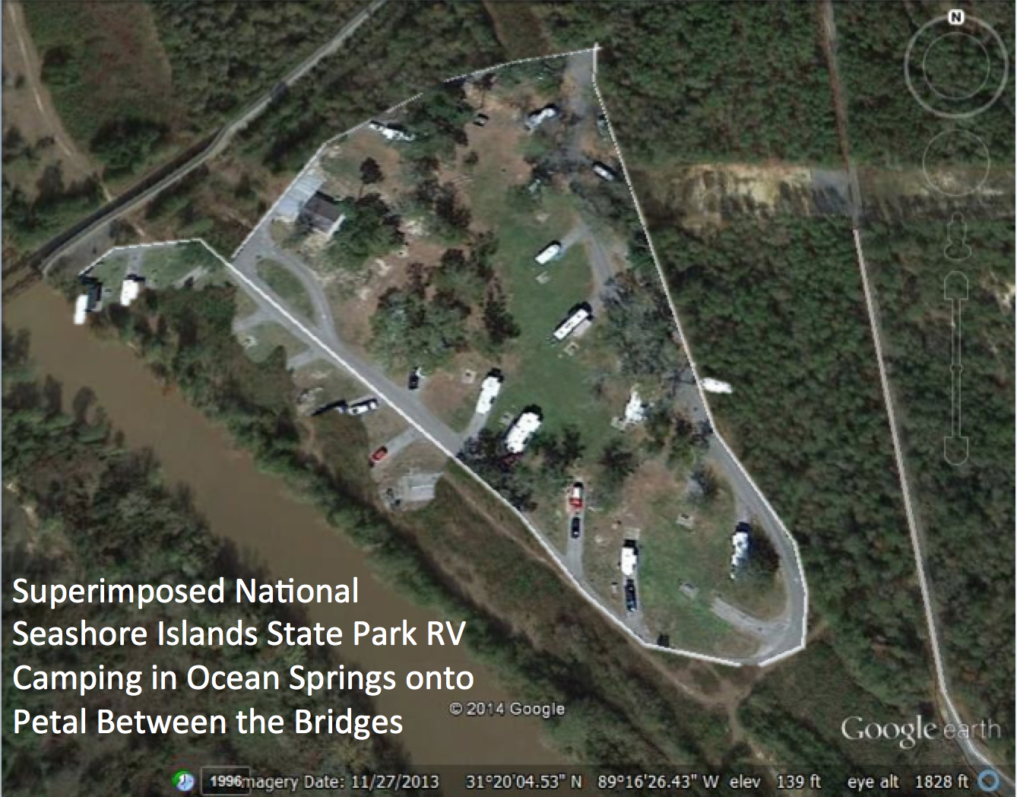

Figure 2. Maps prepared by graduate student Chris Ryals, with data from undergraduate students Mary Travis and Danielle Walters.

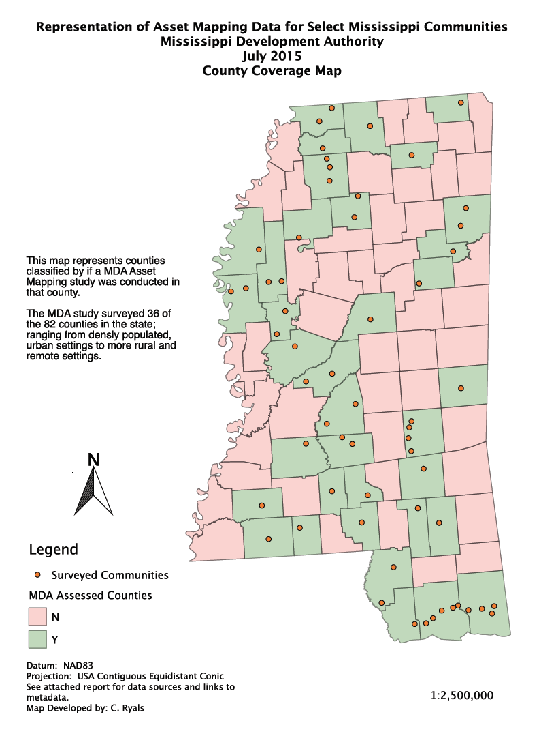

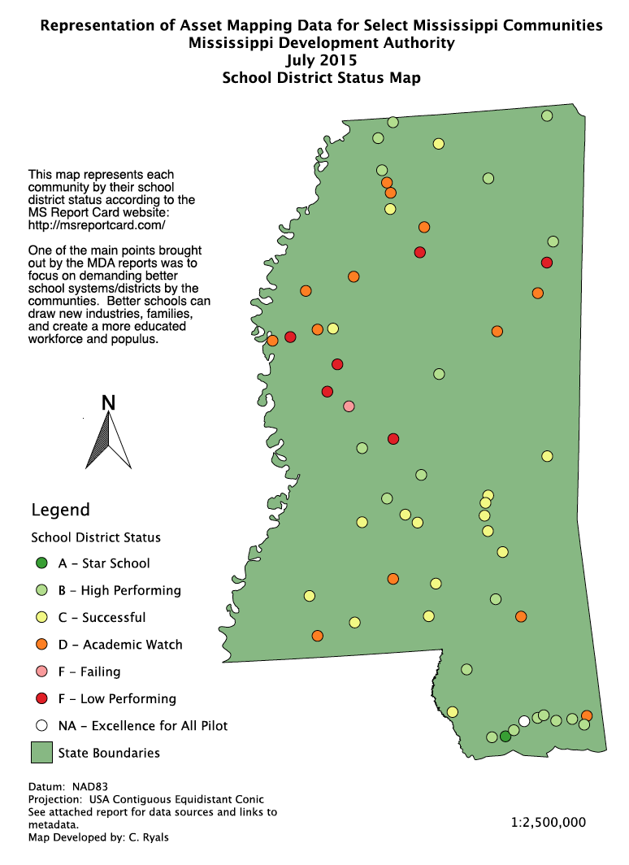

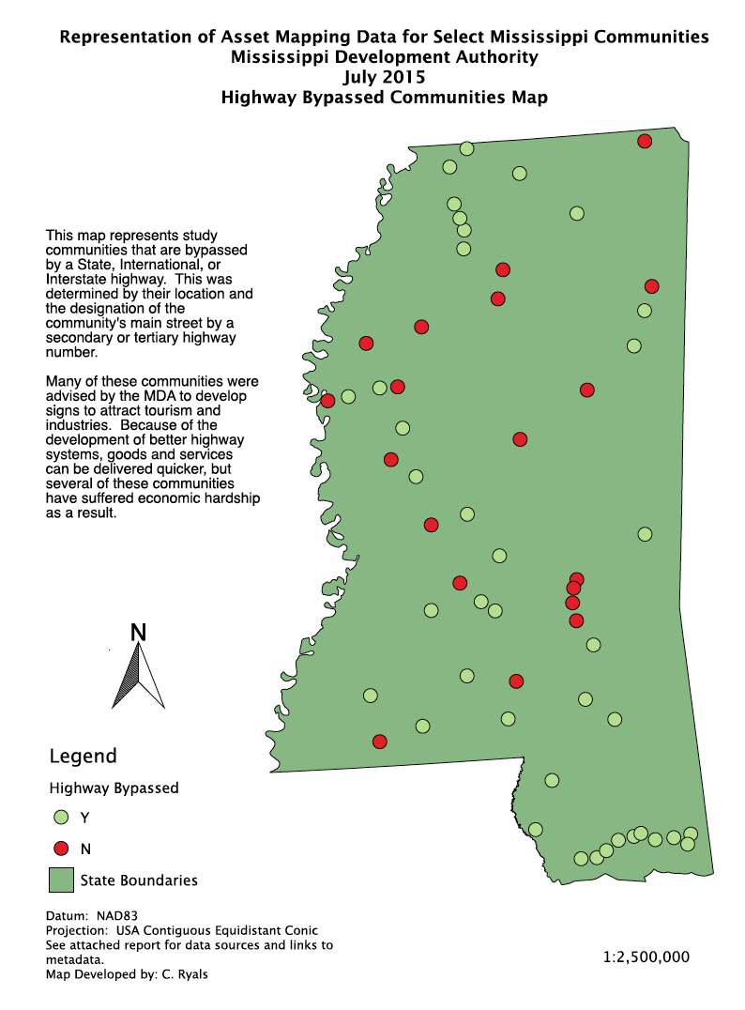

Figure 3. Excerpts from bike development-related infographics prepared by students Joshua Wiles and Samantha Metzler.

