2016 | Volume XX, Issue XX | Pages XX-XX

Communication challenges to designing an online professional development course.
Jose L. Fulgencio, Oklahoma State University

Communication between project manager and client is key to a successful experience. Losing communication can create confusion, misunderstanding, and frustration. In this article the focus will be on the communication challenges and how those challenges were resolved between an executive-director of a non-profit organization and project manager when designing an online professional development course.
Copyright © 2016 by the International Journal of Designs for Learning, a publication of the Association of Educational Communications and Technology. (AECT). Permission to make digital or hard copies of portions of this work for personal or classroom use is granted without fee provided that the copies are not made or distributed for profit or commercial advantage and that copies bear this notice and the full citation on the first page in print or the first screen in digital media. Copyrights for components of this work owned by others than IJDL or AECT must be honored. Abstracting with credit is permitted.

Jose L. Fulgencio is a native Chicagoan and doctoral student at Oklahoma State University in the Higher Education – Educational Technology program. Jose is an instructor with interdisciplinary courses. Jose’s research interest includes educational technology tools in instructional design, personal finance, and entrepreneurship.

INTRODUCTION
I had the opportunity to partner with a non-profit organization in a Mid-western state as a project manager to develop an online professional development course for teachers that teach personal finance. The organization wanted me to convert two face-to-face workshops into online courses, Better Money Habits and Financial Fitness. There was no set perimeters in terms what learning management system to use, what should be in the online course, or if there would be any media associated with the course. The main reasons for converting the curriculum into online courses was to increase the number of participants in the professional development workshops.

As the project manager I was in charge of the planning, build-up, implementation, and close out (HBR, 2012). The sponsor was the non-profit organization and team members just consisted of one person, myself. During the development of the project I had direct communication with the Executive Director of the organization in the development of the courses. There were no other team members assigned to assist in the project because the organization only had two-full time employees (Executive Director, Program Director) and one part-time employee, all of whom were assigned other tasks. The initial idea of the Executive Director was for me to design and implement the online courses and train the Program Director on how to teach the online courses.

The project had no budget, the courses were developed from free online resources and I was to assure the online courses had interaction with the user. Initially the Executive Director had plans to use the hosting institutions learning management system (D2L) but the idea would not be approved because the organization was not charging the user. My first thought was to use Moodle but the system was complex and decided to use Schoology. Schoology was cost-effective, the app allowed for easy online access to users, and the system was not complex as other learning management systems. After talks with the Executive Director about what was available on a zero-dollar budget Schoology was the learning management system of choice.

Communication is key between project manager and client in the design process. No matter how much confidence there is between project manager and client communicating through verbal exchanges and emails is essential to understand the needs and wants of both parties. Not having a clear communication can cause trouble in the long wrong of the project. I will discuss within my design case how communication affects the design and design process.

Change of Management
A few days into the project the Program Director resigned, which was the beginning of the miscommunication. I was surprised by the sudden resignation because the Executive Director planned that I would work along with the Projector Director on the implementation of the course and to see it through. It was my understanding that the former Program Director had zero experience in online teaching therefore it potentially created an opportunity for me to continue with the creation and teaching of the online professional development courses. After the resignation of the Program Director the communication between the Executive Director and myself grew on a daily basis where approval was given on the course development as the search for a new Program Director was underway. During the ongoing discussion about the design of the course the Executive Director decided to give each participant a gift card if they successfully completed the course. The Executive Director felt that the gift card would be an incentive to get people to take the course and complete the course. Successful completion included completion of discussion boards, pre & post surveys, and the actual implementation of a teaching lesson provide in the course. As the Executive Director was working on the hiring of a new Program Director I kept working on the design of the courses.

The Design of the Courses:
To design the courses, I used the ADDIE Model to get the process going (Figure 1). The ADDIE (Analyze, Design, Develop, Implement, Evaluate) Model is the illustration of the essential steps of the instructional design/development process (Brown & Green, 2011). The hosting institution had an e-Learning center that provided free consultation on the development of the online workshops using the Learning Environment Modeling (LEM), which is a visual and collaborative process for designing the spaces and places where people learn (Dodd & Gillmore, 2016). After consultation with the e-Learning center (Figures 8,9,10), redesign of the course using LEM, and from online teaching experience I built discussion boards for each module associated with the course (Figure 2) to give the face-to-face experience that the Executive Director wanted from the beginning. The online discussion board was designed to give the same interaction between users as they would from the face-to-face workshops, which is why the Executive Director stressed the importance of interaction. The Executive Director wanted the course to feel real to the participants as if they were in the actual face-to-face workshop. One of the stipulations that the user had to fulfill in order to receive professional development credit and receive a gift card was to answer the questions in each of the modules and respond to another user in each of the modules. Each module had a due date in order to ensure users were completing the material and being active.

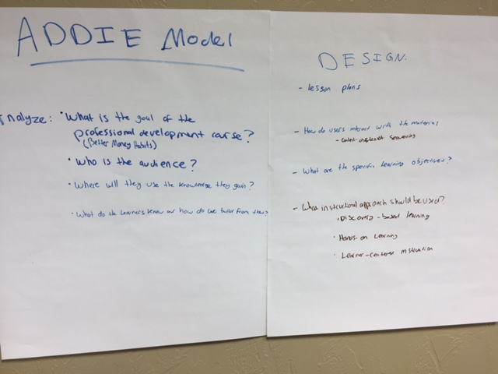
Figure 1: ADDIE Model
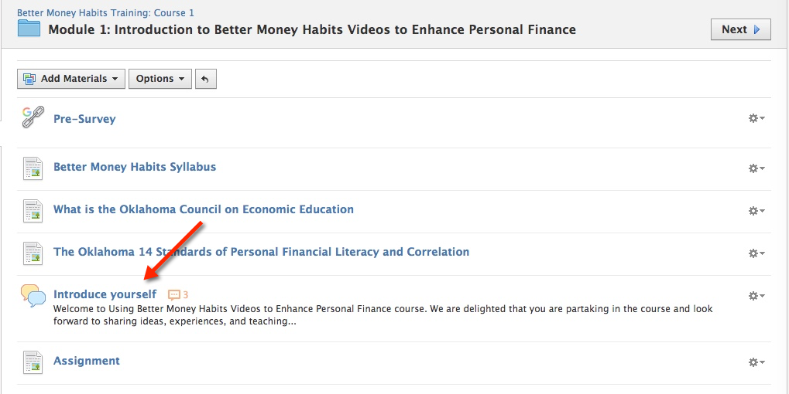

Figure 2: Module 1
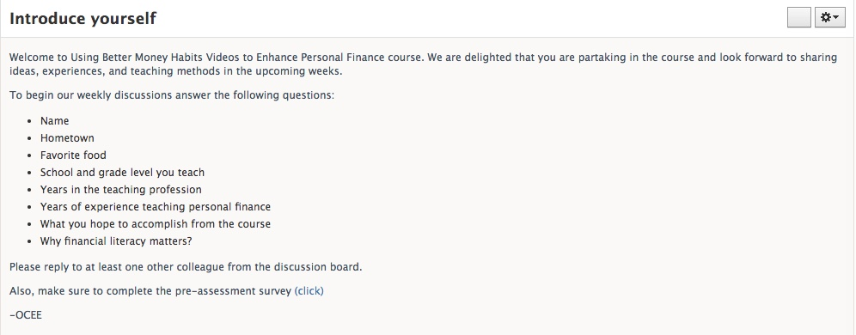

Figure 3: Discussion Board for Module 1
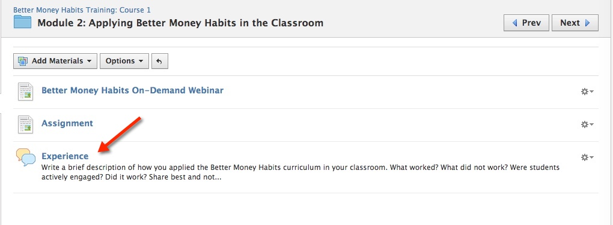

Figure 4: Module 2
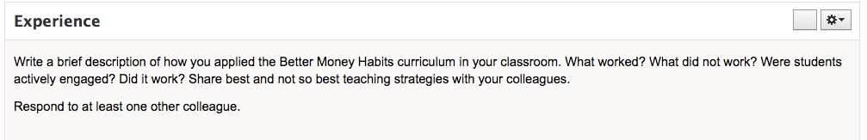

Figure 5: Discussion Board for Module 2

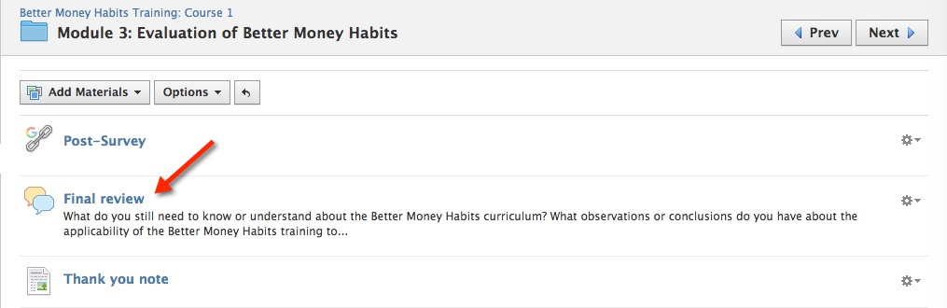

Figure 6: Module 3
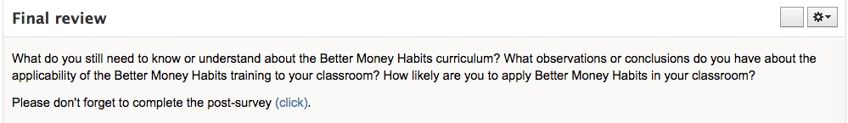

Figure 7: Discussion Board for Module 3
The Institute for Learning Environment Design from the organizations residing institution assisted in providing free consultation on the design of the course. The institute approved the design with minor additions in improving the course such as the design of the discussion boards and changing the names of each assignment from “weeks” to “modules.”

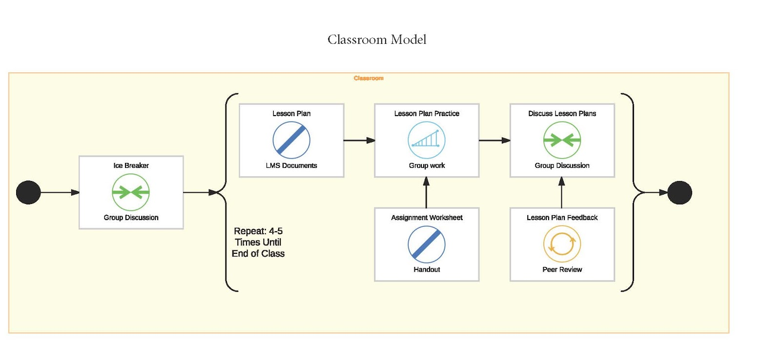
Figure 8: Classroom Model for Face-to-Face workshop

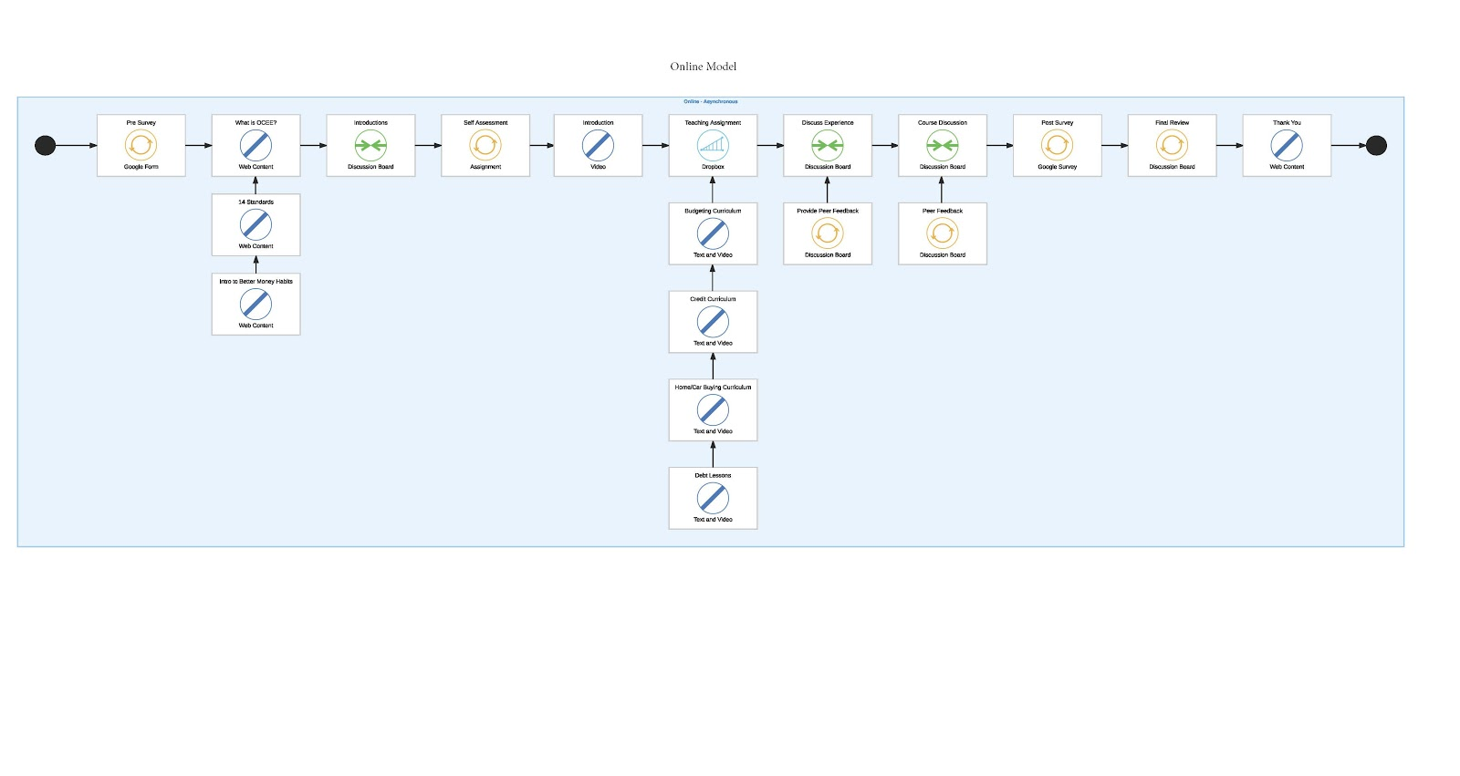
Figure 9: Conversion to online class

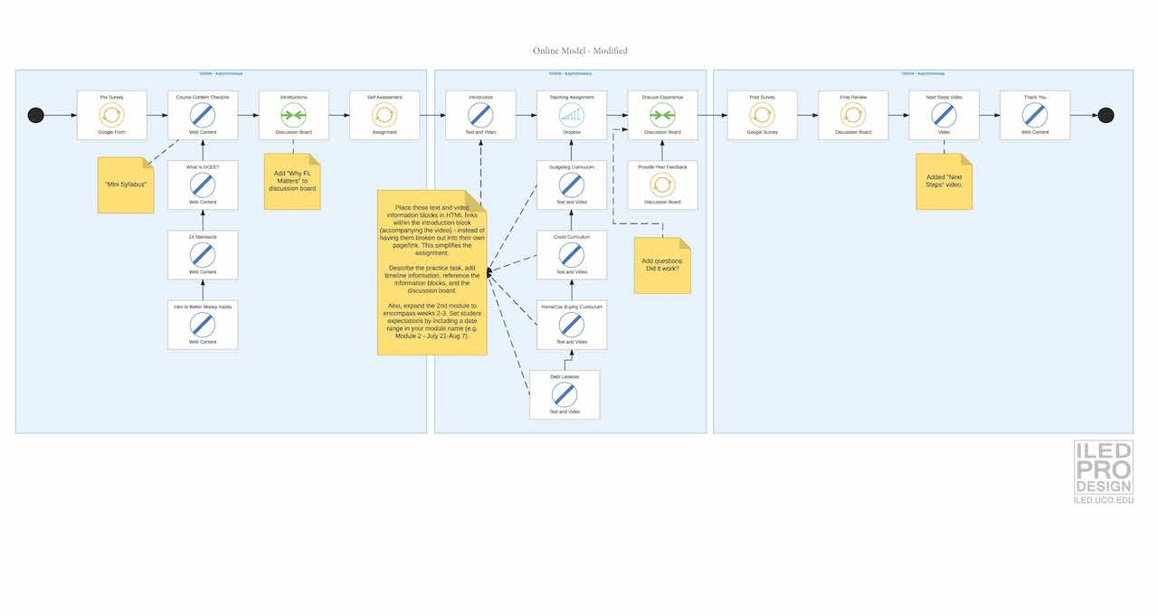

Figure 10: Edits to Online Course

Leadership Change:
Towards the end of the project a new Program Director was hired and the Executive Director decided that the new Program Director would take part in the Better Money Habits course as a student and lead discussions, which may have confused users as to who was leading the course because I emailed the users stating that I was the lead instructor. The Program Director has no online teaching experience and I did not have time to train the Program Director on how to manage the online course. There was no explanation from the Executive Director why the need to have the Program Director involved as lead instructor and that was the end of that discussion. The question became who is taking lead the program director or lead instructor? There was also no formal introduction of the program director, which could have helped in communicating the lead roles for the course.

Another major miscommunication occurred when deciding on how to distribute gift cards to the users after successful completion of the course. The Executive Director and I had spoken at the beginning of the partnership about giving out gift cards for the best posts and teaching experience stories. The new Program Director was told different which confused the distribution of gift cards.

After emailing and discussing on phone with the Program Director I was notified that the Executive Director did not recall our conversation about the disbursement of the gift cards. I made the mistake of not having the gift card discussion written down on paper or email to show proof of the discussion. I expected to work hand in hand with the Executive Director since we had worked on the development from the beginning. But with the Program Director getting in the middle of the communication it made the course implementation difficult to do with the miscommunication about the gift cards and who would lead the course. The Program Director and myself communicated via email about the final decision would be to distribute gift cards to each participant who successfully completed the course and the Program Director would be in charge of mailing out the gift cards. There was no affect on the course from the miscommunication on the gift cards.

After two modules the Program Director was not involved in the discussion boards, it was as if the Program Director disappeared. My understanding was that the Program Director needed to focus on other projects. Although the Program Director was not involved for the entire duration of the course, which was four weeks, I was able to manage the entire course and communicate with users on classroom related material. The constant communication with the users made the course a success.

At the close out stage of the course users enjoyed the course saying comments such as:
“Learning more about the Better Money Habits curriculum”
“The group discussions”
“The ability to share this information, including the video with students who really appreciated the information”
“The online aspect”
“I like that I have been introduced to more resources with my class. Thank you!”

Some of the dislikes included:
“I would enjoy a little more interaction, but it is online so this Is understandable”
“It was very short”
“Too fast paced”
“I like in person professional developments. I was given resources but, being a hand-on learner, I would have liked someone showing me what it would look like. For example, going through a couple lessons and letting me be the students with worksheets and everything...acting it out”

Suggestions included:
“Make the course longer with lesson plans for each week”
“Have videos of the lessons being taught”
“If you ever offer a life professional development, even if it took away a Saturday, I would definitely attend”
“Maybe a live chat some?”

After successful successful completion of the course there were discussions about developing a similar course with the possible implementation of live chat.

Reflections:
Lessons I learned from the experience are the following: develop a proper project management timetable that includes planning, build-up, implementation, closeout; have everything written down on paper and confirmed by both parties; and state from the beginning who will be the leader of the course. An email trail of information would suffice in order to backtrack on what was said and to confirm on the agreements when it came to leadership of the course and distribution of gift cards. The gift cards were not an important part of the design it was an example of miscommunication.

Developing a course is difficult and time consuming but adding miscommunication between the instructor and leadership of the organization makes the job difficult. When there is a clear defining of leadership from the beginning, especially written on paper, it makes the job easier to maneuver regardless of leadership change in the organization.

Communication is key to the success of any course and the focus of this design case. Without having a clear defining of who will lead the course once it's been developed it could lead to miscommunication later down the road. An issue such as how to distribute gift cards is something that should not takeover the discussion of the course. Instead getting users accommodated and prepared for the course are the conversations that should be occurring.

REFERENCES:
Brown, A., & Green, T.D. (2011). The essentials of instructional design: Connecting fundamental principles with process and practice (2nd ed.). Upper Saddle River, NJ: Pearson/Merrill Prentice Hall.
Dodd, B., & Gillmore, J. (2016). Learning environment modeling: Redefining learning environment design. University of Central Oklahoma: Edmond, OK.
HBR guide to project management. (2012). Boston, MA: Harvard Business Review Press.

ACKNOWLEDGMENTS
I want to thank the Institute for Learning Environment Design for assisting me in developing the article at the SLAM Workshop at AECT 2016. This article also wouldn’t have been possible without the encouragement of Dr. John Baaki.

