Summary of RT Survey of Field/Marine Station Director and Managers, Spring 2017
Intent: We hoped to gain a general perspective on the use and needs of stations for cyberinfrastructure, and further to assess their use of cloud resources, and willingness to adopt cloud resources, such as the NSF-funded Jetstream. This process was initiated by corresponding with colleagues in the field of ecology to gain a general idea of needs (see reply from David Inouye, Appendix 1) and by reviewing white papers and surveys by the National Association of Marine Laboratories and Organization of Biological Field Stations (NAML and OBFS; ref. 1-3).
Methods used: This survey was conducted over March and April of 2017. Users were identified as registered members of the Organization of Biological Field Stations (OBFS), by consumed all of the OBFS site’s pages via a crawler and extracted the addresses. These consist mostly of contact emails for the stations; currently OBFS lists 223 member stations. We assume that most of the stations’ directors or managers are included. This generated a mailing list of 310 email addresses. Recruitment letter (Appendix 2). Questionnaire (Appendix 3).
Demographics of field stations: 53 responses were returned, for a return rate of 17%. 17 were willing to be contacted further (many simply didn’t answer this question). We didn’t ask for further demographic details of the respondents, but rather for descriptions of the stations. FTE/station ranged from 0-56 (Dauphin Island Sea Lab), with most having 8-16 (Fig 1). Projects underway per station had a similar range of 1-100+ (Fig. 2; there is a 67.49% correlation between FTEs and # of Project). The majority were doctorate granting and research focused. There were 3 minority serving, and 9 were in EPSCoR states (Fig. 3). We don’t have this data for the entire 223 member stations (the polling information OBFS has provided doesn’t contain this sort of information), so we can’t determine how representative these respondents are. We didn’t ask about funding sources: given the traditional emphases of field stations, we feel it is a safe assumption that a majority of funding is from NSF directorates.

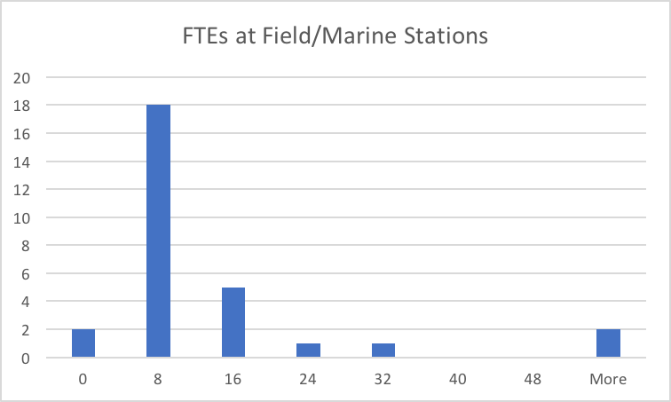
Figure 1. FTEs per Field Station

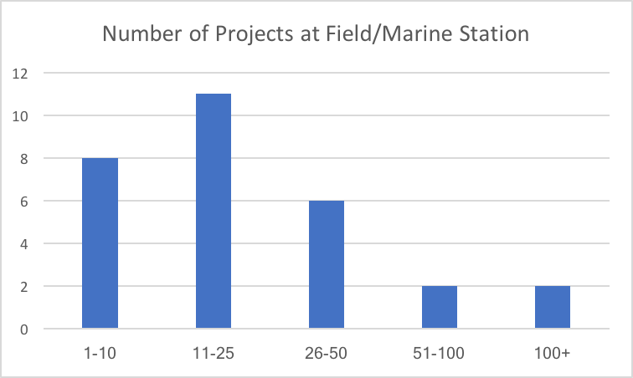
Figure 2. Projects per Field station

Figure 3. Distribution of responding stations

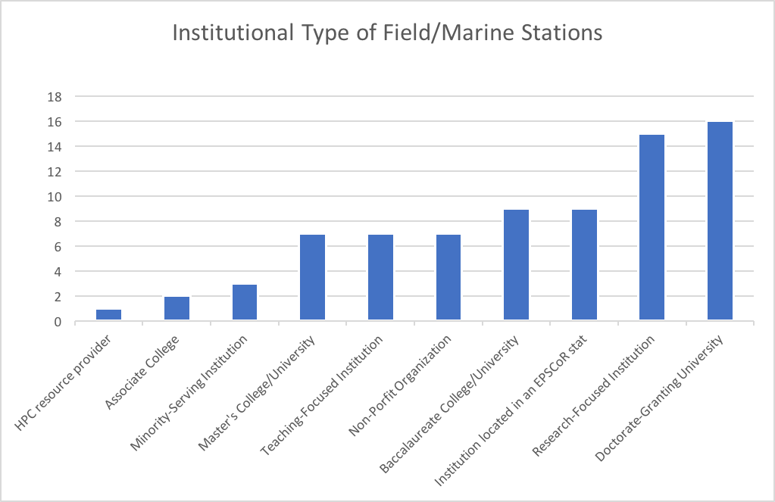
Figure 4. Instituional type/associated to (select all that apply)

Resources used and needed:

The majority (50%) of data generated at stations was ecological, environmental, and GIS. Images accounted for 24%. DNA/RNA/Protein sequence accounted for only 7%. We should have asked a question about what analysis was done and where, and if off-site would on-site would on-site be preferable. Current and future needs were dominated by data: data sharing, data finding, data management; these were followed by satellite and sensor data management, and only then by analysis workflows and pipelines. Cloud computing, HPC, and bioinformatics were the least named needs. Note that in the comments and correspondence outside this survey, data movement from the field has come up regularly.

The emphases on data suggests that the current interest of Jennifer Laherty of Wells Library in field station support is appropriate.

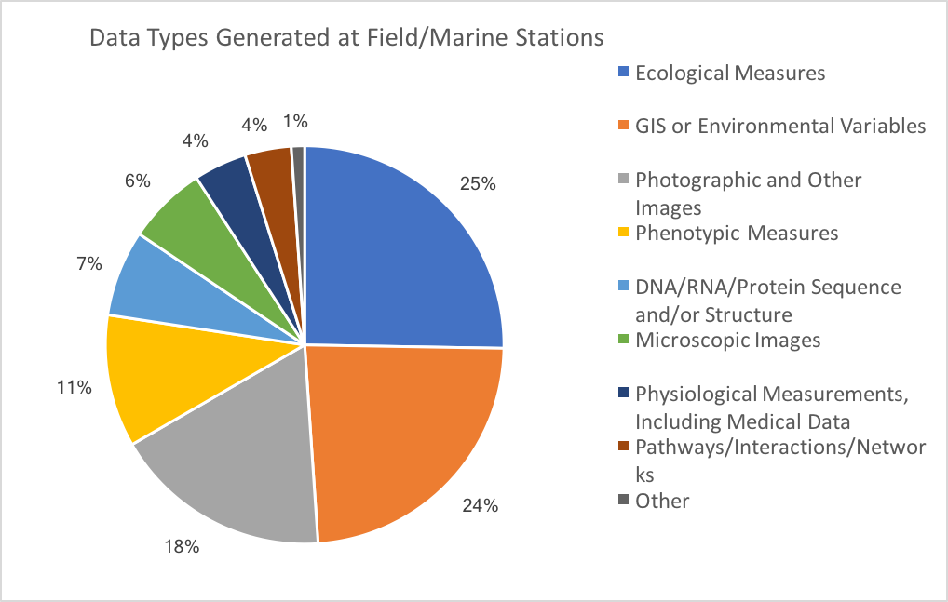
Figure 5. Methods used; data types generated

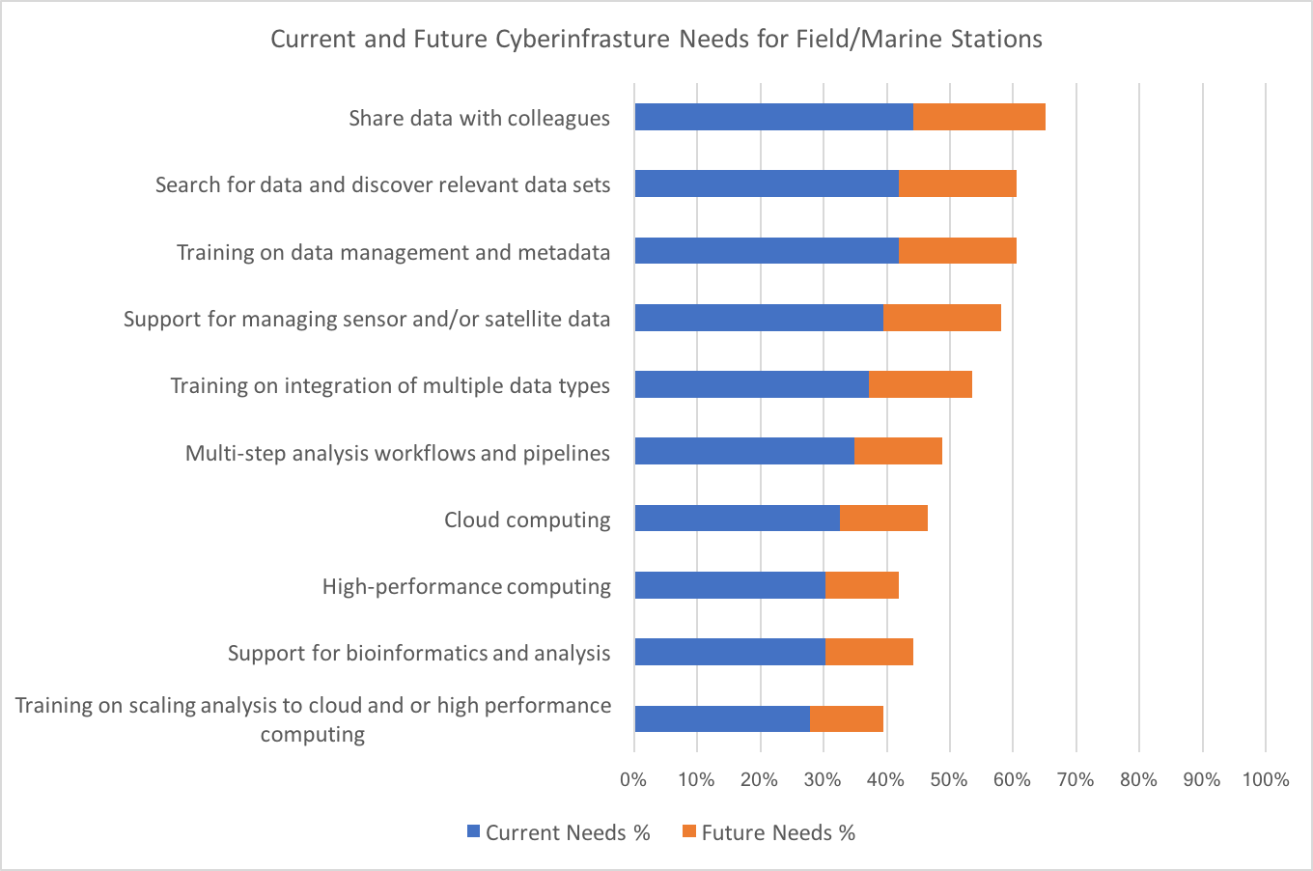
Figure 6. Current and future cyberinfrastructure needs
Cloud Use and Uses:
27% of the respondents said they now use a cloud resource, and 33% have explored the use of cloud resources, and intend to use them in the future (Fig. 6). 16% once used the cloud, but no longer do (it would be interesting to know why). 16% had no interest at all in using the cloud. Of those using cloud, most used either a commercial or academic-provided one (Fig. 8). When asked what clouds are useful for (Fig. 9), distributing information, storing data and/or collections, and uploading data were tied for first, followed by data analysis and as a platform for citizen science. There is a not a great correlation between the results of Fig. 5, 6 and 9: data collected, cyber infrastructure needs, and what the cloud is now used for. But only 27% of the respondents are now using the cloud.

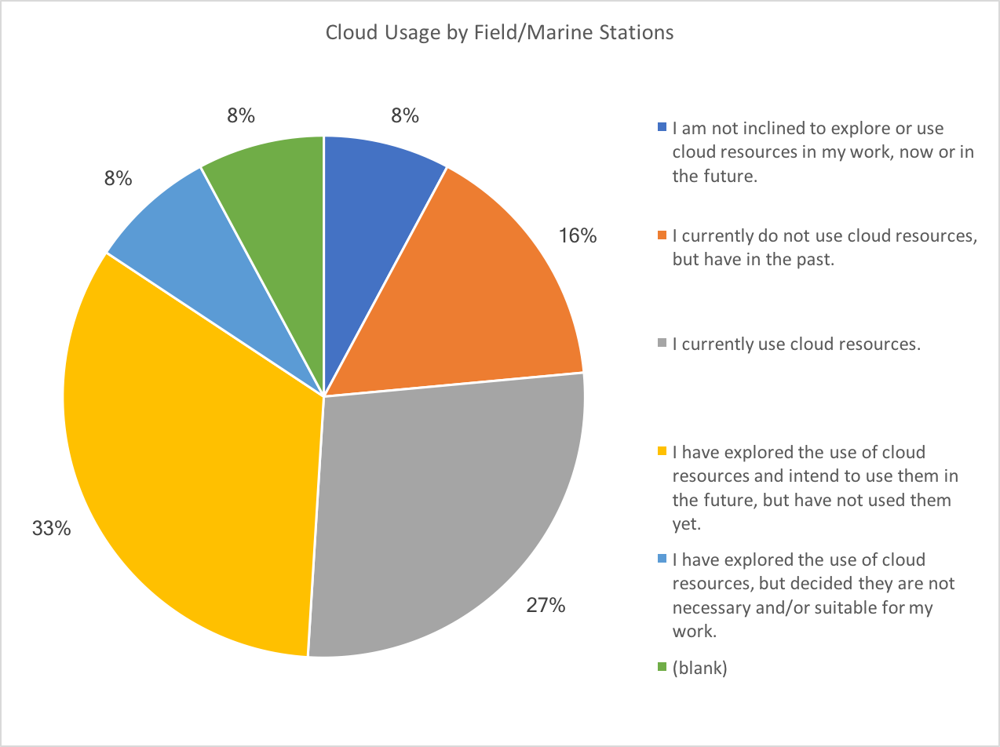
Figure 7. Use of cloud resources
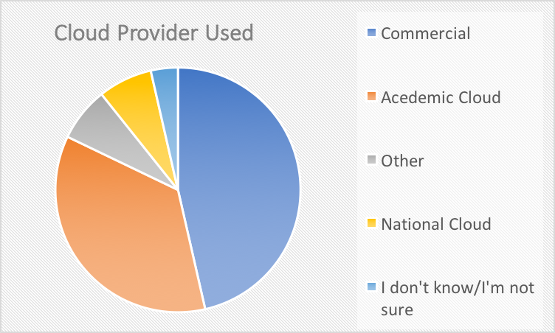
Figure 8 Cloud Provider Used

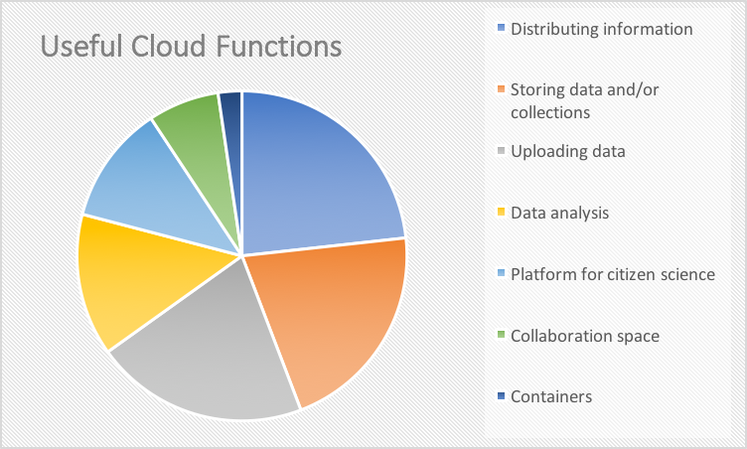
Figure 9 What are clouds good for?

Additional comments of respondents:
A common theme (really, the only issue that comes up in comments) is getting data from a remote location to a central site, in a timely fashion. This is thus at the very furthest end of the supply chain from Jetstream.

Potential first use cases:
These are the Stations that had needs at some level unanswered, and use or have a willingness to use the cloud. There is a large range of station sizes. Several are in EPSCoR states, two are minority serving. I have stared my first four picks, based in part on how engaged the answers were. It results in a nice geographic distribution as well, by chance.

Institute of Arctic Biology, UofA

* Mohonk Preserve

N.Y., nonprofit

* Bonderman Field Station at Rio Mesa, U. of Utah

EPSCoR state, Minority-Serving Institution

Highlands Biological Station

Sagehen Creek Field Station

Shoals Marine Laboratory

* Pepperwood Preserve, Santa Rosa, CA

Minority-Serving Institution (MSI), nonprofit (?)

* Baruch Institute of Coastal Ecology and Forest Science

EPSCoR state, Clemson University, S.C.

Overall conclusions from the Field Station Survey:

Data management is the overall emphasis, and computation is a minor issue. This holds true for both large and small institutions, although larger stations list more needs.

References:

Billick, I., I. Babb, B. Kloeppel, J. C. Leong, J. Hodder, J. Sanders, and H. Swain. Field Stations and Marine Laboratories of the Future: A Strategic Vision. National Association of Marine Laboratories and Organization of Biological Field Stations. http://www.obfs.org/fsml-future.
National Association of Marine Laboratories and Organization of Biological Field Stations (NAML and OBFS). 2013a. Building and operating the field stations and marine laboratories of the future: Workshop report. November 17–18, 2011. http://www.obfs.org/fsml-future.
National Association of Marine Laboratories and Organization of Biological Field Stations (NAML and OBFS). 2013b. Place-based research site strategic planning survey: Results summary. http://www.obfs.org/fsml-future.

Appendix 1.
From: David W. Inouye [mailto:inouye@umd.edu]
Sent: Wednesday, February 22, 2017 6:18 PM
Subject: Fwd: RE: Help with Field/Marine Station computational needs
Tom-
I’d be happy about this from the perspective of someone running a field station—which may not be what you need. I did oversee a field station and marine lab planning effort that collated information from scientists as well as surveyed general needs (and puts IT within a larger context). You can find more at:
http://www.obfs.org/fsml-future
My quick response is that the greatest demand from field scientists is on integrating and finding information from across a wide range of subjects, collaboration/workflow tools, and tools which provide them immediate benefit (professional data management, data integration, version control) instead of being focused on serving individuals who didn’t collect the data. Typically there is a huge disconnect between the people that generate the data and professional data managers who seem focused on serving on people performing metanalyses. I have a chapter on data management at field stations in the Ecology of Place, which I edited with Mary Price.
If you have more narrow questions within genomics related to field science, I would recommend reaching out to Noah Whiteman (Berkeley), Jenn Rudgers (New Mexico), Carol Boggs (South Carolina), Ken Williams (Lawrence Berkeley Lab), or Tom Mitchell-Olds (Duke). They are RMBL field scientists funded by NSF, NIH, and DOE doing quite a bit of genomics work.

Appendix 2.

Field Station Survey – Recruitment message

Dear Colleagues,
Indiana University has funding from the National Science Foundation (NSF) to help biologists across the country. Some of you may already be familiar with the National Center for Genome Analysis Support (ncgas.org), but Indiana University also now runs the first NSF-funded science and engineering cloud, known as Jetstream, the use of which is offered at no-cost to US-based researchers. One key audience for Jetstream is researchers at field and marine stations, which are often removed from major computational centers.
We are writing because we would like to know more about the needs researchers at field and marine stations have for informatics and computational support so that we can better address these areas in the Jetstream cloud environment. These might include computation needs, storage capacity for field data, curated domain-specific software sets, data uploading and archiving from the field, etc. We are interested in the needs of both large or small field stations, and those of the field biologists working out of your stations. We welcome your suggestions, as well as any additional questions you might have for us.

Please give us your feedback by participating in the survey at:

https://iu.co1.qualtrics.com/field_marine_station

Your responses will remain completely confidential. Neither your name nor your organization will be associated with any data you provide or included in any reports. If you have any questions about this survey or how the results will be used, please feel free to contact Julie Wernert, Information Manager, Indiana University, at jwernert@iu.edu, or (812) 856-5517.

Sincerely,

Craig A. Stewart
Principal Investigator, Jetstream
Indiana University Pervasive Technology Institute

David Y. Hancock
Project Director, Jetstream
Indiana University Pervasive Technology Institute

Appendix 3.

Jetstream Field and Marine Station Computational Needs Survey

INFORMED CONSENT: You are invited to participate in the Field and Marine Station Computational Needs Survey conducted by principal investigators of the National Science Foundation-funded Jetstream project. We ask that you read this statement and ask any questions you may have before agreeing to take part in the survey. This study is administered on behalf of the Jetstream project by the Indiana University Pervasive Technology Institute and is funded, in part, by the National Science Foundation.

STUDY PURPOSE: The purpose of the Jetstream Field and Marine Station Computational Needs Survey is aimed at assessing current and future computational needs for researchers at field and marine stations, as well as the factors informing the adoption and use of cloud-based resources. Survey information will be used to guide Jetstream personnel in (1) assessing and addressing current and future needs, (2) focusing outreach and training efforts, (3) making decisions related to resource provisioning, and (4) informing plans for future expansion of resources and services.

PROCEDURES FOR THE STUDY: If you agree to take part in the study, you will complete an online survey in which you will not be required to provide any identifying information. You will have the option of providing your name and contact information if future contact is desired. Future contact may be in the form of telephone, video-conference, or in-person interview, and/or focus group. [You will be asked to disclose your gender, race, ethnicity and other demographic information for tracking purposes only.] The survey will remain confidential, and survey responses will not be associated with any identifying information, even if you choose to disclose your name and contact information for potential future contact. You will receive via email an initial letter of invitation, followed by up to three reminder messages. After the initial letter of invitation, only those who have not responded will receive subsequent messages. You will have the opportunity to opt out of all future communications upon receipt of the initial letter of invitation. The survey should not take more than 10 minutes to complete, with an average time for completion in the five- to seven-minute range.

CONFIDENTIALITY: Efforts will be made to keep any personal information that you might inadvertently disclose confidential. We cannot guarantee absolute confidentiality. Your personal information may be disclosed if required by law. Your identity will be held in confidence in reports in which the survey results may be published and/or databases in which results may be stored. Organizations that may inspect and/or copy survey records for quality assurance and data analysis include groups such as the study investigator and his/her research associates, the Indiana University Institutional Review Board or its designees, the study sponsor, the National Science Foundation, and (as allowed by law) state or federal agencies, specifically the Office for Human Research Protections (OHRP). CONTACTS FOR QUESTIONS OR PROBLEMS: For questions about the study, contact Indiana University Information Manager Julie Wernert at (812) 856-5517 or jwernert@iu.edu. For questions about your rights as a participant or to discuss problems, complaints, or concerns about a research study, to obtain information, or to offer input, please contact the IU Human Subjects Office at (812) 856-4242 or by email at irb@iu.edu.

VOLUNTARY NATURE OF STUDY: Taking part in this study is voluntary. You may choose not to take part or may leave the survey at any time. Leaving the survey will not result in any penalty. Your decision whether or not to participate in this survey will not affect your current or future relations with the Indiana University Pervasive Technology Institute, the Jetstream program, or the National Science Foundation.This study was approved by the Indiana University Institutional Review Board on xxxx, xx, 2017. Please reference Study # xxxxxxxxxxxxx/xxxxxxx when inquiring.

Do you consent to participate in this survey?
- I agree (1)
- I disagree (2)
Condition: I agree Is Selected. Skip To: End of Block.Condition: I disagree Is Selected. Skip To: End of Survey.

Q1 Of the following computational needs, please indicate which are current needs in your research, teaching, training, and/or outreach activities, and which you anticipate needing in the future.
 | Current Needs (1) | Future Needs (2)
Publish data to the community (1)
Sufficient data storage (2)
Share data with colleagues (3)
Training on data management and metadata (4)
Support for managing sensor and/or satellite data (5)
Support for bioinformatics and analysis (6)
Search for data and discover relevant data sets (7)
Multi-step analysis workflows and pipelines (8)
High-performance computing (9)
Training on integration of multiple data types (10)
Cloud computing (11)
Training on scaling analysis to cloud and or high performance computing (12)

Q2 What are the major data types used in your research, teaching, training, and/or outreach activities? Select all that apply.
- DNA/RNA/Protein Sequence and/or Structure (e.g., genomics and metagenomics) (1)
- Photographic and Other Images (2)
- Phenotypic Measures (3)
- Ecological Measures (4)
- GIS or Environmental Variables (5)
- Microscopic Images (6)
- Pathways/Interactions/Networks (7)
- Physiological Measurements, including Medical Data (8)
- Other (specify): (9) ____________________

Q3 Which presently describes your current status with regard to the use of cloud resources in your research, teaching, training, and/or outreach activities?
- I currently use cloud resources. (1)
- I currently do not use cloud resources, but have in the past. (2)
- I have explored the use of cloud resources and intend to use them in the future, but have not used them yet. (3)
- I have explored the use of cloud resources, but decided they are not necessary and/or suitable for my work. (4)
- I am not inclined to explore or use cloud resources in my work, now or in the future. (5)

Q4 What sort of cloud resources do you use (or have you used) in your research, teaching, training, and/or outreach activities? Select all that apply
- Commercial cloud services (e.g., Amazon Web Services, Microsoft Azure, Google Cloud, etc.) (1)
- Academic cloud resources (provided by your academic or research institution) (2)
- National cyberinfrastructure cloud resources (e.g., Cloud resources available through NSF-funded projects, such as XSEDE, etc.) (3)
- I don’t know/ I’m not sure (4)
- Other: (5) ____________________

Q6 How are you currently using (or have you in the past used) cloud resources in your research, teaching, training and/or outreach activities? Select all that apply.
- Uploading data (1)
- Storing data and/or collections (2)
- Distributing information (3)
- Data analysis (4)
- Virtual machines (5)
- Container technologies (e.g., Docker) (6)
- Collaboration space (7)
- Platform for citizen scientists’ contributions (8)
- Other: (9) ____________________

Q8 Please indicate the approximate number of projects underway at your field station.
- 1-10 (1)
- 11-25 (2)
- 26-50 (3)
- 52-100 (4)
- Over 100 (5)

Q9 Approximately, how many funded individuals staff your field station? Please report your answer as full and/or partial FTEs.

Q10 With what type of institution is your field station associated? Select all that apply.
- Institution located in an EPSCoR state (1)
- Minority-Serving Institution (MSI) (2)
- Associate’s College (all degrees are at the associate’s level) (3)
- Baccalaureate College/University (4)
- Master’s College/University (5)
- Doctorate-Granting University (6)
- Teaching-Focused Institution (7)
- Research-Focused Institution (8)
- Government Lab or Center (9)
- High performance computing resource provider (e.g. NCSA, TACC, etc.) (10)
- Non-Profit Organization (non-academic) (11)
- Corporate/Industrial Organization (12)

Q11 Are there any general comments on the use of cloud resources, or more broadly on your station’s computational needs, that you would like to share?

Q12 May we contact you for additional insights on the use of cloud resources in your research, teaching, training and/or outreach activities?
- Yes (1)
- No (2)
Condition: No Is Selected. Skip To: End of Survey.Condition: Yes Is Selected. Skip To: Thank you for your willingness to tak....

Q14 Thank you for your willingness to take part in a follow-up discussion. Please provide your name and best contact information.
Name (1)
Preferred Email Address (2)
Preferred Phone Number (3)

Q18 What sort of cloud resources do you use (or have you used) in your research, teaching, training, and/or outreach activities? Select all that apply
- Commercial cloud services (e.g., Amazon Web Services, Microsoft Azure, Google Cloud, etc.) (1)
- Academic cloud resources (provided by your academic or research institution) (2)
- National cyberinfrastructure cloud resources (e.g., Cloud resources available through NSF-funded projects, such as XSEDE, etc.) (3)
- I don’t know/ I’m not sure (4)
- Other: (5) ____________________

Q19 If you are not presently using cloud resources for your work, please indicate why not. Select all that apply.
- Concerns about the security of my data (1)
- Concerns about reliable access (connectivity) to my data (2)
- Concerns about maintaining control of my data (3)
- Effort required to transition my work to the cloud outweighs the benefit (4)
- My institution does not offer or support cloud resources (5)
- Too expensive/ I don’t have funding to acquire cloud resources (6)
- My current mechanisms and work flows satisfy my needs (7)
- I don’t need these resources for my work (8)
- I really haven’t ever considered this option (9)
- I am not familiar with using cloud resource and don’t have time to learn (10)
- Other: (11) ____________________
Condition: Other: Is Selected. Skip To: If you were to adopt the use of cloud....

Q20 How are you currently using (or have you in the past used) cloud resources in your research, teaching, training and/or outreach activities? Select all that apply.
- Uploading data (1)
- Storing data and/or collections (2)
- Distributing information (3)
- Data analysis (4)
- Virtual machines (5)
- Container technologies (e.g., Docker, etc) (6)
- Collaboration space (7)
- Platform for citizen scientists’ contributions (8)
- Other: (9) ____________________
Condition: Uploading data Is Selected. Skip To: If you were to adopt the use of cloud....

Q21 If you were to adopt the use of cloud resources for your research, teaching, training and/or outreach activities in the future, in what activities would you anticipate them being useful? Select all that apply.
- Uploading data (1)
- Storing data and/or collections (2)
- Distributing information (3)
- Data analysis (4)
- Virtual machines (5)
- Container technologies (e.g., Docker, etc. (6)
- Collaboration space (7)
- Platform for citizen scientists’ contributions (8)
- Other: (9) ____________________
Condition: Platform for citizen scien... Is Selected. Skip To: Please indicate the approximate numbe....

Q22 Please indicate the approximate number of projects underway at your field station.
- 1-10 (1)
- 11-25 (2)
- 26-50 (3)
- 52-100 (4)
- Over 100 (5)

Q23 Approximately, how many funded individuals staff your field station? Please report your answer as full and/or partial FTEs.

Q24 With what type of institution is your field station associated? Select all that apply.
- Institution located in an EPSCoR state (1)
- Minority-Serving Institution (MSI) (2)
- Associate’s College (all degrees are at the associate’s level) (3)
- Baccalaureate College/University (4)
- Master’s College/University (5)
- Doctorate-Granting University (6)
- Teaching-Focused Institution (7)
- Research-Focused Institution (8)
- Government Lab or Center (9)
- High performance computing resource provider (e.g. NCSA, TACC, etc.) (10)
- Non-Profit Organization (non-academic) (11)
- Corporate/Industrial Organization (12)

Q25 Are there any general comments on the use of cloud resources, or more broadly on your station’s computational needs, that you would like to share?

Q26 May we contact you for additional insights on the use of cloud resources in your research, teaching, training and/or outreach activities?
- Yes (1)
- No (2)
Condition: No Is Selected. Skip To: End of Survey.Condition: Yes Is Selected. Skip To: Thank you for your willingness to tak....

Q27 Thank you for your willingness to take part in a follow-up discussion. Please provide your name and best contact information.
Name (1)
Preferred Email Address (2)
Preferred Phone Number (3)

Q29 If you are not presently using cloud resources for your work, please indicate why not. Select all that apply.
- Concerns about the security of my data (1)
- Concerns about reliable access (connectivity) to my data (2)
- Concerns about maintaining control of my data (3)
- Effort required to transition my work to the cloud outweighs the benefit (4)
- My institution does not offer or support cloud resources (5)
- Too expensive/ I don’t have funding to acquire cloud resources (6)
- My current mechanisms and work flows satisfy my needs (7)
- I don’t need these resources for my work (8)
- I really haven’t ever considered this option (9)
- I am not familiar with using cloud resource and don’t have time to learn (10)
- Other: (11) ____________________
Condition: Other: Is Selected. Skip To: If you were to adopt the use of cloud....

Q31 If you were to adopt the use of cloud resources for your research, teaching, training and/or outreach activities in the future, in what activities would you anticipate them being useful? Select all that apply.
- Uploading data (1)
- Storing data and/or collections (2)
- Distributing information (3)
- Data analysis (4)
- Virtual machines (5)
- Container technologies (e.g., Docker, etc.) (6)
- Collaboration space (7)
- Platform for citizen scientists’ contributions (8)
- Other: (9) ____________________
Condition: Platform for citizen scien... Is Selected. Skip To: Please indicate the approximate numbe....

Q32 Please indicate the approximate number of projects underway at your field station.
- 1-10 (1)
- 11-25 (2)
- 26-50 (3)
- 52-100 (4)
- Over 100 (5)

Q33 Approximately, how many funded individuals staff your field station? Please report your answer as full and/or partial FTEs.

Q34 With what type of institution is your field station associated? Select all that apply.
- Institution located in an EPSCoR state (1)
- Minority-Serving Institution (MSI) (2)
- Associate’s College (all degrees are at the associate’s level) (3)
- Baccalaureate College/University (4)
- Master’s College/University (5)
- Doctorate-Granting University (6)
- Teaching-Focused Institution (7)
- Research-Focused Institution (8)
- Government Lab or Center (9)
- High performance computing resource provider (e.g. NCSA, TACC, etc.) (10)
- Non-Profit Organization (non-academic) (11)
- Corporate/Industrial Organization (12)

Q58 Are there any general comments on the use of cloud resources, or more broadly on your station’s computational needs, that you would like to share?

Q36 May we contact you for additional insights on the use of cloud resources in your research, teaching, training and/or outreach activities?
- Yes (1)
- No (2)
Condition: No Is Selected. Skip To: End of Survey.Condition: Yes Is Selected. Skip To: Thank you for your willingness to tak....

Q37 Thank you for your willingness to take part in a follow-up discussion. Please provide your name and best contact information.
Name (1)
Preferred Email Address (2)
Preferred Phone Number (3)

Q39 If you are not presently using cloud resources for your work, please indicate why not. Select all that apply.
- Concerns about the security of my data (1)
- Concerns about reliable access (connectivity) to my data (2)
- Concerns about maintaining control of my data (3)
- Effort required to transition my work to the cloud outweighs the benefit (4)
- My institution does not offer or support cloud resources (5)
- Too expensive/ I don’t have funding to acquire cloud resources (6)
- My current mechanisms and work flows satisfy my needs (7)
- I don’t need these resources for my work (8)
- I really haven’t ever considered this option (9)
- I am not familiar with using cloud resource and don’t have time to learn (10)
- Other: (11) ____________________

Q41 If you were to adopt the use of cloud resources for your research, teaching, training and/or outreach activities in the future, in what activities would you anticipate them being useful? Select all that apply.
- Uploading data (1)
- Storing data and/or collections (2)
- Distributing information (3)
- Data analysis (4)
- Virtual machines (5)
- Container technologies (e.g., Docker, etc.) (6)
- Collaboration space (7)
- Platform for citizen scientists’ contributions (8)
- Other: (9) ____________________

Q42 Please indicate the approximate number of projects underway at your field station.
- 1-10 (1)
- 11-25 (2)
- 26-50 (3)
- 52-100 (4)
- Over 100 (5)

Q43 Approximately, how many funded individuals staff your field station? Please report your answer as full and/or partial FTEs.

Q44 With what type of institution is your field station associated? Select all that apply.
- Institution located in an EPSCoR state (1)
- Minority-Serving Institution (MSI) (2)
- Associate’s College (all degrees are at the associate’s level) (3)
- Baccalaureate College/University (4)
- Master’s College/University (5)
- Doctorate-Granting University (6)
- Teaching-Focused Institution (7)
- Research-Focused Institution (8)
- Government Lab or Center (9)
- High performance computing resource provider (e.g. NCSA, TACC, etc.) (10)
- Non-Profit Organization (non-academic) (11)
- Corporate/Industrial Organization (12)

Q45 Are there any general comments on the use of cloud resources, or more broadly on your station’s computational needs, that you would like to share?

Q46 May we contact you for additional insights on the use of cloud resources in your research, teaching, training and/or outreach activities?
- Yes (1)
- No (2)
Condition: No Is Selected. Skip To: End of Survey.Condition: Yes Is Selected. Skip To: Thank you for your willingness to tak....

Q47 Thank you for your willingness to take part in a follow-up discussion. Please provide your name and best contact information.
Name (1)
Preferred Email Address (2)
Preferred Phone Number (3)

Q60 Are there any general comments on the use of cloud resources, or more broadly on your station’s computational needs, that you would like to share?

Q49 If you are not presently using cloud resources for your work, please indicate why not. Select all that apply.
- Concerns about the security of my data (1)
- Concerns about reliable access (connectivity) to my data (2)
- Concerns about maintaining control of my data (3)
- Effort required to transition my work to the cloud outweighs the benefit (4)
- My institution does not offer or support cloud resources (5)
- Too expensive/ I don’t have funding to acquire cloud resources (6)
- My current mechanisms and work flows satisfy my needs (7)
- I don’t need these resources for my work (8)
- I really haven’t ever considered this option (9)
- I am not familiar with using cloud resource and don’t have time to learn (10)
- Other: (11) ____________________

Q52 Please indicate the approximate number of projects underway at your field station.
- 1-10 (1)
- 11-25 (2)
- 26-50 (3)
- 52-100 (4)
- Over 100 (5)

Q53 Approximately, how many funded individuals staff your field station? Please report your answer as full and/or partial FTEs.

Q54 With what type of institution is your field station associated? Select al that apply.
- Institution located in an EPSCoR state (1)
- Minority-Serving Institution (MSI) (2)
- Associate’s College (all degrees are at the associate’s level) (3)
- Baccalaureate College/University (4)
- Master’s College/University (5)
- Doctorate-Granting University (6)
- Teaching-Focused Institution (7)
- Research-Focused Institution (8)
- Government Lab or Center (9)
- High performance computing resource provider (e.g. NCSA, TACC, etc.) (10)
- Non-Profit Organization (non-academic) (11)
- Corporate/Industrial Organization (12)

Q55 Are there any general comments on the use of cloud resources, or more broadly on your station’s computational needs, that you would like to share?

Q56 May we contact you for additional insights on the use of cloud resources in your research, teaching, training and/or outreach activities?
- Yes (1)
- No (2)
Condition: No Is Selected. Skip To: End of Survey.Condition: Yes Is Selected. Skip To: Thank you for your willingness to tak....

Q57 Thank you for your willingness to take part in a follow-up discussion. Please provide your name and best contact information.
Name (1)
Preferred Email Address (2)
Preferred Phone Number (3)

